UNITED STATES
SECURITIES AND EXCHANGE COMMISSION
WASHINGTON, D.C. 20549

FORM 8-K
CURRENT REPORT

Pursuant to Section 13 or 15(d) of the
Securities Exchange Act of 1934

Date of report (Date of earliest event reported): August 6, 2026

Verastem, Inc.
(Exact Name of Registrant as Specified in Charter)

Delaware |  | 001-35403 |  | 27-3269467
(State or Other Jurisdiction  of Incorporation) |  | (Commission  File Number) |  | (IRS Employer  Identification No.)

117 Kendrick Street, Suite 500, Needham, MA |  | 02494
(Address of Principal Executive Offices) |  | (Zip Code)

Registrant’s telephone number, including area code: (781) 292-4200

(Former Name or Former Address, if Changed Since Last Report)

Check the appropriate box below if the Form 8-K filing is intended to simultaneously satisfy the filing obligation of the registrant under any of the following provisions:

☐ | Written communications pursuant to Rule 425 under the Securities Act (17 CFR 230.425)
☐ | Soliciting material pursuant to Rule 14a-12 under the Exchange Act (17 CFR 240.14a-12)
☐ | Pre-commencement communications pursuant to Rule 14d-2(b) under the Exchange Act (17 CFR 240.14d-2(b))
☐ | Pre-commencement communications pursuant to Rule 13e-4(c) under the Exchange Act (17 CFR 240.13e-4(c))

Securities registered pursuant to Section 12(b) of the Act:

Title of each class |  | Trading  Symbol(s) |  | Name of each exchange on which registered
Common stock, $0.0001 par value per share |  | VSTM |  | The Nasdaq Capital Market

Indicate by check mark whether the registrant is an emerging growth company as defined in Rule 405 of the Securities Act of 1933 (§230.405 of this chapter) or Rule 12b-2 of the Securities Exchange Act of 1934 (§240.12b-2 of this chapter).

Emerging growth company ☐

If an emerging growth company, indicate by check mark if the registrant has elected not to use the extended transition period for complying with any new or revised financial accounting standards provided pursuant to Section 13(a) of the Exchange Act. ☐

Item 1.01 Entry into a Material Definitive Agreement

On August 6, 2026 (the “Amendment Closing Date”), Verastem, Inc., (the “Company”) entered into Amendment No. 3 (the “Amendment”) to that certain Note Purchase Agreement, dated as of January 13, 2025 (the “Original Closing Date”), as previously amended by Amendment No. 1 dated as of October 31, 2025 and Amendment No. 2 dated as of March 2, 2026 (as so amended, the “Note Purchase Agreement”) by and among the Company, certain funds managed by Oberland Capital Management LLC (together with other purchasers party thereto from time to time, the “Purchasers”) and RGCM SA LLC, as purchaser agent.

The Amendment amends the financing arrangement under the Note Purchase Agreement by establishing two separate series of senior secured notes: (i) “Initial Notes,” which are the notes in an initial aggregate principal amount of $75.0 million previously issued on the Original Closing Date in connection with the first purchase under the Note Purchase Agreement, and (ii) “Revenue Notes,” which are a new series of notes to be issued in two tranches under the Note Purchase Agreement with an aggregate purchase price of up to $75.0 million (the Initial Notes and Revenue Notes, together, the “Notes”). The establishment of the Revenue Notes replaces the previous conditional second and third tranches of $25.0 million principal amount of Initial Notes and $50.0 million principal amount of Initial Notes, respectively.

The Amendment provides that:

 | • | an initial tranche of $50.0 million in Revenue Notes will be issued on August 28, 2026, subject to satisfaction of certain customary conditions precedent (the “Second Purchase”); and
 | • | at the option of the Company, a second tranche of $25.0 million principal amount of Revenue Notes may be issued (the “Third Purchase”), at any time on or prior to May 15, 2027, provided that worldwide net sales of avutometinib and defactinib are at least $40.0 million for the calendar quarter ended immediately prior to the Third Purchase and subject to certain other customary conditions precedent.

The Revenue Notes are a separate series of Notes which, rather than bearing fixed interest, entitle the Purchasers to quarterly payments (the “Revenue Payments”) equal to the “Revenue Payment Percentage” of net sales of the Company’s products that combine avutometinib and defactinib for such fiscal quarter, including any monetary damages recovered from a third party in any action brought for such third party’s infringement of any intellectual property related to such products, but only to the extent such damages are awarded for lost sales of the product and are net of specified enforcement expenses and amounts required to be allocated to licensors or sublicensees. The Revenue Payment Percentage will initially be 4.50%. If the total Revenue Payments are equal to or greater than 100% of the then total purchase price paid by the Purchasers for all Revenue Notes (the “Funded Amount”) (such condition, the “Test Date Condition”) as of December 31, 2031 (the “Test Date”), the Revenue Payment Percentage will automatically decrease to 1.75% after the Test Date. If the Test Date Condition is not satisfied by the Test Date, the Purchasers will be entitled to a one-time contingent make-whole payment from the Company (the “Contingent Make-Whole Payment”) in an amount equal to 100% of the Funded Amount as of the Test Date less the total Revenue Payments made by the Company as of the Test Date.

The maturity date for the Revenue Notes is June 30, 2033 (the “Revenue Notes Maturity Date”). All of the Revenue Notes may be redeemed prior to the Revenue Note Maturity Date at the option of the Company, subject to payment of the “Repayment Amount” (as defined in the Note Purchase Agreement). If the Revenue Notes are redeemed or repaid, the “Repayment Amount” will be: (a) 135% of the Funded Amount if redemption occurs on or prior to the first anniversary of the date of the Second Purchase (the “Second Purchase Date”) upon a change of control of the Company; (b) 150% of the Funded Amount if clause (a) does not apply and redemption occurs on or prior to the first anniversary of the Second Purchase Date upon a sale or exclusive license by the Company of all or substantially all intellectual property relating to the Primary Product (as defined in the Note Purchase Agreement) within the United States; (c) 150% of the Funded Amount if clauses (a) and (b) do not apply and the Repayment Amount is paid on or prior to the Test Date and the Test Date Condition has been met; (d) 165% of the Funded Amount if clauses (a), (b) and (c) do not apply and redemption occurs on or prior to the third anniversary of the Second Purchase Date; and (e) 185% of the Funded Amount (the “Cap Amount”) if clauses (a), (b) and (c) do not apply and redemption occurs after the third anniversary of the Second Purchase Date (provided that the Cap Amount decreases to 150% of the Funded Amount following the Test Date if the Test Date Condition has been met), minus, in each case, total Revenue Payments, any Contingent Make-Whole Payment, and all payments of original issue discount in respect of the Revenue Notes paid in cash prior to such date.

In the event of any voluntary prepayment of the Revenue Notes upon the sale or exclusive license (other than a Permitted License (as defined in the Note Purchase Agreement)) of all or substantially all intellectual property relating to the Primary Product within the United States, a portion of the Repayment Amount for the Revenue Notes in an amount not to exceed 25% of the Funded Amount may, at the option of the Company, be paid in shares of the Company’s common stock, subject to certain conditions and limitations. The Purchasers may demand redemption of the Notes prior to the applicable maturity date in the event of certain change of control events or events of default, subject to payment of the then-applicable Repayment Amount.

The Company’s obligations under the Note Purchase Agreement, as amended, continue to be secured by a first-priority security interest (subject to certain permitted liens) on substantially all of the Company’s and its subsidiaries’ assets, including its intellectual property related to avutometinib and defactinib, and subject to a negative pledge on the Company’s intellectual property. The Note Purchase Agreement contains no financial covenants. The Company’s obligations remain subject to customary affirmative and negative covenants, including limitations on the Company’s ability to dispose of assets, undergo a change of control, merge with or acquire other entities, incur debt, incur liens, pay dividends or other distributions to holders of its capital stock, repurchase stock and make investments, in each case subject to certain exceptions.

Until the maturity date of the Initial Notes (the seventh anniversary of January 13, 2025) (the “Initial Notes Maturity Date”), the Company is obligated to make quarterly Revenue Participation Payments to the Purchasers equal to the “Revenue Participation Percentage” of net sales of the Company’s products that combine avutometinib and defactinib during such fiscal quarter, subject to a cap of $100.0 million of such net sales in each fiscal year. Following the Amendment, the Revenue Participation Percentage is fixed at 1.00% and will not be adjusted in connection with the issuance of additional Notes. The applicable interest rate and other terms of the Initial Notes remain unchanged as a result of the Amendment. The outstanding principal amount of the Initial Notes bear interest at a rate per annum equal to the sum of (i) the greater of the Term SOFR (as defined in the Note Purchase Agreement) and 4.29%, and (ii) 3.71%, subject to adjustment in certain circumstances set forth in the Note Purchase Agreement and an overall cap of 9.75%, payable quarterly in arrears until the Initial Notes Maturity Date. For the first eight (8) payment dates on which interest on the Initial Notes is owed and continuing, at the Company’s option, up to 50% of the interest due may be paid-in-kind and added to the then-outstanding principal balance of the Initial Notes. Upon the occurrence and during the continuance of an Event of Default (as defined in the Note Purchase Agreement), the then-applicable interest rate on all outstanding Initial Note obligations may be increased by an additional 5.00%.

A copy of the amendment is attached as Exhibit 10.1 to this Current Report on Form 8-K and is incorporated herein by reference. The foregoing summary of the amendment does not purport to be complete and is qualified in its entirety by reference to the complete text of the Amendment and the Note Purchase Agreement.

Item 2.03 Creation of a Direct Financial Obligation or an Obligation under an Off-Balance Sheet Arrangement of a Registrant.

The information set forth in Item 1.01 of this Current Report on Form 8-K is incorporated by reference into this Item 2.03.

Item 7.01 Regulation FD Disclosure

On August 6, 2026, Verastem, Inc. posted its updated corporate presentation on its website, a copy of which is furnished hereto as Exhibit 99.1 to this Current Report on Form 8-K.

Item 9.01 Financial Statements and Exhibits

Exhibit No. |  | Description
10.1 |  | Amendment No. 3 to Note Purchase Agreement, dated August 6, 2026, by and among Verastem, Inc., RGCM SA LLC and certain funds managed by Oberland Capital Management LLC.
99.1 |  | Corporate Presentation, dated August 6, 2026
104 |  | Cover Page Interactive Data File (embedded within the Inline XBRL document)

SIGNATURES

Pursuant to the requirements of the Securities Exchange Act of 1934, the registrant has duly caused this report to be signed on its behalf by the undersigned hereunto duly authorized.

 | VERASTEM, INC.
Dated: August 6, 2026 | By: | /s/ Daniel W. Paterson
 |  | Daniel W. Paterson
 |  | Chief Executive Officer

Exhibit 10.1

Execution Version

AMENDMENT NO. 3 TO NOTE PURCHASE AGREEMENT

August 6, 2026

This Amendment No. 3 to Note Purchase Agreement (this “Amendment”), dated as of the date first set forth above, is entered into by and among Verastem, Inc., a Delaware corporation (“Issuer”), the Persons listed on the signature pages hereof under the heading “PURCHASERS” (each a “Purchaser” and, collectively, the “Purchasers”), and RGCM SA LLC, a Delaware limited liability company (“Purchaser Agent”).

Reference is hereby made to the Note Purchase Agreement, dated as of January 13, 2025 (as amended by the Amendment No. 1 to Note Purchase Agreement and Waiver, dated as of October 31, 2025, the Amendment No. 2 to Note Purchase Agreement, dated February 27, 2026, and as further amended, restated, amended and restated, supplemented or otherwise modified prior to the date hereof, the “Existing Purchase Agreement” and as amended pursuant to this Amendment, the “Amended Purchase Agreement”), among Issuer, the Purchasers party thereto from time to time and Purchaser Agent. Capitalized terms not otherwise defined in this Amendment shall have the meanings set forth in the Purchase Agreement. Issuer, the Purchasers and Purchaser Agent are sometimes referred to herein individually as a “Party” and collectively as the “Parties.”

WHEREAS, without waiving or altering any other previously agreed conditions, requirements, or representations made in any prior agreement between the Parties, the Parties wish to amend the Purchase Agreement on the terms set forth herein.

NOW, THEREFORE, for good and valuable consideration, the sufficiency and receipt of which are hereby acknowledged, the Parties intending to be legally bound do hereby agree as follows:

 | 1. | Amendment. Subject to Section 2 of this Amendment, the Existing Purchase Agreement (including the schedules and exhibits thereto) is hereby amended as set forth in Exhibit A hereto (stricken text shall be deleted from the Existing Purchase Agreement (indicated textually in the same manner as the following example: stricken text) and double-underlined text shall be added to the Existing Purchase Agreement (indicated textually in the same manner as the following examples: double-underlined text or double-underlined text)).

 | 2. | Conditions Precedent to Effectiveness. The effectiveness of this Amendment shall be subject to the following conditions precedent:

 | 2.1 | Purchaser Agent shall have received this Amendment, duly executed by Issuer, Purchaser Agent and the Purchasers as required by Section 13.6(a) of the Purchase Agreement;

 | 2.2 | No Event of Default shall have occurred and not been waived as of the effective date of this Amendment; and

 | 2.3 | Issuer shall have paid all Reimbursable Expenses and all other amounts then due and owing pursuant to the Purchase Agreement.

 | 3. | Representations and Warranties.

 | 3.1 | The execution, delivery and performance by Issuer of this Amendment have been duly authorized by all necessary corporate or other organizational action. This Amendment and the Purchase Agreement constitute Issuer’s legal, valid and binding obligation, enforceable against it in accordance with its terms.

 | 3.2 | All written certificates and written statements heretofore furnished to Purchaser Agent or any Purchaser by or on behalf of Issuer for purposes of or in connection with this Amendment or any Note Document contemplated hereby are, taken as a whole, true, complete and correct in all material respects and Issuer has not omitted to state a material fact necessary in order to make such information, taken as a whole, not misleading in light of the circumstances under which they were furnished.

 | 3.3 | To the knowledge of Issuer or its Subsidiaries, there are no facts or circumstances that indicate that the RAMP 301 trial could fail to achieve any of its efficacy endpoints or that any safety issue has occurred, or is likely to occur, that is in any way inconsistent with the results from the RAMP 201 trial.

 | 3.4 | Each of the representations and warranties in Article V of the Purchase Agreement are true, accurate and complete in all material respects as of the date hereof; provided, however, that such materiality qualifier shall not be applicable to any representations and warranties that already are qualified or modified by materiality in the text thereof; provided further that those representations and warranties expressly referring to a specific date shall be true, accurate and complete in all material respects as of such date.

 | 3.5 | No Event of Default has occurred and is continuing and no event has occurred and is continuing which, with the giving of notice or passage of time, or both, would constitute an Event of Default, on or prior to the effective date of this Amendment.

 | 4. | Release of Claims.

 | 4.1 | Issuer hereby absolutely and unconditionally releases and forever discharges Purchaser Agent and each Purchaser, and any and all parent corporations, subsidiary corporations, affiliated corporations, successors and assigns thereof, together with all of the present and former directors, officers, agents, attorneys and employees of any of the foregoing (each, a “Releasee” and collectively, the “Releasees”), from any and all claims, demands or causes of action of any kind, nature or description, whether arising in law or equity or upon contract or tort or under any state or federal law or otherwise (each, a “Claim” and collectively, the “Claims”), which Issuer has had, now has or has made claim to have against any such person for or by reason of any act, omission, matter, cause or thing whatsoever arising from the beginning of time to and including the date of this Amendment, whether such claims, demands and causes of action are matured or unmatured or known or unknown. Issuer understands, acknowledges and agrees that the release set forth above may be pleaded as a full and complete defense to any Claim and may be used as a basis for an injunction against any action, suit or other proceeding which may be instituted, prosecuted or attempted in breach of the provisions of such release. Issuer agrees that no fact, event, circumstance, evidence or Note Document which could now be asserted or which may hereafter be discovered will affect in any manner the final, absolute and unconditional nature of the release set forth above.

 | 4.2 | Issuer hereby absolutely, unconditionally and irrevocably covenants and agrees with and in favor of each Releasee that it will not sue (at law, in equity, in any regulatory proceeding or otherwise) any Releasee on the basis of any Claim released, remised and discharged by Issuer pursuant to Section 4.1 above. If Issuer violates the foregoing covenant, Issuer for itself and its successors and assigns, agrees to pay, in addition to such other damages as any Releasee may sustain as a result of such violation, all Reimbursable Expenses incurred by any Releasee as a result of such violation.

 | 5. | General.

 | 5.1 | Issuer hereby (i) acknowledges and agrees that all of its obligations under the Purchase Agreement and each other Note Document and under any other document or instrument executed and delivered or furnished in connection with such Note Documents are reaffirmed and remain in full force and effect on a continuous basis, including, for the avoidance of doubt, after giving effect to this Amendment, (ii) acknowledges and agrees that each Lien in the Collateral granted by it to Purchaser Agent under the Note Documents for the ratable benefit of the Purchasers is and shall remain in full force and effect after giving effect to this Amendment and hereby confirms the grant to the Purchaser Agent, for the benefit of the Secured Parties, of a continuing security interest in the Collateral (as defined in the Amended Purchase Agreement) pursuant to Section 4.1 of the Amended Purchase Agreement, (iii) agrees that the Obligations secured by the Note Document to which it is a party shall include all Obligations arising after giving effect to this Amendment and (iv) agrees that the Guaranteed Obligations guaranteed by the Guaranty to which it is a party shall include all Obligations arising after giving effect to this Amendment.

 | 5.2 | (i) Except as expressly set forth in Section 1 above, the execution, delivery and effectiveness of this Amendment shall not operate as a waiver of any rights, power or remedy of the Purchasers or Purchaser Agent under the Purchase Agreement or any other documents executed in connection with the Purchase Agreement or constitute a waiver of any provision of the Purchase Agreement or any other document executed in connection therewith including, without limitation, any Event of Default and (ii) this Amendment shall not by implication, course of dealing or otherwise limit, modify, amend or in any way affect any of the terms, conditions, obligations, covenants or agreements in the Note Documents, in each case, except to the extent limited, modified, amended or affected by this Amendment.

 | 5.3 | Except as expressly modified by this Amendment, the terms and provisions of the Purchase Agreement shall remain unchanged and in full force and effect in accordance with its terms. In the event of any inconsistencies between the provisions of this Amendment and the provisions of Purchase Agreement or any other Note Document, the provisions of this Amendment shall govern and prevail. This Amendment is a Note Document.

 | 5.4 | This Amendment shall be governed by, and construed, interpreted and enforced in accordance with, the laws of the state of New York, without giving effect to the principles of conflicts of law thereof.

 | 5.5 | The provisions of Article X (Notices; Service of Process), Section 13.6 (Amendments in Writing; No Integration), Section 13.7 (Counterparts; Effectiveness; Electronic Signature), Section 13.4 (Severability of Provisions) and Article XI (Choice of Law, Venue and Jury Trial Waiver) of the Purchase Agreement are hereby incorporated by reference into this Amendment, mutatis mutandis.

[Signature Page Follows]

IN WITNESS WHEREOF, the Parties have caused this Amendment to be duly executed by their respective duly authorized officers as of the date first written above.

ISSUER:
VERASTEM, INC.
By: | /S/ Daniel Calkins
Name: | Daniel Calkins
Title: | Chief Financial Officer

[Signature Page to Amendment No. 3]

PURCHASER AGENT:
RGCM SA LLC
By: | /s/ David Dubinsky
Name: | David Dubinsky
Title: | Authorized Signatory
PURCHASERS:
TPC INVESTMENTS SOLUTIONS LP
By: | /s/ David Dubinsky
Name: | David Dubinsky
Title: | Authorized Signatory
TPC INVESTMENTS SOLUTIONS CO-INVEST
By: | /s/ David Dubinsky
Name: | David Dubinsky
Title: | Authorized Signatory

[Signature Page to Amendment No. 3]

Exhibit A

Conformed Agreement

[Attached]

Exhibit A
Conformed through Amendment No. 1
Conformed through Amendment No. 2

NOTE PURCHASE AGREEMENT

dated as of January 13, 2025 and

as amended through Amendment No. 3 dated as of August 6, 2026

among

VERASTEM, INC.

as Issuer,

THE OTHER OBLIGORS PARTY HERETO,

THE PURCHASERS PARTY HERETO,

and

RGCM SA LLC
as Purchaser Agent

Table of Contents

Page

Article I ACCOUNTING AND OTHER TERMS |  | 1
Article II Notes; Terms of Payment; Revenue Participation |  | 2
Section 2.1 | Purchase and Sale of Notes | 2
Section 2.2 | Payments of Repayment Amount and, Contingent Make-Whole Payment, Revenue Participation Payments and Revenue Payments | 2
Section 2.3 | Payments of Principal and, Interest and Other Obligations | 34
Section 2.4 | Form of Notes; Note Record | 67
Section 2.5 | Reimbursable Expenses | 67
Article III CONDITIONS PRECEDENT |  | 8
Section 3.1 | Conditions Precedent to the Effective Date | 8
Section 3.2 | Conditions Precedent to the First Purchase Date | 78
Section 3.3 | Conditions Precedent to any Second Purchase Date | 89
Section 3.4 | Conditions Precedent to any Third Purchase Date | 89
Section 3.5 | Conditions Precedent to all Note Purchases | 10
Section 3.6 | Post-Closing Items | 910
Section 3.7 | Covenant to Deliver | 11
Section 3.8 | Procedures for Issuance and Purchase | 11
Article IV CREATION OF SECURITY INTEREST |  | 1011
Section 4.1 | Grant of Security Interest | 1011
Section 4.2 | Authorization to File Financing Statements | 12
Section 4.3 | Pledge of Collateral | 12
Article V REPRESENTATIONS AND WARRANTIES |  | 1113
Section 5.1 | Due Organization, Authorization: Power and Authority | 1113
Section 5.2 | Collateral | 1213
Section 5.3 | Litigation | 14
Section 5.4 | No Material Deterioration in Financial Condition; Financial Statements | 1314
Section 5.5 | Solvency | 1314
Section 5.6 | Compliance with Laws | 1314
Section 5.7 | Investments | 16
Section 5.8 | Tax; Pension Contributions | 16
Section 5.9 | SEC Reports | 1516
Section 5.10 | Shares | 1516
Section 5.11 | Intellectual Property | 1517
Section 5.12 | Privacy | 1819

i

Table of Contents
(continued)

Page

Section 5.13 | Regulatory Approvals | 20
Section 5.14 | Material Agreements | 23
Section 5.15 | Broker Fees | 2223
Section 5.16 | Full Disclosure | 2223
Section 5.17 | Insurance | 2224
Section 5.18 | ERISA Compliance, Employee and Labor Matters; Pension Matters | 2224
Section 5.19 | Environmental Matters | 25
Section 5.20 | Definition of “Knowledge.” | 25
Article VI AFFIRMATIVE COVENANTS |  | 2425
Section 6.1 | Government Compliance | 2425
Section 6.2 | Financial Statements, Reports, Certificates | 2426
Section 6.3 | Maintenance of Properties | 2829
Section 6.4 | Taxes; Pensions | 2830
Section 6.5 | Insurance | 2830
Section 6.6 | Operating Accounts | 2930
Section 6.7 | Regulatory Approvals; Protection of Intellectual Property Rights | 31
Section 6.8 | Litigation Cooperation | 32
Section 6.9 | Notices of Litigation and Default | 3132
Section 6.10 | Landlord Waivers; Bailee Waivers | 3133
Section 6.11 | [Reserved] | 33
Section 6.12 | Creation/Acquisition of Subsidiaries | 33
Section 6.13 | Pari Passu Ranking | 33
Section 6.14 | Employee and Pension Matters | 3233
Section 6.15 | Use of Proceeds | 3234
Section 6.16 | Further Assurances | 3234
Article VII NEGATIVE COVENANTS |  | 34
Section 7.1 | Transfers | 34
Section 7.2 | Changes in Business, Management, Ownership, or Business Locations | 35
Section 7.3 | Mergers or Acquisitions | 3436
Section 7.4 | Indebtedness | 3436
Section 7.5 | Encumbrance | 36
Section 7.6 | Maintenance of Collateral Accounts | 36
Section 7.7 | Distributions; Investments | 36

ii

Table of Contents
(continued)

Page

Section 7.8 | Transactions with Affiliates | 36
Section 7.9 | Permitted Convertible Notes; Subordinated Debt | 37
Section 7.10 | Compliance with Laws | 3638
Section 7.11 | Material Agreements | 3739
Section 7.12 | Accounting Changes | 39
Section 7.13 | Verastem Germany | 39
Section 7.14 | Verastem Securities | 39
Article VIII EVENTS OF DEFAULT |  | 39
Section 8.1 | Payment Default | 3839
Section 8.2 | Covenant Default | 3840
Section 8.3 | Material Adverse Change | 40
Section 8.4 | Attachment; Levy; Restraint on Business | 40
Section 8.5 | Insolvency | 40
Section 8.6 | Other Agreements | 3941
Section 8.7 | Judgments | 3941
Section 8.8 | Misrepresentations | 41
Section 8.9 | Permitted Convertible Notes | 41
Section 8.10 | Guaranty | 41
Section 8.11 | Governmental Approvals | 41
Section 8.12 | Lien Priority | 41
Section 8.13 | Subordinated Debt | 4041
Section 8.14 | Adverse Regulatory Event; Medicare/Medicaid Reimbursement | 4042
Section 8.15 | Delisting | 4042
Article IX RIGHTS AND REMEDIES |  | 42
Section 9.1 | Rights and Remedies | 42
Section 9.2 | Power of Attorney | 45
Section 9.3 | Protective Payments | 4345
Section 9.4 | Application of Payments and Proceeds | 45
Section 9.5 | Liability for Collateral | 4446
Section 9.6 | Licenses Related to Included Products | 4446
Section 9.7 | No Waiver; Remedies Cumulative | 46
Section 9.8 | Demand Waiver | 47

iii

Table of Contents
(continued)

Page

Article X NOTICES; Service of process |  | 4547
Article XI CHOICE OF LAW, VENUE AND JURY TRIAL WAIVER |  | 4648
Article XII GUARANTY |  | 49
Section 12.1 | The Guaranty | 49
Section 12.2 | Obligations Unconditional | 4749
Section 12.3 | Reinstatement | 50
Section 12.4 | Subrogation | 51
Section 12.5 | Remedies | 51
Section 12.6 | Instrument for the Payment of Money | 4951
Section 12.7 | Continuing Guarantee | 4951
Section 12.8 | Rights of Contribution | 4951
Section 12.9 | General Limitation on Guarantee Obligations | 52
Article XIII GENERAL PROVISIONS |  | 5052
Section 13.1 | Successors and Assigns | 5052
Section 13.2 | Indemnification | 5153
Section 13.3 | Time of Essence | 54
Section 13.4 | Severability of Provisions | 5254
Section 13.5 | Correction of Note Documents | 5254
Section 13.6 | Amendments in Writing; Integration | 5254
Section 13.7 | Counterparts; Effectiveness; Electronic Signature | 5355
Section 13.8 | Survival | 55
Section 13.9 | Confidentiality | 55
Section 13.10 | [Reserved] | 5557
Section 13.11 | Right of Set Off | 5557
Section 13.12 | Cooperation of the Obligors | 5557
Section 13.13 | Representations and Warranties of the Purchasers | 58
Section 13.14 | Agency | 58
Article XIV Tax |  | 61
Section 14.1 | Withholding and Gross-Up | 61
Section 14.2 | Reporting and Documentation | 5961
Article XV DEFINITIONS |  | 62
Section 15.1 | Definitions | 62
Section 15.2 | Divisions | 9399

iv

SCHEDULES:

Schedule 1.1(a) | Purchasers and Commitments
Schedule 1.1(b) | Avutometinib Chemical Structure
Schedule 1.1(c) | Defactinib Chemical Structure
Schedule 4.1 | Grant of Security Interest
Schedule 5.11 | Intellectual Property
Schedule 7.8 | Transactions With Affiliates
Schedule 15.1 | In-Licenses

EXHIBITS:

Exhibit A | Description of Collateral
Exhibit B | Form of Purchase Notice
Exhibit C | Compliance Certificate
Exhibit D-1 | Form of Initial Note
Exhibit D-2 | Form of Revenue Note
Exhibit E | [Reserved]
Exhibit F | Form of Guarantee Assumption Agreement
Exhibit G | [Reserved]
Exhibit H | Subordination Terms for Permitted Convertible Notes

v

NOTE PURCHASE AGREEMENT

This Note Purchase Agreement (as the same may from time to time be amended, modified, supplemented or restated, this “Agreement”) is made and dated as of January 13, 2025 (the “Effective Date”) and amended as of October 31, 2025, March 2, 2026 and August 6, 2026, among the Purchasers listed on Schedule 1.1(a) hereof or otherwise a party hereto from time to time (each a “Purchaser” and collectively, the “Purchasers”), RGCM SA LLC, a Delaware limited liability company, as agent for the Purchasers (in such capacity, “Purchaser Agent”), VERASTEM, INC., a Delaware corporation (“Issuer”), and the other Obligors from time to time party hereto. The parties agree as follows:

Article I
ACCOUNTING AND OTHER TERMS

Except as specifically provided otherwise in this Agreement, all accounting terms used herein that are not specifically defined have the meanings given to them in accordance with GAAP, as in effect from time to time, provided that if Issuer notifies Purchaser Agent that Issuer requests an amendment to any provision hereof to eliminate the effect of any change occurring after the date hereof in GAAP or in the application thereof on the operation of such provision, regardless of whether any such notice is given before or after such change in GAAP or in the application thereof, then such provision shall be interpreted on the basis of GAAP as in effect and applied immediately before such change shall have become effective until such notice shall have been withdrawn or such provision amended in accordance herewith. Notwithstanding the foregoing, any obligations of a Person that are or would have been treated as operating leases for purposes of GAAP, prior to the issuance by the adoption of FASB ASC 842 shall continue to be accounted for as operating leases for purposes of all financial definitions, calculations and covenants for purpose of this Agreement (whether or not such operating lease obligations were in effect on such date) notwithstanding the fact that such obligations are required in accordance with FASB ASC 842 to be treated as a Capital Lease (or finance lease) obligations in accordance with GAAP; provided that any financial statements of the Obligors shall be prepared in accordance with GAAP, consistently applied, including in accordance with FASB ASC 842.

Capitalized terms not otherwise defined in this Agreement shall have the meanings set forth in Article XV. All other capitalized terms contained in this Agreement that are not defined in this Agreement, unless otherwise indicated, shall have the meaning provided by the UCC to the extent such terms are defined therein.

All references to “Dollars” or “$” are United States Dollars, unless otherwise noted. For purposes of this Agreement, (a) the words “include,” “includes” and “including” shall be deemed to be followed by the words “without limitation”; (b) the word “or” is not exclusive; and (c) the words “herein,” “hereof,” “hereby,” “hereto” and “hereunder” refer to this Agreement as a whole. The definitions given for any defined terms in this Agreement shall apply equally to both the singular and plural forms of the terms defined. Whenever the context may require, any pronoun shall include the corresponding masculine, feminine and neuter forms. Any notice or delivery to Purchasers shall be satisfied by notice or delivery, as applicable, to Purchaser Agent. Unless the context otherwise requires, references herein to: (x) Articles, Sections, and Exhibits mean the Articles and Sections of, and Exhibits attached to, this Agreement and (y) an agreement, instrument or other document means such agreement, instrument or other document as amended, amended and restated, supplemented and modified from time to time to the extent permitted by the provisions thereof.

1

Article II
Notes; Terms of Payment; Revenue Participation

Section 2.1 Purchase and Sale of Notes.

(a) Subject to the terms and conditions of this Agreement (including the conditions precedent set forth in Sections 3.1, 3.2, and 3.5), on the First Purchase Date, the Purchasers agree, severally and not jointly, to purchase Notes from Issuer, and Issuer agrees to issue and sell Initial Notes to each Purchaser, in an aggregate principal amount of $75,000,000 in one (1) purchase according to each Purchaser’s Commitment as set forth on Schedule 1.1(a) hereto for a purchase price equal to 100% of the principal amount thereof (the “First Purchase”).

(b) Subject to the terms and conditions of this Agreement (including the conditions precedent set forth in Sections 3.1, 3.3 and 3.5), on the Second Purchase Date, at the option of Issuer, the Purchasers agree, severally and not jointly, to purchase Revenue Notes from Issuer, and Issuer agrees to issue and sell Revenue Notes to each Purchaser, in an aggregate principal amount of $25,000,000 in one (1) purchase according to each Purchaser’s Purchase Percentage, in each case for aan aggregate purchase price equal to 100% of the principal amount thereof$50,000,000 (the “Second Purchase”).

(c) Subject to the terms and conditions of this Agreement (including the conditions precedent set forth in Sections 3.1, 3.4 and 3.5), on the Third Purchase Date, at the option of Issuer, the Purchasers agree, severally and not jointly, to purchase Notes from Issuer, and Issuer agrees to issue and sell Revenue Notes to each Purchaser, in an aggregate principal amount of $50,000,000 in one (1) purchase according to each Purchaser’s Purchase Percentage, in each case for a purchase price equal to 100% of the principal amount thereof$25,000,000 (the “Third Purchase”; together with the First Purchase and any Second Purchase, individually, a “Purchase” and collectively the “Purchases”).

Notwithstanding anything to the contrary herein, (A) each Purchaser’s Commitments shall expire on the applicable Commitment Termination Date, (B) the Purchasers’ aggregate Commitments shall not exceed $150,000,000, and (C) the aggregate principal amount (excluding any PIK Interest) of Initial Notes to be issued pursuant to this Agreement will not exceed $150,000,000.75,000,000, and (D) the aggregate purchase price for Revenue Notes to be issued pursuant to this Agreement shall not exceed $75,000,000. Each of the Initial Notes and the Revenue Notes shall constitute a separate series of Notes issued under this Agreement.

Section 2.2 Payments of Repayment Amount and, Contingent Make-Whole Payment, Revenue Participation Payments and Revenue Payments.

(a) Repayment of the Notes. TheFor each of the Initial Notes and the Revenue Notes, the Repayment Amount for such series of Notes, together with any accrued and unpaid default interest and Reimbursable Expenses, shall be due and payable in full on the earlier of (i) the Maturity Date for such series of Notes and (ii) the date that all Obligations are accelerated and become due and payable pursuant to Section 9.1 or otherwise. To the extent redeemed or otherwise repaid, the Notes may not be re-issued and the principal amount thereunder may not be re-borrowed.

2

(b) Voluntary Repurchase and Repayment. Issuer shall have the option to repurchase all of the outstanding Notes (if any) of any series and pay all other outstanding Obligations with respect to such series under this Agreement, provided Issuer provides at least five (5) Business Days’ advance written notice to Purchaser Agent of the date of such redemption and payment and the series of Notes subject to such redemption and payment. On the applicable date, Issuer shall repurchase the Notes of the applicable series and pay all other Obligations with respect to such series by paying the Repayment Amount for such series of Notes, plus all accrued and unpaid default interest, Reimbursable Expenses and all other Obligations with respect to such series to the Purchasers. Notwithstanding anything to the contrary contained in this Agreement, Issuer may rescind any notice of full repurchase and payment pursuant to this Section 2.2(b) if such repurchase would have resulted from a refinancing of the Obligations or a Change of Control, which refinancing or Change of Control shall not be consummated or shall otherwise be delayed; provided that Issuer must provide Purchaser Agent with a new notice at least five (5) Business Days prior to any repurchase date if Issuer has rescinded the prior notice. Upon repurchase of the Notes or any series pursuant to this Section 2.2(b), the Purchasers’ remaining Commitments with respect to such series shall immediately and irrevocably terminate. Notwithstanding the foregoing, in the event of any voluntary prepayment under this Section 2.2(b) upon the sale or exclusive license (other than a Permitted License) of all or substantially all Intellectual Property relating to the Primary Product within the United States, a portion of the Repayment Amount for the Revenue Notes in an amount not to exceed 25% of the Funded Amount of the Revenue Notes may, at the option of the Issuer, be paid in shares of Common Stock at a price per share equal to the closing price of the Common Stock immediately prior to announcement of such sale or licensing transaction, subject to compliance with the Equity Conditions; provided that no shares of Common Stock shall be issuable in respect of the Repayment Amount payable to any Purchaser, and the Repayment Amount payable to such Purchaser shall not be payable in shares of Common Stock, to the extent that immediately after giving effect to such issuance of Common Stock, such Purchaser (together with its Affiliates and any other Persons acting as a group together with such Purchaser or any of such Purchaser’s Affiliates), would beneficially own, determined in accordance with Section 13(d) of the Securities Exchange Act of 1934, as amended, shares of Common Stock in excess of 4.99% of the number of shares of the Common Stock outstanding immediately prior to, and immediately after giving effect to, such issuance of Common Stock.

(c) [Reserved]. Contingent Make-Whole Payment. If the Test Date Condition is not satisfied on or prior to the Test Date, then Issuer will, on the Test Date, make a one-time payment to each Purchaser in accordance with its Pro Rata Share, by wire transfer of immediately available funds to the account or accounts designated by such Purchaser, in an amount, if greater than $0, equal to 100% of the Funded Amount for all Revenue Notes held by such Purchaser as of the Test Date less Total Revenue Payments as of the Test Date (such amount, the “Contingent Make-Whole Payment”).

(d) Revenue Participation Payments and Revenue Payments.

(i) From and after the commencement of the Revenue Participation Period, Issuer shall pay to the Purchasers the Revenue Participation Payments quarterly in cash on each Payment Date, until the earlier of (x) Payment in Full and (y) the end of the Revenue Participation Period. From and after the commencement of the Revenue Payment Period, Issuer shall pay to the Purchasers the Revenue Payments quarterly in cash on each Payment Date, until the earlier of (x) Payment in Full and (y) the end of the Revenue Payment Period.

(ii) With respect to each fiscal quarter, the relevant amount payable in respect of the Revenue Participation Payments and Revenue Payments for such fiscal quarter shall be paid on the applicable Payment Date, with such payment to be calculated based on Issuer’s good faith estimate of net cash receipts for such fiscal quarter; provided that all payments in respect of any fiscal quarter shall be subject to reconciliation (x) based on the final Net Sales for the applicable fiscal quarter on the Payment Date for the subsequent fiscal quarter, and (y) based on the final Net Sales for the applicable fiscal year in which such fiscal quarter occurs based on the audited financial statements for such fiscal year on the Payment Date for the first fiscal quarter of the subsequent fiscal year, in each case of (x) and (y), with such reconciliation to be prepared by Issuer and delivered to the Purchasers and Purchaser Agent in the form of a Reconciliation Report in accordance with Section 6.2(b). With respect to each reconciliation, any overpayments shall be credited against, and any underpayments shall be added to, the immediately subsequent payment in respect of the Revenue Participation Payments or Revenue Payment, as applicable. For the avoidance of doubt, the Purchasers shall not be required to refund any Revenue Participation Payments or Revenue Payments.

3

(iii) All Revenue Participation Payments, Revenue Payments and other payments pursuant to this Section 2.2(d) shall be made to each Purchaser in accordance with its Pro Rata Share of such payments.

(e) Change of Control. In the event of any Change of Control, or an announcement of an intention to make a voluntary takeover offer for a Change of Control (each such event a “Change of Control Mandatory Repurchase Event”), Issuer shall provide ten (10) Business Days’ prior written notice of the anticipated date of consummation of such Change of Control Mandatory Repurchase Event to Purchaser Agent and the Purchasers. In connection with any Change of Control or consummation of a voluntary takeover offer for a Change of Control, the Required Purchasers in their sole discretion may require Issuer to repurchase the outstanding Notes (if any) and pay all other outstanding Obligations under this Agreement. If the Required Purchasers require Issuer to repurchase the outstanding Notes (if any) and pay all other Obligations, the Required Purchasers (or Purchaser Agent on behalf of the Required Purchasers) shall provide written notice thereof no later than five (5) Business Days after receipt of Issuer’s notice of a Change of Control Mandatory Repurchase Event. If the Required Purchasers have elected to require Issuer to repurchase the Notes (if any) and pay all other Obligations pursuant to this Section 2.2(e), Issuer shall make such repurchase and payment immediately prior to, or concurrently with, the consummation of such Change of Control Mandatory Repurchase Event (or on such later date as is acceptable to the Required Purchasers in their sole discretion) by paying the Repayment AmountAmounts for both series of Notes, plus all accrued and unpaid default interest, Reimbursable Expenses and all other Obligations to the Purchasers.

Section 2.3 Payments of Principal and, Interest and Other Obligations

(a) Interest and Principal Payments. Issuer shall make quarterly payments of interest on each outstanding Initial Note and any other Obligations commencing on the first (1st) Payment Date following the First Purchase Date and continuing on each successive Payment Date thereafter through and including the Payment Date immediately preceding the Maturity Date for the Initial Notes. Notwithstanding the foregoing, commencing on the first Payment Date on which interest on the Initial Notes is owed and continuing through, and including, the eighth Payment Date on which interest on the Initial Notes is owed, the Issuer shall have the option (the “PIK Option”) to pay up to 50% of the interest owed for each applicable period in kind by capitalizing and adding such interest to the outstanding principal amount of the Initial Notes on such Payment Date (“PIK Interest”); provided, that notwithstanding the foregoing, the PIK Option shall not be available upon the occurrence of a Default or Event of Default. The Issuer shall exercise the PIK Option by providing irrevocable written notice to the Purchaser Agent, no later than 12:00 noon Eastern time three (3) Business Days prior to the immediately succeeding Payment Date. Such notice shall set forth the percentage of interest payable on such Payment Date to be paid as PIK Interest. Any amounts not payable as PIK Interest shall be payable in cash as regular interest on such Payment Date. For purposes of this Agreement and the other Note Documents, PIK Interest capitalized pursuant to this Section 2.3(a) shall constitute a portion of the principal amount of the Initial Notes issued and outstanding hereunder and shall bear interest in accordance with this Section 2.3, and all references herein or in any other Note Document to the principal amount of the Initial Notes (including, without limitation, in the definition of “Repayment Amount” for the Initial Notes) shall include all interest accrued and capitalized as a result of any payment of PIK Interest. Any PIK Interest shall automatically be capitalized on the applicable Payment Date in accordance with the foregoing. Issuer shall make a payment of principal on each outstanding Initial Note on the sixth anniversary of the First Purchase Date in an amount equal to half of the aggregate principal amount of such Initial Note outstanding on such date.

4

(b) Interest Rate. Subject to Section 2.3(c), the principal amount outstanding under the Initial Notes and any other Obligations that are past due shall accrue interest at per annum rate equal to the Applicable Rate, which interest shall be payable quarterly in arrears in accordance with Sections 2.3(a) and 2.3(f). Interest shall accrue on each Initial Note commencing on, and including, the Purchase Date of such Initial Note, and shall accrue on the principal amount outstanding under such Initial Note through and including the day on which such Initial Note is paid in full. Interest shall accrue on all other Obligations commencing on, and including, the date that such Obligations are due, and shall accrue on the unpaid amount of such Obligations through and including the day on which such Obligations are paid in full.

(c) Default Rate. Immediately upon the occurrence and during the continuance of an Event of Default, all outstandingthe Initial Notes and all other Obligations that are past due shall accrue interest at a floating per annum rate equal to the rate that is otherwise applicable thereto plus five percentage points (5.00%) (the “Default Rate”). Payment or acceptance of the increased interest rate provided in this Section 2.3(c) is not a permitted alternative to timely payment and shall not constitute a waiver of any Event of Default or otherwise prejudice or limit any rights or remedies of Purchaser Agent or any Purchaser.

(d) 360-Day Year. Interest shall be computed on the basis of a three hundred sixty (360) day year, and the actual number of days elapsed.

(e) Inability to Determine Rates; Illegality; Benchmark Replacement.

(i) Inability to Determine Rates. If, on or prior to the first day of any Interest Period (an “Affected Interest Period”), Purchaser Agent determines in consultation with Issuer (which determination shall be conclusive and binding on Issuer and the other Obligors) that the then current Benchmark cannot be determined pursuant to the definition thereof, Purchaser Agent will promptly so notify Issuer. For each Affected Interest Period thereafter, until Purchaser Agent provides written notice that the then current Benchmark is available for the Interest Period immediately following the date of such notice, all Notes shall bear interest at the Applicable Rate using the following adjustments:

(1) the Prime Rate shall replace the then current Benchmark and the Prime Rate Floor shall replace the then applicable Floor; and

(2) the Applicable Margin shall be adjusted to equal (1) 4.29% minus (2) the difference between the Prime Rate and the then current Benchmark in effect as of the immediately preceding Interest Period.

(ii) Illegality. If Purchaser Agent or any Purchaser determines that any applicable law has made it unlawful, or that any Governmental Authority has asserted that it is unlawful, for any Purchaser or its applicable lending office to purchase or hold Notes whose interest is determined by reference to the then current Benchmark, or to determine or charge interest rates based upon the then current Benchmark, then, upon notice thereof by Purchaser Agent to Issuer, any obligation of the Purchasers to purchase or hold Notes whose interest is determined by reference to the then current Benchmark shall be suspended until Purchaser Agent notifies Issuer that the circumstances giving rise to such determination no longer exist. Upon receipt of such notice that it is illegal for any Purchaser to make or maintain loans whose interest is determined by reference to the then current Benchmark, all Notes shall thereafter bear interest at the Applicable Rate subject to the adjustments provided pursuant to Section 2.3(e)(i)(1) and Section 2.3(e)(i)(2).

5

(iii) Benchmark Transition.

(1) Benchmark Replacement. Notwithstanding anything to the contrary herein or in any other Note Document, upon the occurrence of a Benchmark Transition Event, Purchaser Agent may amend this Agreement to replace the then-current Benchmark with a Benchmark Replacement. Any such amendment with respect to a Benchmark Transition Event will become effective at 5:00 p.m. on the fifth (5th) Business Day after Purchaser Agent has posted such proposed amendment to all affected Purchasers and Issuer so long as Purchaser Agent has not received, by such time, written notice of objection to such amendment from Purchasers comprising the Required Purchasers. No replacement of a Benchmark with a Benchmark Replacement pursuant to this Section 2.3(e)(iii) will occur prior to the applicable Benchmark Transition Start Date.

(2) Benchmark Replacement Conforming Changes. In connection with the implementation of a Benchmark Replacement, Purchaser Agent will have the right, in consultation with Issuer, to make Benchmark Replacement Conforming Changes from time to time and, notwithstanding anything to the contrary herein or in any other Note Document, any amendments implementing such Benchmark Replacement Conforming Changes will become effective without any further action or consent of any other party to this Agreement.

(3) Notices; Standards for Decisions and Determinations. Purchaser Agent will promptly notify Issuer and the Purchasers of (1) any occurrence of a Benchmark Transition Event and its related Benchmark Replacement Date and Benchmark Transition Start Date, (2) the implementation of any Benchmark Replacement, (3) the effectiveness of any Benchmark Replacement Conforming Changes and (4) the commencement or conclusion of any Benchmark Unavailability Period. Any determination, decision or election that may be made by Purchaser Agent or Purchasers pursuant to this Section 2.3(e)(iii), including any determination with respect to a tenor, rate or adjustment or of the occurrence or non-occurrence of an event, circumstance or date and any decision to take or refrain from taking any action, will be conclusive and binding absent manifest error and may be made in its or their sole discretion and without consent from any other party hereto, except, in each case, as expressly required pursuant to this Section 2.3(e)(iii).

(4) Benchmark Unavailability Period. Upon Issuer’s receipt of notice of the commencement of a Benchmark Unavailability Period, all Notes shall bear interest at the Applicable Rate subject to the adjustments provided in Sections 2.3(e)(i)(1) and 2.3(e)(i)(2).

(f) AHYDO Savings Payments. Notwithstanding anything to the contrary herein, it is intended that the Notes will not be treated as “applicable high yield discount obligations” (“AHYDO”) within the meaning of Section 163(i)(1) of the Code and the provisions contained herein shall be construed so that the Notes are not treated as AHYDO. Accordingly, starting on the fifth anniversary of the date of purchase of the Notes (or any portion thereof) and prior to the end of each accrual period (as defined in Section 1272(a)(5) of the Code) thereafter, the Issuer shall pay such amounts of accrued and unpaid interest or original issue discount (as determined for U.S. federal income tax purposes) on the Notes as necessary to ensure that the Notes are not treated as having “significant original issue discount” within the meaning of Section 163(i)(1) of the Code. The computations and determinations made by the Issuer under this provision shall be made in good faith and shall binding upon each Purchaser, absent manifest error.

6

(g) Debit of Accounts. Purchaser Agent and each Purchaser may debit (or ACH) the Designated Deposit Account, or, to the extent adequate funds are not available in the Designated Deposit Account, any other Collateral Account maintained by Issuer or any of its Subsidiaries, for principal and interest payments or any other amounts Issuer owes the Purchasers under the Note Documents when due. Any such debits (or ACH activity) shall not constitute a set-off.

(h) Payments. Except as otherwise expressly provided herein, all payments by Issuer under the Note Documents shall be made to the respective Purchaser to which such payments are owed (or in the case of any Obligations owed to Purchaser Agent, to Purchaser Agent), at such Purchaser’s office (or if applicable, Purchaser Agent’s office) in immediately available funds on the date specified herein. Payments received after 12:00 noon Eastern time are considered received at the opening of business on the next Business Day. When a payment is due on a day that is not a Business Day, the payment is due the next preceding Business Day. All payments to be made by Issuer or any Guarantor hereunder or under any other Note Document, including payments of principal and interest, and all fees, expenses, indemnities and reimbursements, shall be made without set-off, recoupment or counterclaim, in lawful money of the United States and in immediately available funds.

Section 2.4 Form of Notes; Note Record. The Initial Notes shall be substantially in the form attached as Exhibit D-1 hereto and the Revenue Notes shall be substantially in the form attached as Exhibit D-2 hereto, and the terms of this Agreement shall be incorporated by reference into the Notes as if set forth therein; provided that in the event of any conflict between the terms of this Agreement and the Notes, the terms of this Agreement shall control. Issuer irrevocably authorizes each Purchaser to make or cause to be made, on or about the Purchase Date of any Notes or at the time of receipt of any payment of principal on such Purchaser’s Note, Revenue Payment or Contingent Make-Whole Payment, an appropriate notation on such Purchaser’s Note Record reflecting the purchase of such Notes or (as the case may be) the receipt of such payment. The outstanding principal amount of each Initial Note and the outstanding Repayment Amount for each Revenue Note set forth on such Purchaser’s Note Record shall be prima facie evidence of the principal amount thereof or Repayment Amount thereof owing and unpaid to such Purchaser, but the failure to record, or any error in so recording, any such amount on such Purchaser’s Note Record shall not limit or otherwise affect the obligations of Issuer under any Note or any other Note Document to make payments of principal of or interest on, or the Repayment Amount in respect of, any Note when due. Upon receipt of an affidavit of an officer of a Purchaser as to the loss, theft, destruction, or mutilation of its Note, Issuer shall issue, in lieu thereof, a replacement Note in the same principal amount thereof and of like tenor.

Section 2.5 Reimbursable Expenses. Issuer shall pay to Purchaser Agent all Reimbursable Expenses (including documented out-of-pocket attorneys’ fees and expenses for documentation and negotiation of this Agreement) incurred through and after the Effective Date, except as set forth in Section 3.1(d) and Section 3.2(q), within five (5) Business Days of the delivery of an invoice therefor, or if later, when due. It is the intention of the parties hereto that Issuer shall pay Reimbursable Expenses directly. In the event Purchaser Agent or any Purchaser pays any of such expenses directly, Issuer will reimburse Purchaser Agent or such Purchaser for such expenses and interest on such expenses shall accrue beginning on the fifth (5th) Business Day following written notice to Issuer of such expenses (such notice to be accompanied by invoices) until reimbursed at the interest rate specified in Section 2.3(b) (or, subject to Section 2.3(c), the Default Rate).

7

Article III
CONDITIONS PRECEDENT

Section 3.1 Conditions Precedent to the Effective Date. The effectiveness of this Agreement is subject to the satisfaction of the following conditions precedent, the satisfaction or performance of which may be waived by the Required Purchasers in their sole discretion:

(a) this Agreement, duly executed by Issuer;

(b) an irrevocable Purchase Notice in respect of the First Purchase;

(c) a completed Perfection Certificate for Issuer and each of its Subsidiaries; and

(d) Issuer shall have paid all Reimbursable Expenses then due and payable to the extent invoiced at least one (1) Business Day prior to the Effective Date.

Section 3.2 Conditions Precedent to the First Purchase Date. The obligation of each Purchaser to make the First Purchase is subject to the satisfaction of the following conditions precedent, the satisfaction or performance of which may be waived by the Required Purchasers in their sole discretion:

(a) [reserved];

(b) [reserved];

(c) [reserved];

(d) UCC-1 financing statements in proper form for filing against each Obligor in its jurisdiction of organization (determined in accordance with the UCC);

(e) short-form security agreements for Intellectual Property in proper form for filing against each Obligor with the United States Patent and Trademark Office or the United States Copyright Office, as applicable;

(f) evidence satisfactory to Purchaser Agent that the insurance policies required by Section 6.5 hereof are in full force and effect, together with appropriate evidence showing loss payable and/or additional insured clauses in favor of Purchaser Agent, for the ratable benefit of the Purchasers;

(g) (i) the Operating Documents of each Obligor, certified by the secretary or an assistant secretary, director or appropriate Responsible Officer, as applicable, of the applicable Obligor, (ii) to the extent such concept is recognized, or customary for transactions of this type, in the jurisdiction of incorporation of that Obligor, good standing certificates of each Obligor certified by the Secretary of State (or equivalent agency) of such Obligor’s jurisdiction of organization or formation, each dated as of a recent date prior to the First Purchase Date, and (iii) incumbency certificates of each Obligor;

(h) certified copies of resolutions duly approved by Issuer’s Board of Directors, authorizing and approving the transactions contemplated hereunder and the execution, delivery and performance of this Agreement and the other Note Documents to which it is a party;

8

(i) customary lien searches, as Purchaser Agent shall request, dated as of a recent date prior to the First Purchase Date, accompanied by written evidence (including any UCC termination statements) that the Liens revealed from such searches either constitute Permitted Liens or have been or, in connection with Notes issued on the First Purchase Date, will be terminated or released;

(j) a duly executed legal opinion of Ropes & Gray LLP, counsel to the Obligors, dated as of the First Purchase Date and in form and substance satisfactory to Purchaser Agent;

(k) [reserved];

(l) a duly executed payoff letter and related documentation in form and substance acceptable to Purchaser Agent in respect of the repayment in full and termination of the Existing Loan Agreement and release of all Liens and security interests in respect of Existing Loan Agreement;

(m) an ACH or other debit authorization with respect to the Designated Deposit Account, in form and substance satisfactory to Purchaser Agent;

(n) [reserved]; and

(o) Issuer shall have paid all Reimbursable Expenses then due and payable to the extent invoiced at least one (1) Business Day prior to the First Purchase Date.

Section 3.3 Conditions Precedent to any Second Purchase Date. The obligation of each Purchaser to make a Second Purchase is subject to the satisfaction of the following conditions precedent, the satisfaction or performance of which may be waived by the Required Purchasers in their sole discretion:

(a) the First Purchase shall have occurred; and

(b) the applicable Second Purchase Date shall occur on or prior to the applicable Commitment Termination Date;

(b) (c) Issuer shall have satisfied all of the post-closing obligations set forth in Section 3.6; and.

(d) Issuer shall have received Marketing Approval from the FDA for the Primary Product for the treatment of low-grade serous ovarian cancer, with a label that has no material deviations adverse to the Issuer or the Purchasers from the draft label provided to Purchaser Agent prior to the Effective Date.

Section 3.4 Conditions Precedent to any Third Purchase Date. The obligation of each Purchaser to make a Third Purchase is subject to the satisfaction of the following conditions precedent, the satisfaction or performance of which may be waived by the Required Purchasers in their sole discretion:

(a) the First Purchase shall have occurred;

(b) the applicable Third Purchase Date shall occur on or prior to the applicable Commitment Termination Date;

(c) Issuer shall have satisfied all of the post-closing obligations set forth in Section 3.6; and

(d) the Third Purchase Milestone Event shall have occurred.

9

Section 3.5 Conditions Precedent to all Note Purchases. The obligation of each Purchaser to make any Purchase is subject to the following conditions precedent, the satisfaction or performance of which may be waived by the Required Purchasers in their sole discretion:

(a) within the time period required by Section 3.8 (or such shorter period as agreed in writing by Purchaser Agent and the Purchasers), receipt by Purchaser Agent of an executed Purchase Notice in the form of Exhibit B attached hereto;

(b) the representations and warranties in Article V hereof shall be true, accurate and complete in all material respects on the date of the Purchase Notice and on the Purchase Date of each purchase of Notes; provided that such materiality qualifier shall not be applicable to any representations and warranties that already are qualified or modified by materiality in the text thereof; and provided further that those representations and warranties expressly referring to a specific date shall be true, accurate and complete in all material respects as of such date;

(c) no Default or Event of Default shall have occurred and be continuing or result from the purchase of Notes;

(d) Since December 31, 2023, there has not been any event or circumstance, either individually or in the aggregate, that has resulted in or could reasonably be expected to result in a Material Adverse Change;

(e) in each Purchaser’s sole but reasonable discretion, there has not been any material adverse deviation by Issuer from the projections by Issuer presented to and accepted by the Purchasers;

(f) Purchasers shall have received duly executed Notes in, favor of each Purchaser with respect to the Notes purchased by such Purchaser in such Purchase, substantially in the form attached hereto as Exhibit D-1 or D-2, as applicable;

(g) Issuer shall have provided updates to the information in the Perfection Certificate since the Effective Date or the most recent update thereto and all financial statements, reports or notices required under the Note Documents prior to the applicable Purchase Date, in each case, to the extent required under Section 6.2; and

(h) payment of Reimbursable Expenses then due as specified in Section 2.5 hereof.

Section 3.6 Post-Closing Items. Issuer agrees to:

(a) Within twenty (20) days of the First Purchase Date (or such later date as Purchaser Agent agrees in its sole discretion), Issuer shall have delivered to Purchaser Agent Control Agreements with respect to the Collateral Accounts (other than Excluded Accounts).

(b) Within thirty (30) days of the First Purchase Date (or such later date as Purchaser Agent agrees in its sole discretion), Issuer shall have delivered to Purchaser Agent, in form and substance reasonably satisfactory to Purchaser Agent, a lender’s loss payable endorsement in favor of Purchaser Agent.

(c) Within ninety (90) days of the First Purchase Date, Issuer shall have used commercially reasonable efforts to deliver, in form and substance reasonably satisfactory to Purchaser Agent, Collateral Access Agreements in accordance with Section 6.10.

10

(d) Within one hundred eighty (180) days of the First Purchase Date (or such later date as Purchaser Agent agrees in its sole discretion), enter into a subordination agreement in form and substance satisfactory to Purchaser Agent and the Purchasers in their sole discretion with respect to the IQVIA Agreement (such agreement, the “IQVIA Subordination Agreement”).

(e) Within ninety (90) days of the First Purchase Date (or such later date as Purchaser Agent agrees in its sole discretion), enter into appropriate security documentation to provide Purchaser Agent with a first priority (subject to Permitted Priority Liens) perfected security interest in all jurisdictions where Issuer maintains Collateral having a book value or Fair Market Value in excess of $1,000,000.

(f) Within five (5) Business Days of the First Purchase Date (or such later date as Purchaser Agent agrees in its sole discretion), provide the certificate(s) for the Shares representing Equity Interests in Verastem Securities, duly endorsed in blank.

Section 3.7 Covenant to Deliver. Issuer agrees to promptly deliver to Purchaser Agent and the Purchasers each item required to be delivered to Purchaser Agent under this Agreement as a condition precedent to any purchase of Notes. Issuer expressly agrees that a purchase of Notes made prior to the receipt by Purchaser Agent or any Purchaser of any such item shall not constitute a waiver by Purchaser Agent or any Purchaser of Issuer’s obligation to deliver such item, and any such purchase of Notes in the absence of a required item shall be made in each Purchaser’s sole discretion.

Section 3.8 Procedures for Issuance and Purchase. Subject to the prior satisfaction of all other applicable conditions to the purchase of Notes set forth in this Agreement, to issue Notes, with respect to each Purchase, Issuer shall notify the Purchasers (which notice shall be irrevocable) by electronic mail or telephone by 12:00 noon Eastern time twelve (12) Business Days (or such shorter periods as agreed in writing by Purchaser Agent and the Purchasers) prior to the date the Notes are to be issued; provided that with respect to the First Purchase, one (1) Business Day’s advance notice shall suffice. Together with any such electronic or telephonic notification, Issuer shall deliver to the Purchasers by electronic mail a completed Purchase Notice executed by a Responsible Officer of Issuer or his or her designee. The Purchasers may rely on any telephone notice given by a person whom a Purchaser reasonably believes is a Responsible Officer of Issuer or designee. On each Purchase Date, each Purchaser shall credit and/or transfer (as applicable) to the Designated Deposit Account, an amount equal to the purchase price of the Notes purchased by such Purchaser on such Purchase Date.

Article IV
CREATION OF SECURITY INTEREST

Section 4.1 Grant of Security Interest. Each Obligor hereby grants Purchaser Agent, for the benefit of the Secured Parties, to secure the payment and performance in full of all of the Obligations, a continuing security interest in all of such Obligor’s right, title and interest in, to and under the Collateral, wherever located, whether now owned or hereafter acquired or arising, and all proceeds and products thereof. Each Obligor represents, warrants, and covenants that, upon the granting of security pursuant to the preceding sentence and Section 3.2(a) and the taking of the actions contemplated by Schedule 4.1 (as updated from time to time after the First Purchase Date in respect of assets acquired or Obligors acquired or formed after the First Purchase Date), the security interests granted herein are and shall at all times thereafter continue to be a first priority (subject to Permitted Priority Liens) perfected security interest in the Collateral. If any Obligor shall acquire a Commercial Tort Claim (as defined in the UCC) asserting damages in excess of $500,000, such Obligor shall promptly notify Purchaser Agent in a writing signed by Issuer, as the case may be, of the general details thereof (and further details as may be reasonably required by Purchaser Agent) and, on or after the First Purchase Date, grant to Purchaser Agent, for the benefit of the Secured Parties, in such writing a security interest therein and in the proceeds thereof, all upon the terms of this Agreement, with such writing to be in form and substance reasonably satisfactory to Purchaser Agent.

11

If this Agreement is terminated, Purchaser Agent’s Lien in the Collateral shall continue until Payment in Full. Upon Payment in Full, Purchaser Agent’s security interest in the Collateral shall automatically terminate and all rights therein shall revert to Issuer and Purchaser Agent shall, at the sole cost and expense of the Obligors, return all possessory collateral on hand to the Obligors and deliver such Uniform Commercial Code termination statements and such other documentation as shall be reasonably requested by Issuer to effect the termination and release of Purchaser Agent’s Lien.

Section 4.2 Authorization to File Financing Statements. Each Obligor hereby authorizes Purchaser Agent, at Issuer’s or such Obligor’s sole cost and expense, to file financing statements, make any registration or take any other action, without notice to any Obligor, with all appropriate jurisdictions (as determined by Purchaser Agent) to perfect or protect Purchaser Agent’s interest or rights under the Note Documents.

Section 4.3 Pledge of Collateral. Effective on the First Purchase Date, each Obligor hereby pledges, assigns and grants to Purchaser Agent, for the benefit of the Secured Parties, a security interest in all the Shares, together with all proceeds and substitutions thereof, all cash, stock and other moneys and property paid thereon, all rights to subscribe for securities declared or granted in connection therewith, and all other cash and noncash proceeds of the foregoing, as security for the performance of the Obligations. On the First Purchase Date, or, to the extent not certificated as of the First Purchase Date, within ten (10) days of the certification of any Shares, the certificate or certificates for such Shares will be delivered to Purchaser Agent, accompanied by an instrument of assignment or stock transfer form duly executed in blank by the applicable Obligor; provided, that for the avoidance of doubt, that this sentence shall not apply to marketable equity securities held in Controlled Accounts. To the extent required by the terms and conditions governing any such Shares, the Obligors shall cause the Books of each entity whose Shares are part of the Collateral and any transfer agent to reflect the pledge of such Shares. Upon the occurrence and during the continuance of an Event of Default hereunder, Purchaser Agent may effect the transfer of any securities included in the Collateral (including but not limited to the Shares) into the name of Purchaser Agent and cause new (as applicable) certificates representing such securities to be issued in the name of Purchaser Agent or its transferee. Each Obligor will execute and deliver such documents, and take or cause to be taken such actions, as Purchaser Agent may reasonably request to perfect or continue the perfection of Purchaser Agent’s security interest in the Shares. Unless an Event of Default shall have occurred and be continuing, each Obligor shall be entitled to exercise any voting rights with respect to the Shares and to give consents, waivers and ratifications in respect thereof, provided that no vote shall be cast or consent, waiver or ratification given or action taken which would be inconsistent with any of the terms of this Agreement or which would constitute or create any violation of any of such terms. All such rights to vote and give consents, waivers and ratifications shall terminate upon the occurrence and continuance of an Event of Default but shall be reinstated upon such Event of Default ceasing to exist.

12

Article V
REPRESENTATIONS AND WARRANTIES

Each Obligor represents and warrants to Purchaser Agent and the Purchasers as follows:

Section 5.1 Due Organization, Authorization: Power and Authority. Issuer and each of its Subsidiaries is duly existing and, to the extent such concept is recognized in the applicable jurisdiction, in good standing as a Registered Organization in its jurisdictions of organization, incorporation or formation and Issuer and each of its Subsidiaries is qualified and licensed to do business and, to the extent such concept is recognized in the applicable jurisdictions, is in good standing (if such concept exists under the relevant jurisdiction) in any jurisdiction in which the conduct of its businesses or its ownership of property requires that it be qualified except where the failure to do so could not reasonably be expected to result in a Material Adverse Change. In connection with this Agreement, Issuer on behalf of itself and each other Obligor has delivered to Purchaser Agent a completed perfection certificate signed by an officer of such Obligor (as updated from time to time (without retroactive effect), subject to the review and approval of Purchaser Agent, pursuant to Section 3.5 and/or Section 6.2, the “Perfection Certificate”). Each Obligor represents and warrants that (a) such Obligor’s exact legal name is that which is indicated on the Perfection Certificate and on the signature page of each Note Document to which it is a party; (b) each Obligor is an organization of the type and is organized or incorporated in the jurisdiction set forth on the Perfection Certificate; (c) the Perfection Certificate accurately sets forth each Obligor’s organizational or company identification number or accurately states that such Obligor has none; (d) the Perfection Certificate accurately sets forth each Obligor’s place of business, or, if more than one, its chief executive office or principal place of business, as applicable, as well as each Obligor’s mailing address (if different than its chief executive office); (e) except as noted in the Perfection Certificate, each Obligor (and each of its respective predecessors) have not, in the past five (5) years, changed its jurisdiction of organization or incorporation, organizational structure or type, or any organizational or company number assigned by its jurisdiction; and (f) all other information set forth on the Perfection Certificate pertaining to the Obligors and the Subsidiaries, is accurate and complete in all material respects. If Issuer or any of its Subsidiaries is not now a Registered Organization but later becomes one, Issuer shall notify Purchaser Agent of such occurrence and provide Purchaser Agent with such Person’s organizational identification number within five (5) Business Days of receiving such organizational or company identification number.

The execution, delivery and performance by each Obligor of the Note Documents to which it is a party have been duly authorized, and do not (i) conflict with such Obligors’ organizational or organizational documents, including its respective Operating Documents, (ii) contravene, conflict with, constitute a default under or violate any material Requirement of Law applicable thereto, (iii) contravene, conflict or violate any applicable material order, writ, judgment, injunction, decree, determination or award of any Governmental Authority by which Issuer or such Obligor, or any of their property or assets may be bound or affected, (iv) require any action by, filing, registration, or qualification with, or Governmental Approval from, any Governmental Authority (except such Governmental Approvals which have already been obtained and are in full force and effect and except for appropriate security interest filings to be made in any applicable jurisdiction) or are being obtained pursuant to Section 6.1(c), or (v) constitute a breach, default or event of default under any Material Agreement by which Issuer or any of such Obligor, or their respective properties, is bound. No Obligor is in default under any agreement to which it is a party or by which it or any of its assets is bound in which such default could reasonably be expected to result in a Material Adverse Change.

Section 5.2 Collateral.

(a) Each Obligor has good title to, has rights in, and the power to transfer each item of the Collateral upon which it purports to grant a Lien under the Note Documents, free and clear of any and all Liens except Permitted Liens, and no Obligor has any Deposit Accounts, Securities Accounts, Commodity Accounts or other bank or investment accounts other than the Collateral Accounts and the Excluded Accounts, if any, described in the Perfection Certificate delivered to Purchaser Agent in connection herewith with respect of which Issuer or such Obligor has given Purchaser Agent notice and, other than with respect to the Excluded Accounts, taken such actions as are necessary to give Purchaser Agent a perfected security interest therein. Each Account owned by any Obligor is a bona fide, existing obligation of the applicable Account Debtor.

13

(b) Except as disclosed on the Perfection Certificate (i) the Collateral is not in the possession of any third party bailee (such as a warehouse), and (ii) no such third party bailee possesses components of the Collateral in excess of $500,000. None of the components of the Collateral shall be maintained at locations other than as disclosed in the Perfection Certificate on the Effective Date or as permitted pursuant to Section 6.10.

(c) All Inventory owned by any Obligor or any Subsidiary is in all material respects of good and marketable quality, free from material defects.

(d) Except as disclosed to Purchaser Agent in writing, no Obligor is a party to, nor is bound by, any Restricted License the termination or breach of could reasonably be expected to have a Material Adverse Change on Issuer and its Subsidiaries.

(e) As of the Effective Date, except as noted on the Perfection Certificate, neither Issuer nor any of its Subsidiaries owns or has title to or interest in, any real property, except for leasehold interest in the real property leased by it as is necessary or desirable to the conduct of its business.

Section 5.3 Litigation. Except as disclosed (i) in the Perfection Certificate delivered on or prior to the Effective Date or (ii) in accordance with Section 6.9 hereof, there are no actions, audits, suits, investigations, or proceedings (including any Environmental Claims) pending or, to the knowledge of Issuer or any of its Subsidiaries, threatened in writing by or against Issuer or any of its Subsidiaries involving more than $500,000. Except as disclosed on the Perfection Certificate delivered on or prior to the Effective Date, there are no actions, audits, suits, investigations or proceedings (including any Environmental Claims) pending or threatened in writing by or against Issuer or any of its Subsidiaries, which, if adversely determined, could reasonably be expected to result in a Material Adverse Change.

Section 5.4 No Material Deterioration in Financial Condition; Financial Statements. All consolidated financial statements for Issuer and its Subsidiaries and the consolidated financial statements for each Subsidiary for the periods prior to the acquisition thereof by Issuer delivered to Purchaser Agent fairly present, in conformity with GAAP, in all material respects the consolidated financial condition of Issuer and its Subsidiaries or such Subsidiary, as applicable, and the consolidated results of operations of Issuer and its Subsidiaries or such Subsidiary, as applicable. There has not been a Material Adverse Change nor any event or circumstance since December 31, 2023 that could reasonably be expected to have a Material Adverse Change.

Section 5.5 Solvency. Issuer is, and will be, after giving effect to the issuance of the Notes, Solvent. The Obligors, taken as a whole, are, and will be, after giving effect to the issuance of the Notes, Solvent.

Section 5.6 Compliance with Laws.

(a) Issuer, its Subsidiaries and, to the knowledge of Issuer or any of its Subsidiaries, their respective licensors relating to each Included Product and their respective Licensees are in compliance with, and at all times during the past six (6) years prior to the Effective Date have complied with, all material Requirements of Law applicable to Issuer or any Subsidiary and by which any property or any asset of Issuer or any Subsidiary is bound. None of Issuer, any Subsidiary or, to the knowledge of Issuer or any of its Subsidiaries, their respective licensors relating to each Included Product and their respective Licensees, have violated any Requirement of Law which violation could reasonably be expected to result in a Material Adverse Change. Neither Issuer nor any Subsidiary nor, to the knowledge of Issuer or any of its Subsidiaries, any licensor relating to each Included Product or any Licensee has received notice of any alleged or actual violation of any material Requirement of Law. No investigation or review is pending or, to the knowledge of Issuer or any of its Subsidiaries, threatened in writing by any Governmental Authority with respect to any alleged violation by Issuer or any Subsidiary of any material Requirement of Law. To the knowledge of Issuer or any of its Subsidiaries, no prospective change in any applicable federal, state, local or foreign laws, rules, regulations or standards has been adopted which, when made effective, could reasonably be expected to result in a Material Adverse Change.

14

(b) Neither Issuer nor any of its Subsidiaries is an “investment company” or a company “controlled” by an “investment company” under the Investment Company Act of 1940, as amended. Neither Issuer nor any of its Subsidiaries is engaged as one of its important activities in extending credit for Margin Stock. None of the proceeds of the Notes will be used, directly or indirectly, for the purpose of purchasing or carrying Margin Stock. Issuer and each of its Subsidiaries has complied in all material respects with the Federal Fair Labor Standards Act.

(c) Neither Issuer nor any of its Subsidiaries is a “holding company” or an “affiliate” of a “holding company” or a “subsidiary company” of a “holding company” as each term is defined and used in the Public Utility Holding Company Act of 2005. Neither Issuer’s nor any of its Subsidiaries’ properties or assets has been used by Issuer or such Subsidiary or, to the knowledge of Issuer or any of its Subsidiaries, by previous Persons, in disposing, producing, storing, treating, or transporting any hazardous substance other than in material compliance with applicable laws. Issuer and each of its Subsidiaries has obtained all consents, approvals and authorizations of, made all declarations or filings with, and given all notices to, all Governmental Authorities that are necessary to continue their respective businesses as currently conducted.

(d) None of Issuer, any of its Subsidiaries, or any of their Affiliates or, to the knowledge of Issuer or any of its Subsidiaries, any of their respective agents acting or benefiting in any capacity in connection with the transactions contemplated by this Agreement is (i) in violation of any Sanctions, Anti-Terrorism Law or Anti-Corruption Laws, (ii) engaging in or conspiring to engage in any transaction that evades or avoids, or has the purpose of evading or avoiding or attempts to violate, any of the prohibitions set forth in any Sanctions, Anti-Terrorism Law or Anti-Corruption Laws, or (iii) a Sanctioned Person. None of Issuer, any of its Subsidiaries or any of their Affiliates or, to the knowledge of Issuer or any of its Subsidiaries, any of their respective agents acting or benefiting in any capacity in connection with the transactions contemplated by this Agreement, (x) directly or indirectly conducts any business or engages in making or receiving any contribution of funds, goods or services to or for the benefit of any Sanctioned Person, (y) directly or indirectly deals in, or otherwise engages in any transaction relating to, any property or interest in property blocked or sanctioned pursuant to any Sanctions (including Executive Order No. 13224, any similar executive order), other Anti-Terrorism Law or other Anti-Corruption Laws, or (z) has directly or indirectly paid, made, offered, promised, authorized, solicited, or accepted any contribution, gift, bribe, rebate, payoff, influence payment, kickback, or other improper payment to or from any Person in order to obtain or retain business, for any improper advantage, or otherwise in violation of Anti-Corruption Laws.

15

(e) In the past six (6) years, none of Issuer or any of its Subsidiaries, or any of their respective officers, directors (in their capacity as such), employees or, to the knowledge of Issuer or any of its Subsidiaries, any of their respective independent contractors or agents have violated, as and to the extent applicable thereto: (A)(i) the civil False Claims Act found at 31 U.S.C. §§3729 et seq; (ii) the criminal False Claims Act found at 42 U.S.C. §1320a-7b(a); (iii) the Civil Monetary Penalties Law found at 42 U.S.C. §1320a-7a; or (iv) the federal anti-kickback statute found at 42 U.S.C. §1320a-7b(b), the Foreign Corrupt Practices Act of 1977, as amended, or any other Anti-Corruption Law; or (B)(i) the federal prohibitions on physician self-referrals found at 42 U.S.C. § 1395nn, and analogous state self-referral prohibitions; (ii) any of the provisions of 42 U.S.C. § 1320a-7, which are, as applicable, cause for mandatory or permissive exclusion from Medicare, Medicaid, or any other State health care program or federal health care program as defined in 42 U.S.C. § 1320a-7b(f); (iii) the Patient Protection and Affordable Care Act of 2010, as amended by the Health Care and Education Reconciliation Act of 2010, in each case as amended, and the regulations promulgated thereunder; (iv) the health care fraud provisions of the Health Insurance Portability and Accountability Act of 1996 (“HIPAA”), in each case as amended, and the regulations promulgated thereunder or (v) any other federal, state or local Requirement of Law or regulation of general applicability to health care fraud, governing or regulating pharmaceutical or device manufacturers or reimbursement for any Included Products, including but not limited to, all applicable Medicare and Medicaid statutes and regulations, or any analogous law of any other Governmental Authority.

Section 5.7 Investments. Neither Issuer nor any of its Subsidiaries owns any Equity Interests except for Permitted Investments.

Section 5.8 Tax; Pension Contributions.

(a) Issuer and each of its Subsidiaries has timely filed all required U.S. federal income and other material tax returns and reports, and Issuer and each of its Subsidiaries, has timely paid all U.S. federal income and other material foreign, state, provincial and local taxes, assessments, deposits and contributions owed by Issuer and such Subsidiaries, in all jurisdictions in which Issuer or any such Subsidiary is subject to taxes, unless such taxes are being contested in good faith through appropriate proceedings.

(b) Except as disclosed in the Perfection Certificate, neither Issuer nor any of its Subsidiaries is aware of any claims or adjustments proposed for any of Issuer’s or such Subsidiaries’ prior tax years which could result in additional taxes becoming due and payable by Issuer or any of its Subsidiaries other than taxes in an aggregate amount of no greater than $50,000.

(c) [Reserved].

(d) Issuer and each of its Subsidiaries have paid all amounts necessary to fund all present pension, profit sharing and deferred compensation plans in accordance with their terms, and neither Issuer nor any of its Subsidiaries have withdrawn from participation in, permitted partial or complete termination of, or permitted the occurrence of any other event with respect to, any such plan which could reasonably be expected to result in material liability of Issuer or its Subsidiaries, including, without limitation, any liability to the Pension Benefit Guaranty Corporation or its successors or any other Governmental Authority.

Section 5.9 SEC Reports. All reports required to be filed by Issuer under the Exchange Act have been duly filed, were in substantial compliance with the requirements of their respective forms, and did not, as of the date filed, contain any untrue statement of material fact or omit to state a material fact necessary in order to make the statements made therein in light of the circumstances under which they were made not misleading.

Section 5.10 Shares. Each Obligor has full power and authority to create a first lien on the Shares pledged by it pursuant to the Note Documents and no disability or contractual obligation exists that would prohibit such Obligor from pledging the Shares pursuant to the Note Documents. To the knowledge of Issuer or any of its Subsidiaries, there are no subscriptions, warrants, rights of first refusal or other restrictions on transfer relative to, or options exercisable with respect to the Shares. The Shares have been and will be duly authorized and validly issued, and are fully paid and, to the extent applicable, non-assessable. To the knowledge of Issuer or any of its Subsidiaries, the Shares are not the subject of any present or threatened suit, action, arbitration, administrative or other proceeding, and neither Issuer nor any Subsidiary knows of any reasonable grounds for the institution of any such proceedings.

16

Section 5.11 Intellectual Property.

(a) Schedule 5.11(a) sets forth, as of the Effective Date, an accurate, true and complete list of all (i) Patents, including the jurisdiction and patent number and indicating which Patents claim which Included Products, whether such Patent is owned or in-licensed (and, if in-licensed, the owner of such Patent, and under which In-License such Patent was in-licensed), (ii) Trademarks, (iii) registered Copyrights or applications for registered Copyrights and (iv) domain name registrations and websites, in each case with respect to clauses (i), (ii), (iii) and (iv) above in this clause (a) that constitute Product Intellectual Property owned by or exclusively licensed to Issuer or any of its Subsidiaries. Except as disclosed therein, (A) each issued Patent and Trademark listed on Schedule 5.11(a) is valid, enforceable and subsisting and has not lapsed, expired, been cancelled or become abandoned, and (B) each pending Patent listed on Schedule 5.11(a) is subsisting and has not lapsed, expired, been cancelled or become abandoned.

(b) Except for Product Intellectual Property owned by or licensed to Issuer or any of its Subsidiaries and set forth on Schedule 5.11(a) (as updated to reflect any Product Intellectual Property internally developed by Issuer and its Subsidiaries or any Transfer permitted pursuant to Section 7.1, of Product Intellectual Property from time to time after the First Purchase Date), no other Intellectual Property is necessary to use, Develop, Manufacture, import or Commercialize the Included Products. To the knowledge of Issuer or any of its Subsidiaries, the use, Development, Manufacture, import or Commercialization by Issuer and its Subsidiaries of the Included Products does not and will not infringe any Patents or misappropriate any other Intellectual Property that is owned or controlled by a Third Party. To the knowledge of Issuer or any of its Subsidiaries, there are no pending patent applications in the United States or any other jurisdiction owned or controlled by a Third Party that, if granted, would be infringed by the use, Development, Manufacture, import or Commercialization of the Included Products.

(c) There are no unpaid maintenance, annuity or renewal fees currently overdue for any of the Patents that constitute Product Intellectual Property or which cover compositions of matter, formulation, method of use, method of manufacture and/or processes which relate to any of the Material Included Products, and that are owned by or licensed to an Obligor or any of its Subsidiaries (“Material Patents”). None of the Obligors, nor any of their Subsidiaries nor, to the knowledge of Issuer or any of its Subsidiaries, any prior owner of such Patent, or any of their respective agents or representatives, has engaged in any conduct, or omitted to perform any necessary act (except, in each case, Transfers explicitly permitted by Section 7.1(k)) the result of which would invalidate or render unpatentable or unenforceable any claims of any Material Patents.

(d) Except as set forth on Schedule 5.11(d), to the knowledge of Issuer or any of its Subsidiaries, (i) there is no product or other technology of any Third Party that infringes a Material Patent or would infringe a Material Patent upon commercialization of such Third Party product or technology, (ii) there is no, nor has there been any, infringement or violation in any material respect by any Person of any of the Product Intellectual Property owned by or exclusively licensed to Issuer or any of its Subsidiaries or any of the rights therein, and (iii) there is no, nor has there been any, misappropriation in any material respect by any Person of any of the Product Intellectual Property owned by or exclusively licensed to Issuer or any of its Subsidiaries or any of the subject matter thereof.

17

(e) Except as set forth on Schedule 5.11(e), there is, and has been, no pending or threatened in writing, decided or settled opposition, interference proceeding, reexamination proceeding, cancellation proceeding, injunction, claim, lawsuit, declaratory judgment, administrative post-grant review proceeding, other administrative or judicial proceeding, hearing, investigation, complaint, arbitration, mediation, International Trade Commission investigation, decree, or any other filed claim (collectively referred to hereinafter as “Disputes”) related to any of the Material Patents nor has any such Dispute been threatened in writing challenging the legality, validity, enforceability or ownership of any Material Patents. There are no Disputes by any Person or Third Party against Issuer or its Subsidiaries or, to the knowledge of Issuer or any of its Subsidiaries, any of their respective licensors relating to each Included Product or Licensees, and neither Issuer nor any Subsidiary has received any written notice or claim of any such Dispute as pertaining to the Included Products or Product Intellectual Property.

(f) Except as set forth on Schedule 5.11(f), as of the Effective Date, there are no settlements, covenants not to sue, consents, judgments, orders or similar obligations which: (i) restrict the rights of any Obligor or any Subsidiary to use any Product Intellectual Property relating to the research, Development, Manufacture, production, use, Commercialization, marketing, importing, storage, transport, packaging, labelling, promotion, advertising, offer for sale, distribution or sale of any Included Product, or (ii) permit any Third Party to use any Product Intellectual Property.

(g) Issuer and its Subsidiaries have taken commercially reasonable measures and precautions to protect and maintain (i) the confidentiality of all trade secrets with respect to any Included Product that it owns or exclusively licenses and (ii) the value of all Intellectual Property related to any Included Product, except where such failure to take action, either individually or in the aggregate, could not reasonably be expected to result in a Material Adverse Change. To the knowledge of Issuer or any of its Subsidiaries, no material trade secret owned or controlled by Issuer or any of its Subsidiaries with respect to any Included Product has been published or disclosed to any Person except pursuant to a written agreement requiring such Person to keep such trade secret confidential.

(h) The Patents included in the Product Intellectual Property have all been assigned by the inventors to the Obligors (either directly or through their Subsidiaries) (“Assigned Patents”) or, to the knowledge of Issuer or any of its Subsidiaries, to the applicable licensor (“Licensed Patents”); either Issuer, or one of its Subsidiaries, or the applicable licensor, is currently recorded at the United States Patent and Trademark Office as the sole assignee of such Assigned Patents or Licensed Patents; to the knowledge of Issuer or any of its Subsidiaries, there are no currently asserted or unasserted claims of any persons disputing the inventorship or ownership of any of such Patents; and there are no liens, security interests or encumbrances that have been filed against any of such Patents.

(i) With respect to the Patents that constitute Product Intellectual Property, except as set forth on Schedule 5.11(i):

(i) all information and prior art material to such Patents was adequately disclosed, to the extent such disclosure is required, to the relevant patent office or, to the knowledge of Issuer or any of its Subsidiaries, considered by the respective patent offices during prosecution of such Patents;

(ii) subsequent to the issuance of such Patents, no Obligor nor any Subsidiary nor any of their respective predecessors-in-interest, has filed any disclaimer (except for terminal disclaimers filed in response to non-statutory double patenting rejections and which did not reduce patent term) or made or permitted any other voluntary reduction in the scope of the inventions claimed in such issued Patents;

18

(iii) subsequent to the issuance of any one of such Patents, no Obligor nor any Subsidiary has become aware of any prior art that would be material to patentability that was not cited to the USPTO during prosecution;

(iv) other than prior art disclosed to the relevant patent offices, no Obligor nor any Subsidiary is aware of any facts that would form a reasonable basis for invalidation of the Patents;

(v) no Obligor nor any Subsidiary is aware of any material deficiencies or inaccuracies on the experimental data that support the patentability of Patents;

(vi) no subject matter designated allowable or allowed by the U.S. Patent and Trademark Office of such Patents is subject to any competing conception claims of allowable or allowed subject matter of any patent applications or patents of any Third Party and have not been the subject of any interference, and such Patents are not and have not been the subject of any re-examination, opposition or any other post-grant proceedings, and neither Issuer nor any of its Subsidiaries has knowledge of any basis for any such interference, re-examination, opposition, inter partes review, post grant review, or any other post-grant proceedings;

(vii) if any of such Patents is terminally disclaimed to another patent or patent application, all patents and patent applications subject to such terminal disclaimer are owned by the same entity and included in the Collateral;

(viii) neither any Obligor nor any Subsidiary has received an opinion from counsel, whether preliminary in nature or qualified in any manner, which concludes that a challenge to the validity or enforceability of any Patents is more likely than not to succeed; and

(ix) (A) neither any Obligor nor any Subsidiary, nor, to the knowledge of Issuer or any of its Subsidiaries, any of their respective agents or representatives, have engaged in any conduct, or omitted to perform any necessary act, the result of which would invalidate or render unpatentable or unenforceable any Patent and (B) to the knowledge of Issuer or any of its Subsidiaries, no prior owner of any Patent of any Obligor or any Subsidiary, nor any of such prior owner’s agents or representatives, have engaged in any conduct, or omitted to perform any necessary act, the result of which would invalidate or render unpatentable or unenforceable any Patent.

Section 5.12 Privacy

(a) In connection with the collection, storage, use, disclosure and/or other Processing of Personal Data by or on behalf of Issuer or its Subsidiaries, Issuer and its Subsidiaries are and have been in material compliance with Privacy Laws and are and have been in compliance in all material respects with (i) Issuer’s privacy policies and public written statements regarding Issuer’s or any of its Subsidiaries privacy or data security practices, and (ii) the requirements of any contractual obligations regarding Processing of Personal Data by which the Issuer or any of its Subsidiaries is bound. Neither Issuer nor any Subsidiary is or has been a covered entity or a business associate under HIPAA.

(b) Issuer and its Subsidiaries maintain and have maintained reasonable physical, technical, and administrative security measures and policies designed to protect all Personal Data owned, stored, used, maintained or controlled by or on behalf of the Issuer and its Subsidiaries from and against unlawful, accidental or unauthorized acquisition, access, loss, compromise, destruction, damage, disclosure, encryption, corruption or alteration or misuse. Issuer and its Subsidiaries are and have been in compliance in all material respects with all laws relating to data breach notification obligations. To the knowledge of Issuer or any of its Subsidiaries, there has been no occurrence of (i) unlawful, accidental or unauthorized acquisition, access, loss, compromise, destruction, damage, disclosure, encryption, corruption or alteration or misuse (by any means) of Personal Data owned, stored, used, maintained or controlled by or on behalf of Issuer or any of its Subsidiaries such that Privacy Laws require or required Issuer or any of its Subsidiaries to notify government authorities, affected individuals or other parties of such occurrence or (ii) unauthorized access to or disclosure of the Issuer’s or any of its Subsidiaries confidential information or trade secrets.

19

Section 5.13 Regulatory Approvals.

(a) Issuer has made available to Purchaser Agent any written reports or other written communications received by Issuer, its Subsidiaries and, to the knowledge of Issuer or any of its Subsidiaries, any licensors relating to each Included Product and any Licensees, from a Governmental Authority that would indicate that any Regulatory Authority (i) is likely to revise or revoke any current Regulatory Approval granted by any Regulatory Authority with respect to any Included Product or (ii) is likely to pursue any material compliance actions against any Obligor. To the knowledge of Issuer, there are no facts or circumstances that would reasonably be expected to (A) indicate that any of the events specified in the immediately preceding clauses (i) or (ii) may occur or (B) cause Issuer or any of its Subsidiaries to voluntarily revise, withdraw or not apply for any material Regulatory Approval for any Included Product.

(b) Issuer and its Subsidiaries possess all material Regulatory Approvals issued or required by any Regulatory Authority, which Regulatory Approvals are necessary to conduct the business relating to the Included Products, including to conduct the current Clinical Trials relating to the Included Products, and neither Issuer nor any Subsidiary has received any notice of proceedings relating to, and, to the knowledge of Issuer, there are no facts or circumstances that would reasonably be expected to lead to, the revocation, suspension, termination or material modification of any such Regulatory Approvals. All applications, notifications, submissions, information, claims, reports and statistics and other data and conclusions derived therefrom, utilized as the basis for or submitted in connection with any and all requests for a Regulatory Approval from the FDA or other Regulatory Authority relating to Issuer or any Subsidiary, their business operations and Included Products, when submitted to the FDA or other Regulatory Authority were true, complete and correct in all material respects as of the date of submission or any necessary or required updates, changes, corrections or modifications to such applications, submissions, information and data have been submitted to the FDA or other Regulatory Authority. To the knowledge of Issuer or any of its Subsidiaries, none of the officers, directors, employees, agents or consultants of Issuer or any Subsidiary has (i) made an untrue statement of material fact or fraudulent statement to any Regulatory Authority or failed to disclose a material fact required to be disclosed to a Regulatory Authority; or (ii) committed an act, made a statement, or failed to make a statement that could reasonably be expected to provide a basis for the FDA to invoke its policy respecting “Fraud, Untrue Statements of Material Facts, Bribery, and Illegal Gratuities,” set forth in 56 Fed. Reg. 46191 (September 10, 1991).

(c) Non-clinical investigations and Clinical Trials conducted on behalf of Issuer or any of its Subsidiaries or, to the knowledge of Issuer, their respective licensors relating to each Included Product and their respective Licensees, were conducted in all material respects in compliance with applicable laws and in accordance with experimental protocols, procedures and controls pursuant to, where applicable, accepted professional and scientific standards. The descriptions and the results of such trials provided by Issuer to Purchaser Agent are, if conducted by or on behalf of Issuer or any of its Subsidiaries, accurate in all material respects and, if conducted by their respective licensors, are, to the knowledge of Issuer, accurate in all material respects. None of Issuer, any Subsidiary nor, to the knowledge of Issuer or any of its Subsidiaries, their respective licensors relating to each Included Product and their respective Licensees have received any written notices, correspondence or other written communication from any Regulatory Authority or comparable authority (including any independent data monitoring committee or similar oversight body) requiring or recommending the termination, suspension, material modification or clinical hold of any Clinical Trials conducted by or on behalf of such Persons with respect to any Included Product.

20

(d) None of Issuer, any Subsidiary nor, to the knowledge of Issuer or any of its Subsidiaries, their respective licensors relating to each Included Product nor their respective Licensees have received any notices from, or had any written or oral communications with any Governmental Authority exercising authority with respect to pricing and reimbursement for the Included Products, that have resulted in, or would reasonably be expected to result in, the adoption of any non-coverage policy in respect of, material reduction in the pricing expected by the Issuer of, or material reduction in reimbursement expected by Issuer with respect to, the Included Products.

(e) All manufacturing operations conducted by or on behalf of Issuer and its Subsidiaries and, to the knowledge of Issuer or any of its Subsidiaries, their respective licensors relating to the Included Products and their respective Licensees have been and are being conducted in compliance in all material respects with current good manufacturing practices set forth in 21 C.F.R. Parts 210, 211, 600 and 820, as applicable. Without limiting the generality of the foregoing, with respect to any Included Product being tested or manufactured by Issuer and its Subsidiaries, neither Issuer nor any Subsidiary has received any written notice from any applicable Governmental Authority (including the FDA) that such Governmental Authority is conducting an investigation or review of (i) Issuer and its Subsidiaries’ (or any third party contractors therefor) manufacturing facilities and processes for manufacturing such Included Product which has identified any material deficiencies or violations of any Requirement of Law or any permit related to the manufacture of such Included Product that, either individually or in the aggregate, could reasonably be expected to result in a Material Adverse Change, or (ii) any such Regulatory Approval that could be reasonably expected to result in a revocation or withdrawal of such Regulatory Approval, nor has any such Governmental Authority issued any order or recommendation stating that the development, testing, or manufacturing of such Included Product by Issuer and its Subsidiaries should cease.

(f) Neither Issuer nor any Subsidiary has received from the FDA, a Warning Letter, Form FDA-483, “Untitled Letter” or similar written correspondence or notice alleging material violations of laws and regulations enforced by the FDA, or any material comparable correspondence from any other Governmental Authority with regard to any Included Product or the manufacture, processing, packaging or holding thereof, the subject of which communication remains unresolved.

(g) (i) There have been no material field notifications, safety warnings, “dear doctor” letters, investigator notices, safety alerts or other material notices of action, relating to an alleged lack of safety or regulatory compliance of any Included Product (collectively, “Safety Notices”), (ii) to the knowledge of Issuer and its Subsidiaries, there are no unresolved material product complaints with respect to the Included Products which could reasonably be expected to result in a Material Adverse Change, (iii) to the knowledge of Issuer and its Subsidiaries, there are no facts that would be reasonably likely to result in (A) a material Safety Notice with respect to the Included Products, (B) a material change in the expected labeling of any of the Included Products, and (iv) neither Issuer nor any Subsidiary has initiated or otherwise engaged in any recall of any Included Product.

(h) The Obligors have made available to the Purchasers all Regulatory Approvals and all material correspondence with Governmental Authorities (including the FDA) with respect to such Regulatory Approvals, with respect to the Included Products and all requested documents related to the Included Products in each case in the possession and control of Issuer or its Subsidiaries.

21

(i) None of Issuer, any Subsidiary or, to the knowledge of Issuer, any of Issuer’s or any Subsidiary’s officers, directors, employees, vendors or independent contractors, are currently charged with or are currently being investigated for a Medicare, Medicaid or state health program related criminal offense or a material violation of federal or state law related to fraud, theft, embezzlement, bribery, breach of fiduciary responsibility, false claims for reimbursement, financial misconduct, or obstruction of an investigation of controlled substances. None of Issuer, any Subsidiary, or to the knowledge of Issuer, any of Issuer’s or any Subsidiary’s respective officers, directors, employees, vendors or independent contractors, has been (1) debarred, excluded, suspended or otherwise limited from participation in Medicare, Medicaid or any other state health care program or any federal health care program as defined in 42 U.S.C. § 1320a-7b(f), (2) convicted of any crime for which debarment is mandated by 21 U.S.C. 335a(a) or authorized by 21 U.S.C. 335a(b), or exclusion is required pursuant to 42 U.S.C. 1320a-7b and related regulations, nor, to the knowledge of Issuer, is any such debarment or exclusion pending. Issuer and each of its Subsidiaries have in place reasonable policies and procedures designed to screen officers, directors and employees, at hire, or in the case of directors, at the start of service to identify those who are excluded, suspended, debarred or otherwise limited from such participation.

(j) None of Issuer, any Subsidiary nor, to the knowledge of Issuer and its Subsidiaries, any Person employed by or engaged by Issuer or any Subsidiary has offered, made or received, or solicited or offered, on behalf of Issuer, any Subsidiary or any Person affiliated with Issuer or any Subsidiary, any illegal payment or contribution in cash or in kind, directly or indirectly, including kickbacks, bribes, rebates, payments, gifts or gratuities, to any Person (including any United States or foreign national or state or local government official, employee or agent or candidate therefor). In the past six (6) years, there have been no false or fictitious entries made in the Books of Issuer or any Subsidiary relating to any payment prohibited by applicable law, and Issuer and its Subsidiaries have not established or maintained any fund for use in making any such payments.

(k) Neither Issuer nor any Subsidiary is subject to a “Deferred Prosecution Agreement”, a “Corporate Integrity Agreement”, “Certification of Compliance Agreement” or similar government-mandated consent agreement or compliance program with the U.S. Department of Justice or Office of Inspector General of the Department of Health and Human Services or other Governmental Authority, nor has any reporting obligations pursuant to any settlement agreement entered into with any Governmental Authority.

(l) Each of Issuer and its Subsidiaries (other than any such Person that has no employees) has established, and maintains, a corporate compliance program that addresses the material applicable Requirements of Law of each applicable Government Authority having jurisdiction of Issuer’s and/or any of its Subsidiaries’ business and operations. Neither Issuer nor any of its Subsidiaries, to the knowledge of Issuer and its Subsidiaries, have made any voluntary or involuntary self-disclosure to any Governmental Authority or representative thereof regarding any potential material non-compliance with any Requirement of Law applicable to Issuer’s and/or any of its Subsidiaries’ business and operations.

(m) Issuer and each of its Subsidiaries are in material compliance with applicable Requirements of Law requiring transparency with respect to their financial relationships with health care providers (i.e., reporting of such financial relationships to a Governmental Authority), including without limitation the U.S. federal Physician Payments Sunshine Act and related implementing regulations.

(n) Issuer, each Subsidiary and, to the knowledge of Issuer and its Subsidiaries, each of their respective officers, employees and agents, have distributed each Included Product in compliance in all material respects with all applicable Requirements of Law.

22

(o) Each Obligor and Subsidiary has maintained records relating to any aspect of the research, development, testing, manufacture, recall, production, handling, labeling, packaging, storage, supply, distribution, import and export of Included Products in compliance in all material respects with applicable Requirements of Law and has submitted to the FDA (or foreign equivalents) and other Governmental Authorities in a timely manner all notices and annual or other reports required to be made, including adverse experience reports and annual reports required to be made for Included Products, except to the extent that could not reasonably be expected to have a materially adverse impact on such Obligor’s or Subsidiary’s rights in respect of the applicable Included Product.

Section 5.14 Material Agreements. Issuer has made available to Purchasers true, correct and complete copies of all Material Agreements. Neither Issuer nor any of its Subsidiaries is in material breach of any Material Agreement or in material default under any Material Agreement. The Perfection Certificate sets forth, as of the Effective Date, an accurate, true and complete list of all Material Agreements. There is no event or circumstance that with notice or lapse of time, or both, would reasonably be expected to (a) constitute a material breach or default by Issuer and/or any of its Subsidiaries or (to the knowledge of Issuer or any of its Subsidiaries) any other party under any Material Agreement, (b) give any Person the right to receive or require a rebate, chargeback, penalty or change in delivery schedule under any Material Agreement other than in the ordinary course of business of Issuer and its Subsidiaries, (c) give any Person the right to accelerate the maturity or performance of any Material Agreement or (d) give any Person the right to cancel, terminate or modify any Material Agreement. To the knowledge of Issuer or any of its Subsidiaries, nothing has occurred and no condition exists that would permit any other party thereto to terminate any Material Agreement. Neither Issuer nor any of its Subsidiaries has received any notice or, to the knowledge of Issuer or any of its Subsidiaries, any threat of termination of any such Material Agreement. To the knowledge of Issuer or any of its Subsidiaries, no other party to a Material Agreement is in material breach of or in default under such Material Agreement. All Material Agreements are valid and binding on Issuer and its Subsidiaries and, to the knowledge of Issuer or any of its Subsidiaries, on each other party thereto, and are in full force and effect. There exists no actual or, to the knowledge of Issuer or any of its Subsidiaries, threatened (in writing) termination, cancellation or limitation of, or modification to or change in, the business relationship between (i) any Obligor, on the one hand, and any customer or any group thereof, on the other hand, or (ii) any Obligor, on the one hand, and any supplier or any group thereof, on the other hand, in either case, which, individually or in the aggregate, could reasonably be expected to result in a Material Adverse Change. There are no Affiliate Agreements other than those identified on Schedule 7.8 or entered into after the date hereof in compliance with Section 7.8. Each Affiliate Agreement was entered into on an arm’s length basis on fair, customary and reasonable terms that are no less favorable to the Obligors than would be obtained in an arm’s length transaction with a non-affiliated Person.

Section 5.15 Broker Fees. There are no brokerage commissions payable in connection with the financing described in this Agreement and the services of a broker have not been engaged by Issuer or any of its Subsidiaries or any of their respective Affiliates in connection with the financing described in this Agreement.

Section 5.16 Full Disclosure. No written representation, warranty or other statement of Issuer or any of its Subsidiaries in any certificate or written statement given to Purchaser Agent or any Purchaser, as of the date such representation, warranty, or other statement was made, taken together with all such written certificates and written statements, in light of the circumstances in which they are made, given to Purchaser Agent or any Purchaser, contains any untrue statement of a material fact or omits to state a material fact necessary to make the statements contained in the certificates or statements not misleading in light of the circumstances under which such statements were made (after giving effect to all supplements and updates thereto) (it being recognized that the projections and forecasts provided by the Obligors in good faith and based upon reasonable assumptions are not viewed as facts and that actual results during the period or periods covered by such projections and forecasts may differ from the projected or forecasted results, and such difference may be material).

23

Section 5.17 Insurance. All policies of insurance maintained by or on behalf of such Obligor and its Subsidiaries are in full force and effect and are of a nature and provide such coverage as is customarily carried by businesses of the size and character of such Obligor and its Subsidiaries. All policies of insurance maintained by Issuer and its Subsidiaries are correctly set forth in the Perfection Certificate.

Section 5.18 ERISA Compliance, Employee and Labor Matters; Pension Matters.

(a) Except as could not reasonably be expected, either individually or in the aggregate, to result in a Material Adverse Change, (i) each Plan is in compliance with the applicable provisions of ERISA, the Code and other federal or state laws and (ii) each Plan that is intended to be a qualified plan under Section 401(a) of the Code has received a favorable determination letter from the IRS to the effect that the form of such Plan is qualified under Section 401(a) of the Code and the trust related thereto has been determined by the IRS to be exempt from federal income tax under Section 501(a) of the Code, or an application for such a letter is currently being processed by the IRS, and, to the knowledge of Issuer and its Subsidiaries, nothing has occurred that would prevent or cause the loss of such tax-qualified status.

(b) There are no pending or, to the knowledge of Issuer and its Subsidiaries, threatened or contemplated claims, actions or lawsuits, or action by any Governmental Authority, with respect to any Plan that, either individually or in the aggregate, could reasonably be expected to result in a Material Adverse Change. There has been no prohibited transaction or violation of the fiduciary responsibility rules with respect to any Plan that, either individually or in the aggregate, has had or could reasonably be expected to result in a Material Adverse Change.

(c) Within the preceding six years no “employee pension benefit plan” (as defined in Section 3(2) of ERISA), other than a customary 401(k) plan, was sponsored, maintained or contributed to by, or required to be contributed by, any member of Issuer and its Subsidiaries or any of their respective ERISA Affiliates.

(d) No ERISA Event has occurred, and no Obligor nor any ERISA Affiliate is aware of any fact, event or circumstance that, either individually or in the aggregate, could reasonably be expected to constitute or result in an ERISA Event with respect to any Pension Plan that, either individually or in the aggregate, has had or could reasonably be expected to result in a Material Adverse Change.

(e) The present value of all accrued benefits under each Pension Plan (based on those assumptions used to fund such Pension Plan) did not, as of the last annual valuation date prior to the date on which this representation is made or deemed made, exceed the value of the assets of such Pension Plan allocable to such accrued benefits by a material amount. As of the most recent valuation date for each Multiemployer Plan, the potential liability of any Obligor or any ERISA Affiliate for a complete withdrawal from such Multiemployer Plan (within the meaning of Section 4203 or Section 4205 of ERISA), when aggregated with such potential liability for a complete withdrawal from all Multiemployer Plans, is zero.

(f) To the extent applicable, each Foreign Plan has been maintained in compliance with its terms and with the requirements of any and all applicable Requirements of Law and has been maintained, where required, in good standing with applicable regulatory authorities, except to the extent that the failure so to comply could not reasonably be expected, either individually or in the aggregate, to result in a Material Adverse Change. Neither Issuer nor any of its Subsidiaries has incurred or could reasonably be expected to incur any material obligation in connection with the termination of or withdrawal from any Foreign Plan. The present value of the accrued benefit liabilities (whether or not vested) under each Foreign Plan that is funded, determined as of the end of the most recently ended fiscal year of Issuer or any of its Subsidiaries, as applicable, on the basis of actuarial assumptions, each of which is reasonable, did not exceed the current value of the property of such Foreign Plan by a material amount, and for each Foreign Plan that is not funded, the obligations of such Foreign Plan are properly accrued.

24

(g) Neither Issuer or any of its Subsidiaries has any liability under ERISA or the Code with respect to any citizen of the United States who performs services outside of the United States.

(h) As of the Effective Date, and except as disclosed to Purchaser Agent in writing after the Effective Date, there are no collective bargaining agreements covering employees of any Obligor or any of its Subsidiaries.

(i) The pension funds of any Obligor are fully covered, i.e. there is no under-coverage.

Section 5.19 Environmental Matters.

(a) Except with respect to any matters that, individually or in the aggregate, could not reasonably be expected to result in a Material Adverse Change, neither such Obligor nor any of its Subsidiaries (i) has failed to comply with any Environmental Law or to obtain, maintain or comply with any permit, license or other approval required under any Environmental Law, (ii) has become subject to any Environmental Liability, (iii) has received notice of any claim with respect to any Environmental Liability or (iv) has knowledge of any basis for any Environmental Liability.

(b) The operations and property of each Obligor and its Subsidiaries comply with all applicable Environmental Laws, except to the extent the failure to so comply (either individually or in the aggregate) could not reasonably be expected to result in a Material Adverse Change.

Section 5.20 Definition of “Knowledge.” For purposes of the Note Documents, whenever a representation or warranty is made as to Issuer’s or a Subsidiary’s knowledge or awareness, to the “best of” Issuer’s or a Subsidiary’s knowledge, or with a similar qualification, knowledge or awareness means the actual knowledge, after reasonable investigation, of the Responsible Officers or other officers of Issuer or any Subsidiary, as applicable, with responsibilities equivalent to those of the foregoing officers.

Article VI
AFFIRMATIVE COVENANTS

Each Obligor shall, and shall cause each of its Subsidiaries, to do all of the following:

Section 6.1 Government Compliance.

(a) Maintain its and all its Subsidiaries’ legal existence (except as permitted pursuant to the first proviso in Section 7.3) and, to the extent such concept is recognized in the applicable jurisdiction, good standing in their respective jurisdictions of organization or incorporation and maintain qualification in each jurisdiction in which the failure to so qualify could reasonably be expected to result in a Material Adverse Change.

(b) Comply with all Requirements of Law, the noncompliance with which, either individually or in the aggregate, could reasonably be expected to result in a Material Adverse Change.

25

(c) Obtain and keep in full force and effect, all of the material Governmental Approvals, including, without limitation, those from or by the FDA, necessary for the performance by Issuer and its Subsidiaries of their respective businesses and obligations under the Note Documents and the grant of a security interest to Purchaser Agent for the benefit of the Secured Parties, in all of the Collateral.

Section 6.2 Financial Statements, Reports, Certificates.

(a) Deliver to Purchaser Agent and each Purchaser:

(i) as soon as available, but no later than forty-five (45) days after the last day of each of the first three calendar quarters of each fiscal year, a company prepared unaudited consolidated and consolidating balance sheet, income statement and cash flow statement covering the consolidated operations of Issuer and its Subsidiaries for such quarter certified by a Responsible Officer of Issuer, all prepared in accordance with GAAP, subject to normal year-end audit adjustments and the absence of disclosures normally made in footnotes, together with (A) a duly completed Compliance Certificate signed by a Responsible Officer of Issuer and (B) projections, which have also been delivered to Issuer’s independent certified public accountants, demonstrating the sufficiency of Cash for the 12 month period following the issuance date of such financial statements;

(ii) as soon as available, but no later than ninety (90) days after the last day of Issuer’s fiscal year, audited consolidated financial statements prepared in accordance with GAAP, consistently applied, together with a report and opinion on the financial statements and on internal controls and procedures, if available, from Ernst & Young LLP, any other “Big 4” accounting firm or any other independent certified public accounting firm acceptable to Purchaser Agent in its reasonable discretion (which report and opinion shall be prepared in accordance with GAAP and, other than with respect to the audited financial statements to be delivered for the fiscal year ended December 31, 2024, shall not be subject to any qualification, emphasis of matter or statement as to “going concern” or scope of audit, except for qualifications relating to changes in accounting principles or practices reflecting changes in GAAP and required or approved by Issuer’s independent certified public accountants), together with (A) a duly completed Compliance Certificate signed by a Responsible Officer of Issuer and (B) projections, which have also been delivered to Issuer’s independent certified public accountants, demonstrating the sufficiency of Cash for the 12 month period following the issuance date of such financial statements;

(iii) promptly following the end of each calendar quarter, but in any event, in each case, no later than forty-five (45) days after the end of each fiscal quarter, as applicable, (a) a reasonably detailed quarterly report setting forth, with respect to such same period, the Clinical Updates, the Regulatory Updates, the Commercial Updates, the Intellectual Property Updates, and any transactions with Affiliates, (b) updates to the Perfection Certificate (excluding Sections 13 and 14 thereof) to reflect any amendments, modifications and updates, if any, to the information in such schedules to the Perfection Certificate since the Effective Date or the most recent update thereto (to the extent not covered in the Intellectual Property Update), (c) commencing with the fiscal quarter ending March 31, 2025, cash flow projections for the four quarter period following such fiscal quarter set forth in a quarter by quarter format, and (d) a financial “DashBoard” report which shall include unrestricted Cash, marketable securities, revenue for the reporting quarter, and year-to-date revenue (provided that the Obligors shall also provide Purchaser Agent with such additional information regarding the updates included in each such quarterly report as Purchaser Agent may reasonably request from time to time) The Obligors shall prepare and maintain and shall cause their respective Affiliates and use commercially reasonable efforts to require their respective Licensees to prepare and maintain reasonably complete and accurate records of the information to be disclosed in each report delivered pursuant to this clause (iii). In addition, the Obligors shall provide the Purchaser Agent with a written or telephonic update within ten (10) calendar days following (1) any significant development with respect to any prior (i) Clinical Update, (ii) the Regulatory Update, (iii) Commercial Update or (iv) Intellectual Property Update and (2) any serious adverse event in any Clinical Trials;

26

(iv) as soon as available after approval thereof by Issuer’s Board of Directors, but no later than ninety (90) days after the last day of each of Issuer’s fiscal years, Issuer’s annual financial projections for the entire current fiscal year as approved by Issuer’s Board of Directors, which such annual financial projections shall be set forth in a quarter-by-quarter format (such annual financial projections as originally delivered to Purchaser Agent are referred to herein as the “Annual Projections”); provided that any revisions of the Annual Projections approved by Issuer’s Board of Directors shall be delivered promptly to Purchaser Agent and in any event no later than seven (7) Business Days after such approval;

(v) within ten (10) Business Days of delivery, copies of all statements, reports and notices made available to Issuer’s security holders, or required to be delivered to the holders (or their agent or trustee) of Permitted Convertible Notes or Subordinated Debt, in each case, other than reports and notices of an immaterial or purely administrative nature;

(vi) promptly and in any event no later than ten (10) Business Days after each regularly-scheduled meeting of Issuer’s Board of Directors, the board kit (or board pack) and other materials delivered to the directors in connection with any such meeting; provided that, (1) such materials may be redacted to remove information relating to the potential refinancing of the obligations under this Agreement or the repurchase of the Notes, and (2) if Issuer, upon the reasonable advice of counsel (which shall include any in-house counsel), reasonably determines that any such information constitutes attorney-client privileged information and the disclosure thereof is prohibited by applicable Requirements of Law or would adversely impair the attorney-client privilege between Issuer and such counsel with respect to such information, Issuer shall be entitled to withhold delivery of, or redact, any such information (and only such information) from Purchaser Agent and the Purchasers (except that this subclause (2) will not apply if Purchaser Agent and Purchasers have entered into a customary common interest agreement with respect to such information, it being understood that Issuer shall enter into such an agreement) and Issuer shall disclose that the information is being withheld on the foregoing basis.

(vii) without limiting the generality of the above clause (vi), promptly after any reasonable request by the Purchaser, copies of any detailed audit reports, management letters or recommendations submitted to Issuer’s Board of Directors (or the audit committee thereof) by independent accountants in connection with the accounts or books of Issuer or any Subsidiary, or any audit of any of them;

(viii) [reserved];

(ix) prompt notice (and in any event no later than ten (10) Business Days) of any event that could reasonably be expected to materially and adversely affect the value of the Intellectual Property;

(x) [reserved];

(xi) prompt notice (and in any event no later than ten (10) Business Days) of (A) the termination of any Material Agreement; (B) the receipt by Issuer or any of its Subsidiaries of any material notice under any Material Agreement; (C) the entering into of any new Material Agreement by an Obligor; or (D) any material amendment to a Material Agreement;

(xii) as soon as possible, and in any event within ten (10) Business Days after the occurrence of any ERISA Event that, either individually or together with any other ERISA Events, could reasonably be expected to result in liability of the Issuer and its Subsidiaries in an aggregate amount exceeding $500,000;

27

(xiii) as soon as possible, and in any event within ten (10) Business Days after receipt thereof, true and correct copies of all Form 483s, notices of adverse finding, warning letters, untitled letters, Safety Notices, clinical holds and other materially adverse written correspondence or written notice from the FDA or any other Governmental Authority having jurisdiction over the facilities or business of Issuer or any of its Subsidiaries;

(xiv) promptly (and in any event no later than ten (10) Business Days) following receipt thereof, copies of all non-privileged written environmental reports submitted to a Governmental Authority, whether prepared by personnel of any Obligor or by independent consultants, Governmental Authorities or any other Persons, with respect to significant environmental matters at any Facility that could be reasonably expected to result in a Material Adverse Change or with respect to any Environmental Claims that could be reasonably expected to result in a Material Adverse Change;

(xv) to the extent not delivered pursuant to Sections 6.2(a)(xiii) and (a)(xiv) above, within ten (10) Business Days after the same are sent or received, copies of all material correspondence, reports, documents and other filings with any Governmental Authority that could reasonably be expected to have a material adverse effect on any of the Governmental Approvals material to the Obligors’ business or otherwise could reasonably be expected to result in a Material Adverse Change; and

(xvi) other information as reasonably requested by Purchaser Agent or any Purchaser.

Notwithstanding the foregoing, documents required to be delivered pursuant to the terms hereof may be delivered electronically and if so delivered, shall be deemed to have been delivered on the date on which (A) Issuer posts such documents, or provides a link thereto, on Issuer’s website on the internet at Issuer’s website address or (B) such documents are posted on Issuer’s behalf on the internet or an intranet website, if any, to which Purchaser Agent and the Purchasers have access. Any documents or other information required to be delivered pursuant to the terms of this Agreement may be redacted by Issuer to protect individually identifiable health information (as defined under HIPAA) or personal data (as defined under Privacy Laws).

(b) (I) Concurrently with the delivery of financial statements pursuant to Section 6.2(a)(i), produce and deliver to the Purchaser Agent a statement, on a country-by-country and Included Product-by-Included Product basis, of the amount of gross sales and Net Sales of Included Products during the applicable calendar quarter (including details of the deductions from gross sales taken in accordance with the definition of Net Sales), the calculation of the Revenue Participation Percentage, the calculation of the amount of Revenue Participation Payment due on such sales for such calendar quarter, and the exchange rates used, if applicable (the “Revenue Report”); and (II) concurrently with the delivery of financial statements pursuant to Sections 6.2(a)(i) and (ii), a Reconciliation Report for such quarter or year, together with a certificate signed by the chief financial officer of Issuer, certifying that to the knowledge of the Obligors (i) such Reconciliation Report is true and complete and (ii) any statements and any data and information therein prepared by the Obligors are true, correct and accurate in all material respects. Upon request by Purchaser Agent, the Obligors and Purchaser Agent shall meet in person or by teleconference to discuss each Reconciliation Report.

28

(c) After delivery of the financial statements pursuant to Section 6.2(a) at the request of Purchaser Agent, Issuer shall cause its chief financial officer to participate in conference calls with Purchaser Agent and the Purchasers to discuss, among other things, the financial condition of each Obligor, any financial or earnings reports and the other reports delivered pursuant to this Section 6.2; provided that such conference calls shall be held during normal business hours upon reasonable advance notice and, so long as no Event of Default has occurred and is continuing, not more frequently than once per fiscal quarter.

(d) Keep proper books of record and account in accordance with GAAP, in all material respects, in which full, true and correct entries shall be made of all dealings and transactions in relation to its business and activities.

(e) Allow, at the sole cost of the Obligors, Purchaser Agent or any Purchaser, during regular business hours upon reasonable prior notice (provided that no notice shall be required when an Event of Default has occurred and is continuing), to visit and inspect any of its properties, to examine and make abstracts or copies from any of its Books, to conduct a collateral audit and analysis of its operations and the Collateral and to conduct an audit of Net Sales. Such audits shall be conducted no more often than once every year unless (and more frequently if) an Event of Default has occurred and is continuing. All such visits and examinations pursuant to this Section 6.2(e) shall comply with Issuer’s or its Subsidiaries’ policies and protocols for safety for visitors to its facilities, including visits to any manufacturing areas, as provided to Purchaser Agent prior to the Effective Date and updated from time to time as necessary to comply with applicable Requirements of Law.

(f) Purchaser Agent hereby notifies Issuer and each of its Subsidiaries that pursuant to the requirements of Anti-Terrorism Laws and Anti-Corruption Laws, and Purchaser Agent’s policies and practices, Purchaser Agent is required to obtain, verify and record certain information and documentation that identifies Issuer and each of its Subsidiaries and their principals, which information includes the name and address of Issuer and each of its Subsidiaries and their principals and such other information that will allow Purchaser Agent to identify such party in accordance with Anti-Terrorism Laws and/or Anti-Corruption Laws.

(g) Notwithstanding anything set forth above to the contrary, during any MNPI Notice Period, if any notice or report required to be furnished pursuant to Section 6.2 contains material non-public information (any such notice, an “MNPI Notice”), the Obligors, instead of delivering such MNPI Notice to the Purchaser Agent and Purchasers, shall promptly deliver notice to Oberland Capital Management LLC (at kwiggert@oberlandcapital.com, attention: Kristian Wiggert (or such other person as specified by Purchaser Agent in writing from time to time)) that the Obligors desire to deliver to the Purchaser Agent and Purchasers an MNPI Notice. Within five (5) Business Days of receipt of such notification, the Purchaser Agent or a Purchaser may either (i) refuse the delivery of such MNPI Notice, in which case the Obligors’ obligations under Section 6.2 with respect to such MNPI Notice shall be deemed satisfied as to the Purchaser Agent or such Purchaser, as applicable, or (ii) direct the delivery of such MNPI Notice to the Purchaser Agent pursuant to procedures acceptable to the Purchaser Agent (which may be designed to comply with the internal procedures of the Purchaser Agent regarding the use of material non-public information).

Section 6.3 Maintenance of Properties. (a) Maintain, preserve and protect all of its properties and equipment necessary in the operation of its business in good working order and condition (ordinary wear and tear and casualty and condemnation events excepted) and (b) make all necessary repairs thereto and renewals and replacements thereof, except to the extent that the failure to do so could not reasonably be expected to result in a Material Adverse Change.

29

Section 6.4 Taxes; Pensions. Timely file and require each of its Subsidiaries to timely file, all required U.S. federal income and other material tax returns and reports and timely pay, and require each of its Subsidiaries to timely file, all U.S. federal income and material foreign, state and local taxes, assessments, deposits and contributions owed by Issuer or its Subsidiaries, except for (i) deferred payment of any taxes contested pursuant to the terms of Section 5.8 hereof and (ii) any failure to timely pay or file state or local taxes in an amount, individually or in the aggregate, in excess of $50,000, and shall deliver to Purchasers, on demand, appropriate certificates attesting to such payments, and pay all amounts necessary to fund all present pension, profit sharing and deferred compensation plans in accordance with the terms of such plans.

Section 6.5 Insurance.

(a) Keep Issuer’s and its Subsidiaries’ business and the Collateral insured for risks and in amounts standard for companies in Issuer’s and its Subsidiaries’ industry and location. Insurance policies shall be in a form, with companies, and in amounts that are reasonably satisfactory to Purchaser Agent and Purchasers (it being understood and agreed that the insurance policies provided to the Purchaser Agent prior to the Effective Date are in form and in amounts reasonably satisfactory). All property policies shall have a lender’s loss payable endorsement showing Purchaser Agent as lender loss payee and waive subrogation against Purchaser Agent, and all liability policies shall show, or have endorsements showing, Purchaser Agent, as additional insured. Purchaser Agent shall be named as lender loss payee and/or additional insured with respect to any such insurance providing coverage in respect of any Collateral, and each provider of any such insurance shall agree, by endorsement upon the policy or policies issued by it or by independent instruments furnished to Purchaser Agent, that it will give Purchaser Agent thirty (30) days prior written notice before any such policy or policies shall be materially altered or canceled; provided that, if any such provider does not agree to provide such notice, then Issuer or the applicable Subsidiary shall not materially alter or cancel any such policy or policies without giving Purchaser Agent thirty (30) days prior written notice. At Purchaser Agent’s request, the Obligors shall deliver certified copies of policies and evidence of all premium payments.

(b) Proceeds payable under any policy shall, at Purchaser Agent’s option, be payable to Purchaser Agent, for the benefit of the Secured Parties, on account of the Obligations. Notwithstanding the foregoing, (a) so long as no Event of Default has occurred and is continuing, the Obligors shall have the option of applying the proceeds of any casualty policy toward the replacement or repair of destroyed or damaged property; provided that any such replaced or repaired property (i) shall be of equal or like value as the replaced or repaired Collateral and (ii) shall be deemed Collateral in which Purchaser Agent has been granted a first priority (except to the extent such replaced or repaired property was for property subject to a Permitted Priority Lien) security interest, and (b) after the occurrence and during the continuance of an Event of Default, all proceeds payable under such casualty policy shall, at the option of Purchaser Agent, be payable to Purchaser Agent, for the benefit of the Secured Parties, on account of the Obligations.

(c) If Issuer or any of its Subsidiaries fails to obtain insurance as required under this Section 6.5 or to pay any amount or furnish any required proof of payment to third persons, Purchaser Agent and/or any Purchaser may make, at Issuer’s expense, all or part of such payment or obtain such insurance policies required in this Section 6.5, and take any action under the policies Purchaser Agent or such Purchaser deems prudent.

Section 6.6 Operating Accounts.

(a) Maintain all of Obligors’ Collateral Accounts in Controlled Accounts in accordance with the terms under this Agreement or other Note Documents.

30

(b) Provide Purchaser Agent five (5) Business Days’ prior written notice before any Obligor establishes any Collateral Account at or with any Person other than the institutions identified to Purchaser Agent in the Perfection Certificate delivered by the Obligors as of the Effective Date. In addition, for each Collateral Account that an Obligor at any time establishes after the Effective Date, and for each Collateral Account of any Subsidiary that is acquired or created pursuant to Section 6.12, such Obligor or such Subsidiary shall cause the applicable bank or financial institution at or with which such Collateral Account is maintained to execute and deliver a Control Agreement or other appropriate instrument with respect to such Collateral Account, to perfect Purchaser Agent’s Lien in such Collateral Account in accordance with the terms hereunder within thirty (30) days (or such longer period as Purchaser Agent may agree in its sole discretion) following the establishment or acquisition of such Collateral Account, which Control Agreement or other instrument, as applicable, may not be terminated without prior written consent of Purchaser Agent; provided that, no Obligor may transfer any funds or investments into any Collateral Account unless such Obligor has executed and delivered a Control Agreement in accordance with this Section (subject to Section 3.6 with respect to Collateral Accounts in existence as of the Effective Date).

(c) Maintain the Designated Deposit Account at all times as Issuer’s primary operating account and as a Controlled Account, which pursuant to Section 3.2(m) shall be subject to an ACH authorization in favor of Purchaser Agent, and which shall be located in the United States.

(d) At all times, either (i) provide Purchaser Agent with read-only online access to all Deposit Accounts, Securities Accounts and Commodity Accounts of Issuer and its Subsidiaries or (ii) promptly (and in any event within two Business Days of any request), deliver such current bank statements and other information relating to all Deposit Accounts, Securities Accounts and Commodity Accounts of Issuer and its Subsidiaries as Purchaser Agent may request from time to time.

For the avoidance of doubt, no Obligor shall maintain any Collateral Accounts except Collateral Accounts maintained in accordance with Sections 6.6(a) and (b).

Section 6.7 Regulatory Approvals; Protection of Intellectual Property Rights.

(a) Maintain, in full force and effect in all material respects, each Regulatory Approval required to conduct their respective businesses as presently conducted; provided that such Obligor or such Subsidiary shall not be required to preserve any such Regulatory Approval if such Obligor or such Subsidiary shall determine in its reasonable good faith judgment that the preservation thereof is no longer necessary in the conduct of the Commercialization, Development or Manufacture of any Included Product.

(b) At its sole expense, use commercially reasonable efforts (including taking legal action to specifically enforce the applicable terms of any License Agreement, to the extent it is commercially reasonable to do so) to (i) prepare, execute, deliver, file and have registered any and all agreements, documents or instruments which are necessary to diligently maintain the Material Patents and any material Trademarks within the Product Intellectual Property, (ii) timely pay all maintenance, annuity or renewal fees for the Material Patents and any material Trademarks within the Product Intellectual Property, (iii) ensure that all patent applications corresponding to the Material Patents are diligently prosecuted with the intent to protect the Included Products, and (iv) diligently defend or assert all Intellectual Property owned by or licensed to Issuer or any Subsidiary and relating to the Included Products against infringement or interference by any other Persons, and against any claims of invalidity or unenforceability (including, without limitation, by bringing any legal action for infringement or defending any claim of invalidity or action of a Third Party for declaratory judgment of non-infringement or non-enforceability), except in the case of this clause (iv), where the failure to do so, either individually or in the aggregate, could not reasonably be expected to result in a Material Adverse Change. No Obligor shall, and each Obligor shall use its commercially reasonable efforts to cause any Licensee not to, disclaim or abandon, or fail to take any action necessary to prevent the disclaimer or abandonment of, the Material Patents or any material Trademarks within the Product Intellectual Property, except where the failure to do so, either individually or in the aggregate, could not reasonably be expected to result in a Material Adverse Change.

31

(c) With respect to Orange Book Patents, take all steps, and with respect to all other Patents, take all commercially reasonable steps (assuming such Patents pertain to Issuer’s primary productthe Primary Product), to obtain patent term extension on any Patent that relates to Avutometinib, Defactinib, or the combinationPrimary Product, in the United States, including timely responding to requests from the United States Patent and Trademark Office and, if multiple applications for patent term extension are filed, timely electing the Patent to which patent term extension will be applied. The application for patent term extension will satisfy the requirements set forth in 35 U.S.C. § 156 and 37 C.F.R. § 1.740 in all material respects.

(d) In the event that any Obligor or any Subsidiary becomes aware that the Development, use, Manufacture or Commercialization of any Included Product infringes or violates any Intellectual Property that is owned or controlled by a Third Party, use commercially reasonable efforts to attempt to secure the right to use such Intellectual Property on behalf of itself and any affected Licensee, as applicable, except where the failure to do so, either individually or in the aggregate, could not reasonably be expected to result in a Material Adverse Change.

(e) Take any and all actions and prepare, execute, deliver and file any and all agreements, documents or instruments to secure and maintain, all applicable Regulatory Approvals, except where the failure to do so, either individually or in the aggregate, could not reasonably be expected to result in a Material Adverse Change.

(f) In the event that any Obligor acquires Intellectual Property during the term of this Agreement, then the provisions of this Agreement shall automatically apply thereto and any such Intellectual Property shall automatically constitute part of the Collateral under this Agreement, without further action by any party, in each case from and after the date of such acquisition (except that any representations or warranties of any Obligor shall apply to any such Intellectual Property only from and after the date, if any, subsequent to such acquisition that such representations and warranties are brought down or made anew as provided herein). For the avoidance of doubt, this Section 6.7(e) shall not supersede or replace the Obligor’s obligation to provide Intellectual Property Updates pursuant to Section 6.2(a)(iii).

Section 6.8 Litigation Cooperation. Commencing on the Effective Date and continuing through the termination of this Agreement, make available to Purchaser Agent and the Purchasers, without expense to Purchaser Agent or the Purchasers, each Obligor and each of such Obligor’s officers, employees and agents and Books, to the extent that Purchaser Agent or any Purchaser may reasonably deem them necessary to prosecute or defend any third-party suit or proceeding instituted by or against Purchaser Agent or any Purchaser with respect to any Collateral or relating to Issuer or any of its Subsidiaries.

Section 6.9 Notices of Litigation and Default.

(a) Provide (x) prompt written notice to Purchaser Agent of any litigation or governmental proceedings pending or threatened in writing against Issuer or any of its Subsidiaries, which could reasonably be expected to result in damages or costs to Issuer or any of its Subsidiaries of $500,000 or more or which could reasonably be expected to result in a Material Adverse Change, (y) prompt written updates to Purchaser Agent and the Purchasers of any material development in any litigation or proceedings described in the preceding clause (x), and (z) promptly upon obtaining knowledge thereof, notice of any ANDA filing with the FDA or the commencement of any ANDA litigation.

32

(b) Without limiting or contradicting any other more specific provision of this Agreement, promptly (and in any event within three (3) Business Days) upon any Obligor obtaining knowledge of the existence of any Event of Default or event which, with the giving of notice or passage of time, or both, would constitute an Event of Default, provide written notice to Purchaser Agent and the Purchasers of such occurrence, which such notice shall include a reasonably detailed description of such Event of Default or event which, with the giving of notice or passage of time, or both, would constitute an Event of Default.

Section 6.10 Landlord Waivers; Bailee Waivers. In the event that any Obligor, after the Effective Date, intends to add any new offices or business locations, including warehouses, or otherwise store any portion of the Collateral with, or deliver any portion of the Collateral to, a bailee, in each case pursuant to Section 7.2, then, in the event that the new location is the chief executive office of such Obligor, or the value of Collateral at any such new location is valued in excess of $500,000 in the aggregate, at the request of Purchaser Agent, such Obligor shall use commercially reasonable efforts for the ninety (90) day period following the acquisition of such new location to obtain a bailee waiver or landlord waiver, as applicable, from such bailee or landlord in form and substance reasonably satisfactory to Purchaser Agent.

Section 6.11 [Reserved].

Section 6.12 Creation/Acquisition of Subsidiaries. In the event any Obligor, or any of its Subsidiaries creates or acquires any Subsidiary, provide prior written notice to Purchaser Agent and each Purchaser of the creation or acquisition of such new Subsidiary and promptly (and in any case within thirty (30) days of such formation or acquisition (or within such later date as the Purchaser Agent may consent to in its sole discretion)) take all such action as may be reasonably required by Purchaser Agent or any Purchaser to cause each such Subsidiary (other than any Excluded Subsidiary) to guarantee the Obligations of such Obligor under the Note Documents (including, without limitation, the execution and delivery of a Guarantee Assumption Agreement, officer’s certificates and, if requested by Purchaser Agent, an opinion of counsel) and, in each case, grant a continuing pledge and security interest in and to the assets of such Subsidiary (substantially as described on Exhibit A-1 hereto); and such Obligor (or its Subsidiary, as applicable) shall grant and pledge to Purchaser Agent, for the benefit of the Secured Parties, a perfected security interest in the Shares of each such newly created or acquired Subsidiary. Notwithstanding anything to the contrary herein, the parties hereto agree that (a) so long as (i) Verastem Securities qualifies as a Massachusetts security corporation under Mass. Gen. L. c. 63, section 38B and (ii) Issuer and Verastem Securities are in compliance with Section 7.14, Verastem Securities shall not be required to become an Obligor or provide a guarantee of the Obligations and, furthermore, Verastem Securities shall not be required to grant a security interest in any of its assets and (b) so long as Issuer and Verastem Germany are in compliance with Section 7.13, Verastem Germany shall not be required to become an Obligor or provide a guarantee of the Obligations and, furthermore, Verastem Germany shall not be required to grant a security interest in any of its assets.

Section 6.13 Pari Passu Ranking. Ensure that at all times any unsecured and unsubordinated claims of a Secured Party against it under the Note Documents rank at least pari passu with the claims of all its other unsecured and unsubordinated creditors except those creditors whose claims are mandatorily preferred by laws of general application to such Obligor.

Section 6.14 Employee and Pension Matters(a) . Other than a customary 401(k) plan, no Obligor nor any ERISA Affiliate shall sponsor, establish, maintain, participate in or incur any liability in respect of any “employee pension benefit plan” as defined in Section 3(2) of ERISA.

33

Section 6.15 Use of Proceeds. Use the proceeds of the Notes solely as working capital and to fund its general business requirements in accordance with the provisions of this Agreement, and not (i) for personal, family, household or agricultural purposes or (ii) directly or indirectly, for the purpose of purchasing or carrying Margin Stock.

Section 6.16 Further Assurances.

(a) Execute any further instruments and take further action as Purchaser Agent or any Purchaser reasonably requests to grant, perfect or continue Purchaser Agent’s Lien in the Collateral or to effect the purposes of this Agreement.

(b) If any real property or improvements thereto or any interest therein with a book value or Fair Market Value greater than or equal to $5,000,000 are acquired by an Obligor after the Effective Date, the Obligors will notify Purchaser Agent thereof within five (5) Business Days, and, if requested by Purchaser Agent, within ninety (90) days thereof (or such longer period as approved by Purchaser Agent in its sole discretion) will cause such assets to be subjected to a Lien securing the Obligations and will take, and cause the other Obligors to take, such actions as shall be necessary or requested by the Purchaser Agent to grant and perfect such Liens, including, without limitation, delivery of mortgages, deeds of trust, title insurance and/or flood insurance policies, surveys and such other deliverables as Purchaser Agent may request, all at the expense of the Obligors.

Article VII
NEGATIVE COVENANTS

Each Obligor shall not, and shall not permit any of its Subsidiaries to, do any of the following without the prior written consent of the Required Purchasers:

Section 7.1 Transfers. Convey, sell, lease, license (including by way of covenants not to sue), transfer, assign, contribute or otherwise dispose of (collectively, “Transfer”), or permit any of its Subsidiaries to Transfer, all or any part of its assets, business or property, or permit any of its Subsidiaries to issue any Equity Interests (other than to an Obligor), except for:

(a) Transfers of Inventory, including to end users (through wholesalers or other typical sales channels) or to distributors, in the ordinary course of business;

(b) Transfers of Equipment, Inventory and other Goods that are worn out or obsolete;

(c) Transfers from a Subsidiary of an Obligor to an Obligor or from one Obligor to another Obligor, provided that any assets so Transferred will continue to be subject to a first priority (subject to Permitted Priority Liens) security interest in favor of Purchaser Agent;

(d) Permitted Liens, Permitted Investments, Permitted Distributions, Permitted Licenses and transactions expressly permitted by Section 7.3;

(e) leases or subleases of real property, or non-exclusive licenses or sublicenses of personal property (other than Intellectual Property) to third parties;

(f) exchanges of existing equipment for new equipment that is substantially similar to the equipment being exchanged and that has a value equal to or greater than the equipment being exchanged;

34

(g) dispositions of equipment to the extent that (A) such equipment is exchanged for credit against the purchase price of similar replacement equipment or (B) the proceeds (determined on an after-tax basis) of such disposition are applied to the purchase price of such replacement;

(h) Transfers to landlords of improvements made to leased real property pursuant to customary terms of leases entered into in the ordinary course of business;

(i) Transfers of receivables in connection with the collection, settlement or compromise thereof, and the forgiveness, release or compromise of any amount owed to Issuer or any Subsidiary in the ordinary course of business;

(j) [reserved];

(k) dispositions in the ordinary course of business consisting of the abandonment of Intellectual Property (other than Material Patents) which, in the reasonable good faith determination of Issuer, are not material to the conduct of its business;

(l) any Involuntary Disposition;

(m) use of Cash in the ordinary course of business or otherwise in transactions permitted hereunder;

(n) the termination of any lease, sublease, license, sublicense, concession or other agreements in accordance with the terms thereof (provided that any termination of a Material Agreement shall comply with Section 7.11); and

(o) other Transfers of assets (other than Intellectual Property) for fair market value in an amount not to exceed $250,000 in the aggregate in any calendar year.

Section 7.2 Changes in Business, Management, Ownership, or Business Locations.

(a) Engage in or permit any of its Subsidiaries to engage in any business other than the businesses engaged in by Issuer and such Subsidiary, as applicable, as of the Effective Date or reasonably related thereto; or (b) liquidate or dissolve (other than as permitted by Section 7.3).

(b) Without at least (x) with respect to clauses (B), (C), (D), (E) or (F), ten (10) days’ prior written notice to Purchaser Agent or (y) with respect to clause (A), providing notice concurrently with the delivery of quarterly financial statements pursuant to Section 6.2(a)(i): (A) add any new offices (other than a new chief executive office location of any of the Obligors) or locations where Collateral is located, including warehouses (unless such new offices or locations (i) contain less than $500,000 in assets or property of Issuer or any of its Subsidiaries), (B) change its jurisdiction of organization or incorporation, (C) change its organizational structure or type, (D) change its legal name, (E) change any organizational or company number (if any) assigned by its jurisdiction of organization or incorporation or (F) change its chief executive office location.

(c) Subject to Section 3.6(e) with respect to Collateral held as of the Effective Date, hold or maintain Inventory or Equipment with a book value or Fair Market Value in excess of $1,000,000 in any jurisdiction where Purchaser Agent does not have a first priority perfected security interest satisfactory to Purchaser Agent in its sole discretion in such Inventory or Equipment.

35

Section 7.3 Mergers or Acquisitions. Merge or consolidate, or permit any of its Subsidiaries to merge or consolidate, with any other Person, or acquire, or permit any of its Subsidiaries to acquire, all or substantially all of the Equity Interests or property of another Person; provided that (a) nothing herein shall prohibit any Obligor from effecting such a transaction to the extent it qualifies as a “Permitted Acquisition”, and (b) an Obligor or a Subsidiary of an Obligor may merge, consolidate, liquidate or dissolve into another Obligor or Subsidiary of an Obligor (provided that (x) if any such Obligor is Issuer, Issuer is the surviving legal entity, (y) if such Subsidiary is an Obligor, the surviving Subsidiary shall be an Obligor, and (z) if such Subsidiary is a Full Guarantor, the surviving Subsidiary shall be a Full Guarantor), in each case so long as no Event of Default is occurring prior thereto or arises as a result therefrom. Without limiting the foregoing, no Obligor shall, without Purchaser Agent’s prior written consent, enter into any binding contractual arrangement with any Person to attempt to facilitate a merger or acquisition of any Obligor, unless (i) no Event of Default exists when such agreement is entered into, and (ii) such agreement does not give such Person the right to claim any fees, payments or damages prior to the closing of the applicable merger or acquisition from any Obligor in excess of (i) prior to the Milestone Event, $2,500,000 and (ii) after the Milestone Event, $5,000,000.

Section 7.4 Indebtedness. Create, incur, assume, or be liable for any Indebtedness, other than Permitted Indebtedness.

Section 7.5 Encumbrance. Create, incur, allow, or suffer any Lien on any of its property, or assign or convey any right to receive income, including the sale of any Accounts, except for Permitted Liens, or permit any Collateral not to be subject to the first priority security interest granted herein (except for Permitted Priority Liens), or enter into any agreement, document, instrument or other arrangement (except with or in favor of Purchaser Agent, for the benefit of the Secured Parties) with any Person which directly or indirectly prohibits or has the effect of prohibiting Issuer, or any of its Subsidiaries, from assigning, mortgaging, pledging, granting a security interest in or upon, or encumbering any of Collateral, except as is otherwise permitted in Section 7.1 hereof and the definition of “Permitted Liens” herein.

Section 7.6 Maintenance of Collateral Accounts. Maintain any Collateral Account except pursuant to the terms of Section 6.6 hereof.

Section 7.7 Distributions; Investments. (a) Pay any dividends (other than dividends payable solely in Equity Interests of Issuer) or make any distribution or payment in respect of or redeem, retire or purchase any Equity Interests, in each case other than Permitted Distributions, or (b) directly or indirectly make any Investment other than Permitted Investments.

Section 7.8 Transactions with Affiliates. Directly or indirectly enter into or permit to exist any transaction or series of related transactions with any Affiliate of Issuer or any of its Subsidiaries with an aggregate value in excess of $250,000, except for:

(a) transactions existing on the Effective Date and disclosed to on Schedule 7.8 (and any amendment thereto or replacement thereof to the extent such an amendment or replacement is not adverse to Issuer and its Subsidiaries or Purchasers);

(b) transactions between or among Obligors and Subsidiaries; provided that, except for Permitted Investments pursuant to clause (f)(iii) of the definition thereof, any transactions with Subsidiaries that are not Obligors are in the ordinary course of Issuer’s and the applicable Subsidiary’s (or Subsidiaries’) business, upon fair, customary and reasonable terms that are no less favorable to the Obligors than would be obtained in an arm’s length transaction with a non-affiliated Person;

(c) customary compensation, benefit and indemnification of, and other employment arrangements with, employees, directors and officers and consultants of Issuer and its Subsidiaries, and reimbursements of expenses of current or former employees, directors and officers and consultants, in each case, in the ordinary course of business and approved by the Issuer’s Board of Directors to the extent required by the Issuer’s organizational documents;

36

(d) the issuance of Equity Interests or Subordinated Debt of Issuer to Affiliates in exchange for cash; provided that the terms of such transaction are no less favorable to Issuer than those that would be obtained in a comparable arm’s length transaction with a Person that is not an Affiliate;

(e) supply agreements with Affiliates entered into in the ordinary course of business on market-standard, arm’s length terms; provided that no Obligor will enter into any agreement pursuant to this clause (e) without first (X) providing Purchaser Agent with at least ten (10) days’ advance written notice of the agreement, together with a substantially final draft thereof and relevant supporting documentation and (Y) receiving Purchaser Agent’s agreement in writing (not to be unreasonably withheld or delayed) that the terms of such agreement are market-standard and arm’s length; and

(f) any transaction permitted by clause (f) of the definition of “Permitted Investments” and clauses (a), (c) and (e) of the definition of “Permitted Distributions”.

Section 7.9 Permitted Convertible Notes; Subordinated Debt.

(a) Repurchase or redeem (or call for redemption), exchange or otherwise prepay any Permitted Convertible Notes, or settle any conversions of any Permitted Convertible Notes in cash (other than cash in lieu of fractional shares); provided, that notwithstanding the foregoing and anything else to the contrary in this Agreement, Issuer may repurchase, exchange or induce the conversion of Permitted Convertible Notes by delivery of common stock of Issuer, or (b) amend any provision in any document relating to the Permitted Convertible Notes which would increase the amount thereof, accelerate the principal or other payment in respect thereof, increase the interest rate or premiums payable thereon or adversely affect the subordination thereof to Obligations owed to the Purchasers.

(b) (i) Make or permit any payment on any Subordinated Debt, except under the terms of the subordination, intercreditor, or other similar agreement to which such Subordinated Debt is subject, or (ii) amend any provision in any document relating to the Subordinated Debt which would increase the amount thereof or adversely affect the subordination thereof to Obligations owed to the Purchasers.

(c) Make or permit any payment of Deferred Payment Amount (as defined in the IQVIA Agreement), Minimum Spend Failure Fee (as defined in the IQVIA Agreement), or any other Indebtedness pursuant to the IQVIA Agreement before the IQVIA Subordination Agreement is in place in accordance with Section 3.6(d).

(d) Once the IQVIA Subordination Agreement is in place in accordance with Section 3.6(d), make or permit any payment of Deferred Payment Amount (as defined in the IQVIA Agreement), Minimum Spend Failure Fee (as defined in the IQVIA Agreement), or any other Indebtedness pursuant to the IQVIA Agreement, except to the extent expressly permitted pursuant to the IQVIA Subordination Agreement.

37

Section 7.10 Compliance with Laws.

(a) Become an “investment company” or a company controlled by an “investment company”, under the Investment Company Act of 1940, as amended, or undertake as one of its activities extending credit to purchase or carry Margin Stock, or use the proceeds of any issuance of Notes directly or indirectly for that purpose; fail to meet the minimum funding requirements of ERISA, permit a Reportable Event or Prohibited Transaction, as defined in ERISA, to occur; fail to comply with the Federal Fair Labor Standards Act or violate any other law or regulation, if the violation, either individually or in the aggregate, could reasonably be expected to result in a Material Adverse Change; withdraw from participation in, permit partial or complete termination of, or permit the occurrence of any other event with respect to, any present pension, profit sharing and deferred compensation plan which could reasonably be expected to result in any liability of Issuer or any of its Subsidiaries, including any liability to the Pension Benefit Guaranty Corporation or its successors or any other Governmental Authority.

(b) Cause or suffer to exist (a) any event that could result in the imposition of a Lien with respect to any Pension Plan or Multiemployer Plan or (b) any other ERISA Event that, in the aggregate, could reasonably be expected to result in a Material Adverse Change.

(c) (i) Use, or permit any of their Subsidiaries, Affiliates, employees or any of their respective agents acting or benefiting in any capacity in connection with the transactions contemplated by this Agreement to use, any proceeds of the Notes for the purposes of financing the activities of or involving any Person who is debarred, excluded, suspended or otherwise limited from participation in U.S. state or federal health care program, or (ii) directly or indirectly, knowingly enter into any documents, instruments, agreements, contracts with, or otherwise employ a Person who is debarred, excluded, suspended or otherwise limited from participation in U.S. state or federal health care program. Issuer and each of its Subsidiaries shall immediately notify Purchaser Agent if Issuer or such Subsidiary has knowledge that Issuer, or any Subsidiary or Affiliate of Issuer, or any of their respective officers, directors, employees, agents, vendors, or independent contractors has been debarred, excluded, suspended or otherwise limited from participation in Medicare, Medicaid or any other state health care program or any federal health care program as defined in 42 U.S.C. § 1320a-7b(f), or convicted of any crime for which debarment is mandated by 21 U.S.C. 335a(a) or authorized by 21 U.S.C. 335a(b), or exclusion is required pursuant to 42 U.S.C. 1320a-7b and related regulations.

(d) Use, or permit any of their Subsidiaries, Affiliates, or any of their respective agents acting or benefiting in any capacity in connection with the transactions contemplated by this Agreement to use, any proceeds of the Notes for the purposes of financing the activities of or involving any Sanctioned Person, or permit any Subsidiary or Affiliate to, directly or indirectly, knowingly enter into any documents, instruments, agreements or contracts with any Sanctioned Person. Issuer and each of its Subsidiaries shall immediately notify Purchaser Agent if Issuer or such Subsidiary has knowledge that Issuer, or any Subsidiary or controlled Affiliate of Issuer, is a Sanctioned Person or (a) is convicted on, (b) pleads nolo contendere to, (c) is indicted on, or (d) is arraigned and held over on charges involving money laundering or predicate crimes to money laundering. Neither Issuer nor any of its Subsidiaries shall, nor shall Issuer or any of its Subsidiaries, permit any controlled Affiliate to, directly or indirectly, (i) conduct any business or engage in any transaction or dealing with any Sanctioned Person, including, without limitation, the making or receiving of any contribution of funds, goods or services to or for the benefit of any Sanctioned Person, (ii) deal in, or otherwise engage in any transaction relating to, any property or interests in property blocked or sanctioned pursuant to any Sanctions (including Executive Order No. 13224 or any similar executive order), other Anti-Terrorism Law or other Anti-Corruption Laws, or (iii) engage in or conspire to engage in any transaction that evades or avoids, or has the purpose of evading or avoiding, or attempts to violate, any of the prohibitions set forth in any Sanctions (including Executive Order No. 13224 or any similar executive order), other Anti-Terrorism Law or other Anti-Corruption Laws.

(e) Fail to comply, and to cause all other Persons, if any, on or occupying any Facilities to comply, with all Environmental Laws, in each case except to the extent such non-compliance could not reasonably be expected to result in any material liability to Issuer or any Subsidiary.

38

(f) Use, generate, manufacture, install, treat, release, store or dispose of any Hazardous Material, except in compliance with all applicable Environmental Laws or where the failure to comply could not reasonably be expected to result in a Material Adverse Change.

Section 7.11 Material Agreements.

(a) Except as could not, individually or in the aggregate, be reasonably expected to adversely impact the interests of the Purchasers in any material respect, fail to comply with any material term or condition of, or fail to fulfill any material obligation under, any Material Agreement, or take or fail to take any action that, in either case, could result in a right of any counterparty to a Material Agreement to terminate such Material Agreement.

(b) Except as could not, individually or in the aggregate, be reasonably expected to adversely impact the interests of the Purchasers in any material respect, upon the occurrence of a material breach of any Material Agreements by any other party thereto, fail to enforce (and cause its Affiliates to seek to enforce all of their) any and all rights and remedies available to Issuer and its Subsidiaries thereunder.

(c) (i) Amend, modify, restate, cancel, supplement, terminate or waive any provision of any Material Agreement, or grant any consent thereunder, or agree to do any of the foregoing, in each case which, either individually or in the aggregate, could reasonably be expected to result in a Material Adverse Change or be adverse in any material respect to the interests of the Purchasers, (ii) take or omit to take any action that results in the termination of any Material Agreement or that permits a Material Agreement to be terminated by any counterparty thereto prior to its stated date of expiration, or (iii) enter into any Restricted License.

Section 7.12 Accounting Changes. Change (a) its accounting policies or reporting practices to a standard other than GAAP, or (b) its fiscal year.

Section 7.13 Verastem Germany. (a) Permit the aggregate amount of cash and the value of any other assets owned, held or maintained by Verastem Germany to exceed $50,000), or (b) permit Verastem Germany to own or license any Intellectual Property.

Section 7.14 Verastem Securities. Cause or permit (i) Verastem Securities to incur any Indebtedness, (ii) any Lien on any assets of Verastem Securities, (iii) Verastem Securities to hold any assets except for Cash, (iiiiv) any transfers from any Deposit Account or Securities Account maintained by Verastem Securities other than to Collateral Accounts of Issuer which are subject to a Control Agreement in favor of Purchaser Agent, (ivv) Verastem Securities to fail to qualify as a Massachusetts security corporation under Mass. Gen. L. c. 63, section 38B, or (vvi) Verastem Securities to hold any assets whatsoever at any time the MSC Investment Conditions are not satisfied.

Article VIII
EVENTS OF DEFAULT

Any one of the following shall constitute an event of default (an “Event of Default”) under this Agreement:

Section 8.1 Payment Default.

(a) Issuer fails to (i) make any payment of principal on any Notes, Contingent Make-Whole Payment or any Repayment Amount on its due date, or (ii) make any payment of interest, make any payment pursuant to Section 2.3(f) of original issue discount (as determined for U.S. federal income tax purposes) on the Notes or pay any Revenue Participation Payment or Revenue Payment within three (3) Business Days of when such payment is due; or

39

(b) Issuer fails to pay any other Obligations within three (3) Business Days after such Obligations are due and payable (which three (3) Business Day grace period shall not apply to payments due on the Maturity Date or the date of acceleration pursuant to Section 9.1(a) hereof).

Section 8.2 Covenant Default.

(a) Issuer or any of its Subsidiaries fails or neglects to perform any obligations in Sections 3.7, 6.1(a) (solely as to the existence of the Obligors), 6.2, 6.5, 6.6, 6.9(b), 6.12, 6.15, or 6.16 or violates any covenant in Article VII; or

(b) Issuer, or any of its Subsidiaries, fails or neglects to perform, keep, or observe any other term, provision, condition, covenant or agreement contained in this Agreement or any Note Documents, and as to any Default (other than those specified in this Article VIII) under such other term, provision, condition, covenant or agreement that can be cured, has failed to cure the Default within ten (10) days after the occurrence thereof; provided, however, that if the default cannot by its nature be cured within the ten (10) day period or cannot after diligent attempts by Issuer be cured within such ten (10) day period, and such default is likely to be cured within a reasonable time, then Issuer shall have an additional period (which shall not in any case exceed twenty (20) days) to attempt to cure such default, and within such reasonable time period the failure to cure the default shall not be deemed an Event of Default (but no Purchases shall be made during such cure period). Grace periods provided under this Section 8.2(b) shall not apply, among other things, to financial covenants or any other covenants set forth in Section 8.2(a) above.

Section 8.3 Material Adverse Change. A Material Adverse Change occurs.

Section 8.4 Attachment; Levy; Restraint on Business.

(a) (i) The service of process seeking to attach, by trustee or similar process, any funds of Issuer or any of its Subsidiaries or of any entity under control of Issuer or its Subsidiaries on deposit with any bank or other institution at which Issuer or any of its Subsidiaries maintains a Collateral Account, or (ii) a notice of lien, levy, or assessment is filed against Issuer or any of its Subsidiaries or their respective assets by any government agency, or any analogous process in any jurisdiction and the same under subclauses (i) and (ii) hereof are not, within thirty (30) days after the occurrence thereof, discharged or stayed (whether through the posting of a bond or otherwise); provided that, no Notes shall be purchased during any thirty (30) day cure period; and

(b) (i) Any material portion of Issuer’s or any of its Subsidiaries’ assets is attached, expropriated, sequestrated, seized, levied on, or comes into possession of a trustee or receiver or any analogous process in any jurisdiction, or (ii) any court order enjoins, restrains, or prevents Issuer or any of its Subsidiaries from conducting any material part of its business.

Section 8.5 Insolvency. (a) Issuer or any of its Subsidiaries is or becomes Insolvent; (b) Issuer or any of its Subsidiaries begins an Insolvency Proceeding; (c) an Insolvency Proceeding is begun against Issuer or any of its Subsidiaries and not dismissed or stayed within forty-five (45) days; or (d) a moratorium is declared in respect of any indebtedness of any Obligor and for the avoidance of doubt, if a moratorium occurs, the ending of the moratorium will not remedy any Event of Default caused by that moratorium.

40

Section 8.6 Other Agreements. (X) There is a default in any agreement to which Issuer or any of its Subsidiaries is a party with a third party or parties (a) that could entitle or permit such third party or parties, after the giving of notice or the expiration of any applicable grace periods, to accelerate the maturity of any Indebtedness in an aggregate amount in excess of $500,000 (even if such third party is restricted from accelerating the maturity of such Indebtedness, including pursuant to the terms of a subordination or other similar agreement) or (b) that could reasonably be expected to result in a Material Adverse Change, or (Y) there occurs under any Permitted Bond Hedge Transaction or Permitted Warrant Transaction an “early termination date” (or similar event) resulting from any event of default or termination event thereunder as to which Issuer or any Subsidiary is the “defaulting party” (or similar term) or the “affected party” (or similar term) and the termination value owed by Issuer or such Subsidiary as a result thereof, taken together, is greater than $500,000, and such termination value is required to be paid in cash and may not be settled by the delivery of shares of Issuer.

Section 8.7 Judgments. One or more judgments, orders, or decrees for the payment of money in an amount, individually or in the aggregate, of at least $500,000 (not covered by independent third-party insurance (other than customary deductibles) as to which liability has not been denied by such insurance carrier) shall be rendered against Issuer or any of its Subsidiaries and shall remain unsatisfied, unvacated or unstayed for a period of forty-five (45) days after the entry thereof.

Section 8.8 Misrepresentations. Issuer or any of its Subsidiaries or any Person acting for Issuer or any of its Subsidiaries makes any representation, warranty, or other written statement now or later in this Agreement, any Note Document or in any writing delivered to Purchaser Agent and/or Purchasers or to induce Purchaser Agent and/or the Purchasers to enter this Agreement or any Note Document, and such representation, warranty, or other written statement is incorrect in any material respect when made.

Section 8.9 Permitted Convertible Notes. A default, breach, “event of default”, “fundamental change” or other event occurs under the terms of any Permitted Convertible Notes that gives the holders thereof the right to require the repurchase of, or to accelerate, such Permitted Convertible Notes or that could otherwise trigger any mandatory repurchases or redemptions of such Permitted Convertible Notes, whether or not or the holders or the trustee (on behalf of the holders) has required the issuer thereof to repurchase or redeem such Permitted Convertible Notes pursuant to such event.

Section 8.10 Guaranty. (a) Any Guaranty terminates or ceases for any reason to be in full force and effect (other than a release thereof in accordance with the Note Documents); (b) any circumstance described in Sections 8.3, 8.4, 8.5, 8.7, or 8.8 occurs with respect to any Guarantor, or (c) the liquidation, winding up, or termination of existence of any Guarantor (except as expressly permitted by Section 7.3(b)).

Section 8.11 Governmental Approvals. Any Governmental Approval shall have been revoked, rescinded, suspended, modified in an adverse manner, or not renewed in the ordinary course for a full term and such revocation, rescission, suspension, modification or non-renewal has resulted in or could reasonably be expected to result in a Material Adverse Change.

Section 8.12 Lien Priority. Any Lien created hereunder or by any other Note Document shall at any time fail to constitute a valid and perfected Lien on any material portion of the Collateral purported to be secured thereby, subject to no prior or equal Lien, other than Permitted Priority Liens.

Section 8.13 Subordinated Debt. A default or breach occurs under any agreement between Issuer or any of its Subsidiaries and any creditor of Issuer or any of its Subsidiaries that signed a subordination, intercreditor, or other similar agreement with Purchaser Agent or the Purchasers, or any creditor that has signed such an agreement with Purchaser Agent or the Purchasers breaches any terms of such agreement. For the avoidance of doubt, defaults or breaches by any Secured Party shall not constitute an Event of Default hereunder.

41

Section 8.14 Adverse Regulatory Event; Medicare/Medicaid Reimbursement. (i) An Adverse Regulatory Event occurs that, individually or when taken together with each other Adverse Regulatory Event that has occurred since the Effective Date, results in fines, penalties, damages or losses (including lost revenue) in excess of $2,000,000 (solely with respect to losses resulting from recalls, after taking into account independent third party insurance coverage as to which liability has not been denied by such insurance carrier), or (ii) Issuer or any Subsidiary is debarred, excluded, suspended or otherwise limited from participation in any United States state or federal health care program.

Section 8.15 Delisting. The common stock of Issuer is delisted from The Nasdaq Capitalan Eligible Market because of failure to comply with continued listing standards thereof or due to a voluntary delisting which results in the common stock of Issuer not being listed on any other nationally recognized stock exchange in the United States having listing standards at least as restrictive as The Nasdaq CapitalEligible Market.

For the avoidance of doubt, a Default or Event of Default shall be deemed to exist at all times during the period commencing on the date that such Default or Event of Default occurs to the date on which such Default or Event of Default is waived in writing pursuant to this Agreement or, in the case of a Default, is cured within any period of cure expressly set forth in this Article VIII; and an Event of Default shall “continue” or be “continuing” until such Event of Default has been waived in writing by the Required Purchasers.

Article IX
RIGHTS AND REMEDIES

Section 9.1 Rights and Remedies.

(a) Upon the occurrence and during the continuance of an Event of Default, Purchaser Agent may, and at the written direction of Required Purchasers shall, without notice or demand, do any or all of the following: (i) deliver notice of the Event of Default to Issuer, (ii) by notice to Issuer declare the Repayment AmountAmounts for both series of Notes and all other Obligations immediately due and payable (but if an Event of Default described in Section 8.5 occurs the Repayment AmountAmounts for both series of Notes and all other Obligations shall be immediately due and payable without any action by Purchaser Agent or the Purchasers) or (iii) by notice to Issuer suspend or terminate the Commitments (but if an Event of Default described in Section 8.5 occurs all Commitments shall be immediately terminated without any action by Purchaser Agent or the Purchasers).

(b) Without limiting the rights of Purchaser Agent and the Purchasers set forth in Section 9.1(a) above, upon the occurrence and during the continuance of an Event of Default, Purchaser Agent shall have the right at the written direction of the Required Purchasers, without notice or demand, to do any or all of the following:

(i) foreclose upon and/or sell or otherwise liquidate, the Collateral;

(ii) apply to the Obligations any (a) balances and deposits of Issuer that Purchaser Agent or any Purchaser holds or controls, or (b) any amount held or controlled by Purchaser Agent or any Purchaser owing to or for the credit or the account of Issuer; and/or

42

(iii) commence and prosecute an Insolvency Proceeding or consent to any Obligor commencing any Insolvency Proceeding.

(c) Without limiting the rights of Purchaser Agent and the Purchasers set forth in Sections 9.1(a) and (b) above, upon the occurrence and during the continuance of an Event of Default, Purchaser Agent shall have the right, without notice or demand, to do any or all of the following:

(i) settle or adjust disputes and claims directly with Account Debtors for amounts on terms and in any order that Purchaser Agent considers advisable, notify any Person owing Issuer money of Purchaser Agent’s security interest in such funds, and verify the amount of such account;

(ii) make any payments and do any acts it considers necessary or reasonable to protect the Collateral and/or its security interest in the Collateral. Each Obligor shall assemble the Collateral if Purchaser Agent requests and make it available in a location as Purchaser Agent reasonably designates. Purchaser Agent may enter premises where the Collateral is located, take and maintain possession of any part of the Collateral, and pay, purchase, contest, or compromise any Lien which appears to be prior or superior to its security interest and pay all expenses incurred. Each Obligor grants Purchaser Agent a license to enter and occupy any of its premises, without charge, to exercise any of Purchaser Agent’s rights or remedies;

(iii) ship, reclaim, recover, store, finish, maintain, repair, prepare for sale, and/or advertise for sale, the Collateral. Purchaser Agent is hereby granted a non-exclusive, royalty-free license or other right to use, without charge, each Obligor and each of its Subsidiaries’ labels, patents, copyrights, mask works, rights of use of any name, trade secrets, trade names, trademarks, service marks, and advertising matter, or any similar property as it pertains to the Collateral, in completing production of, advertising for sale, and selling any Collateral and, in connection with Purchaser Agent’s exercise of its rights under this Section 9.1, each Obligor’s and each of its Subsidiaries’ rights under all licenses and all franchise agreements inure to Purchaser Agent, for the benefit of the Secured Parties;;

(iv) place a “hold” on any account maintained with Purchaser Agent or the Purchasers and/or deliver a notice of exclusive control, any entitlement order, or other directions or instructions pursuant to any Control Agreement or similar agreements providing control of any Collateral;

(v) demand and receive possession of any Obligor’s Books;

(vi) appoint a receiver to seize, manage and realize any of the Collateral, and such receiver shall have any right and authority as any competent court will grant or authorize in accordance with any applicable law, including any power or authority to manage the business of Issuer or any of its Subsidiaries; and

(vii) subject to Sections 9.1(a) and (b), exercise all rights and remedies available to Purchaser Agent and each Purchaser under the Note Documents or at law or equity, including all remedies provided under the UCC (including disposal of the Collateral pursuant to the terms thereof).

43

Notwithstanding any provision of this Section 9.1 to the contrary, upon the occurrence of any Event of Default, Purchaser Agent shall have the right to exercise any and all remedies referenced in this Section 9.1 without the written consent of Required Purchasers following the occurrence of an Exigent Circumstance. As used in the immediately preceding sentence, “Exigent Circumstance” is any event or circumstance that, in the reasonable judgment of Purchaser Agent, imminently threatens the ability of Purchaser Agent to realize upon all or any material portion of the Collateral, such as, without limitation, fraudulent removal, concealment, or abscondment thereof, destruction or material waste thereof, or failure of Issuer or any of its Subsidiaries after reasonable demand to maintain or reinstate adequate casualty insurance coverage, or which, in the judgment of Purchaser Agent, could reasonably be expected to result in a material diminution in value of the Collateral.

For the avoidance of doubt the Repayment AmountAmounts for both series of Notes shall be due and payable at any time the Obligations become due and payable or are otherwise accelerated hereunder for any reason, whether due to acceleration pursuant to the terms of this Agreement (in which case it shall be due immediately, upon the giving of notice to Issuer in accordance with Section 9.1(a), or automatically, in accordance with the parenthetical to Section 9.1(a)(ii)), by operation of law or otherwise (including where bankruptcy filings or the exercise of any bankruptcy right or power, whether in any plan of reorganization or otherwise, results or would result in a payment, discharge, modification or other treatment of the Notes or Note Documents that would otherwise evade, avoid, or otherwise disappoint the expectations of the Purchasers in receiving the full benefit of their bargained-for Repayment Amount). The Obligors acknowledge and agree that none of the Repayment AmountAmounts for either series of Notes shall constitute unmatured interest, whether under Section 502(b)(2) of the United States Bankruptcy Code or otherwise, but instead is reasonably calculated to ensure that the Purchasers receive the benefit of their bargain under the terms of this Agreement. Upon becoming due and payable pursuant to the terms of this Agreement, the Repayment AmountAmounts for both series of Notes shall be deemed to be principal of the Notes and interest shall accrue thereon from and after the applicable triggering event. In the event the Obligations are reinstated in connection with or following any applicable triggering event (whether pursuant to Section 1124 of the United States Bankruptcy Code or otherwise), it is understood and agreed that the Obligations shall include any Repayment AmountAmounts payable in accordance with the Note Documents. The Obligors acknowledge and agree that the Purchasers shall be entitled to recover the full amount of the Repayment AmountAmounts for both series of Notes in each and every circumstance such amount is due pursuant to or in connection with this Agreement, including in the case of any Insolvency Proceeding affecting Issuer or any of its Subsidiaries, so that the Purchasers shall receive the benefit of their bargain hereunder and otherwise receive full recovery as agreed under every possible circumstance. EACH OBLIGOR HEREBY WAIVES THE PROVISIONS OF ANY PRESENT OR FUTURE STATUTE OR LAW THAT PROHIBITS OR MAY PROHIBIT THE COLLECTION OF ANY PORTION OF THE FULL REPAYMENT AMOUNTAMOUNTS FOR BOTH SERIES OF NOTES AND ANY DEFENSE TO PAYMENT OF THE FULL REPAYMENT AMOUNTAMOUNTS FOR BOTH SERIES OF NOTES, WHETHER SUCH DEFENSE MAY BE BASED IN PUBLIC POLICY, AMBIGUITY, OR OTHERWISE. The Obligors further acknowledge and agree, and waive any argument to the contrary, that payment of such amounts does not constitute a penalty or an otherwise unenforceable or invalid obligation. Each Obligor acknowledges and agrees that, prior to executing this Agreement, it has had the opportunity to review, evaluate, and negotiate the Repayment AmountAmounts for both series of Notes and the calculations thereof with its advisors, and that (i) the Repayment AmountAmounts for both series of Notes is reasonable and is the product of an arm’s-length transaction between sophisticated business people, ably represented by counsel, (ii) the Repayment AmountAmounts for both series of Notes shall be payable notwithstanding the then prevailing market rates at the time payment is made, (iii) each Obligor shall be estopped hereafter from claiming differently than as agreed to in this Section 9.1, (iv) the Issuer’s agreement to pay the Repayment AmountAmounts for both series of Notes is a material inducement to the Purchaser’s agreement to purchase the Notes, and (v) the Repayment Amount representsAmounts for both series of Notes represent a good faith, reasonable estimate and calculation of the lost profits, losses or other damages of the Purchasers and that it would be impractical and extremely difficult to ascertain the actual amount of damages to the Purchasers or profits lost by the Purchasers as a result of such any applicable triggering event. Any damages that the Purchasers may suffer or incur resulting from or arising in connection with any breach hereof or thereof by any Obligor shall constitute Secured Obligations owing to the Purchasers.

44

Section 9.2 Power of Attorney. Each Obligor hereby irrevocably appoints Purchaser Agent by way of security as its lawful attorney-in-fact, exercisable upon the occurrence and during the continuance of an Event of Default, to: (a) endorse such Obligor’s or any of its Subsidiaries’ name on any checks or other forms of payment or security; (b) sign such Obligor’s or any of its Subsidiaries’ name on any invoice or bill of lading for any Account or drafts against Account Debtors; (c) settle and adjust disputes and claims about the Accounts directly with Account Debtors, for amounts and on terms Purchaser Agent determines reasonable; (d) make, settle, and adjust all claims under any Obligor’s insurance policies; (e) pay, contest or settle any Lien, charge, encumbrance, security interest, and adverse claim in or to the Collateral, or any judgment based thereon, or otherwise take any action to terminate or discharge the same; and (f) transfer the Collateral into the name of Purchaser Agent or a third party as the UCC or any applicable law permits. Each Obligor hereby appoints Purchaser Agent as its lawful attorney-in-fact to sign such Obligor’s or any of its Subsidiaries’ name on any documents necessary to perfect or continue the perfection of Purchaser Agent’s security interest in the Collateral regardless of whether an Event of Default has occurred until Payment in Full. Purchaser Agent’s foregoing appointment as each Obligor’s or any of its Subsidiaries’ attorney in fact, and all of Purchaser Agent’s rights and powers, coupled with an interest, are irrevocable until Payment in Full.

Section 9.3 Protective Payments. If Issuer or any of its Subsidiaries fail to obtain the insurance called for by Section 6.5 or fails to pay any premium thereon or fails to pay any other amount which Issuer or any of its Subsidiaries is obligated to pay under this Agreement or any other Note Document, Purchaser Agent may obtain such insurance or make such payment, and all amounts so paid by Purchaser Agent are Reimbursable Expenses and immediately due and payable, bearing interest at the Default Rate, and secured by the Collateral. Purchaser Agent will make reasonable efforts to provide Issuer with notice of Purchaser Agent obtaining such insurance or making such payment at the time it is obtained or paid or within a reasonable time thereafter. No such payments by Purchaser Agent are deemed an agreement to make similar payments in the future or Purchaser Agent’s waiver of any Event of Default.

Section 9.4 Application of Payments and Proceeds. Notwithstanding anything to the contrary contained in this Agreement, upon the occurrence and during the continuance of an Event of Default, (a) each Obligor irrevocably waives the right to direct the application of any and all payments at any time or times thereafter received by Purchaser Agent from or on behalf of any Obligor or any of its Subsidiaries of all or any part of the Obligations, and, as between the Obligors on the one hand and Purchaser Agent and Purchasers on the other, Purchaser Agent shall have the continuing and exclusive right to apply and to reapply any and all payments received against the Obligations in such manner as Purchaser Agent may deem advisable notwithstanding any previous application by Purchaser Agent, and (b) the proceeds of any sale of, or other realization upon all or any part of the Collateral shall be applied: first, to the Reimbursable Expenses; second, to accrued and unpaid interest on the Obligations (including any interest which, but for the provisions of the United States Bankruptcy Code, would have accrued on such amounts); third, to the principal amount of the Obligations outstanding; and fourth, to any other indebtedness or obligations of the Obligors owing to Purchaser Agent or any Purchaser under the Note Documents. Any balance remaining shall be delivered to applicable Obligor or to whoever may be lawfully entitled to receive such balance or as a court of competent jurisdiction may direct. In carrying out the foregoing, (x) amounts received shall be applied in the numerical order provided until exhausted prior to the application to the next succeeding category, and (y) each of the Persons entitled to receive a payment in any particular category shall receive an amount equal to its Pro Rata Share of amounts available to be applied pursuant thereto for such category. Any reference in this Agreement to an allocation between or sharing by the Purchasers of any right, interest or obligation “ratably,” “proportionally” or in similar terms shall refer to Pro Rata Share unless expressly provided otherwise. Purchaser Agent, or if applicable, each Purchaser, shall promptly remit to the other Purchasers such sums as may be necessary to ensure the ratable repayment of each Purchaser’s portion of any Note and the ratable distribution of interest, fees and reimbursements paid or made by any Obligor. Notwithstanding the foregoing, a Purchaser receiving a scheduled payment shall not be responsible for determining whether the other Purchasers also received their scheduled payment on such date; provided that, if it is later determined that a Purchaser received more than its ratable share of scheduled payments made on any date or dates, then such Purchaser shall remit to Purchaser Agent or other Purchasers such sums as may be necessary to ensure the ratable payment of such scheduled payments, as instructed by Purchaser Agent. If any payment or distribution of any kind or character, whether in cash, properties or securities, shall be received by a Purchaser in excess of its ratable share, then the portion of such payment or distribution in excess of such Purchaser’s ratable share shall be received by such Purchaser in trust for and shall be promptly paid over to the other Purchaser for application to the payments of amounts due on the other Purchasers’ claims. To the extent any payment for the account of an Obligor is required to be returned as a voidable transfer or otherwise, the Purchasers shall contribute to one another as is necessary to ensure that such return of payment is on a pro rata basis. If any Purchaser shall obtain possession of any Collateral, it shall hold such Collateral for itself and as agent and bailee for Purchaser Agent and other Purchasers for purposes of perfecting Purchaser Agent’s security interest therein.

45

Section 9.5 Liability for Collateral. So long as Purchaser Agent and the Purchasers comply with reasonable banking practices regarding the safekeeping of the Collateral in the possession or under the control of Purchaser Agent and the Purchasers, Purchaser Agent and the Purchasers shall not be liable or responsible for: (a) the safekeeping of the Collateral; (b) any loss or damage to the Collateral; (c) any diminution in the value of the Collateral; or (d) any act or default of any carrier, warehouseman, bailee, or other Person. The Obligors bear all risk of loss, damage or destruction of the Collateral.

Section 9.6 Licenses Related to Included Products. For the purpose of enabling Purchaser Agent and Purchasers to exercise rights and remedies under this Article 9 and the other Note Documents (including in order to take possession of, collect, receive, assemble, process, appropriate, remove, realize upon, sell, assign, license out, convey, transfer or grant options to purchase any Collateral), each Obligor hereby grants to Purchaser Agent an irrevocable, nonexclusive, assignable license (which license may be exercised only upon the occurrence and during the continuance of an Event of Default and for the purposes of, or in connection with, the exercise of remedies under this Article 9 and the other Note Documents), without payment of royalty, return on net sales, revenue share or other compensation to Issuer or any of its Subsidiaries or Affiliates, including the right to practice, use, sublicense or otherwise exploit, solely in connection with the Included Products or other items in the Collateral, any Intellectual Property owned or controlled by such Person, wherever the same may be located, and including in such license reasonable access to all media in which any of the licensed items may be recorded or stored and to all computer software and programs used for the compilation or printout thereof to the extent that such non-exclusive license is not prohibited by any applicable law. Any license, sublicense or other transaction entered into by Purchaser Agent in accordance with the provisions of this Section 9.6 will be binding upon any applicable Obligor, notwithstanding any subsequent cure of an Event of Default.

Section 9.7 No Waiver; Remedies Cumulative. Failure by Purchaser Agent or any Purchaser, at any time or times, to require strict performance by the Obligors of any provision of this Agreement or any other Note Document shall not waive, affect, or diminish any right of Purchaser Agent or any Purchaser thereafter to demand strict performance and compliance herewith or therewith. No waiver hereunder shall be effective unless signed by Purchaser Agent and the Required Purchasers and then is only effective for the specific instance and purpose for which it is given. The rights and remedies of Purchaser Agent and the Purchasers under this Agreement and the other Note Documents are cumulative. Purchaser Agent and the Purchasers have all rights and remedies provided under the UCC, any applicable law, by law, or in equity. The exercise by Purchaser Agent or any Purchaser of one right or remedy is not an election, and Purchaser Agent’s or any Purchaser’s waiver of any Event of Default is not a continuing waiver. Purchaser Agent’s or any Purchaser’s delay in exercising any remedy is not a waiver, election, or acquiescence.

46

Section 9.8 Demand Waiver. Each Obligor waives, to the fullest extent permitted by law, demand, notice of default or dishonor, notice of payment and nonpayment, notice of any default, nonpayment at maturity, release, compromise, settlement, extension, or renewal of Accounts, Documents, Instruments, Chattel Paper, and guarantees held by Purchaser Agent or any Purchaser on which Issuer or any Subsidiary is liable.

Article X
NOTICES; Service of process

All notices, consents, requests, approvals, demands or other communication (collectively, “Communication”) by any party to this Agreement or any other Note Document must be in writing and shall be deemed to have been validly served, given, or delivered: (a) upon the earlier of actual receipt and three (3) Business Days after deposit in the U.S. mail, first class, registered or certified mail return receipt requested, with proper postage prepaid; (b) upon transmission, when sent by email transmission as evidenced by a transmission confirmation sheet or server delivery confirmation notice, as applicable; (c) one (1) Business Day after deposit with a reputable overnight courier with all charges prepaid; or (d) when delivered, if hand-delivered by messenger, all of which shall be addressed to the party to be notified and sent to the address, or email address indicated below. Any of Purchaser Agent, the Purchasers or Issuer may change its mailing address or email address by giving the other party written notice thereof in accordance with the terms of this Article X.

 | If to any Obligor: | Verastem, Inc.  117 Kendrick Street, Suite 500  Needham, MA 02494  Attention: Daniel Calkins  Email: [***]
 | with a copy (which shall not constitute notice) to: | Ropes & Gray LLP  191 North Wacker Drive, 32nd Floor  Chicago, IL 60606  Attention: Gregory Bauer  Email: [***]
 | If to Purchaser Agent: | RGCM SA LLC  c/o Oberland Capital Management LLC  1700 Broadway, 37th41st Floor  New York, NY 10019  Attn: Kristian Wiggert  Telephone: [***]  E-mail: [***]
 | with a copy (which shall not constitute notice) to: | Cooley LLP  3 Embarcadero Center 20th Floor  San Francisco, CA 94111-4004  Attention: Mischi a Marca  Email: [***]

 | If to any Purchaser | As specified on the applicable signature page hereto.

47

Each party hereto irrevocably consents to service of process in any action or proceeding arising out of or relating to any Note Document, in the manner provided for notices in this Article X. Nothing in this Agreement or any other Note Document will affect the right of any party hereto to serve process in any other manner permitted by applicable laws. Each Foreign Obligor hereby irrevocably appoints Issuer as its agent for service of process with respect to all of the Note Documents and all other related agreements to which it is a party (the “Process Agent”) and Issuer hereby accepts such appointment as the Process Agent and hereby agrees to forward promptly to each Foreign Obligors all legal process addressed to such Foreign Obligor received by the Process Agent.

Article XI
CHOICE OF LAW, VENUE AND JURY TRIAL WAIVER

This Agreement and the other Note Documents and any claims, controversy, dispute or cause of action (whether in contract or tort or otherwise) based upon, arising out of or relating to this Agreement or any other Note Document (except as may be expressly otherwise provided in any Note Document) shall be governed by, and construed in accordance with, the law of the State of New York (including Sections 5-1401 and 5-1402 of the New York General Obligations Law, but excluding all other choice of law and conflicts of law rules).

Each Obligor, Purchaser Agent and each Purchaser each submit to the exclusive jurisdiction of the courts of the State of New York sitting in the City and County of New York and of the United States District Court of the Southern District of New York and any appellate court thereof and agrees that all claims in respect of any such action, litigation or proceeding shall be heard and determined in such state court or, to the fullest extent permitted by applicable law, in such federal court; provided that the foregoing shall not preclude Purchaser Agent from bringing suit or taking other legal action in any other jurisdiction to realize on the Collateral. Each of the parties hereto agrees that a final judgment in any such action, litigation or proceeding shall be conclusive and may be enforced in other jurisdictions by suit on the judgment or in any other manner provided by law. EACH PARTY HERETO HEREBY IRREVOCABLY WAIVES, TO THE FULLEST EXTENT PERMITTED BY APPLICABLE LAW, ANY RIGHT IT MAY HAVE TO A TRIAL BY JURY IN ANY LEGAL PROCEEDING DIRECTLY OR INDIRECTLY ARISING OUT OF OR RELATING TO THIS AGREEMENT OR ANY OTHER NOTE DOCUMENT OR THE TRANSACTIONS CONTEMPLATED HEREBY OR THEREBY (WHETHER BASED ON CONTRACT, TORT OR ANY OTHER THEORY). EACH PARTY HERETO (A) CERTIFIES THAT NO REPRESENTATIVE, AGENT OR ATTORNEY OF ANY OTHER PERSON HAS REPRESENTED, EXPRESSLY OR OTHERWISE, THAT SUCH OTHER PERSON WOULD NOT, IN THE EVENT OF LITIGATION, SEEK TO ENFORCE THE FOREGOING WAIVER AND (B) ACKNOWLEDGES THAT IT AND THE OTHER PARTIES HERETO HAVE BEEN INDUCED TO ENTER INTO THIS AGREEMENT AND THE OTHER NOTE DOCUMENTS BY, AMONG OTHER THINGS, THE MUTUAL WAIVERS AND CERTIFICATIONS IN THIS ARTICLE XI.

48

Article XII
GUARANTY

Section 12.1 The Guaranty. Each Guarantor hereby jointly and severally with each other Guarantor guarantees to Purchaser Agent and the Purchasers, and their successors and assigns, (i) the prompt payment in full when due (whether at stated maturity, by acceleration or otherwise) of the principal of and interest on the Notes, all fees and other amounts and Obligations from time to time owing to Purchaser Agent and the Purchasers by Issuer and each other Obligor under the Notes, this Agreement or any other Note Document and (ii) the full and prompt performance and observance by Issuer and the other Guarantors of each and all of the covenants, liabilities, obligations and agreements required to be performed or observed by such Obligors under the Notes, this Agreement or any other Note Document, in each case strictly in accordance with the terms hereof and thereof (such obligations being herein collectively called the “Guaranteed Obligations”). Each Guarantor hereby further jointly and severally with each other Guarantor agrees that if Issuer or any other Obligor shall fail to pay in full when due (whether at stated maturity, by acceleration or otherwise) any of the Guaranteed Obligations, such Guarantor will promptly pay the same, without any demand or notice whatsoever, and that in the case of any extension of time of payment or renewal of any of the Guaranteed Obligations, the same will be promptly paid in full when due (whether at extended maturity, by acceleration or otherwise) in accordance with the terms of such extension or renewal.

Section 12.2 Obligations Unconditional. The Guaranteed Obligations are absolute and unconditional, joint and several, independent and irrespective of the value, genuineness, validity, regularity or enforceability of the obligations of Issuer under the Notes, this Agreement or any other agreement or instrument referred to herein, or any substitution, release or exchange of any other guarantee of or security for any of the Guaranteed Obligations, and, to the fullest extent permitted by law, irrespective of any other circumstance whatsoever that might otherwise constitute a legal or equitable discharge or defense of a surety or guarantor, it being the intent of this Section 12.2 that the obligations of the Guarantors hereunder shall be absolute and unconditional, joint and several, under any and all circumstances. Without limiting the generality of the foregoing, it is agreed that the occurrence of any one or more of the following shall not alter or impair the liability of the Guarantors hereunder, which shall remain absolute and unconditional as described above:

(a) at any time or from time to time, without notice to the Guarantors, the manner, place, time for any payment, performance of or compliance with any of the Guaranteed Obligations shall be extended, amended, modified or waived;

(b) any of the acts mentioned in any of the provisions of this Agreement or any other agreement or instrument referred to herein shall be done or omitted or any failure, lack of diligence, omission or delay on the part of Purchaser Agent or any Purchaser to enforce, assert or exercise any right, power or remedy conferred on it thereunder;

(c) the maturity of any of the Guaranteed Obligations shall be accelerated, or any of the Guaranteed Obligations shall be modified, supplemented or amended in any respect, or any right under this Agreement or any other agreement or instrument referred to herein shall be waived or any other guarantee of any of the Guaranteed Obligations or any security therefor shall be released or exchanged in whole or in part or otherwise dealt with; or

(d) any Lien or security interest granted to, or in favor of, Purchaser Agent as security for any of the Guaranteed Obligations shall fail to be perfected or any manner of sale, disposition or application of proceeds of any collateral or other assets to all or part of the Guaranteed Obligations;

(e) any voluntary or involuntary bankruptcy, insolvency, reorganization, arrangement, readjustment, assignment for the benefit of creditors, composition, receivership, examinership, liquidation, marshalling of assets and liabilities or similar events or proceedings with respect to any Obligor or any other guarantor of the Guaranteed Obligations, as applicable, or any of their respective property or creditors, or any action taken by any trustee or receiver or by any court in any such proceeding;

49

(f) any merger or consolidation of any Obligor into or with any entity, or any sale, lease or transfer of any of the assets of any Obligor or any other guarantor of the Guaranteed Obligations to any other person or entity;

(g) any change in the ownership of any Obligor or any change in the relationship between any Obligor or any other guarantor of the Guaranteed Obligations, or any termination of any such relationship;

(h) the existence of any claim, set-off or other right which any Guarantor may have at any time against any Obligor, Purchaser Agent, any Purchaser or any other Person;

(i) any failure by Purchaser Agent or any Purchaser to disclose to the Guarantors any information relating to the business, condition (financial or otherwise), operations, performance, properties or prospects of any Obligor now or hereafter known to Purchaser Agent or any Purchaser;

(j) any obligations or liabilities the Obligors or any other guarantor of the Guaranteed Obligations owed to any Guarantor;

(k) the acceptance or the availability of any other security, collateral or guarantee, or other assurance of payment, for all or any part of the Guaranteed Obligations;

(l) any default, act or omission to act or delay of any kind (willful or otherwise) by any Obligor, Purchaser Agent, any Purchaser or any other Person or any other circumstance whatsoever which might, but for the provisions of this clause, constitute a legal or equitable discharge of the Guarantors’ obligations hereunder (except that the Guarantors may assert the defense of payment in full of the Guaranteed Obligations); or

(m) any notice of any sale, transfer or other disposition of any right, title or interest of Purchaser Agent or any Purchasers under the Notes, this Agreement or any other Note Document.

The Guarantors hereby expressly waive diligence, presentment, demand of payment, notice of acceptance, notice of non-performance, nonpayment, default, acceleration, dishonor, protest and any other notices whatsoever, which may be required by statute, rule of law or otherwise, now or hereafter in effect, to preserve any rights against the Guarantors with respect to or under the Notes, this Agreement or any other Note Document or any failure on the part of any Obligor, Guarantors or any other guarantor of the Guaranteed Obligations to perform or comply with any covenant, agreement, term or condition of the Notes, this Agreement or any other Note Document. The Guarantors further expressly waive any requirement that Purchaser Agent or any Purchaser exhaust any right, power or remedy or proceed against Issuer under this Agreement or any other agreement or instrument referred to herein, or against any other Person under any other guarantee of, or against or exhaust any security or collateral for, any of the Guaranteed Obligations.

Section 12.3 Reinstatement. The obligations of the Guarantors under this Article XII shall be automatically reinstated if and to the extent that for any reason any payment by or on behalf of Issuer in respect of the Guaranteed Obligations is rescinded or must be otherwise restored by any holder of any of the Guaranteed Obligations, whether as a result of any proceedings in bankruptcy or reorganization or otherwise, and the Guarantors jointly and severally agree that they will indemnify Purchaser Agent and the Purchasers on demand for all reasonable costs and expenses (including fees of counsel) incurred by such Persons in connection with such rescission or restoration, including any such costs and expenses incurred in defending against any claim alleging that such payment constituted a preference, fraudulent transfer or similar payment under any bankruptcy, insolvency or similar law.

50

Section 12.4 Subrogation. The Guarantors hereby jointly and severally agree that, until Payment in Full, they shall not exercise any right or remedy arising by reason of any performance by them of their guarantee in Section 12.1, whether by subrogation or otherwise, against Issuer or any other guarantor of any of the Guaranteed Obligations or any security for any of the Guaranteed Obligations.

Section 12.5 Remedies. The Guarantors jointly and severally agree that, as between the Guarantors, on one hand, and Purchaser Agent and the Purchasers, on the other hand, the obligations of Issuer under the Notes, this Agreement and under the other Note Documents may be declared to be forthwith due and payable as provided in Section 9.1 (and shall be deemed to have become automatically due and payable in the circumstances provided in Section 9.1) for purposes of Section 12.1 notwithstanding any stay, injunction or other prohibition preventing such declaration (or such obligations from becoming automatically due and payable) as against Issuer and that, in the event of such declaration (or such obligations being deemed to have become automatically due and payable), such obligations (whether or not due and payable by Issuer) shall forthwith become due and payable by the Guarantors for purposes of Section 12.1.

Section 12.6 Instrument for the Payment of Money. Each Guarantor hereby acknowledges that the guarantee in this Article XII constitutes an instrument for the payment of money, and consents and agrees that Purchaser Agent and the Purchasers, at their sole option, in the event of a dispute by such Guarantor in the payment of any moneys due hereunder, shall have the right to proceed by motion for summary judgment in lieu of complaint pursuant to N.Y. Civ. Prac. L&R § 3213.

Section 12.7 Continuing Guarantee. The guarantee in this Article XII is a continuing guarantee, and shall apply to all Guaranteed Obligations whenever arising.

Section 12.8 Rights of Contribution. The Guarantors hereby agree, as between themselves, that if any Guarantor shall become an Excess Funding Guarantor (as defined below) by reason of the payment by such Guarantor of any Guaranteed Obligations, each other Guarantor shall, on demand of such Excess Funding Guarantor (but subject to the next sentence), pay to such Excess Funding Guarantor an amount equal to such Guarantor’s Fair Share (as defined below and determined, for this purpose, without reference to the properties, debts and liabilities of such Excess Funding Guarantor) of the Excess Payment (as defined below) in respect of such Guaranteed Obligations. The payment obligation of a Guarantor to any Excess Funding Guarantor under this Section 12.8 shall be subordinate and subject in right of payment to the prior payment in full of the obligations of such Guarantor under the other provisions of this Article XII and such Excess Funding Guarantor shall not exercise any right or remedy with respect to such excess until payment and satisfaction in full of all of such obligations. For purposes of this Section 12.8, (i) “Excess Funding Guarantor” means, in respect of any Guaranteed Obligations, a Guarantor that has paid an amount in excess of its Fair Share of such Guaranteed Obligations, (ii) “Excess Payment” means, in respect of any Guaranteed Obligations, the amount paid by an Excess Funding Guarantor in excess of its Fair Share of such Guaranteed Obligations and (iii) “Fair Share” means, for any Guarantor, the ratio (expressed as a percentage) of (x) the amount by which the aggregate present fair saleable value of all properties of such Guarantor (excluding any shares of stock of any other Guarantor) exceeds the amount of all the debts and liabilities of such Guarantor (including contingent, subordinated, unmatured and unliquidated liabilities, but excluding the obligations of such Guarantor hereunder and any obligations of any other Guarantor that have been guaranteed by such Guarantor) to (y) the amount by which the aggregate fair saleable value of all properties of all of the Guarantors exceeds the amount of all the debts and liabilities (including contingent, subordinated, unmatured and unliquidated liabilities, but excluding the obligations of Issuer and the Guarantors hereunder and under the other Note Documents) of all of the Guarantors, determined (A) with respect to any Guarantor that is a party hereto on the Effective Date, as of the Effective Date, and (B) with respect to any other Guarantor, as of the date such Guarantor becomes a Guarantor hereunder.

51

Section 12.9 General Limitation on Guarantee Obligations. In any action or proceeding involving any provincial, territorial or state corporate law, or any state or federal bankruptcy, insolvency, reorganization or other law affecting the rights of creditors generally, if the obligations of any Guarantor under Section 12.1 would otherwise, taking into account the provisions of Section 12.8, be held or determined to be void, invalid or unenforceable, or subordinated to the claims of any other creditors, on account of the amount of its liability under Section 12.1, then, notwithstanding any other provision hereof to the contrary, the amount of such liability shall, without any further action by such Guarantor, Purchaser Agent, any Purchaser or any other Person, be automatically limited and reduced to the highest amount that is valid and enforceable and not subordinated to the claims of other creditors as determined in such action or proceeding.

Article XIII
GENERAL PROVISIONS

Section 13.1 Successors and Assigns.

(a) This Agreement binds and is for the benefit of the successors and permitted assigns of each party. Issuer may not transfer, pledge or assign this Agreement or any rights or obligations under it without Purchaser Agent’s and each Purchaser’s prior written consent (which may be granted or withheld in Purchaser Agent’s and each Purchaser’s sole discretion, subject to Section 13.6). The Purchasers have the right, without the consent of or notice to Issuer, to sell, transfer, assign, pledge, negotiate, or grant participation in (any such sale, transfer, assignment, negotiation or grant of a participation, a “Purchaser Transfer”) all or any part of, or any interest in, the Notes and the Purchasers’ obligations, rights, and benefits under this Agreement and the other Note Documents; provided that any such Purchaser Transfer (other than a transfer, pledge, sale or assignment to an Eligible Assignee) of its obligations, rights, and benefits under this Agreement and the other Note Documents shall require the prior written consent of the Required Purchasers (such approved assignee, an “Approved Purchaser”). Issuer and Purchaser Agent shall be entitled to continue to deal solely and directly with such Purchaser in connection with the interests so assigned until Purchaser Agent shall have received and accepted an effective assignment or transfer agreement in form satisfactory to Purchaser Agent executed, delivered and fully completed by the applicable parties thereto, and shall have received such other information regarding such Eligible Assignee or Approved Purchaser as Purchaser Agent reasonably shall require. Notwithstanding anything to the contrary contained herein, so long as no Default or Event of Default has occurred and is continuing, no Purchaser Transfer (other than a Purchaser Transfer in connection with (x) assignments by a Purchaser due to a forced divestiture at the request of any regulatory agency; or (y) upon the occurrence of a default, event of default or similar occurrence with respect to a Purchaser’s own financing or securitization transactions) shall be permitted, without Issuer’s consent, to any Person (i) that is not an Eligible Assignee (except for the grant of any participation, which, for the avoidance of doubt, may be made to any Person) or (ii) which has been identified in writing by Issuer to Purchaser Agent as an Affiliate or Subsidiary of Issuer or a direct competitor of Issuer.

52

(b) Purchaser Agent, acting solely for this purpose as a non-fiduciary agent of Issuer, shall maintain at its office referred to in Article X a copy of each assignment and assumption delivered to it and a register for the recordation of the names and addresses of the Purchasers, and the commitments of, and principal amounts (and stated interest) of the Obligations owing to, each Purchaser pursuant to the terms hereof from time to time (the “Register”). The entries in the Register shall be conclusive absent manifest error, and Issuer, Purchaser Agent and each Purchaser shall treat each Person whose name is recorded in the Register pursuant to the terms hereof as a Purchaser hereunder for all purposes of the Note Documents. The Register shall be available for inspection by Issuer and each Purchaser, at any reasonable time and from time to time upon reasonable prior notice. For the avoidance of doubt, (i) each Note issued pursuant to this Agreement is a registered obligation, (ii) the right, title and interest of each Purchaser and its assignees in and to such Notes shall be transferable only upon notation of such transfer in the Register and (iii) no assignment thereof or participation therein shall be effective until recorded therein. This Agreement shall be construed so that each Note is at all times maintained in “registered form” within the meaning of the Code and United States Treasury Regulations, including without limitation Sections 163(f), 871(h)(2) and 881(c)(2) of the Code and Section 5f.103-1(c) of the United States Treasury Regulations.

(c) Each Purchaser that sells a participation shall, acting solely for this purpose as a non-fiduciary agent of the Issuer, maintain a register complying with the requirements of Sections 163(f), 871(h) and 881(c)(2) of the Code and the United States Treasury regulations issued thereunder on which it enters the name and address of each participant and the principal amounts (and stated interest) of each participant’s interest in the Notes or other obligations under the Agreement (the “Participant Register”); provided that no Purchaser shall have any obligation to disclose all or any portion of the Participant Register (including the identity of any participant or any information relating to a participant’s interest in any commitments, loans, letters of credit or its other obligations under this Agreement or any Note) to any Person except to the extent that such disclosure is necessary to establish that such commitment, loan, letter of credit or other obligation is in registered form under the Code or United States Treasury Regulations, including without limitation Section 5f.103-1(c) of the United States Treasury Regulations, or is otherwise required thereunder. The entries in the Participant Register shall be conclusive absent manifest error, and such Purchaser shall treat each Person whose name is recorded in the Participant Register as the owner of such participation for all purposes of this Agreement notwithstanding any notice to the contrary. For the avoidance of doubt, the Purchaser Agent (in its capacity as Purchaser Agent) shall have no responsibility for maintaining a Participant Register.

Section 13.2 Indemnification. Each Obligor agrees to indemnify, defend and hold Purchaser Agent and the Purchasers and their respective directors, officers, employees, agents, attorneys, or any other Person affiliated with or representing Purchaser Agent or the Purchasers (each, an “Indemnified Person”) harmless against: (a) all obligations, demands, claims, and liabilities (collectively, “Claims”) asserted by any other party (including Issuer or any of its Subsidiaries) in connection with, related to, following, or arising from, out of or under, (i) the transactions contemplated by the Note Documents, (ii) any Notes or the use or proposed use of the proceeds therefrom or (iii) any actual or alleged presence or release of Hazardous Materials on or from any property owned or operated by any Obligor or any of its Subsidiaries, or any Environmental Liability related in any way to any Obligor or any of its Subsidiaries; and (b) all losses or Reimbursable Expenses incurred, or paid by Indemnified Person in connection with, related to, following, or arising from, out of or under, the transactions contemplated by the Note Documents between Purchaser Agent, and/or the Purchasers and Issuer (including reasonable attorneys’ fees and expenses), except for Claims and/or losses are determined by a court of competent jurisdiction by final and nonappealable judgment to have directly resulted from such Indemnified Person’s gross negligence or willful misconduct. Issuer hereby further indemnifies, defends and holds each Indemnified Person harmless from and against any and all liabilities, obligations, losses, damages, penalties, actions, judgments, suits, claims, costs, documented out-of-pocket expenses and disbursements of any kind or nature whatsoever (including the documented out-of-pocket fees and disbursements of counsel for such Indemnified Person) in connection with any investigative, response, remedial, administrative or judicial matter or proceeding, whether or not such Indemnified Person shall be designated a party thereto and including any such proceeding initiated by or on behalf of Issuer or any of its Subsidiaries, and the reasonable expenses of investigation by engineers, environmental consultants and similar technical personnel and any commission, fee or compensation claimed by any broker (other than any broker retained by Purchaser Agent or Purchasers) asserting any right to payment for the transactions contemplated hereby which may be imposed on, incurred by or asserted against such Indemnified Person as a result of or in connection with the transactions contemplated hereby and the use or intended use of the proceeds of the Notes except for liabilities, obligations, losses, damages, penalties, actions, judgments, suits, claims, costs, expenses and disbursements directly caused by such Indemnified Person’s gross negligence or willful misconduct. For the avoidance of doubt this Section 13.2 shall not apply to Tax matters, which shall be subject to Article XIV. All amounts due under this Section 13.2 shall be payable not later than five (5) Business Days after demand therefor together with an invoice with respect thereto.

53

Section 13.3 Time of Essence. Time is of the essence for the performance of all Obligations in this Agreement.

Section 13.4 Severability of Provisions. Each provision of this Agreement is severable from every other provision in determining the enforceability of any provision.

Section 13.5 Correction of Note Documents. Purchaser Agent and the Purchasers may correct patent errors and fill in any blanks in this Agreement and the other Note Documents consistent with the agreement of the parties.

Section 13.6 Amendments in Writing; Integration.

(a) No amendment, modification, termination or waiver of any provision of this Agreement or any other Note Document, no approval or consent thereunder, or any consent to any departure by Issuer or any of its Subsidiaries therefrom, shall in any event be effective unless the same shall be in writing and signed by Issuer, Purchaser Agent and the Required Purchasers provided that:

(i) no such amendment, waiver or other modification that would have the effect of increasing or reducing a Purchaser’s Commitment or Commitment Percentage shall be effective as to such Purchaser without such Purchaser’s written consent;

(ii) no such amendment, waiver or modification that would affect the rights and duties of Purchaser Agent shall be effective without Purchaser Agent’s written consent or signature; and

(iii) no such amendment, waiver or other modification shall, unless signed by all the Purchasers directly affected thereby, (A) reduce the principal of, rate of interest on or any fees with respect to any Note or forgive any principal, interest (other than default interest) or fees (other than late charges) with respect to any Note; (B) postpone the date fixed for, or waive, any payment of principal of any Note or of interest on any Note (other than default interest) or any fees provided for hereunder (other than late charges or for any termination of any commitment); (C) reduce the applicable Contingent Make-Whole Payment, Revenue Participation Payments, Revenue Payment or Repayment Amount; (D) change the definition of the term “Required Purchasers” or the percentage of Purchasers which shall be required for the Purchasers to take any action hereunder; (E) release all or substantially all of the Collateral, authorize the Obligors to sell or otherwise dispose of all or substantially all or any material portion of the Collateral or release any Guarantor of all or any portion of the Obligations or its guaranty obligations with respect thereto, except, in each case with respect to this clause (E), as otherwise may be expressly permitted under this Agreement or the other Note Documents (including in connection with any disposition permitted hereunder); (F) amend, waive or otherwise modify this Section 13.6 or the definitions of the terms used in this Section 13.6 insofar as the definitions affect the substance of this Section 13.6; (G) consent to the assignment, delegation or other transfer by Issuer of any of its rights and obligations under any Note Document or release Issuer of its payment obligations under any Note Document, except, in each case with respect to this clause (G), pursuant to a merger or consolidation permitted pursuant to this Agreement; (H) amend any of the provisions of Section 9.4 or amend any of the definitions of Pro Rata Share, Commitment, Commitment Percentage or that provide for the Purchasers to receive their Pro Rata Shares of any fees, payments, setoffs or proceeds of Collateral hereunder; (I) subordinate the Liens granted in favor of Purchaser Agent securing the Obligations; or (J) amend any of the provisions of Section 13.11.

54

(b) Other than as expressly provided for in Sections 13.6(a)(i), (ii) and (iii), Purchaser Agent may, if requested by the Required Purchasers, from time to time designate covenants in this Agreement less restrictive by notification to a representative of Issuer.

(c) This Agreement and the Note Documents represent the entire agreement about this subject matter and supersede prior negotiations or agreements. All prior agreements, understandings, representations, warranties, and negotiations between the parties about the subject matter of this Agreement and the Note Documents merge into this Agreement and the Note Documents.

Section 13.7 Counterparts; Effectiveness; Electronic Signature. This Agreement may be executed in any number of counterparts and by different parties on separate counterparts, each of which, when executed and delivered, is an original, and all taken together, constitute one Agreement. This Agreement shall become effective when each party hereto shall have received a counterpart hereof signed by the other parties hereto. Any counterpart may be executed by facsimile or pdf signature and such facsimile or pdf signature shall be deemed an original. The words ‘execution’, ‘signed’, ‘signature’, ‘delivery’ and words of like import in or relating to any document to be signed in connection with this Agreement or any other Note Document and the transactions contemplated hereby shall be deemed to include Electronic Signatures, deliveries or the keeping of records in electronic form, each of which shall be of the same legal effect, validity or enforceability as a manually executed signature, physical delivery thereof or the use of a paper-based recordkeeping system, as the case may be, to the extent and as provided for in any applicable law, including the Federal Electronic Signatures in Global and National Commerce Act, the New York State Electronic Signatures and Records Act, or any other similar State laws based on the Uniform Electronic Transactions Act; provided, that nothing herein shall require any Person to accept electronic signatures in any form or format without its prior written consent. Without limiting the generality of the foregoing, the parties hereto hereby (a) agree that, for all purposes, including in connection with any workout, restructuring, enforcement of remedies, bankruptcy proceedings or litigation among the Purchasers and the Obligors, electronic images of this Agreement or any other Note Document (in each case, including with respect to any signature pages thereto) shall have the same legal effect, validity and enforceability as any paper original, and (b) waive any argument, defense or right to contest the validity or enforceability of the Note Documents based solely on the lack of paper original copies of any Note Documents, including with respect to any signature pages thereto.

Section 13.8 Survival. All covenants, representations and warranties made in this Agreement continue in full force and effect until Payment in Full. The obligation of the Obligors in Section 13.2 to indemnify each Purchaser and Purchaser Agent, as well as the confidentiality provisions in Section 13.9 and the obligations under Section 2.5 and under Article XIV, shall survive until the statute of limitations with respect to such claim or cause of action shall have run.

Section 13.9 Confidentiality.

(a) In handling any Confidential Information of (i) the Obligors, in the case of the Purchaser Agent and the Purchasers and (ii) the Purchaser Agent and the Purchasers, in the case of the Obligors (in either case, as applicable, the party receiving Confidential Information, the “Receiving Party” and, the party disclosing such Confidential Information, the “Disclosing Party”) shall, in each case, exercise the same degree of care that they exercise for their own proprietary information (but in no event less than a reasonable standard of care). The Receiving Party agrees to: (x) hold any Confidential Information received in confidence; (y) use or permit the use of the Confidential Information solely in connection with preparing, amending, executing, negotiating, administering, defending and enforcing the Note Documents (the “Permitted Purpose”); and (z) except as otherwise permitted herein, not disclose the Confidential Information to any Person not a party to this Agreement.

55

(b) Subject to the terms and conditions of this Agreement: (i) either Receiving Party may disclose such Confidential Information (A) to its Affiliates and to the Receiving Party’s and its Affiliates’ directors, officers (including managing members or partners), limited partners, employees, accountants, attorneys, financial advisors or consultants (together, “Representatives”) who (1) have a need to know the Confidential Information for the Permitted Purpose, (2) are apprised of the confidential nature of the Confidential Information and (3) are under written or professional obligations of confidentiality, non-disclosure and non-use in respect of Confidential Information at least as stringent as those contained herein or (B) as required by law, regulation, subpoena or court order or otherwise in connection with a judicial, administrative or governmental proceeding, provided that, in the event that the Receiving Party is required or requested to make such disclosure, the Receiving Party shall, to the extent legally permissible, notify the Disclosing Party in advance of the disclosure so as to allow the Disclosing Party an opportunity to seek (at the Disclosing Party’s sole expense) a protective order or other appropriate remedy; provided, further, that such notice and opportunity shall not be required in respect of (x) disclosures required pursuant to the Securities Act, the Exchange Act, or the listing rules of the Nasdaq Capital Market, the Nasdaq Global Select Market, the Nasdaq Global Market or the New York Stock Exchange (or any nationally recognized securities exchange that is a successor to any of the foregoing) on which Issuer’s common stock is listed or (y) disclosures to any regulatory or self-regulatory authority as required by applicable law in connection with an examination, audit, inspection, inquiry, request or general supervisory oversight, and (ii) the Purchaser and Purchaser Agent may disclose such Confidential Information (A) so long as any Persons receiving Confidential Information pursuant to this clause (A) are subject to customary confidentiality obligations, in connection with a Purchaser’s own financing or securitization transactions and upon the occurrence of a default, event of default or similar occurrence with respect to such financing or securitization transaction, (B) to prospective transferees (other than those identified in the immediately preceding clause (A)) or purchasers of any interest in the Notes (provided that the Purchasers and Purchaser Agent shall obtain such prospective transferee’s or purchaser’s agreement to the terms of this provision or to similar confidentiality terms), (C) as Purchaser Agent reasonably considers appropriate in exercising remedies under the Note Documents or (D) to any actual or potential investors, co-investors, members, and partners (including limited partners) of Purchaser Agent or any Purchaser or any of their Affiliates so long as such Persons are subject to customary confidentiality obligations. The Receiving Party shall be responsible for any breaches of this Section by its Representatives. For the avoidance of doubt, any disclosure of Confidential Information in compliance with this clause (b) shall not alter the confidential nature of such Confidential Information, or the confidentiality, non-disclosure and non-use obligations applicable thereto, for all other purposes.

(c) Notwithstanding the foregoing, the prohibitions on disclosure in this Section shall not apply to information that the Receiving Party can demonstrate by competent evidence: (i) was in the public domain prior to disclosure to the Receiving Party by the Disclosing Party, or becomes part of the public domain after such, in each case through no act or failure to act by the Receiving Party or its Representatives; (ii) was in the Receiving Party’s rightful possession prior to disclosure to the Receiving Party by the Disclosing Party; or (iii) is disclosed to the Receiving Party by a third party who is known by Receiving Party to be in rightful possession thereof and not prohibited from disclosing the information.

56

(d) Notwithstanding anything herein to the contrary, (i) the Purchasers and Purchaser Agent may use Confidential Information for the development of client databases, reporting purposes and market analysis, (ii) after the First Purchase Date, Purchaser Agent and any Purchaser may disclose the transaction contemplated by the Note Documents on its or its investment manager’s website and in its or its investment manager’s marketing materials (which may include use of names and logos of one or more of the Obligors) and (iii) on the First Purchase Date, the Obligors shall issue the Press Release. Except as otherwise provided in this Section, a party may not use the name, likeness or trademarks of the other party or its Representatives for any purpose, including without limitation, to express or imply any relationship or affiliation between the parties, or any endorsement of any product or service, without the other party’s prior written consent.

(e) The agreements provided under this Section supersede all prior agreements, understanding, representations, warranties, and negotiations between the parties about the subject matter of this Section. For the avoidance of doubt the parties’ obligations with respect to Confidential Information received prior to the Effective Date shall continue to be defined by the terms of any prior agreements with respect thereto, but effective as of the Effective Date, obligations in respect of all Confidential Information will be governed by this Section.

Section 13.10 [Reserved].

Section 13.11 Right of Set Off. Each Obligor hereby grants to Purchaser Agent and to each Purchaser, a lien, security interest and right of set off as security for all Obligations to Purchaser Agent and each Purchaser hereunder, whether now existing or hereafter arising upon and against all deposits, credits, collateral and property, now or hereafter in the possession, custody, safekeeping or control of Purchaser Agent or the Purchasers or any entity under the control of Purchaser Agent or the Purchasers (including a Purchaser Agent affiliate) or in transit to any of them. At any time after the occurrence and during the continuance of an Event of Default, without demand or notice, Purchaser Agent or the Purchasers may set off the same or any part thereof and apply the same to any liability or obligation of Issuer even though unmatured and regardless of the adequacy of any other collateral securing the Obligations. ANY AND ALL RIGHTS TO REQUIRE PURCHASER AGENT TO EXERCISE ITS RIGHTS OR REMEDIES WITH RESPECT TO ANY OTHER COLLATERAL WHICH SECURES THE OBLIGATIONS, PRIOR TO EXERCISING ITS RIGHT OF SETOFF WITH RESPECT TO SUCH DEPOSITS, CREDITS OR OTHER PROPERTY OF ANY OBLIGOR ARE HEREBY KNOWINGLY, VOLUNTARILY AND IRREVOCABLY WAIVED.

Section 13.12 Cooperation of the Obligors. If necessary, each Obligor agrees to (i) execute any documents (including new Notes) reasonably required to effectuate and acknowledge each assignment of a Commitment or Note to an assignee in accordance with Section 13.1, (ii) make its management available to meet with Purchaser Agent and prospective participants and assignees of Commitments or Notes (which meetings shall be conducted no more often than twice every twelve months unless an Event of Default has occurred and is continuing), and (iii) assist Purchaser Agent or the Purchasers in the preparation of information relating to the financial affairs of Issuer and its Subsidiaries as any prospective participant or assignee of a Commitment or Note reasonably may request. Subject to the provisions of Section 13.9, each Obligor authorizes each Purchaser to disclose to any prospective participant or assignee of a Commitment, any and all information in such Purchaser’s possession concerning Issuer and its Subsidiaries and their financial affairs which has been delivered to such Purchaser by or on behalf of any Obligor pursuant to this Agreement, or which has been delivered to such Purchaser by or on behalf of such Obligor in connection with such Purchaser’s credit evaluation of such Obligor prior to entering into this Agreement.

57

Section 13.13 Representations and Warranties of the Purchasers. Each Purchaser, severally and not jointly, represents and warrants to Issuer as of the date such Person becomes a Purchaser and as of each Purchase Date, that:

(a) Each of the Notes to be received by such Purchaser hereunder will be acquired for such Purchaser’s own account, and not with a view to the resale or distribution of any part thereof in violation of the Securities Act, except pursuant to sales registered or exempted under the Securities Act, and such Purchaser has no present intention of selling, granting any participation in, or otherwise distributing the same in violation of the Securities Act without prejudice, however, to such Purchaser’s right at all times to sell or otherwise dispose of all or any part of such Notes in compliance with applicable federal and state securities laws.

(b) Such Purchaser can bear the economic risk and complete loss of its investment in the Notes and has such knowledge and experience in financial or business matters that it is capable of evaluating the merits and risks of the investment contemplated hereby.

(c) Such Purchaser has had an opportunity to receive, review and understand all information related to Issuer requested by it and to ask questions of and receive answers from Issuer regarding Issuer, its Subsidiaries, its business and the terms and conditions of the offering of the Notes, and has conducted and completed its own independent due diligence.

(d) Based on the information such Purchaser has deemed appropriate, it has independently made its own analysis and decision to enter into the Note Documents.

(e) Such Purchaser understands that the Notes are characterized as “restricted securities” under the U.S. federal securities laws inasmuch as they are being acquired from Issuer in a transaction not involving a public offering and that under such laws and applicable regulations such securities may be resold without registration under the Securities Act only in certain limited circumstances. Such Purchaser understands that no United States federal or state agency, or similar agency of any other country, has reviewed, approved, passed upon, or made any recommendation or endorsement of Issuer or the purchase of the Notes.

(f) Such Purchaser is an “accredited investor” as defined in Regulation D promulgated under the Securities Act.

(g) Such Purchaser did not learn of the investment in the Notes as a result of any general solicitation or general advertising.

Section 13.14 Agency.

(a) Each Purchaser hereby irrevocably appoints Purchaser Agent to act on its behalf as Purchaser Agent hereunder and under the other Note Documents and authorizes Purchaser Agent to take such actions on its behalf, to exercise such powers as are delegated to Purchaser Agent by the terms hereof or thereof and to act as agent of such Purchaser for purposes of acquiring, holding, enforcing and perfecting all Liens granted by the Obligors on the Collateral to secure any of the Obligations, in each case together with such actions and powers as are reasonably incidental thereto.

58

(b) Each Purchaser agrees to indemnify Purchaser Agent in its capacity as such (to the extent not reimbursed by the Obligors and without limiting the obligation of the Obligors to do so), according to its respective Pro Rata Share (in effect on the date on which indemnification is sought under this Section 13.14), from and against any and all liabilities, obligations, losses, damages, penalties, actions, judgments, suits, costs, expenses or disbursements of any kind whatsoever that may at any time be imposed on, incurred by or asserted against Purchaser Agent in any way relating to or arising out of, the Notes, this Agreement, any of the other Note Documents or any documents contemplated by or referred to herein or therein or the transactions contemplated hereby or thereby or any action taken or omitted by Purchaser Agent under or in connection with any of the foregoing. The agreements in this Section 13.14 shall survive the payment of the Repayment AmountAmounts for both series of Notes and all other amounts payable hereunder.

(c) The Person serving as Purchaser Agent hereunder shall have the same rights and powers in its capacity as Purchaser as any other Purchaser and may exercise the same as though it were not Purchaser Agent and the term “Purchaser” shall, unless otherwise expressly indicated or unless the context otherwise requires, include each such Person serving as Purchaser Agent hereunder in its individual capacity.

(d) Purchaser Agent shall have no duties or obligations except those expressly set forth herein and in the other Note Documents. Without limiting the generality of the foregoing, Purchaser Agent shall not:

(i) be subject to any fiduciary or other implied duties, regardless of whether any Default or any Event of Default has occurred and is continuing;

(ii) have any duty to take any discretionary action or exercise any discretionary powers, except discretionary rights and powers expressly contemplated hereby or by the other Note Documents that Purchaser Agent is required to exercise as directed in writing by any Purchaser; provided that Purchaser Agent shall not be required to take any action that, in its opinion or the opinion of its counsel, may expose Purchaser Agent to liability or that is contrary to any Note Document or applicable law; and

(iii) except as expressly set forth herein and in the other Note Documents, have any duty to disclose, and Purchaser Agent shall not be liable for the failure to disclose, any information relating to Issuer or any of its Affiliates that is communicated to or obtained by any Person serving as Purchaser Agent or any of its Affiliates in any capacity.

(e) Purchaser Agent shall not be liable for any action taken or not taken by it (i) with the consent or at the request of the Required Purchasers or as Purchaser Agent shall believe in good faith shall be necessary, under the circumstances or (ii) in the absence of its own gross negligence or willful misconduct.

(f) Purchaser Agent shall not be responsible for or have any duty to ascertain or inquire into (i) any statement, warranty or representation made in or in connection with this Agreement or any other Note Document, (ii) the contents of any certificate, report or other document delivered hereunder or thereunder or in connection herewith or therewith, (iii) the performance or observance of any of the covenants, agreements or other terms or conditions set forth herein or therein or the occurrence of any Default or Event of Default, (iv) the validity, enforceability, effectiveness or genuineness of this Agreement, any other Note Document or any other agreement, instrument or document or (v) the satisfaction of any condition set forth in Article III or elsewhere herein, other than to confirm receipt of items expressly required to be delivered to Purchaser Agent.

59

(g) Purchaser Agent may rely, and shall be fully protected in acting, or refraining to act, upon, any resolution, statement, certificate, instrument, opinion, report, notice, request, consent, order, bond or other paper or document that it has no reason to believe to be other than genuine and to have been signed or presented by the proper party or parties or, in the case of cables, telecopies and telexes, to have been sent by the proper party or parties. In the absence of its gross negligence or willful misconduct, Purchaser Agent may conclusively rely, as to the truth of the statements and the correctness of the opinions expressed therein, upon any certificates or opinions furnished to Purchaser Agent and conforming to the requirements of this Agreement or any of the other Note Documents. Purchaser Agent may consult with counsel, and any opinion or legal advice of such counsel shall be full and complete authorization and protection in respect of any action taken, not taken or suffered by Purchaser Agent hereunder or under any Note Documents in accordance therewith. Purchaser Agent shall have the right at any time to seek instructions concerning the administration of the Collateral from any court of competent jurisdiction. Purchaser Agent shall not be under any obligation to exercise any of the rights or powers granted to Purchaser Agent by this Agreement and the other Note Documents at the request or direction of the Required Purchasers unless Purchaser Agent shall have been provided by the Purchasers with adequate security and indemnity against the costs, expenses and liabilities that may be incurred by it in compliance with such request or direction.

(h) Purchaser Agent may resign at any time by delivering notice of such resignation to the Purchasers and Issuer, effective on the date set forth in such notice or, if no such date is set forth therein, upon the thirtieth (30th) day following the date such notice is delivered. If Purchaser Agent delivers any such notice, or if Purchaser Agent becomes insolvent or bankrupt, the Required Purchasers shall have the right to appoint a successor Purchaser Agent. If, within 30 days after the retiring Purchaser Agent having given notice of resignation, no successor Purchaser Agent has been appointed by the Required Purchasers that has accepted such appointment, then the retiring Purchaser Agent may, on behalf of the Purchasers, appoint a successor Purchaser Agent from among the Purchasers. Each appointment under this Section 13.14(h) shall be subject to the prior consent of Issuer, which may not be unreasonably withheld, delayed or conditioned but shall not be required during the continuance of an Event of Default. Effective immediately upon its resignation, (i) the retiring Purchaser Agent shall be discharged from its duties and obligations under the Note Documents, (ii) the Purchasers shall assume and perform all of the duties of Purchaser Agent until a successor Purchaser Agent shall have accepted a valid appointment hereunder, (iii) the retiring Purchaser Agent shall no longer have the benefit of any provision of any Note Document other than with respect to any actions taken or omitted to be taken while such retiring Purchaser Agent was, or because such Purchaser Agent had been, validly acting as Purchaser Agent under the Note Documents and (iv) subject to its rights under Section 13.14, the retiring Purchaser Agent shall take such action as may be reasonably necessary to assign to the successor Purchaser Agent its rights as Purchaser Agent under the Note Documents. Effective immediately upon its acceptance of a valid appointment as Purchaser Agent, a successor Purchaser Agent shall succeed to, and become vested with, all the rights, powers, privileges and duties of the retiring Purchaser Agent under the Note Documents.

(i) The Purchasers irrevocably authorize the Purchaser Agent, at its option and in its discretion,

(i) to release any Lien on any Collateral granted to or held by the Purchaser Agent under any Note Document (i) upon Payment in Full, (ii) that is sold or otherwise disposed of or to be sold or otherwise disposed of as part of or in connection with any sale or other Transfer permitted hereunder, or (iii) as approved in accordance with Section 13.6;

60

(ii) to subordinate or release any Lien on any property granted to or held by the Purchaser Agent under any Note Document to the holder of any Lien on such property that is permitted by clauses (b) and (d) of the definition of “Permitted Liens”;

(iii) [reserved]; and

(iv) to release any Guarantor from its obligations under the Guaranty (i) if such Person ceases to be a Subsidiary as a result of a transaction permitted under the Note Documents or (ii) upon Payment in Full.

Article XIV
Tax

Section 14.1 Withholding and Gross-Up. Notwithstanding anything to the contrary in this Agreement, if any Governmental Authority and /or Requirements of Law requires any Obligor to deduct or withhold any amount from, or any Purchaser to pay any present or future Tax, assessment, or other governmental charge on, any payment to any Purchaser (“Withholding Payment”), the Obligors will, in addition to paying the applicable Purchaser such reduced payment, simultaneously pay such Purchaser such additional amounts such that such Purchaser receives the full contractual amount of the applicable payment from the Obligors as if no such Withholding Payment had occurred; provided that, the Obligors shall not be required to pay such additional amounts to a particular Purchaser with respect to any Withholding Payment that is attributable to any Excluded Taxes for the Purchaser. The parties shall discuss and cooperate regarding applicable mechanisms for minimizing such Taxes to the extent possible in compliance with Requirement of Law. The Obligors shall deliver to such Purchaser the original or a certified copy of a receipt issued by any Governmental Authority or other document reasonably evidencing the payment of any withholding Tax on such Purchaser’s behalf.

Section 14.2 Reporting and Documentation. If any Purchaser is entitled to an exemption from or reduction of a Withholding Payment with respect to payments made under this Agreement, it shall deliver to Issuer, at the time or times reasonably requested by Issuer, such properly completed and executed documentation reasonably requested by Issuer as will permit such payments to be made without withholding or at a reduced rate of withholding. In addition, each Purchaser, if reasonably requested by Issuer, shall deliver such other documentation prescribed by Requirement of Law as will enable the Obligors to determine whether or not such Purchaser is subject to backup withholding or information reporting requirements. Notwithstanding anything to the contrary in the preceding two sentences, and other than with respect to Internal Revenue Service Forms W-8 or W-9 and required attachments, the completion, execution and submission of such documentation shall not be required if in such Purchaser’s reasonable judgment such completion, execution or submission would subject the Purchaser to any material unreimbursed cost or expense or would materially prejudice the legal or commercial position of such Purchaser and, for clarity, such Purchaser shall be deemed to have complied with its obligations under this Section 14.2 if it has so exercised its reasonable judgment. Each Purchaser agrees that if any form or certification it previously delivered expires or becomes obsolete or inaccurate in any respect, it shall update such form or certification or notify Issuer in writing of its legal inability to do so, in either case within a reasonable amount of time following Issuer’s request for an update.

61

Article XV
DEFINITIONS

Section 15.1 Definitions. As used in this Agreement, the following terms have the following meanings:

“Account” means any “account” as defined in the UCC with such additions to such term as may hereafter be made, and includes, without limitation, all accounts receivable and other sums owing to any Obligor.

“Account Debtor” means any “account debtor” as defined in the UCC with such additions to such term as may hereafter be made.

“Acquisition” means (a) any transaction, or any series of related transactions, by which any Person directly or indirectly, by means of a take-over bid, tender offer, amalgamation, merger, purchase of assets or shares or similar transaction having the same effect as any of the foregoing, (i) acquires any business, product, business line or product line, division or unit of operation of any Person, or all or substantially all of the assets of any business, product, business line or product line, division or other unit of operation of any Person, (ii) acquires control of securities of a Person representing more than 50% of the ordinary voting power for the election of directors or other governing body of such Person if the business affairs of such Person are managed by a board of directors or other governing body or (iii) acquires control of more than 50% of the ownership interest in any Person that is not managed by a board of directors or other governing body and (b) any In-License.

“Acquisition Cost” means consideration paid or payable for an Acquisition (including (x) all milestone, maintenance and/or similar payments, earnouts (whether earned or contingent), deferred purchase price and any other contractual commitment, whether fixed or contingent, (y) any transition support costs and (z) dedicated post-closing research and development and capital spend (as reasonably determined by Issuer’s Board in connection with such Acquisition), but excluding (i) royalties on sales calculated on an arm’s-length basis and (ii) future sales-based milestones).

“Adverse Regulatory Event” means the occurrence of any of the following events or circumstances: (a) any Regulatory Authority has commenced any regulatory enforcement action, investigation or inquiry (other than routine or periodic inspections or post-marketing reviews), or has issued a warning letter or Safety Notice, with respect to any Included Product or any Commercialization, Development or Manufacturing activities with respect thereto, including, without limitation, any such notice that requires (or is reasonably likely to require or cause) Issuer or any of its Subsidiaries to discontinue, withdraw or recall the marketing or sale of any Included Product, or requires or causes (or is reasonably likely to require or cause) a cessation or delay in the manufacture or sale of any Included Product, which discontinuance, withdrawal, recall, cessation or delay will last (or is reasonably expected to last) in excess of ninety (90) days; (b) any Regulatory Authority commences any criminal, injunctive, seizure, detention, civil penalty or other enforcement action against Issuer or any of its Subsidiaries; (c) Issuer or any of its Subsidiaries enters into any consent decree, plea agreement or other settlement with any Regulatory Authority with respect to any Included Product or any Commercialization, Development or Manufacturing activity; (d) Issuer or any Subsidiary either (x) recalls any Included Product, or (y) halts or discontinues the marketing or sale of any Included Product for a period of ninety (90) consecutive days or longer; or (e) any disruption in the supply of any Included Product occurs that continues for more than ninety (90) days.

“Affected Interest Period” is defined in Section 2.3(e)(i).

“Affiliate” of any Person means another Person that owns or Controls directly or indirectly such Person, any Person that Controls or is Controlled by or is under common Control with such Person, and each of that Person’s senior executive officers, directors, partners and, for any Person that is a limited liability company, that Person’s managers and members.

62

“Affiliate Agreements” means any agreement or arrangement between or among Issuer and/or any Subsidiary, on one hand, and any Affiliate (other than Issuer or any Subsidiary), on the other hand, other than employment agreements, indemnification agreements and similar agreements and arrangements with officers or directors of Issuer or any Subsidiary in the ordinary course in connection with their employment or service as a director.

“Agreement” is defined in the preamble hereof.

“Annual Projections” is defined in Section 6.2(a)(iv).

“Anti-Corruption Laws” means all laws of any jurisdiction applicable to Issuer or any of its Subsidiaries from time to time prohibiting bribery or corruption, including without limitation: (a) legislation implementing the OECD Convention on Combating Bribery of Foreign Public Officials in International Business Transactions, 1997; (b) the United Kingdom Bribery Act 2010; (c) the United States Foreign Corrupt Practices Act of 1977, as amended; and (d) other similar laws, rules and regulations in other jurisdictions.

“Anti-Terrorism Laws” means any laws relating to terrorism or money laundering, including, without limitation, (i) the Money Laundering Control Act of 1986 (e.g., 18 U.S.C. §§ 1956 and 1957), (ii) the Bank Secrecy Act of 1970 (e.g., 31 U.S.C. §§ 5311 – 5330), as amended by the USA PATRIOT Act, (iii) the laws, regulations and Executive Orders administered by OFAC, (iv) the Comprehensive Iran Sanctions, Accountability, and Divestment Act of 2010 and implementing regulations by the United States Department of the Treasury, (v) any law prohibiting or directed against terrorist activities or the financing of terrorist activities (e.g., 18 U.S.C. §§ 2339A and 2339B), (vi) any legislation or regulations applicable to any party to the Note Documents and relating to the fight against money laundering for capital arising from drug-trafficking and the activities of criminal organizations and counter-terrorist financing, or (vii) any similar laws enacted in the United States, United Kingdom, European Union or any other jurisdictions in which the parties to this agreement operate, and all other present and future legal requirements of any Governmental Authority governing, addressing, relating to, or attempting to eliminate, terrorist acts and acts of war.

“Applicable Margin” means 3.71%, subject to potential adjustment pursuant to Section 2.3(e).

“Applicable Rate” means a rate per annum equal to the sum of (a) the greater of (i) Term SOFR (subject to Term SOFR being replaced with the Prime Rate pursuant to Section 2.3(e)), and (ii) the SOFR Floor (subject to SOFR Floor being replaced with the Prime Rate Floor pursuant to Section 2.3(e)), plus (b) the Applicable Margin; provided that, for the avoidance of doubt, the Applicable Rate shall never be greater than 9.75% (including following implementation of a Benchmark Replacement). If a Benchmark Transition Event has occurred, this definition shall be modified as part of the Benchmark Replacement Conforming Changes.

“Approved Fund” means any (i) investment company, fund, trust, securitization vehicle or conduit that is (or will be) engaged in making, purchasing, holding or otherwise investing in commercial loans and similar extensions of credit in the ordinary course of its business or (ii) any Person (other than a natural person) which temporarily warehouses loans for any Purchaser or any entity described in the preceding clause (i) and that, with respect to each of the preceding clauses (i) and (ii), is administered or managed by (a) a Purchaser, (b) an Affiliate of a Purchaser or (c) a Person (other than a natural person) or an Affiliate of a Person (other than a natural person) that administers or manages a Purchaser.

“Approved Purchaser” is defined in Section 13.1(a).

63

“Assigned Patents” is defined in Section 5.11(h).

“Avutometinib” means any pharmaceutical product or treatment containing, whether alone or with any other active ingredient, (a) avutometinib, having the chemical structure shown on Schedule 1.1(b), (b) prodrugs that directly or indirectly convert to a compound in clause (a), (c) metabolites of any compound in clauses (a) or (b), (d) prodrugs that directly or indirectly convert to metabolites of clause (c), and (e) any amorphous forms, co-crystals, stereoisomers, isotopic substitutions, salts, hydrates, solvates, and polymorphs of any compound described in clauses (a)-(e), in all forms, doses, presentations, formulations or dosage forms, under any brand name, or as an authorized generic product, and any derivative, improvement, enhancement, modification or subsequent iteration of any of the foregoing.

“Benchmark” means, initially, Term SOFR; provided that if a Benchmark Transition Event has occurred with respect to Term SOFR or the then-current Benchmark, then “Benchmark” means the applicable Benchmark Replacement to the extent that such Benchmark Replacement has replaced such prior benchmark rate pursuant to Section 2.3(e)(iii).

“Benchmark Replacement” means, with respect to any Benchmark Transition Event, the sum of: (a) the alternate benchmark rate that has been selected by Purchaser Agent in consultation with Issuer giving due consideration to (i) any selection or recommendation of a replacement rate or the mechanism for determining such a rate by the Relevant Governmental Body or (ii) any evolving or then-prevailing market convention for determining a rate of interest as a replacement to the then current Benchmark for U.S. dollar-denominated syndicated credit facilities and (b) the Benchmark Replacement Adjustment; provided that, if the Benchmark Replacement as so determined would be less than the SOFR Floor, the Benchmark Replacement will be deemed to be the SOFR Floor for the purposes of this Agreement.

“Benchmark Replacement Adjustment” means is, with respect to any replacement of the then current Benchmark with an Unadjusted Benchmark Replacement for each applicable Interest Period, the spread adjustment, or method for calculating or determining such spread adjustment, (which may be a positive or negative value or zero) that has been selected by Purchaser Agent and Issuer giving due consideration to (i) any selection or recommendation of a spread adjustment, or method for calculating or determining such spread adjustment, for the replacement of such Benchmark with the applicable Unadjusted Benchmark Replacement by the Relevant Governmental Body or (ii) any evolving or then-prevailing market convention for determining a spread adjustment, or method for calculating or determining such spread adjustment, for the replacement of such Benchmark with the applicable Unadjusted Benchmark Replacement for U.S. dollar-denominated syndicated credit facilities at such time.

“Benchmark Replacement Conforming Changes” means, with respect to any Benchmark Replacement, any technical, administrative or operational changes (including changes to the definition of “Prime Rate,” the definition of “Interest Period,” timing and frequency of determining rates and making payments of interest and other administrative matters) that Purchaser Agent in consultation with Issuer decides may be appropriate to reflect the adoption and implementation of such Benchmark Replacement and to permit the administration thereof by Purchaser Agent in a manner substantially consistent with market practice (or, if Purchaser Agent decides that adoption of any portion of such market practice is not administratively feasible or if Purchaser Agent determines that no market practice for the administration of the Benchmark Replacement exists, in such other manner of administration as Purchaser Agent decides is reasonably necessary in connection with the administration of this Agreement).

“Benchmark Replacement Date” means the earlier to occur of the following events with respect to SOFR: (a) in the case of clause (a) or (b) of the definition of “Benchmark Transition Event,” the later of (i) the date of the public statement or publication of information referenced therein and (ii) the date on which the administrator of the then current Benchmark permanently or indefinitely ceases to provide such Benchmark; or (b) in the case of clause (c) of the definition of “Benchmark Transition Event,” the date of the public statement or publication of information referenced therein.

64

“Benchmark Transition Event” means the occurrence of one or more of the following events with respect to the then current Benchmark: (a) a public statement or publication of information by or on behalf of the administrator of such Benchmark announcing that such administrator has ceased or will cease to provide such Benchmark, permanently or indefinitely, provided that, at the time of such statement or publication, there is no successor administrator that will continue to provide such Benchmark; (b) a public statement or publication of information by the regulatory supervisor for the administrator of such Benchmark, the U.S. Federal Reserve System, an insolvency official with jurisdiction over the administrator for such Benchmark, a resolution authority with jurisdiction over the administrator for such Benchmark or a court or an entity with similar insolvency or resolution authority over the administrator for such Benchmark, which states that the administrator of such Benchmark has ceased or will cease to provide such Benchmark permanently or indefinitely, provided that, at the time of such statement or publication, there is no successor administrator that will continue to provide such Benchmark; or (c) a public statement or publication of information by the regulatory supervisor for the administrator of such Benchmark announcing that such Benchmark is no longer representative.

“Benchmark Transition Start Date” means, in the case of a Benchmark Transition Event, the earlier of (a) the applicable Benchmark Replacement Date and (b) if such Benchmark Transition Event is a public statement or publication of information of a prospective event, the 90th day prior to the expected date of such event as of such public statement or publication of information (or if the expected date of such prospective event is fewer than 90 days after such statement or publication, the date of such statement or publication).

“Benchmark Unavailability Period” means the period (x) beginning at the time that such Benchmark Replacement Date has occurred if, at such time, no Benchmark Replacement has replaced the then current Benchmark for all purposes hereunder in accordance with Section 2.3(e)(iii) and (y) ending at the time that a Benchmark Replacement has replaced the then current Benchmark for all purposes hereunder pursuant to Section 2.3(e)(iii).

“Books” means Issuer’s or any of its Subsidiaries’ books and records including ledgers, federal, and state tax returns, records regarding Issuer’s or its Subsidiaries’ assets or liabilities, the Collateral, business operations or financial condition, and all computer programs or storage or any equipment containing such information.

“Business Day” means any day of the year on which banks are open for business in New York, New York.

“Cap Amount” means 185% of the Funded Amount of Revenue Notes issued pursuant to this Agreement; provided that, if the Test Date Condition has been met prior to the Test Date, the Cap Amount shall equal 150% of the Funded Amount of Revenue Notes on and after the Test Date.

“Capital Lease” means any lease or similar arrangement which is of a nature that payment obligations of the lessee or obligor thereunder at the time are or should be capitalized and shown as liabilities (other than current liabilities) upon a balance sheet of such lessee or obligor prepared in accordance with GAAP.

65

“Capital Lease Obligations” means, with respect to any Capital Lease, the amount of the obligation of the lessee thereunder that would, in accordance with GAAP, appear on a balance sheet of such lessee with respect to such Capital Lease.

“Cash” means all cash and Cash Equivalents.

“Cash Equivalents” means (i) securities issued or unconditionally guaranteed or insured by the United States of America or any agency or instrumentality thereof, backed by the full faith and credit of the United States of America and maturing within one year from the date of acquisition, (ii) commercial paper issued by any Person organized under the laws of the United States of America, maturing within 360 days from the date of acquisition and, at the time of acquisition, having a rating of at least A-1 or the equivalent thereof by Standard & Poor’s Ratings Services or at least P-1 or the equivalent thereof by Moody’s Investors Service, Inc., or F-1 or better by Fitch Investor Services, (iii) time deposits and certificates of deposit maturing within 360 days from the date of issuance and issued by a bank or trust company organized under the laws of the United States of America (or any state thereof) (A) that has combined capital and surplus of at least $500,000,000 or (B) that has (or is a subsidiary of a bank holding company that has) a long-term unsecured debt rating of at least A or the equivalent thereof by Standard & Poor’s Ratings Services or at least A2 or the equivalent thereof by Moody’s Investors Service, Inc. or A or better by Fitch Investor Services, and (iv) money market funds that are SEC registered 2a-7 eligible only, have assets in excess of $1,000,000,000, offer a daily purchase/redemption feature and seek to maintain a constant share price; provided that, the Obligors will invest only in ‘no-load’ funds which have a constant $1.00 net asset value target.

“Change of Control” means:

(a) any “person” or “group” (as such terms are used in Sections 13(d) and 14(d) of the Exchange Act), but excluding any employee benefit plan of Issuer or its Subsidiaries (and any person or entity acting in its capacity as trustee, agent or other fiduciary or administrator of any such plan), becoming the “beneficial owner” (as defined in Rules 13d-3 and 13d-5 under the Exchange Act) of more than thirty-five percent (35%) of the Equity Interests of Issuer entitled to vote for members of its Board of Directors on a fully diluted basis (and taking into account all such securities that such person or group has the right to acquire pursuant to any option right);

(b) a merger or consolidation of Issuer with any Person in which the stockholders of Issuer immediately prior to such merger or consolidation do not continue to hold immediately following the closing of such merger or consolidation at least fifty-one percent (51%) of the aggregate ordinary voting power entitled to vote for the election of directors of Issuer represented by the issued and outstanding Equity Interests of the entity surviving or resulting from such consolidation;

(c) the Transfer in one or a series of transactions (whether or not related) of all or substantially all of the consolidated assets of Issuers and its Subsidiaries; or

(d) the occurrence of a change of control or other similar provision, as defined in any agreement or instrument evidencing any Indebtedness in an aggregate amount in excess of $1,000,000 triggering a default, a mandatory prepayment or other obligation to repurchase, redeem or repay such Indebtedness.

“Change of Control Mandatory Repurchase Event” is defined in Section 2.2(e).

“Claims” are defined in Section 13.2.

66

“Clinical Trial” means any clinical trial or study of the Included Products conducted by or on behalf of Issuer or any of its Subsidiaries.

“Clinical Updates” means, with respect to each ongoing or proposed Clinical Trial, a summary of (a) the current status of enrollment, (b) the estimated completion date, (c) the status of any clinical hold imposed, or threatened to be imposed, by any Regulatory Authority, (d) any serious adverse event, unexpected fatal or life-threatening suspected adverse reaction, as that term is defined in 21 CFR 312.32 (or comparable regulations under other applicable law), and (e) any other material information and developments with respect to each such Clinical Trial, including any change or modification to or termination of such Clinical Trial.

“Code” means the Internal Revenue Code of 1986, as amended, or any successor federal tax code. Any reference to any provision of the Code shall also include the income tax regulations promulgated thereunder, whether final, temporary or proposed.

“Collateral” means any and all properties, rights and assets of Obligors described on Exhibit A-1.

“Collateral Account” means any Deposit Account, Securities Account, or Commodity Account, or any other bank account maintained by any Obligor at any time (other than any Excluded Account).

“Commercial Updates” means a summary of material information and developments with respect to the Obligors’ Commercialization plans and prospects for the Included Products.

“Commercialization” means any and all activities, other than manufacturing, directed to the preparation for sale of, or sale of any product, including activities related to marketing, promoting, distributing, and importing such product, and interacting with any Regulatory Authority regarding any of the foregoing. When used as a verb, “to Commercialize” and “Commercializing” means to engage in Commercialization, and “Commercialized” has a corresponding meaning.

“Commitment” means, for any Purchaser, the obligation of such Purchaser to purchase Notes, up to the principal amount shown on Schedule 1.1(a). “Commitments” means the aggregate amount of such commitments of all Purchasers.

“Commitment Percentage” is set forth in Schedule 1.1(a), as amended from time to time.

“Commitment Termination Date” means the earliest of (i) (a) with respect to the First Purchase, the First Purchase Date, (b) with respect to the Second Purchase, June 30, 2026the Second Purchase Date, and (c) with respect to the Third Purchase, December 31May 15, 20262027, (ii) the occurrence of a Change of Control, (iii) the redemption or repurchase by Issuer in full of all outstanding Notes, (iv) the payment to the Purchasers of the Repayment AmountAmounts for both series of Notes, and (v) the termination of the Commitments pursuant to Section 9.1.

“Commodity Account” means any “commodity account” as defined in the UCC with such additions to such term as may hereafter be made.

“Common Stock” means Issuer’s common stock, par value $0.0001 per share.

“Communication” is defined in Article X.

“Compliance Certificate” means that certain certificate in the form attached hereto as Exhibit C.

67

“Confidential Information” means (a) all information disclosed, directly or indirectly, through any means of communication or observation, by or on behalf of the Disclosing Party to the Receiving Party on or after the date hereof, that relates to or is derived from the Disclosing Party’s business, strategic, marketing or technological affairs, or to any other matter that the Receiving Party is advised or has reason to know is the confidential or proprietary information of the Disclosing Party (including Personal Data), (b) the Note Documents, any amendments or modifications thereto or waivers thereof, and any term sheets, transaction structures, draft agreements, discussions or negotiations relating thereto and (c) all notes, analyses, reports, compilations, forecasts, memoranda, studies or other documents or writings (including emails, text or other instant messages and handwritten documents) based on, containing or relating to any of the foregoing which may be prepared or created by, for or on behalf of the Receiving Party or its Representatives.

“Contingent Make-Whole Payment” has the meaning set forth in Section 2.2(c).

“Contingent Obligation” means, as to any Person, any obligation, agreement, understanding or arrangement of such person guaranteeing or intended to guarantee any Indebtedness, leases, dividends or other obligations (“primary obligations”) of any other Person (the “primary obligor”) in any manner, whether directly or indirectly, including any obligation of such person, whether or not contingent, (a) to purchase any such primary obligation or any property constituting direct or indirect security therefor; (b) to advance or supply funds (i) for the purchase or payment of any such primary obligation or (ii) to maintain working capital or equity capital of the primary obligor or otherwise to maintain the net worth or solvency of the primary obligor; (c) to purchase property, securities or services primarily for the purpose of assuring the owner of any such primary obligation of the ability of the primary obligor to make payment of such primary obligation; (d) with respect to bankers’ acceptances, letters of credit and similar credit arrangements, until a reimbursement obligation arises (which reimbursement obligation shall constitute Indebtedness); or (e) otherwise to assure or hold harmless the holder of such primary obligation against loss in respect thereof; provided, however, that the term “Contingent Obligation” does not include endorsements of instruments for deposit or collection in the ordinary course of business, typical contractual indemnities provided in the ordinary course of business or any product warranties. The amount of any Contingent Obligation is deemed to be an amount equal to the stated or determinable amount of the primary obligation in respect of which such Contingent Obligation is made (or, if less, the maximum amount of such primary obligation for which such person may be liable, whether singly or jointly, pursuant to the terms of the instrument evidencing such Contingent Obligation) or, if not stated or determinable, the maximum reasonably anticipated liability in respect thereof (assuming such person is required to perform thereunder) as determined by such person in good faith.

“Control” means the possession, directly or indirectly, of the power to direct or cause the direction of the management or policies of a Person, whether through the ability to exercise voting power, by contract or otherwise provided that with respect to any Intellectual Property, “control” means that the applicable Person owns or has a license to such item or right and has the ability to grant to a party a license, sublicense, or rights of access and use under such item or right without (a) violating the terms or conditions of any agreement or other arrangement between such Person and any Third Party in existence as of the time such party would be required hereunder to grant such license, sublicense, or rights of access and use, and (b) paying any consideration to any Third Party. “Controlling” and “Controlled” have meanings correlative thereto.

“Control Agreement” means any control agreement (or other appropriate instrument), in form and substance reasonably satisfactory to Purchaser Agent, entered into among the depository institution at which any Obligor maintains a Deposit Account or the securities intermediary or commodity intermediary at which any Obligor maintains a Securities Account or a Commodity Account, such Obligor, and Purchaser Agent pursuant to which Purchaser Agent obtains “control” (within the meaning of the UCC or any other perfection regime) for the benefit of the Secured Parties over such Deposit Account, Securities Account, or Commodity Account.

68

“Controlled Account” means a Collateral Account that is subject to a Control Agreement or another instrument in favor of Purchaser Agent, in each case satisfactory to Purchaser Agent in its sole discretion, that provides Purchaser Agent with a first priority (subject to solely to Permitted Liens identified in clause (b), (h) and (n) of the definition thereof) perfected Lien in such Collateral Account.

“Copyrights” means any and all copyright rights, copyright applications, copyright registrations and like protections in each work or authorship and derivative work thereof, whether published or unpublished and whether or not the same also constitutes a trade secret.

“Corporate Benefit Limitations” means, with respect to any Guaranty or the grant or perfection of any security interest by any Foreign Obligor, any limitations on such Guaranty or such grant or perfection imposed pursuant to Requirements of Law in the applicable jurisdiction (other than limitations that do not impair the rights and remedies of the Secured Parties more than analogous restrictions imposed under the laws of the United States as reasonably determined by Purchaser Agent).

“Defactinib” means any pharmaceutical product or treatment containing, whether alone or with any other active ingredient, (a) defactinib, having the chemical structure shown on Schedule 1.1(c), (b) prodrugs that directly or indirectly convert to a compound in clause (a), (c) metabolites of any compound in clauses (a) or (b), (d) prodrugs that directly or indirectly convert to metabolites of clause (c), and (e) any amorphous forms, co-crystals, stereoisomers, isotopic substitutions, salts, hydrates, solvates, and polymorphs of any compound described in clauses (a)-(e), in all forms, doses, presentations, formulations or dosage forms, under any brand name, or as an authorized generic product, and any derivative, improvement, enhancement, modification or subsequent iteration of any of the foregoing.

“Default” means any event that upon the giving of notice, the passage of time or both, would constitute an Event of Default.

“Default Rate” is defined in Section 2.3(c).

“Deposit Account” means any “deposit account” as defined in the UCC with such additions to such term as may hereafter be made.

“Designated Deposit Account” means Issuer’s deposit account, account number ending [***], maintained with [***], and any successor deposit account designated by Issuer as such by written notice to Purchaser Agent; provided that the Designated Deposit Account shall be (a) located in the United States, (b) held with a financial institution that meets the requirements set forth in clause (iii) of the definition of “Cash Equivalents”, and (c) at all times subject to a Control Agreement and an ACH authorization in favor of Purchaser Agent.

“Development” means all activities related to discovery, research and development of a product, including creation and prosecution of Intellectual Property, pre-clinical and other non-clinical testing, test method development and stability testing, toxicology, formulation, process development, manufacturing scale-up, qualification and validation, quality assurance/quality control, Clinical Trials, including Manufacturing in support thereof, statistical analysis and report writing, the preparation and submission of applications for Regulatory Approval, regulatory affairs with respect to the foregoing and all other activities necessary or reasonably useful or otherwise requested or required by a Regulatory Authority as a condition or in support of obtaining or maintaining a Regulatory Approval for such product. When used as a verb, “Develop” means to engage in Development.

69

“Disclosing Party” is defined in Section 13.9(a)

“Disputes” is defined in Section 5.11(d).

“Disqualified Equity Interest” means any Equity Interest which, by its terms (or by the terms of any security into which it is convertible or for which it is exchangeable), or upon the happening of any event, (a) matures (excluding any maturity as the result of an optional redemption by the issuer thereof) or is mandatorily redeemable, pursuant to a sinking fund obligation or otherwise, or is redeemable at the option of the holder thereof, in whole or in part, on or prior to 181 days after the Maturity Date (other than solely for (x) Equity Interests that are not Disqualified Equity Interests and (y) cash in lieu of fractional shares), (b) is convertible into or exchangeable (unless at the sole option of the issuer thereof) for (i) debt securities or (ii) any Equity Interests referred to this definition, in each case at any time on or prior to 181 days after the Maturity Date, or (c) contains any repurchase obligation or provides for mandatory distributions which may come into effect prior to Payment in Full; provided, however, that if such Equity Interests are issued pursuant to any plan for the benefit of any employee, director, manager or consultant of Issuer or its Subsidiaries or by any such plan to such employee, director, manager or consultant, such Equity Interests shall not constitute Disqualified Equity Interests because they may be required to be repurchased by Issuer or its Subsidiaries (x) to the extent permitted by clause (c) of the definition of Permitted Distributions, in order to satisfy applicable statutory or regulatory obligations or (y) to the extent permitted by clause (a) of the definition of Permitted Distributions, as a result of the termination, death or disability of such employee, director, manager or consultant.

“Dollars,” “dollars” and “$” each are lawful money of the United States.

“DTC” means The Depository Trust Company, or any successor performing substantially the same service for Issuer.

“DWAC Eligible” means that (a) the Common Stock is eligible at DTC for full services pursuant to DTC’s Operational Arrangements, including transfer through DTC’s Deposit/Withdrawal at Custodian (DWAC) system, (b) Issuer has been approved (without revocation) by the DTC’s underwriting department, (c) Issuer’s transfer agent is approved as an agent in the DTC/Fast Automated Securities Transfer (FAST) Program, (d) the applicable shares of Common Stock are otherwise eligible for delivery via DWAC, and (e) Issuer’s transfer agent does not have a policy prohibiting or limiting delivery of shares of Common Stock via DWAC.

“Effective Date” is defined in the preamble of this Agreement.

“Electronic Signature” means an electronic sound, symbol or process attached to, or associated with, a contract or other record and adopted by a Person with the intent to sign, authenticate or accept such contract or record.

“Eligible Assignee” means (i) a Purchaser, (ii) an Affiliate of a Purchaser, (iii) an Approved Fund and (iv) any commercial bank, savings and loan association or savings bank or any other entity which is an “accredited investor” (as defined in Regulation D under the Securities Act of 1933, as amended) and which extends credit or buys loans as one of its businesses, including insurance companies, mutual funds, lease financing companies and commercial finance companies, in each case of this clause (iv), which either (A) has a rating of BBB or higher from Standard & Poor’s Rating Group and a rating of Baa2 or higher from Moody’s Investors Service, Inc. at the date that it becomes a Purchaser or (B) has total assets in excess of Five Billion Dollars ($5,000,000,000); provided that, notwithstanding the foregoing, “Eligible Assignee” shall not include, unless an Event of Default has occurred and is continuing, a direct competitor of Issuer or a vulture hedge fund, each as determined by Purchaser Agent.

70

“Eligible Market” means any of The New York Stock Exchange, The NYSE American LLC, The Nasdaq Capital Market, The Nasdaq Global Market or The Nasdaq Global Select Market (or any of their respective successors).

“Environmental Claims” means any investigation, notice, notice of violation, claim, action, suit, proceeding, demand, abatement order or other order or directive (conditional or otherwise), by any Governmental Authority or any other Person, arising (i) pursuant to or in connection with any actual or alleged violation of any Environmental Law; (ii) in connection with any Hazardous Material or any actual or alleged Hazardous Materials Activity; or (iii) in connection with any actual or alleged damage, injury, threat or harm to health, safety, natural resources or the environment, arising out of a violation of Environmental Law or any Hazardous Material Activity.

“Environmental Laws” means all laws, rules, regulations, codes, ordinances, orders, decrees, judgments, injunctions, notices or binding agreements issued, promulgated or entered into by any Governmental Authority, relating in any way to (i) environmental matters, including those relating to any Hazardous Materials Activity; (ii) the generation, use, storage, transportation or disposal of Hazardous Materials; or (iii) to the extent related to Hazardous Material Activity, occupational safety and health, industrial hygiene, land use or the protection of human, plant or animal health or welfare, in any manner applicable to Issuer or any of its Subsidiaries or any Facility.

“Environmental Liability” means any liability, contingent or otherwise (including any liability for damages, costs of environmental remediation, fines, penalties or indemnities), of any Obligor or any of its Subsidiaries directly or indirectly resulting from or based upon (i) violation of any Environmental Law, (ii) the generation, use, handling, transportation, storage, treatment or disposal of any Hazardous Materials, (iii) exposure to any Hazardous Materials, (iv) the release or threatened release of any Hazardous Materials into the environment or (v) any contract, agreement or other consensual arrangement pursuant to which liability is assumed or imposed with respect to any of the foregoing.

“Equipment” means all “equipment” as defined in the UCC with such additions to such term as may hereafter be made, and includes without limitation all machinery, fixtures, goods, vehicles (including motor vehicles and trailers), and any interest in any of the foregoing.

“Equity Interest” means, with respect to any Person, any and all shares (including any American Depository Shares, each representing one or more of such shares), interests, partnership interests (whether general or limited), membership interests, rights to purchase, warrants, options, participations or other equivalents, including membership interests (however designated, whether voting or nonvoting), of equity of such Person, and any other interest or participation that confers on a Person the right to receive a share of the profits and losses of, or distributions of property of, such Person; provided that Equity Interest shall not include any Permitted Convertible Notes.

“Equity Conditions” means, with respect to a given date of determination: (i) one or more registration statements filed with the SEC shall be effective and the prospectus contained therein shall be available on such applicable date of determination for the offer and sale by Issuer of all shares of Common Stock issuable as part of the Repayment Amount for the Revenue Notes; (ii) the Common Stock (including all shares of Common Stock issuable as part of the Repayment Amount for the Revenue Notes) is listed or designated for quotation (as applicable) on an Eligible Market and shall not have been suspended from trading on an Eligible Market nor shall delisting or suspension by an Eligible Market have been threatened (with a reasonable prospect of delisting occurring within 45 days after giving effect to all applicable notice, appeal, compliance and hearing periods) or pending as evidenced by (A) a writing by such Eligible Market or (B) Issuer falling below the minimum listing maintenance requirements of the Eligible Market on which the Common Stock is then listed or designated for quotation, as applicable; (iii) Issuer shall have obtained all requisite board approval with respect to the issuance of shares of Common Stock issuable as part of the Repayment Amount for the Revenue Notes; (iv) any shares of Common Stock issuable as part of the Repayment Amount for the Revenue Notes may be issued in full without violating the rules or regulations of the Eligible Market on which the Common Stock is then listed or designated for quotation (as applicable); (v) no public announcement of a pending, proposed or intended Change of Control shall have occurred which has not been abandoned, terminated or consummated; (vi) Issuer shall have no knowledge of any fact that would reasonably be expected to cause any registration statement filed with the SEC relating to the offer and sale by Issuer of the shares of Common Stock issuable as part of the Repayment Amount for the Revenue Notes to not be effective or the prospectus contained therein to not be available for such offer and sale; (vii) there shall not be a Volume Failure; (viii) on the applicable date of determination all shares of Common Stock issuable as part of the Repayment Amount for the Revenue Notes may be issued in full from the authorized and available shares of Common Stock of Issuer; (ix) there shall not have occurred and there shall not exist any Event of Default or event that with the giving of notice or passage of time would constitute a Event of Default; (x) the shares of Common Stock issuable as part of the Repayment Amount for the Revenue Notes are duly authorized and will be listed and eligible upon issuance for trading on an Eligible Market; (xi) the shares of Common Stock issuable as part of the Repayment Amount for the Revenue Notes will be Freely Tradable by the Purchasers upon issuance; (xii) the Common Stock is DWAC Eligible; and (xiii) the Purchasers are not in possession of any information provided by the Obligors or any of their Affiliates that constitutes, or may constitute, material non-public information.

71

“ERISA” means the Employee Retirement Income Security Act of 1974, as amended, and its regulations.

“ERISA Affiliate” means any Person, trade or business (whether or not incorporated) under common control with Issuer within the meaning of Section 414(b) or (c) of the Code (and Sections 414(b), (c), (m) and (o) of the Code for purposes or Section 4001(b) of ERISA).

“ERISA Event” means (a) a Reportable Event with respect to a Pension Plan; (b) the failure by an Obligor or any ERISA Affiliate to meet all applicable requirements under the Pension Funding Rules or the filing of an application for the waiver of the minimum funding standards under the Pension Funding Rules; (c) the incurrence by an Obligor or any ERISA Affiliate of any liability pursuant to Section 4063 or 4064 of ERISA or a cessation of operations with respect to a Pension Plan within the meaning of Section 4062(e) of ERISA; (d) a complete or partial withdrawal by an Obligor or any ERISA Affiliate from a Multiemployer Plan or notification that a Multiemployer Plan is in reorganization or insolvent (within the meaning of Title IV of ERISA); (e) the filing of a notice of intent to terminate a Pension Plan under, or the treatment of a Pension Plan amendment as a termination under, Section 4041 of ERISA; (f) the institution by the PBGC of proceedings to terminate a Pension Plan; (g) any event or condition that constitutes grounds under Section 4042 of ERISA for the termination of, or the appointment of a trustee to administer, any Pension Plan; (h) the determination that any Pension Plan is in at-risk status (within the meaning of Section 430 of the Code or Section 303 of ERISA) or that a Multiemployer Plan is in endangered or critical status (within the meaning of Section 432 of the Code or Section 305 of ERISA); (i) the imposition or incurrence of any liability under Title IV of ERISA, other than for PBGC premiums due but not delinquent under Section 4007 of ERISA, upon any Obligor or any ERISA Affiliate; (j) the engagement by any Obligor or any ERISA Affiliate in a transaction that could be subject to Section 4069 or Section 4212(c) of ERISA; (k) the imposition of a lien upon any Obligor pursuant to Section 430(k) of the Code or Section 303(k) of ERISA; or (l) the making of an amendment to a Pension Plan that could result in the posting of bond or security under Section 436(f)(1) of the Code.

72

“Event of Default” is defined in Article VIII.

“Exchange Act” means the Securities Exchange Act of 1934, as amended.

“Excluded Accounts” means, collectively, (a) any Deposit Account of any Obligor that is used for payroll, payroll taxes and other employee wage and benefit payments to or for the benefit of Issuer’s or any of its Subsidiaries’ employees, (b) any escrow accounts, Deposit Accounts and trust accounts that are pledged or otherwise encumbered pursuant to Permitted Liens, (c) “zero balance” accounts, and (d) other accounts, the cash balance of which such accounts, in the case of this clause (d), does not exceed $250,000 individually and $500,000 in the aggregate at any time.

“Excluded Subsidiary” means (A) each Foreign Subsidiary, (B) Verastem Securities, and (C) any Subsidiary that is prohibited by any Requirement of Law or by any contractual obligation existing on the Effective Date (or, if later, the date of acquisition or formation of such Subsidiary) (provided such contractual obligation was not entered into in contemplation thereof) from guaranteeing the Obligations or any Subsidiary that would require any Governmental Approval in order to guarantee the Obligations unless such Governmental Approval has been received or can be obtained by the Subsidiary through the use of commercially reasonable efforts.

“Excluded Taxes” means any of the following Taxes imposed on or with respect to any Purchaser or required to be withheld or deducted from a payment to any Purchaser: (a) Taxes imposed on or measured by net income (however denominated), franchise Taxes, and branch profits Taxes, in each case (i) imposed as a result of the Purchaser being organized under the laws of, or having its principal office located in, the jurisdiction imposing such Tax (or any political subdivision thereof) or (ii) that are Other Connection Taxes; (b) Taxes attributable to such Purchaser’s failure to comply with Section 14.2; (c) Taxes resulting directly from such Purchaser changing its jurisdiction of domicile or form of legal entity; (d) any withholding Taxes imposed under FATCA; and (e) U.S. backup withholding Taxes. For the purposes of the definition of “Excluded Taxes,” the term “Purchaser” includes its successors and assigns pursuant to Section 13.1.

“Existing Loan Agreement” means that certain Loan and Security Agreement, dated as of March 25, 2022, among Issuer, as the borrower, the lenders party thereto from time to time, and Oxford Finance LLC, as collateral agent, as amended by the First Amendment to Loan and Security Agreement, dated as of January 4, 2024.

“Facility” means any real property (including all buildings, fixtures or other improvements located thereon) now, hereafter or heretofore owned, leased, operated or used by any Obligor or any of its Subsidiaries.

“Fair Market Value” means the value that would be paid by a willing buyer to an unaffiliated willing seller in a transaction not involving distress or necessity of either party, determined in good faith by the Board of Directors of Issuer.

“FATCA” means Sections 1471 through 1474 of the Code, as of the date of this Agreement (or any amended or successor version that is substantively comparable and not materially more onerous to comply with), any current or future regulations or official interpretations thereof, any agreements entered into pursuant to Section 1471(b)(1) of the Code and any fiscal or regulatory legislation, rules or practices adopted pursuant to any intergovernmental agreement, treaty or convention among Governmental Authorities and implementing such Sections of the Code.

73

“FDA” means the United States Food and Drug Administration and any successor agency thereto.

“First Purchase” is defined in Section 2.1(a).

“First Purchase Date” means the Purchase Date in respect of the First Purchase, which shall occur on the Effective Date (or such later date as specified in writing by the Required Purchasers in their sole discretion).

“Floor” means the SOFR Floor, subject to adjustment by Purchaser Agent for Benchmark Replacement Conforming Changes following any Benchmark Replacement Date.

“Foreign Obligor” means any Obligor that is not an entity organized under the laws of the United States or any territory thereof.

“Foreign Plan” means any employee pension benefit plan, program, policy, arrangement or agreement maintained or contributed to by Issuer or any Subsidiary with respect to employees employed outside the United States (other than any governmental arrangement).

“Foreign Subsidiary” means any Subsidiary of Issuer that is not an entity organized under the laws of the United States or any state or territory thereof.

“Freely Tradable” means that the shares of Common Stock will be issued free of any restrictive legend and through DTC’s DWAC system to one or more accounts designated by the applicable Purchaser.

“Full Guarantor” means any Guarantor that is not a Limited Guarantor.

“Funded Amount” means, as of any date of determination and with respect to any Notes, the purchase price paid by the Purchaser for such Notes pursuant to Section 2.1.

“GAAP” means generally accepted accounting principles as in effect in the United States of America on the Effective Date (except as expressly provided in the first paragraph of Article I).

“GDPR” is defined in the definition of “Privacy Laws.”

“General Intangibles” means all “general intangibles” as defined in the UCC in effect on the Effective Date with such additions to such term as may hereafter be made, and includes without limitation, all copyright rights, copyright applications, copyright registrations and like protections in each work of authorship and derivative work, whether published or unpublished, any patents, trademarks, service marks and, to the extent permitted under applicable law, any applications therefor, whether registered or not, any trade secret rights, including any rights to unpatented inventions, payment intangibles, royalties, contract rights, goodwill, franchise agreements, purchase orders, customer lists, route lists, telephone numbers, domain names, claims, income and other tax refunds, security and other deposits, options to purchase or sell real or personal property, rights in all litigation presently or hereafter pending (whether in contract, tort or otherwise), insurance policies (including without limitation key man, property damage, and business interruption insurance), payments of insurance and rights to payment of any kind.

“GenFleet Agreement” means that certain Collaboration and Option Agreement, dated as of August 24, 2023, by and between Issuer and GenFleet Therapeutics (Shanghai), Inc.

74

“Governmental Approval” means any consent, authorization, approval, order, license, franchise, permit, certificate, accreditation, registration, filing or notice, of, issued by, from or to, or other act by or in respect of, any Governmental Authority (including, without limitation, the FDA and any similar state or foreign Governmental Authority).

“Governmental Authority” means any government, court, regulatory or administrative agency, body or commission, or other governmental authority, agency or instrumentality, whether foreign, federal, national, state or other political subdivision, local or supranational (domestic or foreign), or other entity exercising executive, legislative, judicial, taxing, regulatory or administrative functions of or pertaining to government, including any central bank, securities exchange or self-regulatory organization.

“Guarantee Assumption Agreement” means a Guarantee Assumption Agreement substantially in the form of Exhibit F by a Person that, pursuant to Section 6.12, is required to become a “Guarantor” hereunder.

“Guaranteed Obligations” is defined in Section 12.1.

“Guarantor” means each Person that is a guarantor of the Obligations under a Guaranty, including, without limitation, a Person that becomes a guarantor pursuant to a Guarantee Assumption Agreement. As of the Effective Date, there are no Guarantors.

“Guaranty” means the guaranty set forth in Article XII and/or any guarantee of all or any part of the Obligations in form and substance satisfactory to Purchaser Agent, as the same may from time to time be amended, restated, modified or otherwise supplemented.

“Hazardous Materials” means any chemical, material or substance, exposure to which is prohibited, limited or regulated by any Governmental Authority or which may or would reasonably be expected to pose a hazard to the health and safety of the owners, occupants or any Persons in the vicinity of any Facility or to the indoor or outdoor environment.

“Hazardous Materials Activity” means any past, current, proposed or threatened activity, event or occurrence involving any Hazardous Materials, including the use, manufacture, possession, storage, holding, presence, existence, location, release, threatened release, discharge, placement, generation, transportation, processing, construction, treatment, abatement, removal, remediation, disposal, disposition or handling of any Hazardous Materials, and any corrective action or response action with respect to any of the foregoing.

“HIPAA” is defined in Section 5.6(f).

“Initial Notes” means senior secured notes issued pursuant to Section 2.1(a) of this Agreement.

“In-License” means any license or other agreement between the Issuer or any of its Subsidiaries and any Third Party pursuant to which the Issuer or such Subsidiary obtains a license or sublicense of, covenant not to sue under, or other similar rights to, any Intellectual Property of such Third Party (other than off-the-shelf software licenses and non-exclusive licenses of Intellectual Property that does not constitute Product Intellectual Property). The In-Licenses existing as of the Effective Date are listed on Schedule 15.1.

“Included Products” means (a) Avutometinib and Defactinib, including any product that contains either one of the foregoing in combination with any other active ingredient(s), whether coformulated, copackaged, or otherwise sold at a single invoiced price, and (b) all other compounds, chemical entities or pharmaceutical products being designed, Developed, licensed, Manufactured or Commercialized by Issuer or any Subsidiary from time to time.

75

“Indebtedness” of any Person means, without duplication, (a) all obligations of such person for borrowed money or advances; (b) all obligations of such person evidenced by bonds, debentures, notes or similar instruments; (c) all obligations of such person under conditional sale or other title retention agreements relating to property purchased by such person; (d) all obligations of such person issued or assumed as the deferred purchase price of property or services (excluding trade accounts payable, accrued obligations incurred in the ordinary course of business on normal trade terms and not overdue by more than 90 days); (e) all Indebtedness of others secured by any Lien on property owned or acquired by such person, whether or not the obligations secured thereby have been assumed, but limited to the Fair Market Value of such property; (f) all Capital Lease Obligations and synthetic lease obligations of such person; (g) all liability or obligations of such Person in respect of hedging agreements and other derivative contracts (for the net amount owed by such Person thereunder), (h) all Contingent Obligations of such Person; (i) all liability and obligations of such Person under guaranteed minimum purchase, take or pay or similar performance requirement contracts, (j) all liability and obligations under receivables factoring, receivable sales or similar transactions or arising under revenue interest agreements, royalty financing agreements or similar financings, (k) all liability and obligations for milestone payments, royalty payments, license payments and similar payments pursuant to any License Agreement, research and development agreement, collaboration or development agreement or merger or acquisition agreement, and (l) Disqualified Equity Interests. The Indebtedness of any Person shall include the Indebtedness of any other entity (including any partnership in which such Person is a general partner) to the extent such Person is liable therefor as a result of such Person’s ownership interest in or other relationship with such entity, except (other than in the case of general partner liability) to the extent that terms of such Indebtedness expressly provide that such Person is not liable therefor. The amount of Indebtedness of any Person for purposes of clause (e) above shall (unless such Indebtedness has been assumed by such Person) be deemed to be equal to the lesser of (i) the aggregate unpaid amount of such Indebtedness and (ii) (X), in the case of Issuer or any Subsidiary, the Fair Market Value of the property encumbered thereby, and (Y) in the case of any other Person, the Fair Market Value of the property encumbered thereby as determined by such Person in good faith. Notwithstanding anything herein to the contrary, Indebtedness shall not include (i) prepaid or deferred revenue arising in the ordinary course of business, (ii) endorsements of checks or drafts arising in the ordinary course of business, (iii) obligations in respect of any Permitted Bond Hedge Transaction or Permitted Warrant Transaction, (iv) obligations to make sales-based milestone payments, and (v) deferred compensation and severance, pension, health and welfare retirement and equivalent benefits or any deferred obligations incurred under ERISA.

“Insolvency Proceeding” means any proceeding by or against any Person under the United States Bankruptcy Code, or any other bankruptcy or insolvency law, including assignments for the benefit of creditors, compositions, extensions generally with its creditors, or proceedings seeking reorganization, arrangement, or other relief.

“Insolvent” means not Solvent.

“Intellectual Property” means all intellectual property and other proprietary rights of any kind or nature, whether registered or unregistered and whether registrable or not, protected, created or arising under any law, including any and all rights in: proprietary information; technical data; laboratory notebooks; clinical data; priority rights; trade secrets; know-how; confidential information; inventions (whether patentable or unpatentable and whether or not reduced to practice or claimed in a pending patent application); Patents; Trademarks, trade names, service marks, trade dress, logos, slogans, including all goodwill associated therewith; domain names; Copyrights and all applications thereof; and all rights in works of authorship of any type, in all forms or media, designs rights, registered designs, database rights and rights in compilations of data.

76

“Intellectual Property Updates” means a summary of any new Patents, trademarks or copyrights issued or patent, trademark or copyright applications filed, amended or supplemented, by Issuer or any Subsidiary (in form sufficient to allow Purchaser Agent to prepare appropriate filings in respect thereof to protect its Liens thereon), together with a summary of any material information or developments with respect to the Material Patents.

“Interest Period” means, with respect to each Note, (a) initially, the period commencing on the Purchase Date of such Note and ending on the last day of the calendar quarter in which such Purchase Date occurs, and (b) thereafter, each period beginning on the first day following the end of the immediately preceding Interest Period and ending on the last day of the next succeeding calendar quarter.

“Inventory” means all “inventory” as defined in the UCC in effect on the date hereof with such additions to such term as may hereafter be made, and includes without limitation all merchandise, raw materials, parts, supplies, packing and shipping materials, work in process and finished products, including without limitation such inventory as is temporarily out of any Person’s custody or possession or in transit and including any returned goods and any documents of title representing any of the above.

“Investment” means (a) any beneficial ownership interest in any Person (including Equity Interests or other securities), (b) any loan, advance, extension of credit, capital contribution or similar payment to any Person, (c) the incurrence of any Contingent Obligation or the assumption of any liabilities of any other Person, (d) any Acquisition, (e) the purchase or ownership of any futures contract or liability for the purchase or sale of currency or other commodities at a future date in the nature of a futures contract, and (f) any investment in any other items that are or would be classified as investments on a balance sheet of such Person prepared in accordance with GAAP. The amount of any Investment shall be the original cost of such Investment plus the cost of all additions thereto, less the amount of Cash or the Fair Market Value of any other property received, returned or repaid as a result of dispositions, distributions or liquidations of all or a portion of such Investment, without any adjustments for increases or decreases in value, or write-ups, write-downs or write-offs with respect to such Investment.

“Involuntary Disposition” means, with respect to any property or assets of the Obligors or their Subsidiaries, any of the following: (a) any loss, destruction or damage of such property or assets or (b) any condemnation, seizure, or taking, by exercise of the power of eminent domain or otherwise, of such property or assets, or confiscation of such property or assets or the requisition of the use of such property or assets.

“IQVIA Agreement” means that certain Licensing and Services Master Agreement, dated as of December 24, 2024, by and between Issuer and IQVIA Inc.

“IQVIA Subordination Agreement” is defined in Section 3.6(d).

“IRS” means the United States Internal Revenue Service.

“Issuer” is defined in the preamble hereof.

“License Agreement” means any existing or future license, commercialization, co-promotion, collaboration, distribution, manufacturing, marketing or partnering agreement entered into before or during the term of this Agreement by Issuer or any of its Subsidiaries that grants a license, covenants not to sue, or other similar rights with respect to any Product Intellectual Property.

77

“Licensed Patents” is defined in Section 5.11(h).

“Licensees” means, collectively, the licensees and any sublicensees under any License Agreement; each a “Licensee”.

“Lien” means a claim, mortgage, deed of trust, levy, charge, pledge, security interest, or other encumbrance of any kind, whether voluntarily incurred or arising by operation of law or otherwise against any property.

“Limited Guarantor” means any Guarantor whose Guaranteed Obligations, or the grant or perfection of a security interest in whose assets, are limited by Corporate Benefit Limitations.

“Manufacture” and “Manufacturing” means all activities related to the supply, production, manufacture, processing, filling, finishing, packaging, labeling, shipping, and holding of any product, or any intermediate thereof, including process development, process qualification and validation, scale-up, pre-clinical, clinical and commercial manufacture and analytic development, product characterization, stability testing, quality assurance, and quality control.

“Margin Stock” means “margin stock” as such term is defined in Regulation T, U, or X of the Board of Governors of the Federal Reserve System.

“Market Capitalization” means, as at any date of determination, the product of (x) the number of issued and outstanding shares of Issuer’s shares on such date multiplied by (y) the closing price per share of such shares on such date on the principal stock exchange on which such shares are then listed, traded and quoted.

“Marketing Approval” means, with respect to any Included Product in any country or region, approval from the applicable Regulatory Authority sufficient for the promotion and sale of such Included Product in such jurisdiction in accordance with applicable law, including, without limitation, the approval by the FDA of a U.S. New Drug Application for such Included Product.

“Material Adverse Change” means (a) a material adverse effect on the business, operations, assets, prospects or condition (financial or otherwise) of Issuer and its Subsidiaries, taken as a whole, or (b) an adverse effect on (i) the validity or enforceability of any of the Note Documents, (ii) the ability of Issuer or any Obligor to perform any of its material obligations under the Note Documents, (iii) the rights or remedies of Purchaser Agent or any Purchaser under any of the Note Documents, (iv) any Material Included Product, the Product Intellectual Property or the ability of any Obligor or a Person acting on behalf of such Obligor to Develop, Commercialize or Manufacture any Material Included Product or (v) the validity, perfection (except to the extent permitted under this Agreement) or first priority of Liens in favor of Purchaser Agent for the benefit of the Secured Parties (except to the extent resulting solely from any actions or inactions on the part of Purchaser Agent and the Purchasers despite timely receipt of information regarding Issuer and its Subsidiaries as required by this Agreement).

“Material Agreement” means: (a) any Affiliate Agreement; (b) any In-License or any License Agreement relating to the Development, Commercialization or Manufacturing of any Included Product; (c) any “material contract” (as such term is defined in Item 601(b)(10) of Regulation S-K of the Securities Act, other than those agreements and arrangements described in Item 601(b)(10)(iii)) with respect to Issuer or its Affiliates; (d) any agreement with consideration or other payments in excess of $500,000 per fiscal year; and (e) any other agreement with respect to Issuer or its Affiliates relating to any Material Patent or Included Product, for which breach, non-performance or failure to renew by Issuer or its Affiliates or the respective counterparty could reasonably be expected to result in a Material Adverse Change.

78

“Material Included Product” means (A) Avutometinib, (B) Defactinib, (C) the Primary Product, and (D) any other Included Product that has generated, or is expected to generate, Net Sales during any consecutive 12 month period in excess of $5,000,000.

“Material Patents” is defined in Section 5.11(c).

“Maturity Date” means (a) with respect to the Initial Notes, the seventh anniversary of the First Purchase Date, and (b) with respect to the Revenue Notes, June 30, 2033.

“Milestone Event” means Purchaser Agent and the Purchasers shall have received financial statements and reports pursuant to Sections 6.2(a)(i) and (ii) and Section 6.2(b) that demonstrate to Purchaser Agent’s and the Purchasers’ satisfaction that Net Sales of the Primary Product for the trailing six-month period iswere at least $55,000,000.

“MNPI Notice” is defined in Section 6.2(g).

“MNPI Notice Period” means any period designated as such by Purchaser Agent by written notice to the Obligors. Each MNPI Notice Period will commence on the Business Day immediately following Purchaser Agent’s written notice to the Obligors of such MNPI Notice Period (or any later date specified by Purchaser Agent in such notice), and will end immediately upon written notice from Purchaser Agent to the Obligors that such MNPI Notice Period is terminated.

“MSC Investment Conditions” means, as of any date of determination, the Obligors hold Cash in Deposit Accounts subject to Control Agreements in an amount equal to or greater than 110% of the outstanding principal amount of the Initial Notes that would be applicable if paid on such date.

“Multiemployer Plan” means any employee benefit plan of the type described in Section 4001(a)(3) of ERISA, to which any Obligor or any ERISA Affiliate makes or is obligated to make contributions, during the preceding five plan years has made or been obligated to make contributions, or has any liability.

“Multiple Employer Plan” means a Plan with respect to which any Obligor or any ERISA Affiliate is a contributing sponsor, and that has two or more contributing sponsors at least two of whom are not under common control, as such a plan is described in Section 4064 of ERISA.

“Net Sales” means, for any relevant fiscal period, with respect to eachany Included Product, the aggregate gross invoiced sales prices from sale or disposition of such Included Product by the Issuer, any Affiliate and any Licensee to Third Parties, less the following deductions without duplication, but solely to the extent included in the gross amount invoiced with respect to such sale or disposition of such Included Product and to the extent such deductions are in accordance with GAAP:

(a) trade, quantity and cash discounts, credits or allowances actually given;

(b) allowances for returns or rejections (due to spoilage, damage, expiration of useful life or otherwise);

(c) freight and insurance, if separately identified on the invoice;

79

(d) mandatory discounts or rebates imposed by any Governmental Authority against Issuer, any Affiliate or any Licensee, as applicable, including any claw-backs or similar pharmaceutical taxes directly related to such Included Product and paid directly by Issuer, such Affiliate or such Licensee, as applicable, or, in the case of claw-backs related to aggregate sales of Issuer, such Affiliate or such Licensee, as applicable, such portion of the claw-back as shall be reasonably determined by Issuer, such Affiliate or such Licensee, as applicable, based on the proportion between the share of Net Sales hereunder and aggregate sales of Issuer, such Affiliate or such Licensee, as applicable;

(e) Third Party rebates, chargebacks, hospital buying group/group purchasing organization administration fees or managed care organization rebates actually given;

(f) rebates and similar payments made with respect to sales paid for by any Governmental Authority or Regulatory Authority such as federal or state Medicaid, Medicare or similar state program;

(g) value-added tax, sales, use or turnover taxes, excise taxes and customs duties assessed by Governmental Authorities on the sale of such Included Product; and

(h) retroactive price reductions or billing corrections.

For purposes of this definition:

(i) In the case of any sale or other disposal for value, such as barter or counter-trade, of ansuch Included Product, or part thereof, other than in an arm’s length transaction exclusively for cash, Net Sales shall be calculated as above on the value of the non-cash consideration received or the fair market price (if higher) of such Included Product in the country of sale or disposal, as determined in accordance with GAAP;

(ii) Sales of such Included ProductsProduct between Issuer, any Affiliate and/or any Licensee for resale shall be excluded from the computation of Net Sales, provided that the subsequent resales of such Included ProductsProduct to a Third Party are included in the computation of Net Sales;

(iii) The Transfer, disposal or use of such Included ProductsProduct, without consideration, for marketing, regulatory, development or charitable purposes, such as clinical trials, compassionate use, named patient use, or indigent patient programs shall not be deemed a sale hereunder; and

(iv) In no event shall Net Sales for any period be less than worldwide net revenue for the Included Products for such period as reported in the Company’s financial statements.

(iv) For purposes of calculating the amount of Revenue Payments only, Net Sales shall include any monetary damages recovered from a Third Party in any action brought for such Third Party’s infringement of any Product Intellectual Property in connection with the exploitation of any product, therapy, or service that actually or prospectively competes with such Included Product or the market for such Included Product, where such damages (whether in the form of judgment or settlement) are awarded for loss of sales of such Included Product, after the reimbursement of any expenses incurred by such Obligor or Affiliate in bringing such action (including reasonable attorney’s fees) not already reimbursed from other damages awarded under the same action, and any amount of such damages required to be allocated to such Obligor’s or Affiliate’s licensors or (sub)licensees.

80

“Note Documents” means, collectively, this Agreement, the Notes, any mortgages, deeds of trust or deeds to secure debt that encumbers real property, the security agreement delivered pursuant to Section 3.2(a), each Guaranty, the Perfection Certificate, each Compliance Certificate, each Purchase Notice, any subordination agreements, notes or guaranties executed by Issuer or any other Obligor and any other present or future agreement entered into by Issuer, any Guarantor or any other Person, in each case, for the benefit of the Secured Parties in connection with this Agreement; all as amended, restated, or otherwise modified.

“Note Record” means a record maintained by each Purchaser with respect to the outstanding Obligations owed by Issuer to Purchaser and credits made thereto.

“Notes” means the senior secured notesInitial Notes and the Revenue Notes issued from time to time pursuant to this Agreement.

“Obligations” means, with respect to any Obligor, all amounts, obligations, liabilities, covenants and duties of every type and description owing by such Obligor to Purchaser Agent or any Purchaser, any other indemnitee hereunder or any participant, arising out of, under, or in connection with, any Note Document, whether direct or indirect (regardless of whether acquired by assignment), absolute or contingent, due or to become due, whether liquidated or not, now existing or hereafter arising and however acquired, and whether or not evidenced by any instrument or for the payment of money, including, without duplication, (i) all principal and interest and other amounts owing under any Note, all Revenue Participation Payments, all Revenue Payments, the Contingent Make-Whole Payment and the Repayment AmountAmounts for both series of Notes, whether or not accruing after the filing of any petition in bankruptcy or after the commencement of any insolvency, reorganization or similar proceeding, and whether or not a claim for post-filing or post-petition interest is allowed in any such proceeding and (ii) all other documented out-of-pocket fees, expenses (including documented out-of-pocket fees, charges and disbursement of counsel), interest, commissions, charges, costs, disbursements, indemnities and reimbursement of amounts paid and other sums chargeable to such Obligor under any Note Document. Unless the context otherwise requires, all references herein to Obligations refers to the Obligations of all of the Obligors.

“Obligors” means, collectively, Issuer and the Guarantors.

“OFAC” means the U.S. Department of Treasury Office of Foreign Assets Control.

“Operating Documents” means, for any Person, such Person’s formation documents, and, (a) if such Person is a corporation, its constitutional documents or bylaws in current form, (b) if such Person is a limited liability company, its certificate of incorporation, memorandum and articles of association, limited liability company agreement or operating agreement (or similar agreement), and (c) if such Person is a partnership, its partnership agreement (or similar agreement), each of the foregoing with all current amendments or modifications thereto.

“Orange Book Patents” means the Patents listed for any Included Product in the FDA’s Orange Book pursuant to 21 U.S.C. Section 355(b)(1) as of the Effective Date, and any additional Patents listed from time to time for any Included Products in the FDA’s Orange Book pursuant to 21 U.S.C. Section 355(b)(1), together with all foreign counterpart patents in respect of each of the foregoing.

“Other Connection Taxes” means, with respect to any Purchaser, Taxes imposed as a result of a present or former connection between such Purchaser and the jurisdiction imposing such Tax (other than connections arising from such Purchaser having executed, delivered, become a party to, performed its obligations under, received payments under, received or perfected a security interest under, engaged in any other transaction pursuant to, or enforced this Agreement).

81

“Participant Register” is defined in Section 13.1(c).

“Patents” means all patents, patent applications and like protections including without limitation divisions, continuations, utility patents, renewals, reissues, revisions, patent term extensions, supplemental protection certificates and continuations-in-part of the same and including all foreign equivalents.

“Payment Date” means each March 31, June 30, September 30 and December 31, commencing on the first such date to occur following the First Purchase Date.

“Payment in Full” means all Obligations of the Obligors (other than inchoate indemnity obligations for which no claim has been made) have been fully repaid in cash and all Commitments have been terminated.

“PBGC” means the Pension Benefit Guaranty Corporation.

“Pension Act” means the Pension Protection Act of 2006.

“Pension Funding Rules” means the rules of the Code and ERISA regarding minimum funding standards and minimum required contributions (including any installment payment thereof) to Pension Plans and Multiemployer Plans and set forth in, with respect to plan years ending prior to the effective date of the Pension Act, Section 412 of the Code and Section 302 of ERISA, each as in effect prior to the Pension Act and, thereafter, Sections 412, 430, 431, 432 and 436 of the Code and Sections 302, 303, 304 and 305 of ERISA.

“Pension Plan” means any employee pension benefit plan (including a Multiple Employer Plan, but excluding a Multiemployer Plan) that is maintained or is contributed to by any Obligor or any ERISA Affiliate and is either covered by Title IV of ERISA or is subject to the minimum funding standards under Section 412 of the Code.

“Perfection Certificate” is defined in Section 5.1.

“Permitted Acquisition” means an Acquisition to the extent that each of the following conditions shall have been satisfied:

(a) immediately prior to, and after giving effect thereto, no Event of Default shall have occurred and be continuing or would result therefrom;

(b) all transactions in connection therewith shall be consummated, in all material respects, in accordance with applicable law;

(c) in the case of the purchase or other acquisition of Equity Interests, (i) all of the Equity Interests (except for any such Equity Interest in the nature of directors’ qualifying shares required pursuant to applicable law) acquired or otherwise issued by such Person or any newly formed Subsidiary in connection with such acquisition shall be wholly owned by Issuer or another Obligor, and (ii) all Persons whose Equity Interests are being acquired shall become Full Guarantors;

(d) the Obligors shall have delivered written notice of such Acquisition to the Purchaser Agent, on behalf of the Purchasers, not less than ten (10) Business Days prior to the execution of a definitive agreement for such Acquisition (or such shorter period as may be specified by the Purchaser Agent in its sole discretion), together with (i) a due diligence package consisting of the Board package(s) provided in connection with such Acquisition, including without limitation, with regard to the Acquisition of the applicable target, business product or In-License (together with any material updates available from time to time prior to the closing of such Acquisition), a summary of the development program for all relevant products, a summary of Intellectual Property related to such product or products and a cash forecast, pro forma for the acquisition (inflows and outflows), (ii) a draft of any acquisition agreement related to the proposed acquisition (together with disclosure schedules, other material agreements and any other related documents reasonably requested by Purchaser Agent and Purchasers), (iii) a general description of the acquired assets or acquired business line or unit or division and the competitive position of such business line or unit or division within the industry, (iv) the sources and uses of funds to finance the proposed acquisition and (v) to the extent available, quarterly and annual audited financial statements of the Person whose Equity Interests or assets are being acquired for the twelve (12) month period immediately prior to such proposed acquisition;

82

(e) Purchaser Agent, on behalf of the Purchasers, shall have received, substantially concurrently with the execution of the definitive documentation relating to such Acquisition, fully executed acquisition agreements and other material agreements with all attachments and schedules;

(f) any assets acquired by Obligors from such Permitted Acquisition shall be subject to the security interest granted to Purchaser Agent under the Note Documents and the security interest in such assets shall be perfected in accordance with requirement set forth in this Agreement and other Note Documents;

(g) prior to the Milestone Event, the aggregate Acquisition Cost that is or may become payable in connection with such Acquisition, either at or before the closing thereof or any time thereafter, combined with the aggregate Acquisition Cost that has or may at any time become payable in connection with all other Permitted Acquisitions entered into during the term of this Agreement, shall not exceed an amount equal to the greater of (x) $25,000,000 or (y) 5.0% of Issuer’s Market Capitalization (measured, with respect to any particular Permitted Acquisition, as of the trading day immediately preceding the execution of the definitive documentation relating to such Permitted Acquisition);

(h) after the Milestone Event, the aggregate Acquisition Cost that is or may become payable in connection with such Acquisition, either at or before the closing thereof or any time thereafter, combined with the aggregate Acquisition Cost that has or may at any time become payable in connection with all other Permitted Acquisitions entered into during the term of this Agreement, shall not exceed an amount equal to the greater of (x) $50,000,000 or (y) 10.0% of Issuer’s Market Capitalization (measured, with respect to any particular Permitted Acquisition, as of the trading day immediately preceding the execution of the definitive documentation relating to such Permitted Acquisition);

(i) Purchaser Agent and the Purchasers have received a certificate from a Responsible Officer of Issuer together with Board approved projections certifying and setting forth in reasonable detail that the Obligors (taking into account the terms of such transaction and all Acquisition Costs incurred or expected to be incurred in connection with or as a result of, such transaction), the Obligors shall have sufficient liquidity to pay their projected expenses and all debt service when due for a period of twelve (12) months after the consummation of such Acquisition (after giving effect to such Acquisition);

(j) No Change of Control shall result from such Permitted Acquisition;

83

(k) the Person whose Equity Interests or business are being acquired shall be engaged in, or the asset acquired shall be used to engage in, or any In-License shall be in relation to, the same line of business as Issuer or a business reasonably related, incidental or ancillary thereto, as determined by the reasonable judgment of the Required Purchasers;

(l) to the extent such Permitted Acquisition is an In-License, such In-License shall not constitute a Restricted License;

(m) such Permitted Acquisition shall be consensual and shall have been approved by the target’s board of directors; and

(n) on or prior to the date of such Permitted Acquisition, Purchaser Agent and Purchasers shall have received, in form and substance reasonably satisfactory to Purchaser Agent and Purchasers, a certificate of the chief financial officer of Issuer certifying compliance with the requirements contained in this definition of “Permitted Acquisition” and with the other terms of the Note Documents (before and after giving effect to such Permitted Acquisition).

“Permitted Bond Hedge Transaction” means any call or capped call option (or substantively equivalent derivative transaction) relating to Issuer’s shares (or other securities or property following a merger event, reclassification or other similar fundamental change of Issuer, or adjustment with respect to the shares of Issuer) that is (A) purchased or otherwise entered into by Issuer in connection with the issuance of any Permitted Convertible Notes, (B) settled in shares of Issuer (or such other securities or property), cash or a combination thereof (such amount of cash determined by reference to the price of Issuer’s shares or such other securities or property), and cash in lieu of fractional shares of Issuer and (C) on terms and conditions customary for bond hedge transactions in respect of transactions related to public market convertible indebtedness (pursuant to a public offering or an offering under Rule 144A or Regulation S of the Securities Act) as reasonably determined by Issuer; provided, that, (x) the purchase price for such Permitted Bond Hedge Transaction, less the proceeds received by Issuer from the sale of any related Permitted Warrant Transaction, does not exceed fifteen percent (15%) of the gross proceeds to Issuer from such issuance of Permitted Convertible Notes, and (y) no cash payments by Issuer or any Subsidiary shall be required in connection with the exercise, unwinding, settlement or termination of such Permitted Bond Hedge Transaction.

“Permitted Convertible Notes” means senior subordinated unsecured notes issued by Issuer that are convertible into a fixed number (subject to customary anti-dilution adjustments, “make-whole” increases and other customary changes thereto) of common stock of Issuer (or other securities or property following a merger event or other change of the common stock of Issuer, but for the avoidance of doubt excluding Disqualified Equity Interests); provided that, (a) no Subsidiary shall guarantee such Permitted Convertible Notes, (b) such Permitted Convertible Notes shall not mature, and no scheduled or mandatory principal payments, repayments, prepayments, cash settlements, repurchases, redemptions or sinking fund or like payments (but excluding, for the avoidance of doubt, regularly scheduled cash interest payments) of such Permitted Convertible Notes shall be required at any time on or prior to the date that is 91 calendar days after the Maturity Date (other than upon a “change of control” or “fundamental change”), (c) such Permitted Convertible Notes shall (i) not include any financial maintenance or negative covenants, (ii) have other terms, conditions, covenants and defaults that are, taken as a whole, not more restrictive on Issuer and its Subsidiaries than the covenants and defaults set forth in the Note Documents and that are customary for public market convertible indebtedness (pursuant to a public offering or an offering under Rule 144A of the Securities Act) and (iii) have a cash interest rate of less than the greater of (x) 5.0% per annum and (y) such cash interest rate as the Purchaser Agent, in its sole discretion, shall approve in writing after the Effective Date, upon the request of the Issuer in light of changes to market interest rates for similar convertible notes, (d) such Permitted Convertible Notes shall include conversion, redemption and fundamental change provisions that are customary for convertible notes issued by public companies in registered or Rule 144A offerings, (e) no Default or Event of Default shall have occurred and be continuing at the time of incurrence of such Permitted Convertible Notes or could result therefrom, (f) such Permitted Convertible Notes shall (x) be subordinated to the Obligations on terms substantially the same form and substance as set forth on Exhibit H and (y) specifically designate this Agreement and all Obligations as “designated senior indebtedness” or similar term so that the subordination terms referred to in clause (f) of this definition specifically refer to such notes as being subordinated to the Secured Obligations pursuant to such subordination terms and (g) Issuer shall have delivered to the Purchaser Agent a certificate of a Responsible Officer of Issuer certifying as to the foregoing.

84

“Permitted Distributions” means:

(a) repurchases pursuant to the terms of employee stock purchase plans, employee restricted stock agreements, stockholder rights plans, director or consultant stock option plans, or similar plans, provided such repurchases do not exceed $500,000 in the aggregate per fiscal year;

(b) repurchases of Equity Interests deemed to occur upon the cash-less or net exercise of stock options, warrants or other convertible or exchangeable securities;

(c) repurchases of Equity Interests deemed to occur upon the withholding of a portion of the Equity Interests granted or awarded to a current or former officer, director, employee or consultant to pay for the taxes payable by such person upon such grant or award (or upon vesting or exercise thereof);

(d) dividends or distributions by any Subsidiary of an Obligor to an Obligor;

(e) payments to Affiliates of Issuer (other than dividends, distributions or payments in respect of any Equity Interests) pursuant to transactions expressly permitted pursuant to Section 7.8 of this Agreement;

(f) payment of cash in lieu of the issuance of fractional shares;

(g) any payment in connection with a Permitted Warrant Transaction by (i) delivery of shares of Issuer upon net share settlement thereof or (ii) set-off and/or payment of an early termination payment or similar payment thereunder, in each case, in shares of common stock of Issuer upon any early termination thereof; and

(h) any payment of premium to a counterparty under a Permitted Bond Hedge Transaction in accordance with the definition thereof.

“Permitted Indebtedness” means:

(a) the Obligors’ Indebtedness to the Purchasers and Purchaser Agent under this Agreement and the other Note Documents;

(b) Indebtedness existing on the Effective Date and disclosed on the Perfection Certificate delivered on or prior to the Effective Date;

(c) Subordinated Debt;

85

(d) unsecured Indebtedness to trade creditors incurred in the ordinary course of business that is not more than 180 days past due;

(e) Indebtedness consisting of Capital Lease Obligations and purchase money Indebtedness, in each case incurred by Issuer or any of its Subsidiaries to finance the acquisition, repair, improvement or construction of fixed or capital assets of such person, provided that the aggregate outstanding principal amount of all such Indebtedness does not exceed $500,000 at any time;

(f) Indebtedness incurred as a result of endorsing negotiable instruments received in the ordinary course of Issuer’s business;

(g) Contingent Obligations of Issuer and its Subsidiaries in respect of Indebtedness otherwise permitted hereunder of Issuer and any Subsidiary;

(h) Indebtedness incurred by Issuer or its Subsidiaries to finance the payment of insurance premiums;

(i) [reserved];

(j) Contingent Obligations (or liabilities as a surety, endorser, accommodation endorser or otherwise) in respect of performance, surety, statutory, appeal or similar obligations incurred in the ordinary course of business but excluding guaranties with respect to any obligations for borrowed money;

(k) Indebtedness comprising Investments permitted by clause (f) of Permitted Investments;

(l) (i) Indebtedness incurred in respect of credit card processing services, debit cards, stored value cards (including so-called “procurement cards” or “P cards”), or (ii) any cash management or related services including treasury, depository, return items, overdraft, controlled disbursement, electronic funds transfer, interstate depository network, automatic clearing house transfer (including the Automated Clearing House processing of electronic funds transfers through the direct Federal Reserve Fedline system) and other cash management arrangements, in each case, incurred in the ordinary course of business; provided that the aggregate amount of all such Indebtedness described in clause (i) above shall not exceed $500,000 at any time outstanding;

(m) unsecured Indebtedness consisting of obligations in respect of (i) purchase price adjustments in connection with the disposition of assets or acquisition of assets permitted hereunder or (ii) any royalty payments, performance or milestone based consideration, including earnouts, indemnification obligations, and non-compete payments and consulting payments, in respect of Permitted Acquisitions, so long as no Event of Default has occurred and is continuing;

(n) reimbursement obligations in connection with letters of credit, banker’s acceptances or similar instruments that are unsecured or secured by Cash and issued on behalf of Issuer or a Subsidiary (i) for real estate purposes in the ordinary course of business in a face amount up to $500,000 at any time outstanding, and (ii) otherwise in a face amount not to exceed $500,000 at any time outstanding;

(o) Indebtedness consisting of hedging obligations incurred in the ordinary course of business for the purpose of directly mitigating bona fide risks associated with interest rates or foreign exchange rates and not for speculative purposes;

86

(p) other unsecured Indebtedness in an aggregate outstanding amount not to exceed $500,000 at any time outstanding;

(q) Permitted Convertible Notes;

(r) payments to contract manufacturing organizations and contract development manufacturing organizations in the ordinary course of business;

(s) unsecured obligations in respect of the Deferred Payment Amount and the Minimum Spend Failure Fee under and as defined in the IQVIA Agreement; and

(t) Indebtedness, in an aggregate principal amount not to exceed $500,000, of Persons that are acquired by Issuer or any Subsidiary or merged into, amalgamated or consolidated with Issuer or a Subsidiary in connection with a Permitted Acquisition..

“Permitted Investments” means:

(a) Investments (and commitments to make Investments) disclosed on the Perfection Certificate and existing on the Effective Date, and Investments consisting of an extension, modification, replacement or renewal of such Investments; provided that the amount of any such Investment may be increased as required by the terms of such Investment as in existence on the Effective Date;

(b) Investments consisting of Cash held in Collateral Accounts that are maintained in accordance with Section 6.6 of this Agreement;

(c) Investments consisting of the endorsement of negotiable instruments for deposit or collection or similar transactions in the ordinary course of business;

(d) Investments in connection with Transfers permitted by Section 7.1;

(e) Investments (i) by Obligors in other Obligors that are Full Guarantors (ii) by Subsidiaries that are not Obligors in other such Subsidiaries (other than in Verastem Securities); (iii) by Obligors in Subsidiaries that are not Obligors or that are not Full Guarantors (other than in Verastem Securities) in an amount not to exceed $250,000 at any time outstanding; and (iv) in Verastem Securities provided that no default or Event of Default exists or would result from such Investment (including pursuant to Section 7.12);

(f) Investments not to exceed $250,000 in the aggregate during any fiscal year consisting of (i) travel advances and employee relocation loans and other employee loans and advances in the ordinary course of business, and (ii) loans to employees, officers or directors relating to the purchase of equity securities of Issuer or its Subsidiaries pursuant to employee stock purchase plans or agreements approved by Issuer’s Board of Directors;

(g) Investments (including debt obligations) received in connection with the bankruptcy or reorganization of customers or suppliers and in settlement of delinquent obligations of, and other disputes with, customers or suppliers arising in the ordinary course of business;

(h) Investments consisting of notes receivable or prepaid royalties and other credit extensions, to customers and suppliers who are not Affiliates in the ordinary course of business; provided that this clause (h) shall not apply to Investments of an Obligor in any other Obligor;

87

(i) Investments consisting of trade credit extended in the ordinary course of business;

(j) Investments consisting of hedging agreements entered into in the ordinary course of business for the purpose of directly mitigating bona fide risks associated with interest rates or foreign exchange rates and not for speculative purposes;

(k) Investments consisting of security deposits with utilities, landlords and other like Persons made in the ordinary course of business, in each case which constitute Permitted Liens;

(l) to the extent constituting Investments, Investments in the form of Permitted Bond Hedge Transactions and Permitted Warrant Transactions, in each case, entered into in connection with Permitted Convertible Notes;

(m) non-cash Investments in joint ventures or strategic alliances in the ordinary course of Issuer’s business consisting of the non-exclusive licensing of technology, the development of technology or the providing of technical support;

(n) other Investments in an aggregate amount at any time not to exceed $500,000 in the aggregate during the term of this Agreement;

(o) Permitted Acquisitions; and

(p) Investments of a Subsidiary acquired after the Effective Date or of an entity merged into or amalgamated or consolidated with a Subsidiary in a Permitted Acquisition after the Effective Date to the extent that such Investments were not made in contemplation of such Permitted Acquisition.

“Permitted Licenses” means (a) any License Agreement for the Development, Manufacture and/or Commercialization of (I) Avutometinib, Defactinib and/or the Primary Product, exclusively outside of the United States and (II) all other Included Products, anywhere in the world; provided that, with respect to both (I) and (II), (i) such License Agreement is not a Restricted License and constitutes an arms-length transaction, the terms of which, on their face, do not provide for a sale or assignment of any Intellectual Property; and (ii) all upfront payments, royalties, milestone payments or other proceeds arising from the License Agreement that are payable to Issuer or any Subsidiary are paid to a Controlled Account; (b) any license granted to any Third Party for the Manufacture of any product or otherwise granted to a contract to a vendor or service provider in order to provide services for the benefit of Issuer or its Affiliates but granting no rights to sell, offer to sell, have sold or otherwise Commercialize any Included Product; (c) any License Agreement relating to any Included Products acquired in a Permitted Acquisition; provided that such License Agreement existed at the time of such Permitted Acquisition and was not entered into in connection with or anticipation of such Permitted Acquisition; (d) any sponsored research or similar agreement providing for the Development of any product that does not grant the counterparty any right to sell, offer to sell, have sold or otherwise Commercialize any Included Product; (e) licenses of over-the-counter software that is commercially available to the public; (f) intercompany non-exclusive licenses or grants of rights for Development, Manufacture, production, Commercialization (including commercial sales to end users), marketing, sale, research, co-promotion, or distribution among Issuer and its Subsidiaries; (g) non-exclusive licenses or sublicenses for the use of the property of Issuer or its Subsidiaries in the ordinary course of business; and (h) any License Agreement existing on the Effective Date which is shown on the Perfection Certificate.

88

“Permitted Liens” means:

(a) Liens existing on the Effective Date and disclosed on the Perfection Certificate delivered on or prior to the Effective Date or arising under this Agreement and the other Note Documents;

(b) [reserved];

(c) Liens for taxes, fees, assessments or other government charges or levies, either (i) not due and payable or (ii) being contested in good faith and for which Issuer or the applicable Subsidiary maintains adequate reserves on its Books, provided that no notice of any such Lien has been filed or recorded under the Code;

(d) Liens securing Indebtedness permitted under clause (e) of the definition of “Permitted Indebtedness,” provided that (i) such Liens exist prior to the acquisition of, or attach substantially simultaneous with, or within twenty (20) days after the, acquisition, lease, repair, improvement or construction of, such property financed or leased by such Indebtedness and (ii) such Liens do not extend to any property other than the property (and proceeds thereof) acquired, leased or built, or the improvements or repairs, financed by such Indebtedness;

(e) Liens of carriers, warehousemen, suppliers, or other Persons that are possessory in nature arising in the ordinary course of business so long as such Liens attach only to Inventory and which are not delinquent or remain payable without penalty or which are being contested in good faith and by appropriate proceedings which proceedings have the effect of preventing the forfeiture or sale of the property subject thereto;

(f) Liens to secure payment of workers’ compensation, employment insurance, old-age pensions, social security and other like obligations incurred in the ordinary course of business (other than Liens imposed by ERISA);

(g) leases or subleases of real property granted in the ordinary course of Issuer’s business (or, if referring to another Person, in the ordinary course of such Person’s business), and leases, subleases, non-exclusive licenses or sublicenses of personal property (other than Product Intellectual Property) granted in the ordinary course of Issuer’s business (or, if referring to another Person, in the ordinary course of such Person’s business), if the leases, subleases, licenses and sublicenses do not prohibit granting Purchaser Agent or any Purchaser a security interest therein;

(h) banker’s liens, rights of setoff and Liens in favor of financial institutions incurred in the ordinary course of business arising in connection with the Obligors’ Deposit Accounts or Securities Accounts held at such institutions provided such accounts are maintained in compliance with Section 6.6 hereof;

(i) Liens arising from judgments, decrees or attachments in circumstances not constituting an Event of Default under Section 8.4 or 8.7;

(j) Permitted Licenses;

(k) easements, rights-of-way, zoning restrictions, minor defects or irregularities in title and other similar encumbrances not interfering in any material respect with the value or use of the property to which such Lien is attached;

(l) Liens on insurance policies and the proceeds thereof securing the financing of premiums with respect thereto to the extent permitted under this Agreement;

89

(m) Liens on Cash deposits securing Indebtedness permitted pursuant to clause (n) of the definition of “Permitted Indebtedness”; provided that the amount of such Cash deposits in respect of any letter of credit does not exceed 105% of the face amount thereof, and Liens on Cash deposits securing Indebtedness permitted pursuant to clause (l) of the definition of “Permitted Indebtedness”;

(n) with respect to any real property, (a) such defects or encroachments as might be revealed by an up-to-date survey of such real property; (b) the reservations, limitations, provisos and conditions expressed in the original grant, deed or patent of such property by the original owner of such real property pursuant to applicable laws; and (c) rights of expropriation, access or user or any similar right conferred or reserved by or in applicable laws, which, in the aggregate for (a), (b) and (c), are not material, and which do not in any case materially detract from the value of the property subject thereto or interfere with the ordinary conduct of the business of any of the Issuer and its Subsidiaries;

(o) Liens in favor of customs and revenue authorities arising as a matter of law to secure payment of customs duties in connection with the importation of goods and incurred in the ordinary course of business;

(p) other Liens which do not secure Indebtedness for borrowed money or letters of credit and as to which the aggregate amount of the obligations secured thereby does not exceed $150,000;

(q) deposits to secure the performance of bids, tenders, trade contracts and leases (other than Indebtedness), statutory obligations, surety, stay, customs and appeal bonds, performance bonds, or as security for the payment of rent, and other obligations of a like nature incurred in the ordinary course of business;

(r) Liens that secure Indebtedness existing on any property acquired after the Effective Date pursuant to a Permitted Acquisition and existing prior to such Permitted Acquisition or existing on any property of any Person that becomes an Obligor after the Effective Date, provided that such lien is not created in contemplation of or in connection with such Permitted Acquisition or such Person becoming an Obligor and such Lien shall secure only those obligations which it secured on the date of such Permitted Acquisition or that such Person becomes an Obligor; and

(s) (i) Liens solely on any cash earnest deposits made by Issuer or its Subsidiaries in connection with any letter of intent or other agreement in respect of any Permitted Acquisition and (ii) on the escrowed cash portion of any earnest moneys paid or the purchase price received in connection with any Permitted Acquisition or Transfer permitted by this Agreement to secure guarantees, indemnities or obligations thereunder, in each case, to the extent such funds are on deposit in accounts described in clause (b) of the definition of “Excluded Accounts” and do not exceed the cap set forth therein.

“Permitted Priority Liens” means Permitted Liens identified in clauses (a), (b), (d), (e), (f), (g), (h), (k), (m), (n), (o) and (r) of the definition thereof and solely with respect to Foreign Obligors, Permitted Liens that have statutory priority to properly perfected security interests under applicable Requirements of Law.

“Permitted Purpose” is defined in Section 13.9(a).

“Permitted Warrant Transaction” means any call option, warrant or right to purchase (or substantively equivalent derivative transaction) relating to Issuer’s shares (or other securities or property following a merger event, reclassification or other change of the shares of Issuer) sold by Issuer, substantially concurrently with any purchase by Issuer of a Permitted Bond Hedge Transaction and settled in shares of Issuer, cash or a combination thereof (such amount of cash determined by reference to the price of Issuer’s shares or such other securities or property), and cash in lieu of fractional shares of Issuer, with a strike price higher than the strike price of the Permitted Bond Hedge Transaction; provided that no cash payments by Issuer or any Subsidiary shall be required in connection with the exercise, unwinding, settlement or termination of such Permitted Warrant Transaction.

90

“Person” means any individual, sole proprietorship, partnership, limited liability company, joint venture, company, trust, unincorporated organization, association, corporation, institution, public benefit corporation, firm, joint stock company, estate, entity or government agency.

“Personal Data” means any information or data that either (a) relates to an identified or identifiable natural person, or that is reasonably capable of being used to identify, contact, or precisely locate a natural person, household, or a particular computing system or device, including without limitation, a natural person’s name, street address, telephone number, email address, financial account number, government-issued identifier, social security number or tax identification number, biometric identifier or biometric information, banking information relating to any natural person, or passport number, client or account identifier, or credit card number, or any Internet protocol address or any other unique identifier, device or machine identifier, photograph, or credentials for accessing any accounts; or (b) is defined as “personally identifiable information,” “personal information,” “personal data,” or other similar terms, by any applicable Privacy Laws.

“PIK Interest” is defined in Section 2.3(a).

“PIK Option” is defined in Section 2.3(a).

“Plan” means any employee benefit plan within the meaning of Section 3(3) of ERISA, maintained for employees of Issuer or any of its Subsidiaries, or any such plan to which Issuer or any of its Subsidiaries required to contribute on behalf of any of its employees or with respect to which Issuer or such Subsidiary has any liability.

“Press Release” means a press release mutually agreed upon by the Obligors and Purchaser Agent in respect of the transactions contemplated by the Note Documents.

“Primary Product” means the Included Product that combines Avutometinib and Defactinib.

“Prime Rate” means, for any day, the per annum rate of interest in effect for such day quoted by the Wall Street Journal as the “prime rate”.

“Prime Rate Floor” means a rate equal to (a) if the then current Benchmark prior to the time of such Benchmark’s replacement by the Prime Rate (pursuant to Section 2.3(e)) was less than or equal to the Floor at such time, the sum of (i) the Prime Rate in effect at such time of replacement plus (ii) the Floor minus such Benchmark and (b) if the then current Benchmark prior to the time of such Benchmark’s replacement by the Prime Rate (pursuant to Section 2.3(e)) was greater than (i) the Floor, the Prime Rate in effect at such time of conversion minus (ii) the difference between such Benchmark and the Floor.

“Privacy Laws” shall mean (A) each applicable Law concerning the privacy, secrecy, security, protection, disposal, international transfer or other Processing of Personal Data, and incident reporting and security incident notification requirements regarding Personal Data, including without limitation, and to the extent applicable, (i) the EU General Data Protection Regulation 2016/679 and EU Member State laws and regulations implementing the same (the “GDPR”), the GDPR as it forms part of United Kingdom law by virtue of section 3 of the European Union (Withdrawal) Act 2018, the EU e-Privacy Directive 2002/58/EC as amended by Directive 2009/136/EC or further amended or replaced from time to time, and any relevant national implementing legislation, and any substantially similar local legislation, including the recommendations and deliberations of the relevant privacy commissioners and other privacy agencies, Personal Data protection, and data protection authorities, the California Consumer Privacy Act of 2018 and any regulations promulgated thereunder, and the California Privacy Rights Act of 2020; (ii) Laws applicable to direct marketing, e-mails, communication by text messages or initiation, transmission, monitoring, recording, or receipt of communications (in any format, including voice, video, email, phone, text messaging, or otherwise); and (iii) state consumer protection Laws, Health Insurance Portability and Accountability Act of 1996, as amended by the Health Information Technology for Economic and Clinical Health Act, the Payment Card Industry Data Security Standard and programs, the Federal Trade Commission Act, Controlling the Assault of Non-Solicited Pornography And Marketing Act of 2003, (B) guidance issued by a Governmental Entity that pertains to one of the laws, rules or standards outlined in clause (A), or (C) industry self-regulatory principles relating to the protection or Processing of Personal Data, direct marketing, emails, text messages or telemarketing.

91

“Pro Rata Share” means, as of any date of determination, with respect to each Purchaser, a percentage (expressed as a decimal, rounded to the ninth decimal place) determined by dividing the outstanding principal amount ofportion of the Funded Amount for all Notes held by such Purchaser by the aggregate outstanding principal amountFunded Amount of all Notes; provided that after repayment of the Notes, each Purchaser’s Pro Rata Share shall be calculated based on the outstanding Notes immediately prior to the repayment hereof.

“Process” or “Processing” means any operation or set of operations, with respect to data, whether or not by automated means, such as the use, collection, processing, storage, recording, organization, adaption, alteration, transfer, retrieval, consultation, disclosure, dissemination, combination, erasure, or destruction of such data, or any other operation that is otherwise considered “processing” or similar term under applicable Privacy Laws.

“Process Agent” is defined in Article X.

“Product Intellectual Property” means all Intellectual Property that is necessary, used or reasonably useful for, or otherwise material to, the Development, Commercialization, and/or Manufacture, or other exploitation, of any Included Product that is owned, licensed or otherwise controlled by Issuer or any of its Subsidiaries as of the Effective Date or developed, acquired, licensed or controlled by an Obligor thereafter, which shall initially include, without limitation, the Patents identified in Schedule 5.11(a).

“Purchase” is defined in Section 2.1(c).

“Purchase Date” means any date on which a purchase of Notes is made by the Purchasers, which date shall be a Business Day.

“Purchase Notice” is that certain form attached hereto as Exhibit B.

“Purchase Percentage” means, for any Purchaser, the percentage set forth on Schedule 1.1(a) opposite such Purchaser’s name.

“Purchaser” means any one of the Purchasers.

92

“Purchaser Agent” means RGCM SA LLC (or any successor thereto pursuant to Section 13.14(h)), not in its individual capacity, but solely in its capacity as agent on behalf of and for the benefit of the Purchasers.

“Purchaser Transfer” is defined in Section 13.1(a).

“Purchasers” means the Persons identified on Schedule 1.1(a) hereto and each assignee that becomes a party to this Agreement or that acquires a Note pursuant to Section 13.1.

“Receiving Party” is defined in Section 13.9(a).

“Reconciliation Report” means, with respect to the relevant calendar quarter or calendar year, (a) a report showing Net Sales for the Included Products for such calendar period, reconciled, in each case, to the most applicable line item in Issuer’s statements of operations for the applicable calendar period and, (b) a reconciliation of all payments made by Issuer to the Purchasers pursuant to this Agreement during such calendar period and (c) a statement of any amounts included in Net Sales pursuant to clause (iv) of the definition thereof. The Reconciliation Report for a calendar year shall also include the foregoing information with respect to the fourth quarter of such calendar year.

“Register” is defined in Section 13.1(b).

“Registered Organization” means any “registered organization” as defined in the UCC with such additions to such term as may hereafter be made.

“Regulatory Approval” means any Governmental Approval, whether U.S. or non-U.S., relating to any Included Product or the Commercialization, Development or Manufacture of such Included Product.

“Regulatory Authority” means a Governmental Authority (including the FDA) with responsibility for the approval of the marketing and sale of pharmaceuticals, biologics or medical devices (including software).

“Regulatory Filings” means all applications, filings, dossiers and the like submitted to a Regulatory Authority for the purpose of obtaining Regulatory Approval from that Regulatory Authority.

“Regulatory Updates” means material information and developments with respect to any Regulatory Filing.

“Reimbursable Expenses” means all audit fees and expenses, costs, and expenses (including reasonable attorneys’ fees and expenses, as well as appraisal fees, consulting fees, advisory fees, fees incurred on account of lien searches, inspection fees, filing fees and fees for registration of security interests in any applicable jurisdiction) for preparing, amending, negotiating, executing, administering, defending and enforcing the Note Documents (including, without limitation, those incurred in connection with appeals or Insolvency Proceedings) or otherwise incurred by Purchaser Agent and/or the Purchasers in connection with the Note Documents.

“Relevant Governmental Body” means the Federal Reserve Board and/or the Federal Reserve Bank of New York, or a committee officially endorsed or convened by the Federal Reserve Board and/or the Federal Reserve Bank of New York or any successor thereto.

93

“Repayment Amount” means Repayment Amount for the Initial Notes or Repayment Amount for the Revenue Notes, as applicable, and “Repayment Amounts” means both the Repayment Amount for the Initial Notes and the Repayment Amount for the Revenue Notes.

“Repayment Amount for the Initial Notes” means, with respect to any payment in full of all ObligationsInitial Notes under this Agreement:

(a) if the Repayment Amount is paid from and after the First Purchase Date and on or prior to the second anniversary of the First Purchase Date upon the consummation of a Change of Control pursuant to Section 2.2(b) or Section 2.2(e), and provided that no default or Event of Default has occurred and is continuing at such time, an amount equal to 135% of the principal amount of the Notes (including PIK Interest) issued pursuant to this Agreement;

(b) if the preceding clause (a) does not apply and the Repayment Amount is paid from and after the First Purchase Date and on or prior to the third anniversary of the First Purchase Date, an amount equal to 175% of the principal amount of the Notes (including PIK Interest) issued pursuant to this Agreement; and

(c) if the Repayment Amount is paid after the third anniversary of the First Purchase Date, an amount equal to 195% of the principal amount of the Notes (including PIK Interest) issued pursuant to this Agreement;

minus, in each case, the sum, without duplication, of (i) all regularly scheduled interest paid in cash to the Purchasers prior to such date with respect to the Notes (excluding for the avoidance of doubt, any default interest), plus (ii) all payments of principal in cash to the Purchasers prior to such date with respect to the Notes, plus (iii) all Revenue Participation Payments paid in cash to the Purchasers prior to such date; plus (iv) all payments of original issue discount as provided for under Section 2.3(f) (it being agreed that payments of original issue discount will solely be subtracted in the calculation of the Repayment Amount pursuant to this clause (iv)); provided that the Repayment Amount for the Initial Notes shall not be less than zero or, if any Initial Notes remain outstanding immediately prior to the payment of the Repayment Amount for the Initial Notes, the outstanding principal amount of the Initial Notes being repurchased.

“Repayment Amount for the Revenue Notes” means, with respect to any payment in full of all Revenue Notes under this Agreement:

(a) if the Repayment Amount is paid from and after the Second Purchase Date and on or prior to the first anniversary of the Second Purchase Date upon the consummation of a Change of Control pursuant to Section 2.2(b) or Section 2.2(e), and provided that no default or Event of Default has occurred and is continuing at such time, an amount equal to 135% of the Funded Amount of the Revenue Notes issued pursuant to this Agreement;

(b) if the preceding clause (a) does not apply and the Repayment Amount is paid from and after the Second Purchase Date and on or prior to the first anniversary of the Second Purchase Date upon the sale or exclusive license (other than a Permitted License) of all or substantially all Intellectual Property relating to the Primary Product within the United States, and provided that no default or Event of Default has occurred and is continuing at such time, an amount equal to 150% of the Funded Amount of the Revenue Notes issued pursuant to this Agreement;

94

(c) if the preceding clauses (a) and (b) do not apply, the Repayment Amount is paid on or prior to the Test Date and the Test Date Condition has been met, an amount equal to 150% of the Funded Amount of the Revenue Notes issued pursuant to this Agreement;

(d) if the preceding clauses (a), (b) and (c) do not apply and the Repayment Amount is paid on or prior to the third anniversary of the Second Purchase Date, an amount equal to 165% of the Funded Amount of the Revenue Notes issued pursuant to this Agreement; and

(e) if the preceding clauses (a), (b) and (c) do not apply and if the Repayment Amount is paid after the third anniversary of the Second Purchase Date, an amount equal to the Cap Amount;

minus, in each case, the sum, without duplication, of Total Revenue Payments, any Contingent Make-Whole Payment and all payments of original issue discount as provided for under Section 2.3(f), in each case indefeasibly paid in cash by Issuer and actually received by the Purchasers in respect of such Revenue Notes prior to such date; provided that the Repayment Amount for the Revenue Notes shall not be less than zero.

“Representatives” is defined in Section 13.9(b).

“Required Purchasers” means, at any time, (i) prior to the expiration of the Commitments, the Purchasers holding at least 50% of the aggregate principal amount of Notes and unused or unexpired Commitments, and (ii) thereafter, the Purchasers holding at least fifty percent (50%) of the Pro Rata Shares. For purposes of Section 2.2(c), the Required Purchasers means the Purchasers holding at least fifty percent (50%) of the aggregate outstanding principal amount of the Notes.

“Requirement of Law” or “Requirements of Law” means as to any Person, the organizational or governing documents of such Person, and any law (statutory or common), treaty, rule or regulation or determination of an arbitrator or a court or other Governmental Authority, in each case applicable to or binding upon such Person or any of its property or to which such Person or any of its property is subject.

“Responsible Officer” means, with respect to any Person, any of the Chairperson of the Board of Directors, President, Chief Executive Officer, Chief Financial Officer or Chief Medical Officer of such Person acting alone.

“Restricted License” means any Material Agreement (i) under which a default or of which a termination could interfere with Purchaser Agent’s or any Purchaser’s right to sell any Collateral, (ii) that cannot be collaterally assigned to secure the Obligations or otherwise contains provisions that restrict or penalize the granting of a security interest in or Lien on such Material Agreement or if entered into after the Effective Date by Issuer or any other Foreign Obligor, does not recognize the collateral assignment thereof to secure the Obligations, (iii) that contains provisions that restrict or penalize the granting of a security interest in or Lien on, or the assignment or other Transfer of, any Product Intellectual Property, (iv) that restricts the assignment of such Material Agreement upon the sale or other disposition of all or substantially all of the assets to which such Material Agreement relates (other than customary provisions requiring the assumption by the applicable purchaser of all obligations under such Material Agreement), or (v) that does not permit the disclosure of information to be provided thereunder to Purchaser Agent and the Purchasers, to any purchaser or prospective purchaser in a foreclosure or other Transfer of all or any portion of the Collateral (subject to customary confidentiality obligations).

“Revenue Notes” means senior secured notes issued pursuant to Section 2.1(b) or Section 2.1(c) of this Agreement.

95

“Revenue Participation Payments” means, for any fiscal quarter, the Revenue Participation Percentage of Net Sales of Included Products for such fiscal quarter (up to $100,000,000 of Net Sales for each fiscal year).

“Revenue Participation Percentage” means, initially, 1.00%, which amount shall increase pro rata immediately upon the making of any Second Purchase or Third Purchase. For example, if $100,000,000 in aggregate principal amount of Notes has been purchased pursuant to this Agreement, the Revenue Participation Percentage will be 1.33%, and if $150,000,000 in aggregate principal amount of Notes has been purchased pursuant to this Agreement, the Revenue Participation Percentage will be 2.00%. For the avoidance of doubt, each increase to the Revenue Participation Percentage is permanent and irreversible. 1.00%.

“Revenue Participation Period” means the period beginning on January 1, 2025 and ending on the Maturity Date for the Initial Notes.

“Revenue Payment Percentage” means, initially, 4.50%; provided that, if the Test Date Condition is satisfied as of the Test Date, the then-applicable Revenue Payment Percentage will automatically decrease to 1.75% after the Test Date.

“Revenue Payment Period” means the period from and including the Second Purchase Date through and including the date on which the Purchasers have received Total Payments, together with any Contingent Make-Whole Payment indefeasibly paid by Issuer and received by the Purchasers, equal to the aggregate applicable Cap Amount for all outstanding Revenue Notes unless earlier terminated upon the indefeasible payment to the Purchasers of the Repayment Amount for the Revenue Notes (i) pursuant to the Purchasers’ exercise, or deemed automatic exercise, of its right to accelerate payment of the Obligations pursuant to Section 2.2(e), Section 9.1(a)(ii) or otherwise, (ii) pursuant to Issuer’s repurchase of the Notes in accordance with Section 2.2(b) or (iii) upon the Maturity Date for the Revenue Notes.

“Revenue Payments” means, for any fiscal quarter, the Revenue Payment Percentage of Net Sales of the Primary Product for such fiscal quarter; provided, that with respect to any calendar quarter, the Total Revenue Payments, together with any Contingent Make-Whole Payment indefeasibly paid by Issuer and received by the Purchasers, will not exceed the Repayment Amount for the Revenue Notes applicable at such time.

“Revenue Report” is defined in Section 6.2(b).

“Sanctioned Country” means, at any time, a country, region or territory which is itself the subject or target of any comprehensive territorial Sanctions (including, but not limited to, Cuba, Iran, North Korea, Russia, Syria, and the Crimea, Donetsk People’s Republic, and Luhansk People’s Republic regions in Ukraine).

“Sanctioned Person” means, at any time, (i) any Person listed in any Sanctions-related list of designated Persons maintained by any Sanctions Authority (including, without limitation, any “Specially Designated Nationals and Blocked Persons” as designated by OFAC), (ii) any Person operating, organized, located or resident in a Sanctioned Country or (iii) any Person 50% or more owned or otherwise controlled by any such Person or Persons described in the foregoing clauses (i) or (ii).

“Sanctions” means all economic or financial sanctions or trade embargoes imposed, administered or enforced from time to time by any Sanctions Authority.

96

“Sanctions Authority” means the U.S. government (including OFAC and the U.S. Department of State), the United Nations Security Council, His Majesty’s Treasury, the State Secretariat for Economic Affairs of Switzerland, the Swiss Directorate of International Law, the European Union, any European Union member state or any other applicable sanctions authority.

“Second Purchase” is defined in Section 2.1(b).

“Second Purchase Date” means each Purchase Date in respect of a Second PurchaseAugust 28, 2026.

“Secured Parties” means Purchaser Agent and the Purchasers.

“Securities Account” means any “securities account” as defined in the UCC with such additions to such term as may hereafter be made.

“Securities Act” means the Securities Act of 1933, as amended.

“Shares” means one hundred percent (100%) of the issued and outstanding Equity Interests or other securities owned or held of record by any Obligor.

“SOFR” means a rate equal to the secured overnight financing rate as administered by the SOFR Administrator.

“SOFR Administrator” means the Federal Reserve Bank of New York (or a successor administrator of the secured overnight financing rate).

“SOFR Floor” means 4.29%.

“Solvent” means, with respect to any Person: that as of the date of determination, such Person and its Subsidiaries on a consolidated basis is “solvent” or not “unable to pay its debts” within the meaning given to such terms and similar terms under applicable laws relating to fraudulent transfers and conveyances or general insolvency law, including that (i) the present fair saleable value of the assets on a going concern basis of such Person and its Subsidiaries on a consolidated basis is not less than the amount that will be required to pay the probable liability of such Person and its Subsidiaries on a consolidated basis on their debts (including contingent, unmatured and unliquidated liabilities) as they become absolute and matured, (ii) such Person and its Subsidiaries will not, on a consolidated basis, have an unreasonably small capital in relation to their business or with respect to any transaction then contemplated, (iii) such Person and its Subsidiaries, on a consolidated basis, will have sufficient cash flow to enable them to pay their debts as they mature in the ordinary course of business, and (iv) the value of such Person’s and its Subsidiaries, on a consolidated basis, assets on a going concern basis is not less than the amount of their liabilities, taking into account its contingent and prospective liabilities on a going concern basis.

“Subordinated Debt” is indebtedness incurred by Issuer or any of its Subsidiaries subordinated to the Obligations on terms, and pursuant to a subordination agreement in form and substance satisfactory to Purchaser Agent and the Purchasers in their sole discretion.

“Subsidiary” means with respect to any Person (i) any corporation of which the outstanding Equity Interests having at least a majority of votes entitled to be cast in the election of directors under ordinary circumstances is at the time owned, directly or indirectly, by such Person or (ii) any other Person of which at least a majority voting interest under ordinary circumstances is at the time, directly or indirectly, owned by such Person. Unless the context otherwise requires, “Subsidiary” refers to a direct or indirect Subsidiary of Issuer.

97

“Taxes” means all present or future taxes, levies, imposts, duties, deductions, withholdings (including backup withholding), assessments, fees or other charges imposed by any Governmental Authority, including any interest, additions to tax or penalties applicable thereto.

“Term SOFR” means, with respect to any Interest Period, the Term SOFR Reference Rate for a tenor comparable to the applicable Interest Period on the day (such day, the “Periodic Term SOFR Determination Day”) that is two (2) U.S. Government Securities Business Days prior to the first day of such Interest Period, as such rate is published by the Term SOFR Administrator; provided, however, that if as of 5:00 p.m. (New York City time) on any Periodic Term SOFR Determination Day the Term SOFR Reference Rate for the applicable tenor has not been published by the Term SOFR Administrator and a Benchmark Replacement Date with respect to the Term SOFR Reference Rate has not occurred, then Term SOFR will be the Term SOFR Reference Rate for such tenor as published by the Term SOFR Administrator on the first preceding U.S. Government Securities Business Day for which such Term SOFR Reference Rate for such tenor was published by the Term SOFR Administrator so long as such first preceding U.S. Government Securities Business Day is not more than three (3) U.S. Government Securities Business Days prior to such Periodic Term SOFR Determination Day; provided, further, that if Term SOFR determined as provided above (including pursuant to the proviso under clause (a) or clause (b) above) shall ever be less than the Floor, then Term SOFR shall be deemed to be the Floor.

“Term SOFR Administrator” means CME Group Benchmark Administration Limited (CBA) (or a successor administrator of the Term SOFR Reference Rate selected by the Purchaser Agent in its reasonable discretion).

“Term SOFR Reference Rate” means the forward-looking term rate based on SOFR.

“Test Date” means December 31, 2031.

“Test Date Condition” means, on or prior to the Test Date, the Total Revenue Payments are equal to or greater than 100% of the Funded Amount for all Revenue Notes.

“Third Party” means any Person other than Purchaser Agent, any Purchaser, Issuer or any Subsidiary; provided that, for purposes of the definition of “Net Sales”, “Third Party” means any Person other than Issuer, its Affiliates and any Licensee.

“Third Purchase” is defined in Section 2.1(c).

“Third Purchase Date” means each Purchase Date in respect of a Third Purchase.

“Third Purchase Milestone” means Purchaser Agent and the Purchasers shall have received financial statements and reports (whether pursuant to Sections 6.2(a)(i) and (ii) and Section 6.2(b) or otherwise) that demonstrate to Purchaser Agent’s and the Purchasers’ satisfaction that ordinary course Net Sales of the Primary Product (excluding, for the avoidance of doubt, amounts otherwise included in Net Sales by virtue of clause (iv) of the definition thereof) for the calendar quarter period ended immediately prior to the Third Purchase Date were at least $40,000,000.

“Trademarks” means all trade names, trademarks and service marks, logos, trademark and service mark registrations, and applications for trademark and service mark registrations, including all renewals of trademark and service mark registrations, together, in each case, with the goodwill of the business connected with the use thereof.

98

“Total Revenue Payments” means, as of any date of determination, the aggregate amount of all Revenue Payments indefeasibly paid in cash by Issuer and actually received by the Purchasers.

“Transfer” is defined in Section 7.1.

“U.S. Government Securities Business Day” means any day except for (a) a Saturday, (b) a Sunday or (c) a day on which the Securities Industry and Financial Markets Association recommends that the fixed income departments of its members be closed for the entire day for purposes of trading in United States government securities.

“UCC” means the Uniform Commercial Code, as the same may, from time to time, be enacted and in effect in the State of New York; provided that, to the extent that the UCC is used to define any term herein or in any Note Document and such term is defined differently in different Articles or Divisions of the UCC, the definition of such term contained in Article or Division 9 shall govern; provided further, that in the event that, by reason of mandatory provisions of law, any or all of the attachment, perfection, or priority of, or remedies with respect to, Purchaser Agent’s Lien on any Collateral is governed by the Uniform Commercial Code in effect in a jurisdiction other than the State of New York, the term “UCC” shall mean the Uniform Commercial Code as enacted and in effect in such other jurisdiction solely for purposes of the provisions thereof relating to such attachment, perfection, priority, or remedies and for purposes of definitions relating to such provisions.

“United States Person” means any Person that is a “United States person” as defined in Section 7701(a)(30) of the Code.

“Verastem Germany” means Verastem Europe GmbH, a company with limited liability incorporated under the laws of Germany and a Subsidiary of Issuer.

“Verastem Securities” means Verastem Securities Company, a wholly-owned Subsidiary incorporated in the Commonwealth of Massachusetts for the purpose of holding Investments as a Massachusetts security corporation under 830 CMR 63.38B.1 of the Massachusetts tax code and applicable regulations (as the same may be amended, modified or replaced from time to time).

“Volume Failure” means, with respect to a particular date of determination, the average daily trading volume (as reported on Bloomberg) of the Common Stock over the 20 trading days immediately preceding such date of determination, multiplied by the closing price per share of the Common Stock on the trading day immediately preceding such date of determination, is less than $10,000,000.

Section 15.2 Divisions. For all purposes under the Note Documents, in connection with any division or plan of division under Delaware law (or any comparable event under a different jurisdiction’s laws): (a) if any asset, right, obligation or liability of any Person becomes the asset, right, obligation or liability of a different Person, then it shall be deemed to have been transferred from the original Person to the subsequent Person, and (b) if any new Person comes into existence, such new Person shall be deemed to have been organized on the first date of its existence by the holders of its Equity Interests at such time.

[Balance of Page Intentionally Left Blank]

99

IN WITNESS WHEREOF, the parties hereto have caused this Agreement to be executed as of the Effective Date.

ISSUER:
VERASTEM, INC.
By:
Name:
Title:

[Signature Page to Note Purchase Agreement]

PURCHASER AGENT:
RGCM SA LLC
By:
Name:
Title:
PURCHASERS:
TPC Investments Solutions LP |  |  | Address for notices:
 |  |  | c/o Oberland Capital Management LLC
By: |  |  | 1700 Broadway, 37th41st Floor
Name: |  |  | New York, NY 10019
Title: |  |  | Facsimile: (212) 257-5851
 |  |  | Telephone: (212) 257-5863
 |  |  | E-mail: kwiggert@oberlandcapital.com

TPC Investments Solutions CO-INVEST LP |  |  | Address for notices:  c/o Oberland Capital Management LLC
By: |  |  | 1700 Broadway, 37th41st Floor
Name: |  |  | New York, NY 10019
Title: |  |  | Facsimile: (212) 257-5851
 |  |  | Telephone: (212) 257-5863
 |  |  | E-mail: kwiggert@oberlandcapital.com

[Signature Page to Note Purchase Agreement]

SCHEDULE 1.1(a)

Purchasers and Commitments

[***]

SCHEDULE 1.1(b)

Avutometinib Chemical Structure

[***]

SCHEDULE 1.1(c)

Defactinib Chemical Structure

[***]

SCHEDULE 4.1

Perfection Actions

[***]

SCHEDULE 5.11

Intellectual Property

[***]

SCHEDULE 7.8

Transactions With Affiliates

[***]

SCHEDULE 15.1

In-Licenses

[***]

Exhibit A

Description of Collateral

The Collateral consists of all of each Obligor’s right, title and interest in and to the following personal property:

(a) all of each Obligor’s goods, Accounts, Equipment, Inventory, contract rights or rights to payment of money, leases, license agreements, franchise agreements, General Intangibles (including Intellectual Property), commercial tort claims, documents, instruments (including any promissory notes), chattel paper (whether tangible or electronic), cash, Deposit Accounts, Securities Accounts and other Collateral Accounts, all certificates of deposit, fixtures, letters of credit rights (whether or not the letter of credit is evidenced by a writing), Shares, securities and all other investment property, supporting obligations, and financial assets, whether now owned or hereafter acquired, wherever located; and

(b) all of each Obligor’s Books relating to the foregoing, and any and all claims, rights and interests in any of the above and all substitutions for, additions, attachments, accessories, accessions and improvements to and replacements, products, proceeds and insurance proceeds of any or all of the foregoing.

Notwithstanding the foregoing, the Collateral does not include (i) any Excluded Account, (ii) any rights or interest in any contract, lease, permit, license, or license agreement covering real or personal property if under the terms of such contract, lease, permit, license, or license agreement, or applicable law with respect thereto, the grant of a security interest or lien therein would result in the abandonment, invalidation, unlawfulness or unenforceability of any right or interest of any Obligor therein or is prohibited as a matter of law or under the terms of such contract, lease, permit, license, or license agreement and such prohibition or restriction has not been waived or the consent of the other party to such contract, lease, permit, license, or license agreement has not been obtained (provided that the foregoing exclusions of this clause (ii) shall in no way be construed to apply (A) to the extent that any described prohibition or restriction is ineffective under Section 9-406, 9-407, 9-408, or 9-409 of the UCC or other applicable law, (B) to the extent that any consent or waiver has been obtained that would permit Purchaser Agent’s security interest or lien to attach notwithstanding the prohibition or restriction on the pledge of such contract, lease, permit, license, or license agreement, (C) to any proceeds or receivables thereof or (D) to the following Material Agreements: the GenFleet Agreement, that certain License Agreement for CKI27, dated as of January 7, 2020, by and between Issuer and Chugai Pharmaceutical Co. Ltd, and that certain License Agreement, dated as of July 11, 2012, by and between Issuer and Pfizer Inc.); (iii) any United States intent-to-use trademark applications to the extent that, and solely during the period in which, the grant of a security interest therein would impair the validity or enforceability of such intent-to-use trademark applications under applicable federal law, provided that upon submission and acceptance by the United States Patent and Trademark Office of an amendment to allege use pursuant to 15 U.S.C. Section 1060(a) (or any successor provision), such intent-to-use trademark application shall be considered Collateral; (iv) any Margin Stock; and (v) property (other than Product Intellectual Property) that is subject to Liens described in clauses (d) and (m) of the definition of “Permitted Liens”, in each case solely to the extent the agreement(s) governing such Liens prohibit the granting of a Lien to Purchaser Agent and such prohibition has not been waived and (vi) Patents owned or co-owned by Issuer that claim GFH375 or its use in treating KRS G12D mutated advanced cancers, and any other Patents owned or co-owned by Issuer that are “Verastem Collaboration Technology” as defined in the GenFleet Agreement as in effect on the Effective Date; provided that such Patents do not claim Avutometinib or Defactinib; provided, further, that (A) the Collateral shall include all Accounts and all proceeds of such Patents and if a judicial authority (including a U.S. Bankruptcy Court) would hold that a security interest in the underlying Patents is necessary to have a security interest in such Accounts and such property that are proceeds of such Patents, then the Collateral shall automatically, and effective as of the Effective Date, include such Patents to the extent necessary to permit perfection of Purchaser Agent’s security interest in such Accounts and such other property of Issuer that are proceeds of such Patents, and (B) the Collateral shall include all such Patents from and after the earliest to occur of the following: (1) commencement of any Clinical Trial, or any arm of any Clinical Trial, involving any Included Product covered by such Patents specifically for use in the treatment of any type of ovarian cancer, (2) commencement of any basket trial, or any arm of any basket trial, involving any Included Product covered by such Patents that could reasonably be expected to be sufficient to support Marketing Approval from the FDA for the treatment of any type of ovarian cancer, (3) the issuance of any recommendation or guidelines by the National Comprehensive Cancer Network for the use of any Included Product covered by such Patents in the treatment of any type of ovarian cancer, and (4) the approval by the FDA of a label for any Included Product covered by such Patents that provides for use thereof in the treatment of any type of ovarian cancer..

Pursuant to the terms of a certain negative pledge arrangement with Purchaser Agent and the Purchasers, Issuer has agreed not to encumber any of its Intellectual Property.

Exhibit B

Form of Purchase Notice

[***]

Exhibit C

Compliance Certificate

[***]

Exhibit D-1

Form of Initial Note

[see attached]

THIS NOTE WILL BE ISSUED WITH ORIGINAL ISSUE DISCOUNT (“OID”) FOR U.S. FEDERAL INCOME TAX PURPOSES. THE ISSUE PRICE, AMOUNT OF OID, ISSUE DATE AND YIELD TO MATURITY WITH RESPECT TO THIS NOTE MAY BE OBTAINED BY WRITING TO ISSUER AT THE FOLLOWING ADDRESS: [__], ATTENTION: [__], FAX NUMBER: [__].

INITIAL NOTE

$[__] | Dated: [__], 202[_]

FOR VALUE RECEIVED, Verastem, Inc. (“Issuer”), hereby promises to pay to [__], a [__] (the “Purchaser”), at its offices located at [__] (or at such other place or places as the Purchaser may designate), at the times and in the manner provided in the Note Purchase Agreement, dated as of January 13, 2025 (as amended, modified, restated or supplemented from time to time, the “Note Purchase Agreement”), among Issuer, the other Obligors from time to time parties thereto, the Purchasers from time to time parties thereto, and RGCM SA LLC, a Delaware limited liability company, as Purchaser Agent and a Purchaser, the Repayment Amount in respect of the principal sum of [__] ($[__]), under the terms and conditions of this senior secured note (this “Note”) and the Note Purchase Agreement. If not sooner paid, the entire principal amount under this Note shall be due and payable on the Maturity Date (as defined in the Note Purchase Agreement). The defined terms in the Note Purchase Agreement are used herein with the same meaning. Issuer also promises to pay interest on the aggregate unpaid principal amount of this Note at the rates applicable thereto and Revenue Participation Payments from time to time as provided in the Note Purchase Agreement.

This Note is one of the Notes referred to in the Note Purchase Agreement and is issued to evidence the purchase thereof by the Purchaser pursuant to the Note Purchase Agreement. All of the terms, conditions and covenants of the Note Purchase Agreement are expressly made a part of this Note by reference in the same manner and with the same effect as if set forth herein at length, and any holder of this Note is entitled to the benefits of and remedies provided in the Note Purchase Agreement and the other Note Documents. Reference is made to the Note Purchase Agreement for provisions relating to transfer and assignments, the interest rate, maturity, payment, prepayment, redemption and acceleration of this Note.

In the event of an acceleration of the maturity of this Note pursuant to the Note Purchase Agreement, this Note (and the Repayment Amount in respect thereof) shall become immediately due and payable, without presentation, demand, protest or notice of any kind, all of which are hereby waived by Issuer. In the event this Note is not paid when due at any stated or accelerated maturity, Issuer agrees to pay, in addition to the principal and interest, all costs of collection, including reasonable attorneys’ fees.

This Note and any claims, controversy, dispute or cause of action (whether in contract or tort or otherwise) based upon, arising out of or relating to this Note shall be governed by, and construed in accordance with, the law of the State of New York. Issuer hereby submits to the nonexclusive jurisdiction and venue of the courts of the State of New York sitting in the City and County of New York and of the United States District Court of the Southern District of New York, and any appellate court from any thereof, although the Purchaser shall not be limited to bringing an action in such courts.

The ownership of an interest in this Note shall be registered on a record of ownership maintained by Purchaser or its agent. Notwithstanding anything else in this Note to the contrary, the right to the principal of, and stated interest on, Repayment Amount and Revenue Participation Payments in respect of, this Note may be transferred only if the transfer is registered on such record of ownership and the transferee is identified as the owner of an interest in the obligation whereby such transfer shall only be registered if carried out pursuant to Section 13.1 of the Note Purchase Agreement. Issuer shall treat the registered holder of this Note (as recorded on such record of ownership) as the owner in fact thereof for all purposes and shall not be bound to recognize any equitable or other claim to or interest in this Note on the part of any other person or entity.

[Balance of Page Intentionally Left Blank]

IN WITNESS WHEREOF, Issuer has caused this Note to be duly executed by one of its officers thereunto duly authorized on the date hereof.

ISSUER:
VERASTEM, INC.
By
Name:
Title:

Exhibit ED-2

[Reserved]Form of Revenue Note

[see attached]

THIS NOTE WILL BE ISSUED WITH ORIGINAL ISSUE DISCOUNT (“OID”) FOR U.S. FEDERAL INCOME TAX PURPOSES. THE ISSUE PRICE, AMOUNT OF OID, ISSUE DATE AND YIELD TO MATURITY WITH RESPECT TO THIS NOTE MAY BE OBTAINED BY WRITING TO ISSUER AT THE FOLLOWING ADDRESS: [__], ATTENTION: [__], FAX NUMBER: [__].

REVENUE NOTE

$[__] FUNDED AMOUNT | Dated: [__], 202[_]

FOR VALUE RECEIVED, Verastem, Inc. (“Issuer”), hereby promises to pay to [__], a [__] (the “Purchaser”), at its offices located at [__] (or at such other place or places as the Purchaser may designate), at the times and in the manner provided in the Note Purchase Agreement, dated as of January 13, 2025 (as amended, modified, restated or supplemented from time to time, the “Note Purchase Agreement”), among Issuer, the other Obligors from time to time parties thereto, the Purchasers from time to time parties thereto, and RGCM SA LLC, a Delaware limited liability company, as Purchaser Agent and a Purchaser, the Repayment Amount in respect of the Funded Amount of [__] ($[__]), under the terms and conditions of this senior secured note (this “Note”) and the Note Purchase Agreement. If not sooner paid, the entire Repayment Amount under this Note shall be due and payable on the Maturity Date (as defined in the Note Purchase Agreement). The defined terms in the Note Purchase Agreement are used herein with the same meaning. Issuer also promises to make Revenue Payments and the Contingent Make-Whole Payment from time to time as provided in the Note Purchase Agreement.

This Note is one of the Revenue Notes referred to in the Note Purchase Agreement and is issued to evidence the purchase thereof by the Purchaser pursuant to the Note Purchase Agreement. All of the terms, conditions and covenants of the Note Purchase Agreement are expressly made a part of this Note by reference in the same manner and with the same effect as if set forth herein at length, and any holder of this Note is entitled to the benefits of and remedies provided in the Note Purchase Agreement and the other Note Documents. Reference is made to the Note Purchase Agreement for provisions relating to transfer and assignments, maturity, payment, prepayment, redemption and acceleration of this Note.

In the event of an acceleration of the maturity of this Note pursuant to the Note Purchase Agreement, this Note (and the Repayment Amount in respect thereof) shall become immediately due and payable, without presentation, demand, protest or notice of any kind, all of which are hereby waived by Issuer. In the event this Note is not paid when due at any stated or accelerated maturity, Issuer agrees to pay, in addition to the principal and interest, all costs of collection, including reasonable attorneys’ fees.

This Note and any claims, controversy, dispute or cause of action (whether in contract or tort or otherwise) based upon, arising out of or relating to this Note shall be governed by, and construed in accordance with, the law of the State of New York. Issuer hereby submits to the nonexclusive jurisdiction and venue of the courts of the State of New York sitting in the City and County of New York and of the United States District Court of the Southern District of New York, and any appellate court from any thereof, although the Purchaser shall not be limited to bringing an action in such courts.

The ownership of an interest in this Note shall be registered on a record of ownership maintained by Purchaser or its agent. Notwithstanding anything else in this Note to the contrary, the right to the Repayment Amount, Revenue Payments and Contingent Make-Whole Payment in respect of, this Note may be transferred only if the transfer is registered on such record of ownership and the transferee is identified as the owner of an interest in the obligation whereby such transfer shall only be registered if carried out pursuant to Section 13.1 of the Note Purchase Agreement. Issuer shall treat the registered holder of this Note (as recorded on such record of ownership) as the owner in fact thereof for all purposes and shall not be bound to recognize any equitable or other claim to or interest in this Note on the part of any other person or entity.

[Balance of Page Intentionally Left Blank]

IN WITNESS WHEREOF, Issuer has caused this Note to be duly executed by one of its officers thereunto duly authorized on the date hereof.

ISSUER:
VERASTEM, INC.
By
Name:
Title:

Exhibit E

[Reserved]

Exhibit F

Form of Guarantee Assumption Agreement

[see attached]

Form of Guarantee Assumption Agreement

GUARANTEE ASSUMPTION AGREEMENT dated as of [DATE] (this “Agreement”) by [NAME OF ADDITIONAL SUBSIDIARY GUARANTOR], a ________ [corporation][limited liability company] (the “Additional Subsidiary Guarantor”), in favor of RGCM SA LLC, as Purchaser Agent for the benefit of the Secured Parties under that certain Note Purchase Agreement, dated as of January 13, 2025 (as amended, restated, supplemented or otherwise modified from time to time, the “Note Purchase Agreement”), among Verastem, Inc. (“Issuer”), the other Obligors from time to time parties thereto, Purchaser Agent, and the Purchasers from time to time party thereto. Capitalized terms used but not defined herein shall have the meanings assigned to such terms in the Note Purchase Agreement.

Pursuant to Section 6.12 of the Note Purchase Agreement, the Additional Subsidiary Guarantor hereby agrees to become a “Guarantor” for all purposes of the Note Purchase Agreement. Without limiting the foregoing, the Additional Subsidiary Guarantor hereby, (i) jointly and severally with the other Guarantors, guarantees to Purchaser Agent and the Purchasers and their successors and assigns the prompt Payment in Full when due (whether at stated maturity, by acceleration or otherwise) of all Guaranteed Obligations (as defined in Section 12.1 of the Note Purchase Agreement) in the same manner and to the same extent as is provided in Article XII of the Note Purchase Agreement and (ii) grants a security interest in the Collateral owned by such Additional Subsidiary Guarantor pursuant to, and on the terms and conditions set forth in, the Note Purchase Agreement. In addition, as of the date hereof, the Additional Subsidiary Guarantor hereby makes the representations and warranties set forth in Article V of the Note Purchase Agreement (other than Section 5.4), with respect to itself and its obligations under this Agreement and the other Note Documents, as if each reference in such Sections to the Note Documents included reference to this Agreement, such representations and warranties to be made as of the date hereof.

The Additional Subsidiary Guarantor hereby instructs its counsel to deliver the opinions referred to in Section 6.12 of the Note Purchase Agreement to Purchaser Agent.

IN WITNESS WHEREOF, the Additional Subsidiary Guarantor has caused this Guarantee Assumption Agreement to be duly executed and delivered as of the day and year first above written.

[ADDITIONAL SUBSIDIARY GUARANTOR]
By
Name:
Title:

Exhibit H

Customary Subordination Terms

[***]

Exhibit 99.1
 |  | Delivering Novel Therapies for RAS/MAPK Pathway-Driven Cancers C O R P O R A T E P R E S E N T A T I O N A U G U S T 2 0 2 6
 | 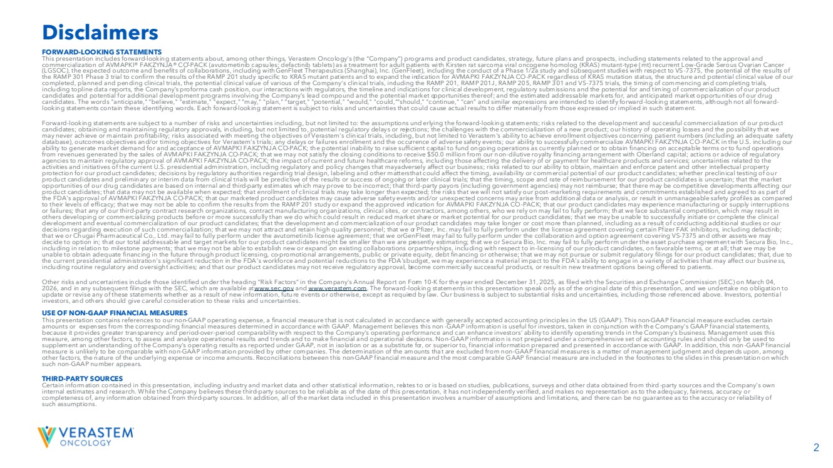 | 2 FORWARD-LOOKING STATEMENTS This presentation includes forward-looking statements about, among other things, Verastem Oncology’s (the “Company”) programs and product candidates, strategy, future plans and prospects, including statements related to the approval and commercialization of AVMAPKI® FAKZYNJA® CO-PACK (avutometinib capsules; defactinib tablets) as a treatment for adult patients with Kirsten rat sarcoma viral oncogene homolog (KRAS) mutant-type (mt) recurrent Low-Grade Serous Ovarian Cancer (LGSOC), the expected outcome and benefits of collaborations, including with GenFleet Therapeutics (Shanghai), Inc. (GenFleet), including the conduct of a Phase 1/2a study and subsequent studies with respect to VS-7375, the potential of the results of the RAMP 301 Phase 3 trial to confirm the results of the RAMP 201 study specific to KRAS mutant patients and to expand the indication for AVMAPKI FAKZYNJA CO-PACK regardless of KRAS mutation status, the structure and potential clinical value of our completed, planned and pending clinical trials, the potential clinical value of various of the Company's clinical trials, including the RAMP 201, RAMP 201J, RAMP 205, RAMP 301 and VS-7375 trials, the timing of commencing and completing trials, including topline data reports, our interactions with regulators, the timeline and indications for clinical development, regulatory submissions and the potential for and timing of commercialization of our product candidates and potential for additional development programs involving the Company’s lead compound and the potential market opportunities thereof; and the estimated addressable markets for, and anticipated market opportunities of our drug candidates. The words "anticipate," "believe," "estimate," "expect," "may," "plan," "target," "potential," "would," "could," "should," "continue," “can” and similar expressions are intended to identify forward-looking statements, although not all forward-looking statements contain these identifying words. Each forward-looking statement is subject to risks and uncertainties that could cause actual results to differ materially from those expressed or implied in such statement. Forward-looking statements are subject to a number of risks and uncertainties including, but not limited to: the assumptions underlying the forward-looking statements; risks related to the development and successful commercialization of our product candidates; obtaining and maintaining regulatory approvals, including, but not limited to, potential regulatory delays or rejections; the challenges with the commercialization of a new product; our history of operating losses and the possibility that we may never achieve or maintain profitability; risks associated with meeting the objectives of Verastem's clinical trials, including, but not limited to Verastem's ability to achieve enrollment objectives concerning patient numbers (including an adequate safety database), outcomes objectives and/or timing objectives for Verastem's trials; any delays or failures enrollment and the occurrence of adverse safety events; our ability to successfully commercialize AVMAPKI FAKZYNJA CO-PACK in the U.S. including our ability to generate market demand for and acceptance of AVMAPKI FAKZYNJA CO-PACK; the potential inability to raise sufficient capital to fund ongoing operations as currently planned or to obtain financing on acceptable terms or to fund operations from revenues generated by the sales of AVMAPKI FAKZYNJA CO-PACK; actions or advice of regulatory agencies to maintain regulatory approval of AVMAPKI FAKZYNJA CO-PACK; the impact of current and future healthcare reforms, including those affecting the delivery of or payment for healthcare products and services; uncertainties related to the activities and initiatives of the current U.S. presidential administration, including regulatory and policy changes that may adversely affect our business; risks related to our ability to obtain, maintain and enforce patent and other intellectual property protection for our product candidates; decisions by regulatory authorities regarding trial design, labeling and other matters that could affect the timing, availability or commercial potential of our product candidates; whether preclinical testing of our product candidates and preliminary or interim data from clinical trials will be predictive of the results or success of ongoing or later clinical trials; that the timing, scope and rate of reimbursement for our product candidates is uncertain; that the market opportunities of our drug candidates are based on internal and third-party estimates which may prove to be incorrect; that third-party payors (including government agencies) may not reimburse; that there may be competitive developments affecting our product candidates; that data may not be available when expected; that enrollment of clinical trials may take longer than expected; the risks that we will not satisfy our post-marketing requirements and commitments established and agreed to as part of the FDA's approval of AVMAPKI FAKZYNJA CO-PACK; that our marketed product candidates may cause adverse safety events and/or unexpected concerns may arise from additional data or analysis, or result in unmanageable safety profiles as compared to their levels of efficacy; that we may not be able to confirm the results from the RAMP 201 study or expand the approved indication for AVMAPKI FAKZYNJA CO-PACK; that our product candidates may experience manufacturing or supply interruptions or failures; that any of our third-party contract research organizations, contract manufacturing organizations, clinical sites, or contractors, among others, who we rely on may fail to fully perform; that we face substantial competition, which may result in others developing or commercializing products before or more successfully than we do which could result in reduced market share or market potential for our product candidates; that we may be unable to successfully initiate or complete the clinical development and eventual commercialization of our product candidates; that the development and commercialization of our product candidates may take longer or cost more than planned, including as a result of conducting additional studies or our decisions regarding execution of such commercialization; that we may not attract and retain high quality personnel; that we or Pfizer, Inc. may fail to fully perform under the license agreement covering certain Pfizer FAK inhibitors, including defactinib; that we or Chugai Pharmaceutical Co., Ltd. may fail to fully perform under the avutometinib license agreement; that we or GenFleet may fail to fully perform under the collaboration and option agreement covering VS-7375 and other assets we may decide to option in; that our total addressable and target markets for our product candidates might be smaller than we are presently estimating; that we or Secura Bio, Inc. may fail to fully perform under the asset purchase agreement with Secura Bio, Inc., including in relation to milestone payments; that we may not be able to establish new or expand on existing collaborations or partnerships, including with respect to in-licensing of our product candidates, on favorable terms, or at all; that we may be unable to obtain adequate financing in the future through product licensing, co-promotional arrangements, public or private equity, debt financing or otherwise; that we may not pursue or submit regulatory filings for our product candidates; that, due to the current presidential administration's significant reduction in the FDA's workforce and potential reductions to the FDA's budget, we may experience a material impact to the FDA's ability to engage in a variety of activities that may affect our business, including routine regulatory and oversight activities; and that our product candidates may not receive regulatory approval, become commercially successful products, or result in new treatment options being offered to patients. Other risks and uncertainties include those identified under the heading “Risk Factors” in the Company’s Annual Report on Form 10-K for the year ended December 31, 2025, as filed with the Securities and Exchange Commission (SEC) on March 04, 2026, and in any subsequent filings with the SEC, which are available at www.sec.govand www.verastem.com. The forward-looking statements in this presentation speak only as of the original date of this presentation, and we undertake no obligation to update or revise any of these statements whether as a result of new information, future events or otherwise, except as required by law. Our business is subject to substantial risks and uncertainties, including those referenced above. Investors, potential investors, and others should give careful consideration to these risks and uncertainties. USE OF NON-GAAP FINANCIAL MEASURES This presentation contains references to our non-GAAP operating expense, a financial measure that is not calculated in accordance with generally accepted accounting principles in the US (GAAP). This non-GAAP financial measure excludes certain amounts or expenses from the corresponding financial measures determined in accordance with GAAP. Management believes this non-GAAP information is useful for investors, taken in conjunction with the Company’s GAAP financial statements, because it provides greater transparency and period-over-period comparability with respect to the Company’s operating performance and can enhance investors’ ability to identify operating trends in the Company’s business. Management uses this measure, among other factors, to assess and analyze operational results and trends and to make financial and operational decisions. Non-GAAP information is not prepared under a comprehensive set of accounting rules and should only be used to supplement an understanding of the Company’s operating results as reported under GAAP, not in isolation or as a substitute for, or superior to, financial information prepared and presented in accordance with GAAP. In addition, this non-GAAP financial measure is unlikely to be comparable with non-GAAP information provided by other companies. The determination of the amounts that are excluded from non-GAAP financial measures is a matter of management judgment and depends upon, among other factors, the nature of the underlying expense or income amounts. Reconciliations between this non-GAAP financial measure and the most comparable GAAP financial measure are included in the footnotes to the slides in this presentation on which such non-GAAP number appears. THIRD-PARTY SOURCES Certain information contained in this presentation, including industry and market data and other statistical information, relates to or is based on studies, publications, surveys and other data obtained from third-party sources and the Company’s own internal estimates and research. While the Company believes these third-party sources to be reliable as of the date of this presentation, it has not independently verified, and makes no representation as to the adequacy, fairness, accuracy or completeness of, any information obtained from third-party sources. In addition, all of the market data included in this presentation involves a number of assumptions and limitations, and there can be no guarantee as to the accuracy or reliability of such assumptions. Disclaimers
 | 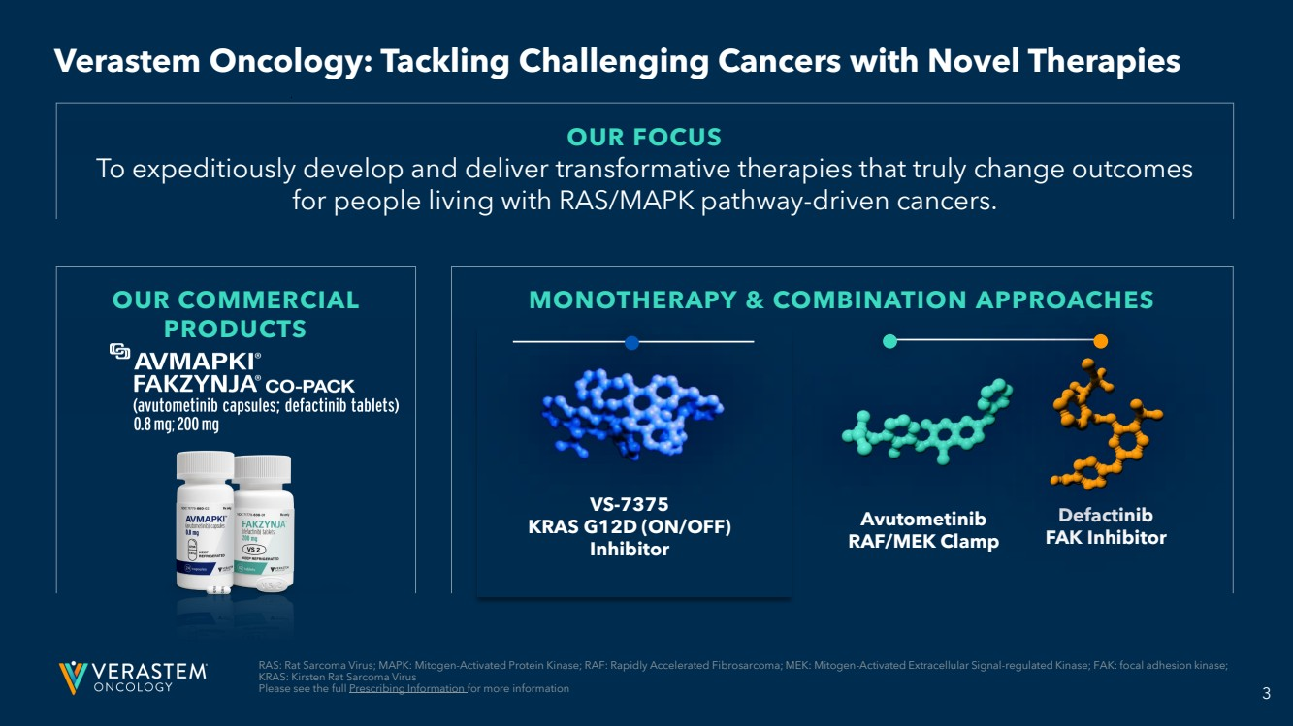 | 3 OUR COMMERCIAL PRODUCTS MONOTHERAPY & COMBINATION APPROACHES RAS: Rat Sarcoma Virus; MAPK: Mitogen-Activated Protein Kinase; RAF: Rapidly Accelerated Fibrosarcoma; MEK: Mitogen-Activated Extracellular Signal-regulated Kinase; FAK: focal adhesion kinase; KRAS: Kirsten Rat Sarcoma Virus Please see the full Prescribing Information for more information OUR FOCUS To expeditiously develop and deliver transformative therapies that truly change outcomes for people living with RAS/MAPK pathway-driven cancers. Avutometinib RAF/MEK Clamp Defactinib FAK Inhibitor VS-7375 KRAS G12D (ON/OFF) Inhibitor Verastem Oncology: Tackling Challenging Cancers with Novel Therapies
 | 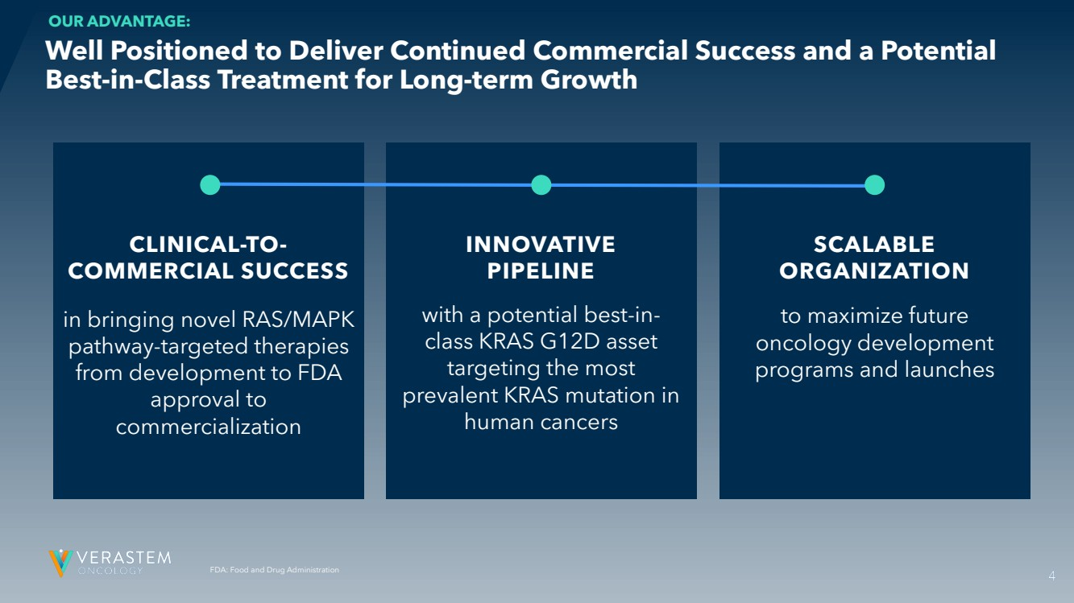 | 4 FDA: Food and Drug Administration CLINICAL-TO-COMMERCIAL SUCCESS in bringing novel RAS/MAPK pathway-targeted therapies from development to FDA approval to commercialization INNOVATIVE PIPELINE with a potential best-in-class KRAS G12D asset targeting the most prevalent KRAS mutation in human cancers SCALABLE ORGANIZATION to maximize future oncology development programs and launches Well Positioned to Deliver Continued Commercial Success and a Potential Best-in-Class Treatment for Long-term Growth OUR ADVANTAGE: 4
 | 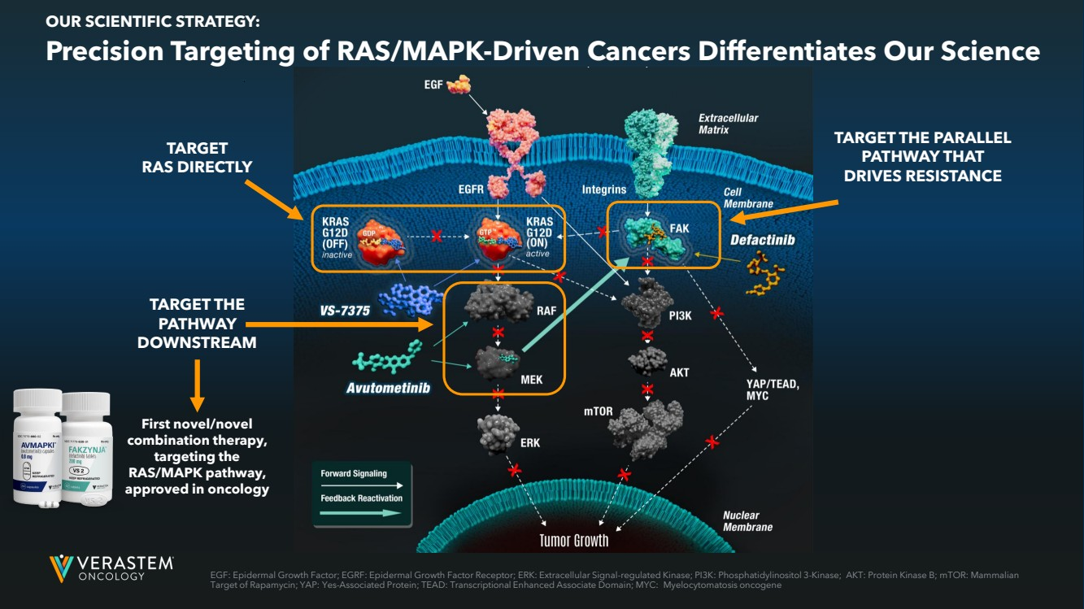 | 5 TARGET RAS DIRECTLY TARGET THE PATHWAY DOWNSTREAM TARGET THE PARALLEL PATHWAY THAT DRIVES RESISTANCE First novel/novel combination therapy, targeting the RAS/MAPK pathway, approved in oncology Precision Targeting of RAS/MAPK-Driven Cancers Differentiates Our Science OUR SCIENTIFIC STRATEGY: EGF: Epidermal Growth Factor; EGRF: Epidermal Growth Factor Receptor; ERK: Extracellular Signal-regulated Kinase; PI3K: Phosphatidylinositol 3-Kinase; AKT: Protein Kinase B; mTOR: Mammalian Target of Rapamycin; YAP: Yes-Associated Protein; TEAD: Transcriptional Enhanced Associate Domain; MYC: Myelocytomatosis oncogene
 | 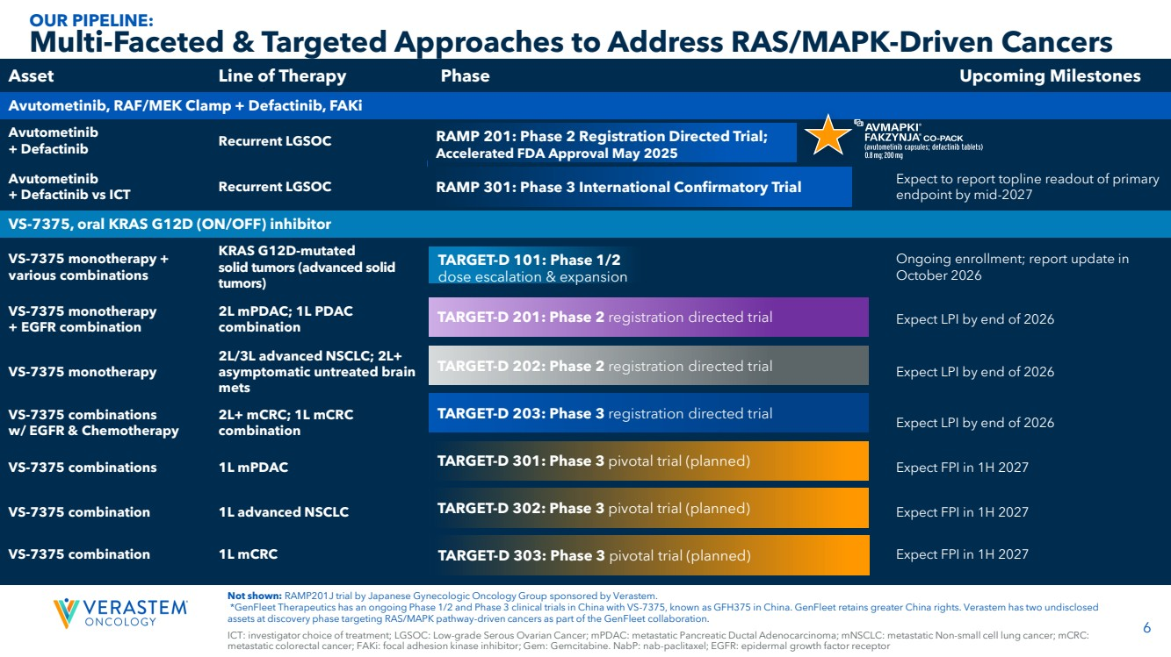 | 6 ICT: investigator choice of treatment; LGSOC: Low-grade Serous Ovarian Cancer; mPDAC: metastatic Pancreatic Ductal Adenocarcinoma; mNSCLC: metastatic Non-small cell lung cancer; mCRC: metastatic colorectal cancer; FAKi: focal adhesion kinase inhibitor; Gem: Gemcitabine. NabP: nab-paclitaxel; EGFR: epidermal growth factor receptor Not shown: RAMP201J trial by Japanese Gynecologic Oncology Group sponsored by Verastem. *GenFleet Therapeutics has an ongoing Phase 1/2 and Phase 3 clinical trials in China with VS-7375, known as GFH375 in China. GenFleet retains greater China rights. Verastem has two undisclosed assets at discovery phase targeting RAS/MAPK pathway-driven cancers as part of the GenFleet collaboration. Asset Line of Therapy Phase Upcoming Milestones Avutometinib, RAF/MEK Clamp + Defactinib, FAKi Avutometinib + Defactinib Recurrent LGSOC Avutometinib + Defactinib vs ICT Recurrent LGSOC Expect to report topline readout of primary endpoint by mid-2027 VS-7375, oral KRAS G12D (ON/OFF) inhibitor VS-7375 monotherapy + various combinations KRAS G12D-mutated solid tumors (advanced solid tumors) Ongoing enrollment; report update in October 2026 VS-7375 monotherapy + EGFR combination 2L mPDAC; 1L PDAC combination Expect LPI by end of 2026 VS-7375 monotherapy 2L/3L advanced NSCLC; 2L+ asymptomatic untreated brain mets Expect LPI by end of 2026 VS-7375 combinations w/ EGFR & Chemotherapy 2L+ mCRC; 1L mCRC combination Expect LPI by end of 2026 VS-7375 combinations 1L mPDAC Expect FPI in 1H 2027 VS-7375 combination 1L advanced NSCLC Expect FPI in 1H 2027 VS-7375 combination 1L mCRC Expect FPI in 1H 2027 Multi-Faceted & Targeted Approaches to Address RAS/MAPK-Driven Cancers OUR PIPELINE: RAMP 201: Phase 2 Registration Directed Trial; Accelerated FDA Approval May 2025 RAMP 301: Phase 3 International Confirmatory Trial TARGET-D 101: Phase 1/2 dose escalation & expansion TARGET-D 201: Phase 2 registration directed trial TARGET-D 202: Phase 2 registration directed trial TARGET-D 203: Phase 3 registration directed trial TARGET-D 301: Phase 3 pivotal trial (planned) TARGET-D 302: Phase 3 pivotal trial (planned) TARGET-D 303: Phase 3 pivotal trial (planned)
 | 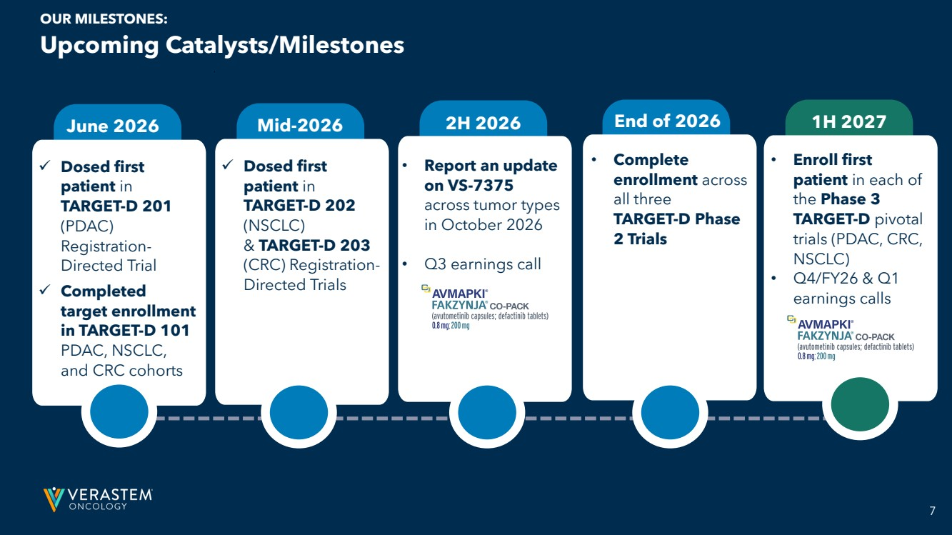 | 7 ✓ Dosed first patient in TARGET-D 201 (PDAC) Registration-Directed Trial June 2026 • Complete enrollment across all three TARGET-D Phase 2 Trials • Report an update on VS-7375 across tumor types in October 2026 • Q3 earnings call Mid-2026 2H 2026 End of 2026 1H 2027 • Enroll first patient in each of the Phase 3 TARGET-D pivotal trials (PDAC, CRC, NSCLC) • Q4/FY26 & Q1 earnings calls ✓ Dosed first patient in TARGET-D 202 (NSCLC) & TARGET-D 203 (CRC) Registration- ✓ Directed Trials Completed target enrollment in TARGET-D 101 PDAC, NSCLC, and CRC cohorts Upcoming Catalysts/Milestones OUR MILESTONES:
 | 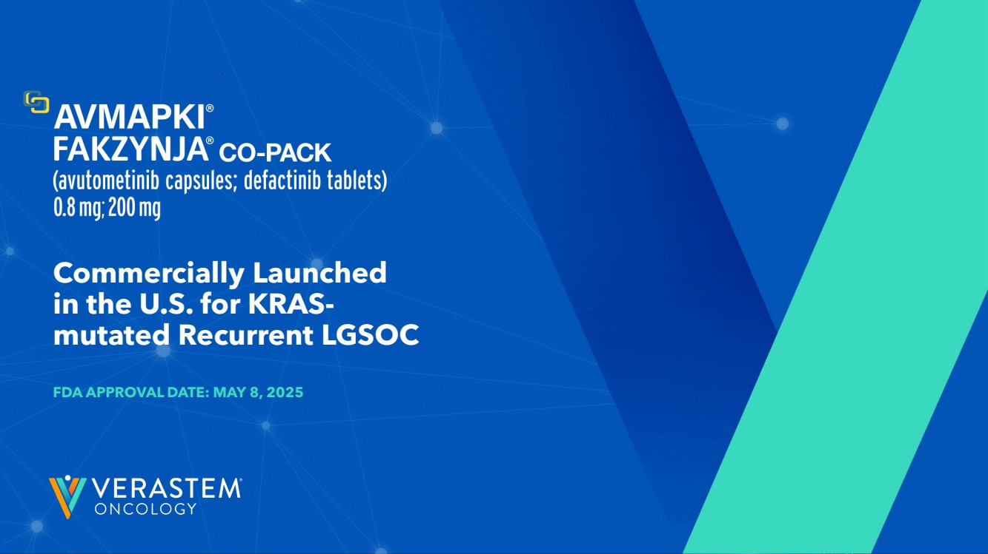 | 8 Commercially Launched in the U.S. for KRAS-mutated Recurrent LGSOC FDA APPROVAL DATE: MAY 8, 2025
 | 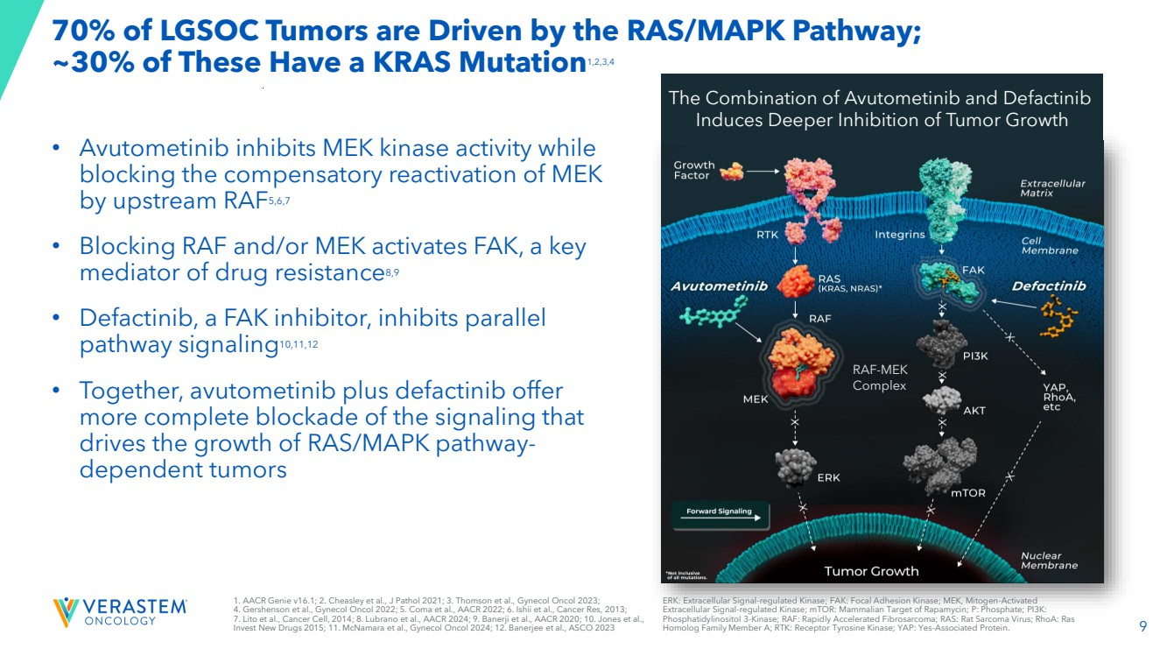 | 9 70% of LGSOC Tumors are Driven by the RAS/MAPK Pathway; ~30% of These Have a KRAS Mutation1,2,3,4 • Avutometinib inhibits MEK kinase activity while blocking the compensatory reactivation of MEK by upstream RAF5,6,7 • Blocking RAF and/or MEK activates FAK, a key mediator of drug resistance8,9 • Defactinib, a FAK inhibitor, inhibits parallel pathway signaling10,11,12 • Together, avutometinib plus defactinib offer more complete blockade of the signaling that drives the growth of RAS/MAPK pathway-dependent tumors RAF-MEK Complex The Combination of Avutometinib and Defactinib Induces Deeper Inhibition of Tumor Growth 1. AACR Genie v16.1; 2. Cheasley et al., J Pathol 2021; 3. Thomson et al., Gynecol Oncol 2023; 4. Gershenson et al., Gynecol Oncol 2022; 5. Coma et al., AACR 2022; 6. Ishii et al., Cancer Res, 2013; 7. Lito et al., Cancer Cell, 2014; 8. Lubrano et al., AACR 2024; 9. Banerji et al., AACR 2020; 10. Jones et al., Invest New Drugs 2015; 11. McNamara et al., Gynecol Oncol 2024; 12. Banerjee et al., ASCO 2023 ERK: Extracellular Signal-regulated Kinase; FAK: Focal Adhesion Kinase; MEK, Mitogen-Activated Extracellular Signal-regulated Kinase; mTOR: Mammalian Target of Rapamycin; P: Phosphate; PI3K: Phosphatidylinositol 3-Kinase; RAF: Rapidly Accelerated Fibrosarcoma; RAS: Rat Sarcoma Virus; RhoA: Ras Homolog Family Member A; RTK: Receptor Tyrosine Kinase; YAP: Yes-Associated Protein.
 | 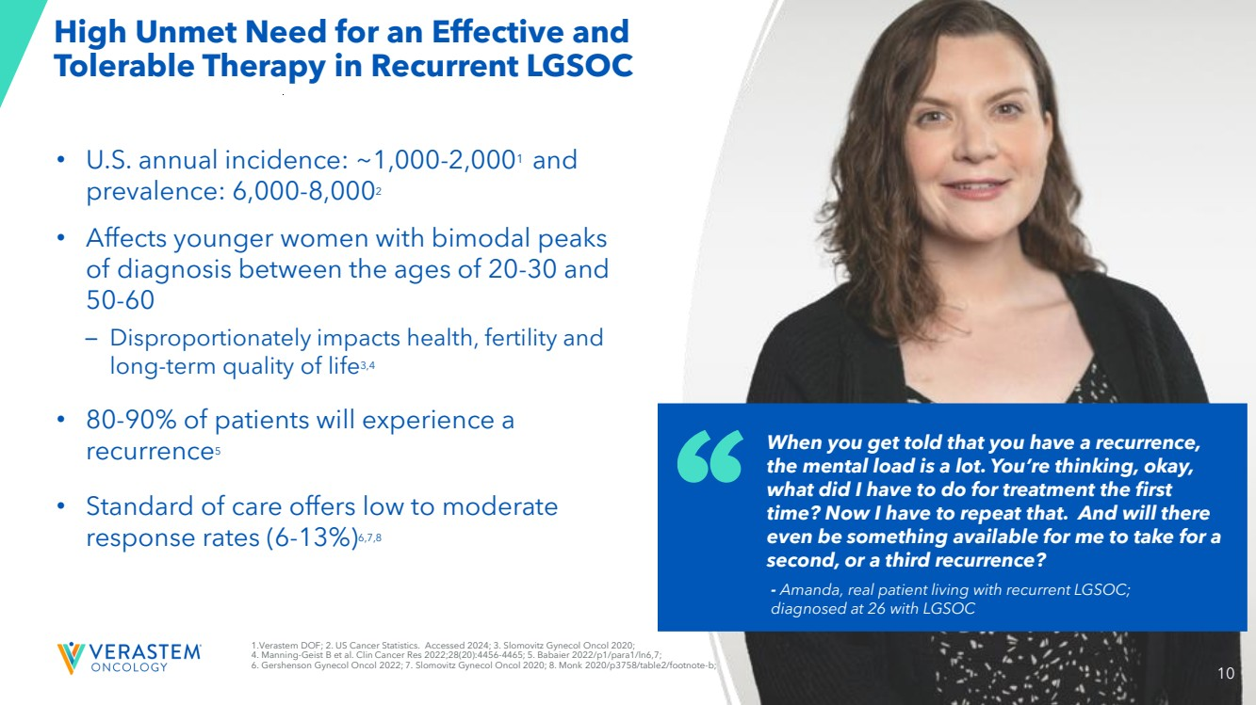 | 10 High Unmet Need for an Effective and Tolerable Therapy in Recurrent LGSOC • U.S. annual incidence: ~1,000-2,0001 and prevalence: 6,000-8,0002 • Affects younger women with bimodal peaks of diagnosis between the ages of 20-30 and 50-60 – Disproportionately impacts health, fertility and long-term quality of life3,4 • 80-90% of patients will experience a recurrence5 • Standard of care offers low to moderate response rates (6-13%)6,7,8 When you get told that you have a recurrence, the mental load is a lot. You’re thinking, okay, what did I have to do for treatment the first time? Now I have to repeat that. And will there even be something available for me to take for a second, or a third recurrence? - Amanda, real patient living with recurrent LGSOC; diagnosed at 26 with LGSOC 1.Verastem DOF; 2. US Cancer Statistics. Accessed 2024; 3. Slomovitz Gynecol Oncol 2020; 4. Manning-Geist B et al. Clin Cancer Res 2022;28(20):4456-4465; 5. Babaier 2022/p1/para1/ln6,7; 6. Gershenson Gynecol Oncol 2022; 7. Slomovitz Gynecol Oncol 2020; 8. Monk 2020/p3758/table2/footnote-b; 10
 | 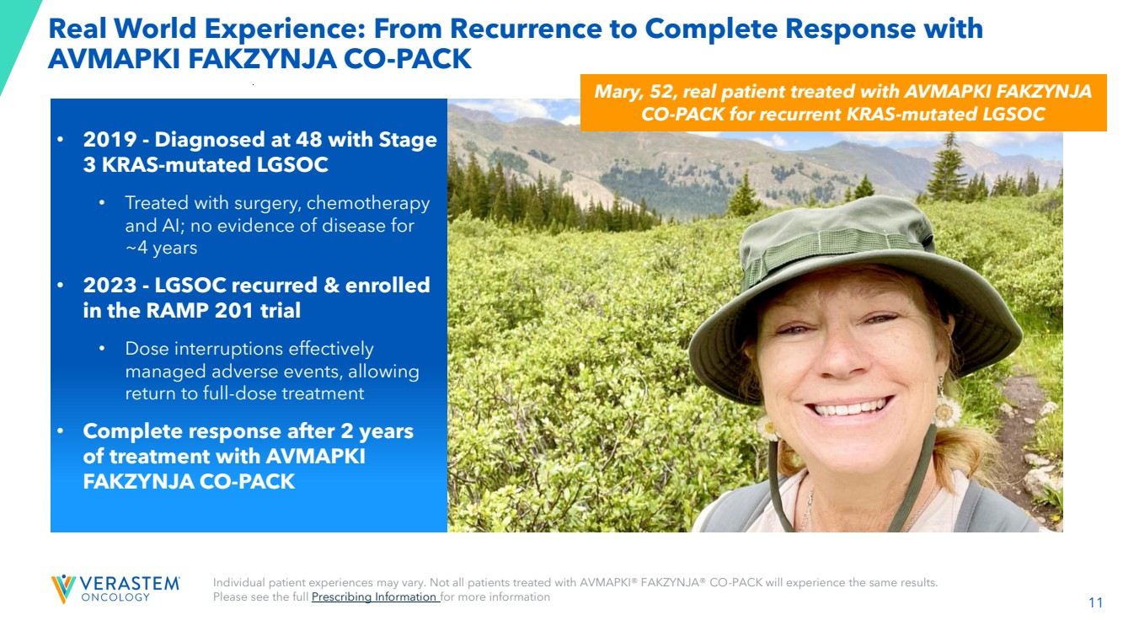 | 11 Individual patient experiences may vary. Not all patients treated with AVMAPKI® FAKZYNJA® CO-PACK will experience the same results. Please see the full Prescribing Information for more information Mary, 52, real patient treated with AVMAPKI FAKZYNJA CO-PACK for recurrent KRAS-mutated LGSOC • 2019 - Diagnosed at 48 with Stage 3 KRAS-mutated LGSOC • Treated with surgery, chemotherapy and AI; no evidence of disease for ~4 years • 2023 - LGSOC recurred & enrolled in the RAMP 201 trial • Dose interruptions effectively managed adverse events, allowing return to full-dose treatment • Complete response after 2 years of treatment with AVMAPKI FAKZYNJA CO-PACK Real World Experience: From Recurrence to Complete Response with AVMAPKI FAKZYNJA CO-PACK
 | 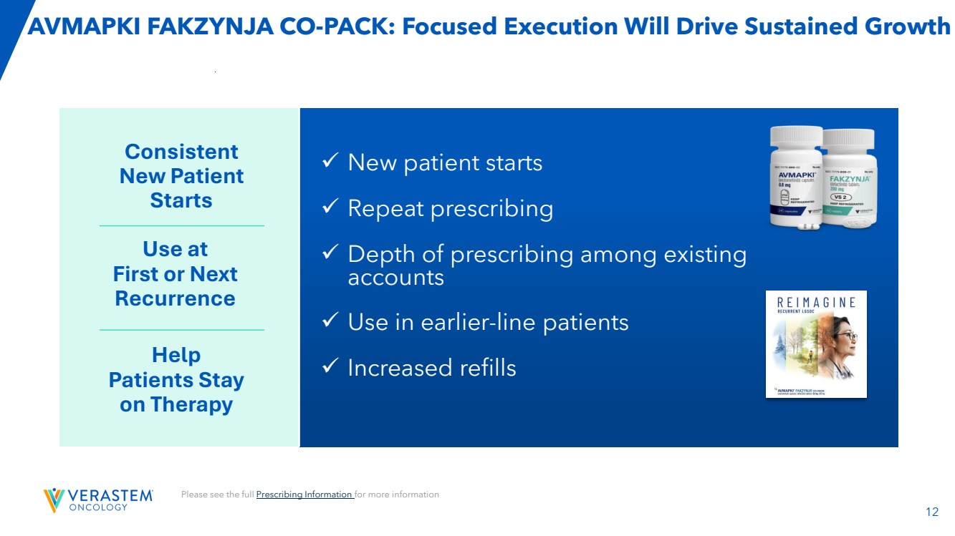 | 12 AVMAPKI FAKZYNJA CO-PACK: Focused Execution Will Drive Sustained Growth Please see the full Prescribing Information for more information ✓ New patient starts ✓ Repeat prescribing ✓ Depth of prescribing among existing accounts ✓ Use in earlier-line patients ✓ Increased refills Consistent New Patient Starts Use at First or Next Recurrence Help Patients Stay on Therapy
 | 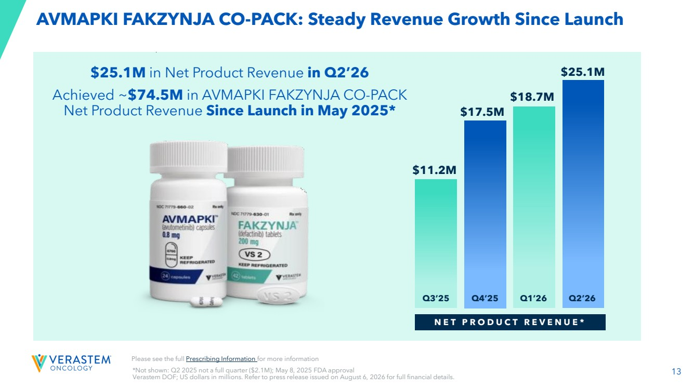 | 13 AVMAPKI FAKZYNJA CO-PACK: Steady Revenue Growth Since Launch $25.1M in Net Product Revenue in Q2’26 Achieved ~$74.5M in AVMAPKI FAKZYNJA CO-PACK Net Product Revenue Since Launch in May 2025* Please see the full Prescribing Information for more information $11.2M $17.5M N E T P R O D U C T R E V E N U E * $18.7M Q3’25 Q4’25 Q1’26 $25.1M Q2’26 *Not shown: Q2 2025 not a full quarter ($2.1M); May 8, 2025 FDA approval Verastem DOF; US dollars in millions. Refer to press release issued on August 6, 2026 for full financial details.
 | 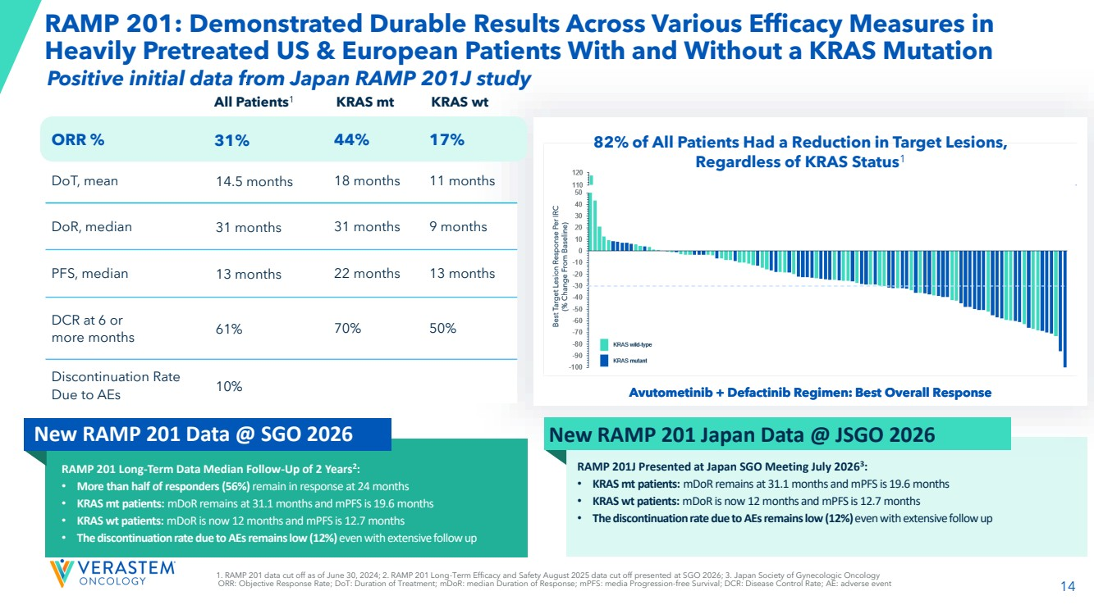 | 14 RAMP 201: Demonstrated Durable Results Across Various Efficacy Measures in Heavily Pretreated US & European Patients With and Without a KRAS Mutation Avutometinib + Defactinib Regimen: Best Overall Response 82% of All Patients Had a Reduction in Target Lesions, Regardless of KRAS Status1 All Patients1 KRAS mt KRAS wt ORR % 31% 44% 17% DoT, mean 14.5 months 18 months 11 months DoR, median 31 months 31 months 9 months PFS, median 13 months 22 months 13 months DCR at 6 or more months 61% 70% 50% Discontinuation Rate Due to AEs 10% 1. RAMP 201 data cut off as of June 30, 2024; 2. RAMP 201 Long-Term Efficacy and Safety August 2025 data cut off presented at SGO 2026; 3. Japan Society of Gynecologic Oncology ORR: Objective Response Rate; DoT: Duration of Treatment; mDoR: median Duration of Response; mPFS: media Progression-free Survival; DCR: Disease Control Rate; AE: adverse event Avutometinib + Defactinib Regimen: Best Overall Response RAMP 201 Long-Term Data Median Follow-Up of 2 Years2 : • More than half of responders (56%) remain in response at 24 months • KRAS mt patients: mDoR remains at 31.1 months and mPFS is 19.6 months • KRAS wt patients: mDoR is now 12 months and mPFS is 12.7 months • The discontinuation rate due to AEs remains low (12%) even with extensive follow up New RAMP 201 Data @ SGO 2026 New RAMP 201 Japan Data @ JSGO 2026 RAMP 201J Presented at Japan SGO Meeting July 20263 : • KRAS mt patients: mDoR remains at 31.1 months and mPFS is 19.6 months • KRAS wt patients: mDoR is now 12 months and mPFS is 12.7 months • The discontinuation rate due to AEs remains low (12%) even with extensive follow up Positive initial data from Japan RAMP 201J study
 | 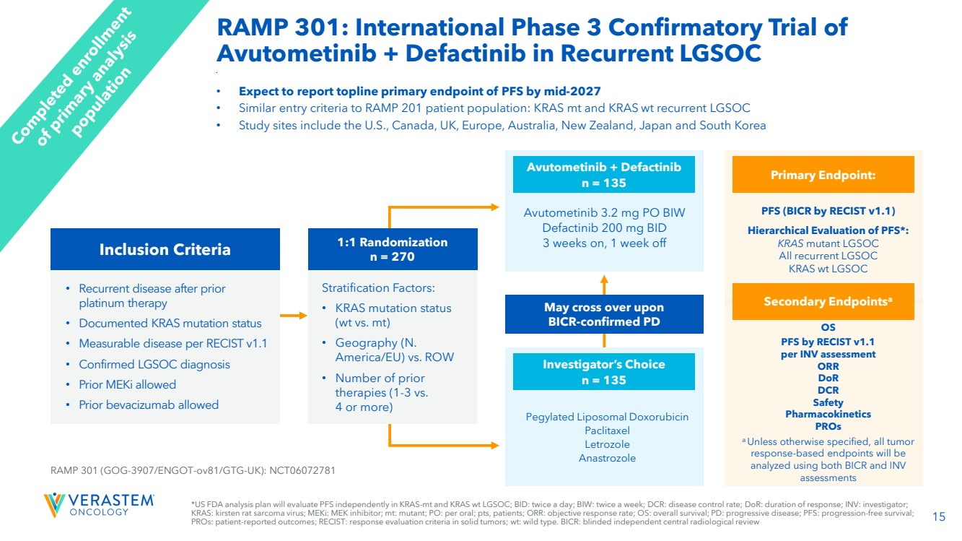 | 15 OS PFS by RECIST v1.1 per INV assessment ORR DoR DCR Safety Pharmacokinetics PROs a Unless otherwise specified, all tumor response-based endpoints will be analyzed using both BICR and INV assessments *US FDA analysis plan will evaluate PFS independently in KRAS-mt and KRAS wt LGSOC; BID: twice a day; BIW: twice a week; DCR: disease control rate; DoR: duration of response; INV: investigator; KRAS: kirsten rat sarcoma virus; MEKi: MEK inhibitor; mt: mutant; PO: per oral; pts, patients; ORR: objective response rate; OS: overall survival; PD: progressive disease; PFS: progression-free survival; PROs: patient-reported outcomes; RECIST: response evaluation criteria in solid tumors; wt: wild type. BICR: blinded independent central radiological review • Expect to report topline primary endpoint of PFS by mid-2027 • Similar entry criteria to RAMP 201 patient population: KRAS mt and KRAS wt recurrent LGSOC • Study sites include the U.S., Canada, UK, Europe, Australia, New Zealand, Japan and South Korea • Recurrent disease after prior platinum therapy • Documented KRAS mutation status • Measurable disease per RECIST v1.1 • Confirmed LGSOC diagnosis • Prior MEKi allowed • Prior bevacizumab allowed RAMP 301 (GOG-3907/ENGOT-ov81/GTG-UK): NCT06072781 Pegylated Liposomal Doxorubicin Paclitaxel Letrozole Anastrozole Investigator’s Choice n = 135 Avutometinib 3.2 mg PO BIW Defactinib 200 mg BID 3 weeks on, 1 week off Avutometinib + Defactinib n = 135 May cross over upon BICR-confirmed PD PFS (BICR by RECIST v1.1) Hierarchical Evaluation of PFS*: KRAS mutant LGSOC All recurrent LGSOC KRAS wt LGSOC Primary Endpoint: Secondary Endpointsa 1:1 Randomization n = 270 Stratification Factors: • KRAS mutation status (wt vs. mt) • Geography (N. America/EU) vs. ROW • Number of prior therapies (1-3 vs. 4 or more) Inclusion Criteria RAMP 301: International Phase 3 Confirmatory Trial of Avutometinib + Defactinib in Recurrent LGSOC
 | 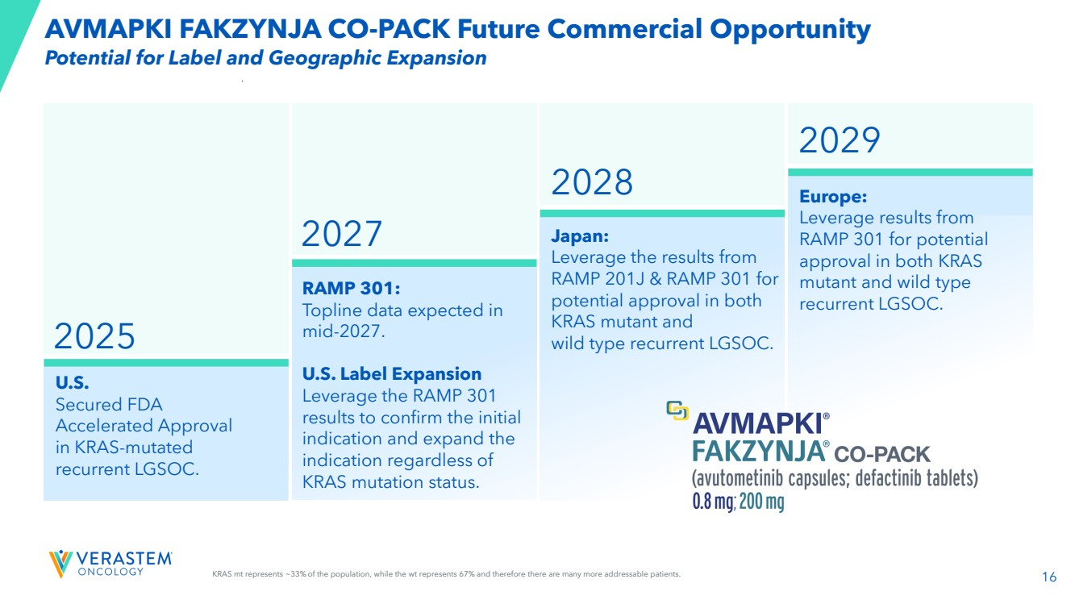 | 16 U.S. Secured FDA Accelerated Approval in KRAS-mutated recurrent LGSOC. 2029 2025 RAMP 301: Topline data expected in mid-2027. U.S. Label Expansion Leverage the RAMP 301 results to confirm the initial indication and expand the indication regardless of KRAS mutation status. Japan: Leverage the results from RAMP 201J & RAMP 301 for potential approval in both KRAS mutant and wild type recurrent LGSOC. Europe: Leverage results from RAMP 301 for potential approval in both KRAS mutant and wild type recurrent LGSOC. 2028 2027 KRAS mt represents ~33% of the population, while the wt represents 67% and therefore there are many more addressable patients. Potential for Label and Geographic Expansion AVMAPKI FAKZYNJA CO-PACK Future Commercial Opportunity
 | 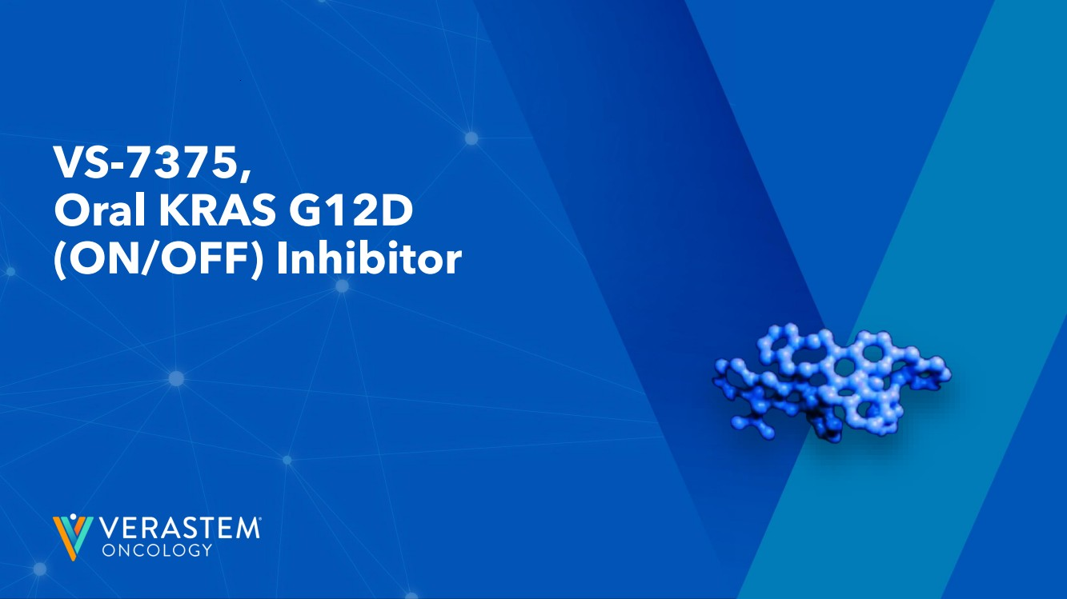 | 17 VS-7375, Oral KRAS G12D (ON/OFF) Inhibitor
 | 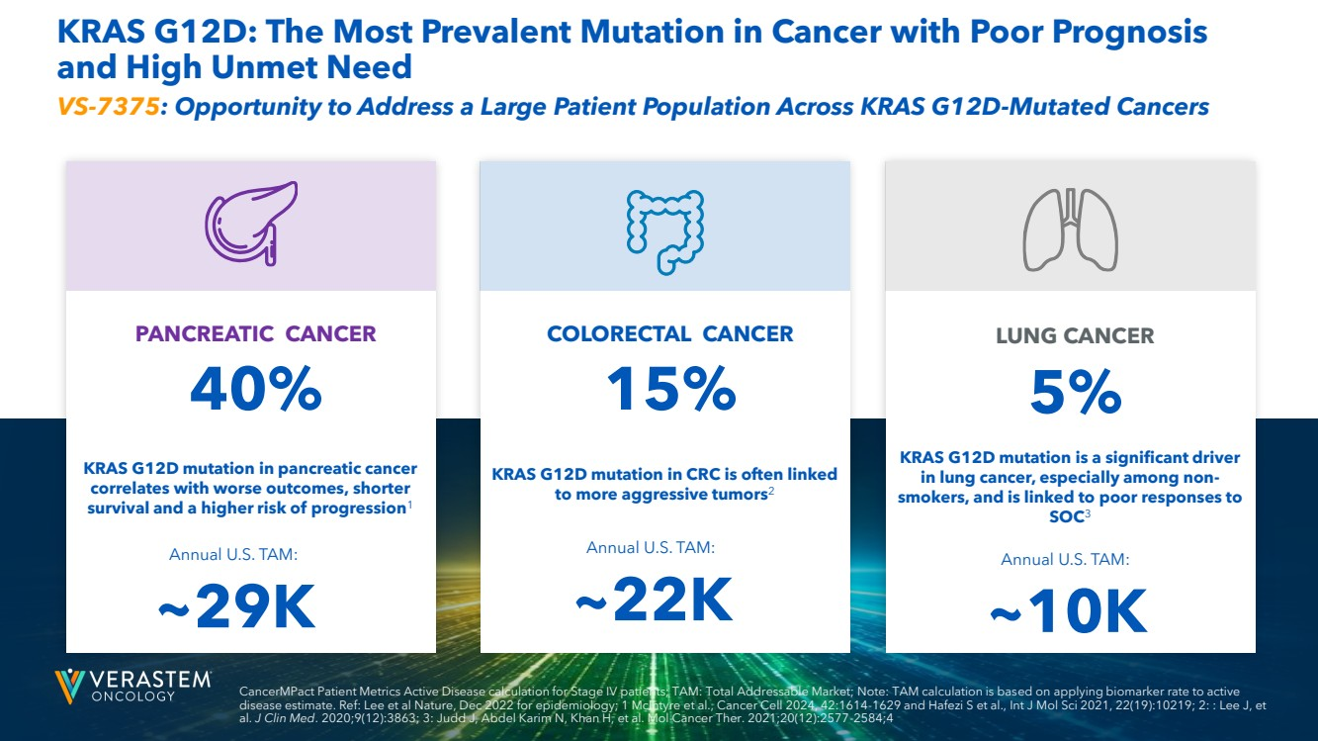 | 18 PANCREATIC CANCER 40% COLORECTAL CANCER 15% LUNG CANCER 5% KRAS G12D: The Most Prevalent Mutation in Cancer with Poor Prognosis and High Unmet Need Annual U.S. TAM: ~29K Annual U.S. TAM: ~22K Annual U.S. TAM: ~10K CancerMPact Patient Metrics Active Disease calculation for Stage IV patients; TAM: Total Addressable Market; Note: TAM calculation is based on applying biomarker rate to active disease estimate. Ref: Lee et al Nature, Dec 2022 for epidemiology; 1 McIntyre et al., Cancer Cell 2024, 42:1614-1629 and Hafezi S et al., Int J Mol Sci 2021, 22(19):10219; 2: : Lee J, et al. J Clin Med. 2020;9(12):3863; 3: Judd J, Abdel Karim N, Khan H, et al. Mol Cancer Ther. 2021;20(12):2577-2584;4 KRAS G12D mutation in pancreatic cancer correlates with worse outcomes, shorter survival and a higher risk of progression1 KRAS G12D mutation is a significant driver in lung cancer, especially among non-smokers, and is linked to poor responses to SOC3 KRAS G12D mutation in CRC is often linked to more aggressive tumors2 VS-7375: Opportunity to Address a Large Patient Population Across KRAS G12D-Mutated Cancers
 | 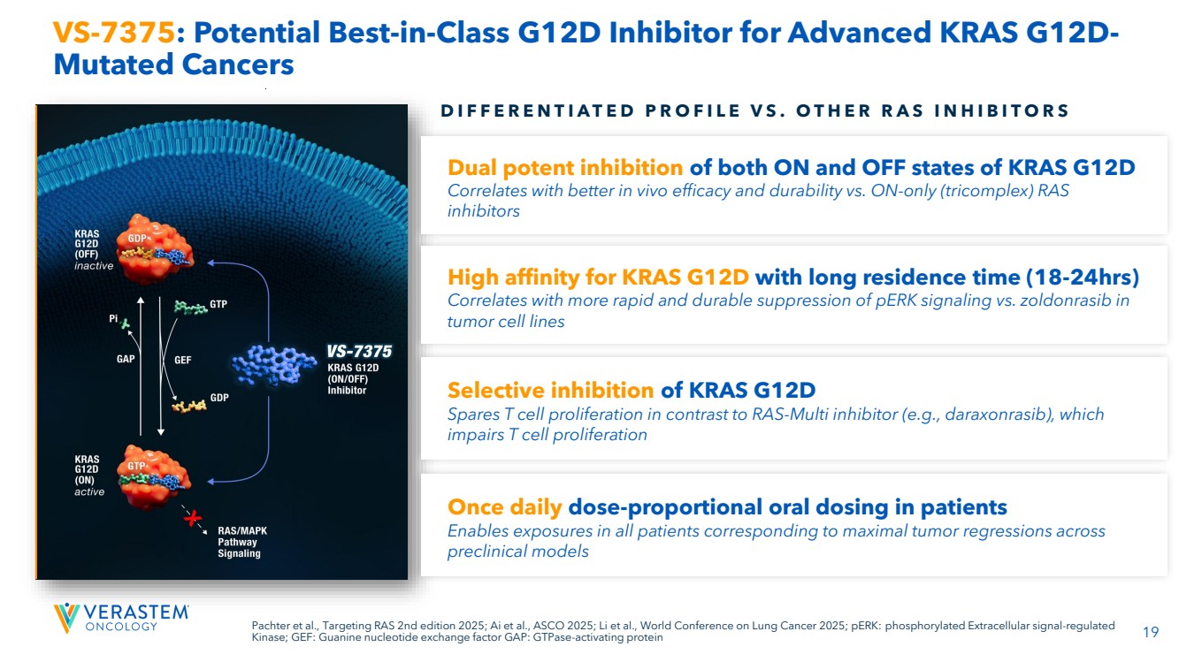 | 19 Pachter et al., Targeting RAS 2nd edition 2025; Ai et al., ASCO 2025; Li et al., World Conference on Lung Cancer 2025; pERK: phosphorylated Extracellular signal-regulated Kinase; GEF: Guanine nucleotide exchange factor GAP: GTPase-activating protein VS-7375: Potential Best-in-Class G12D Inhibitor for Advanced KRAS G12D-Mutated Cancers D I F F E R E N T I A T E D P R O F I L E V S . O T H E R R A S I N H I B I T O R S Dual potent inhibition of both ON and OFF states of KRAS G12D Correlates with better in vivo efficacy and durability vs. ON-only (tricomplex) RAS inhibitors High affinity for KRAS G12D with long residence time (18-24hrs) Correlates with more rapid and durable suppression of pERK signaling vs. zoldonrasib in tumor cell lines Selective inhibition of KRAS G12D Spares T cell proliferation in contrast to RAS-Multi inhibitor (e.g., daraxonrasib), which impairs T cell proliferation Once daily dose-proportional oral dosing in patients Enables exposures in all patients corresponding to maximal tumor regressions across preclinical models
 | 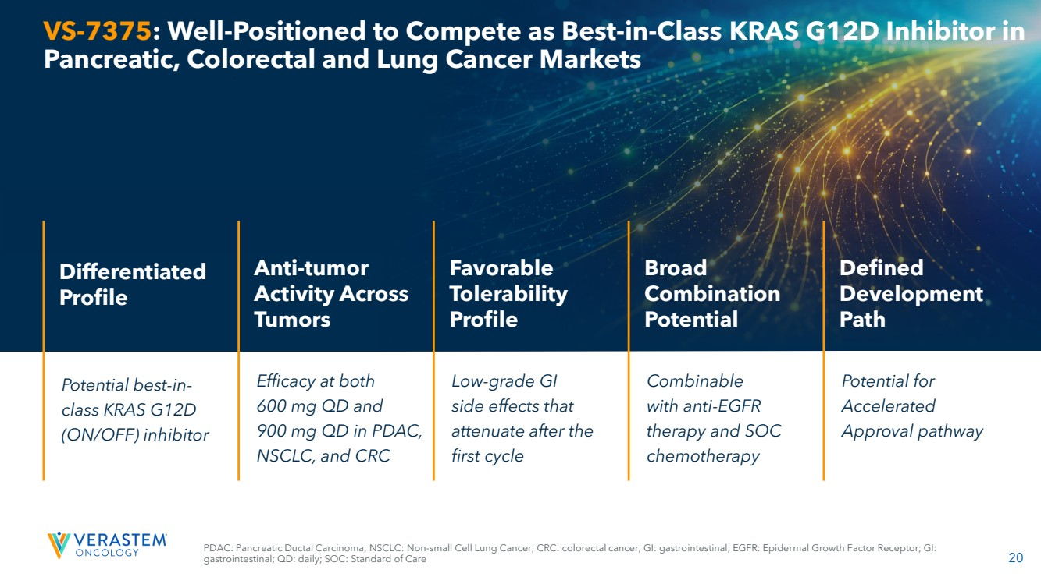 | 20 VS-7375: Well-Positioned to Compete as Best-in-Class KRAS G12D Inhibitor in Pancreatic, Colorectal and Lung Cancer Markets Potential best-in-class KRAS G12D (ON/OFF) inhibitor Differentiated Profile Efficacy at both 600 mg QD and 900 mg QD in PDAC, NSCLC, and CRC Anti-tumor Activity Across Tumors Low-grade GI side effects that attenuate after the first cycle Favorable Tolerability Profile Combinable with anti-EGFR therapy and SOC chemotherapy Broad Combination Potential Potential for Accelerated Approval pathway Defined Development Path PDAC: Pancreatic Ductal Carcinoma; NSCLC: Non-small Cell Lung Cancer; CRC: colorectal cancer; GI: gastrointestinal; EGFR: Epidermal Growth Factor Receptor; GI: gastrointestinal; QD: daily; SOC: Standard of Care
 | 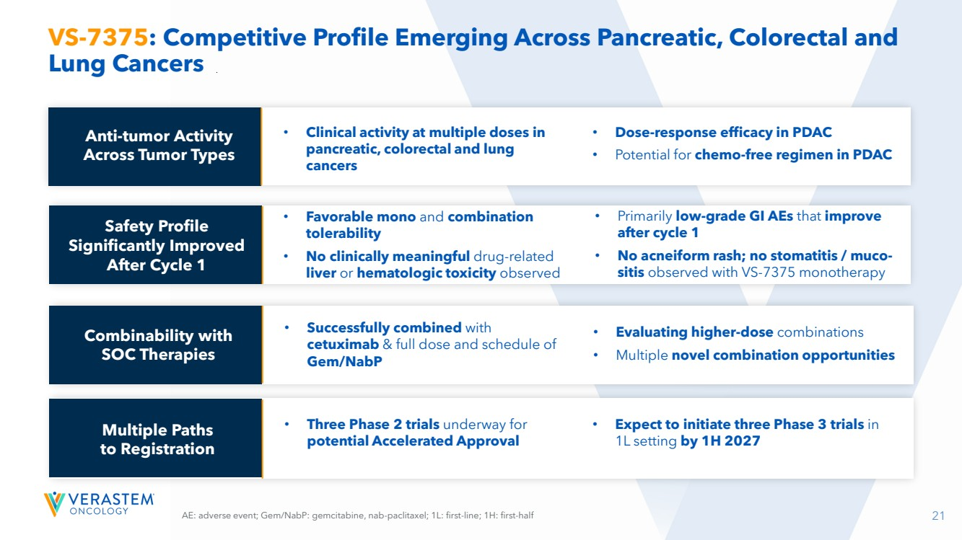 | 21 VS-7375: Competitive Profile Emerging Across Pancreatic, Colorectal and Lung Cancers AE: adverse event; Gem/NabP: gemcitabine, nab-paclitaxel; 1L: first-line; 1H: first-half Safety Profile Significantly Improved After Cycle 1 Combinability with SOC Therapies Multiple Paths to Registration • Clinical activity at multiple doses in pancreatic, colorectal and lung cancers • Dose-response efficacy in PDAC • Potential for chemo-free regimen in PDAC • Favorable mono and combination tolerability • No clinically meaningful drug-related liver or hematologic toxicity observed • Primarily low-grade GI AEs that improve after cycle 1 • No acneiform rash; no stomatitis / muco-sitis observed with VS-7375 monotherapy • Successfully combined with cetuximab & full dose and schedule of Gem/NabP • Evaluating higher-dose combinations • Multiple novel combination opportunities • Three Phase 2 trials underway for potential Accelerated Approval • Expect to initiate three Phase 3 trials in 1L setting by 1H 2027 Anti-tumor Activity Across Tumor Types
 | 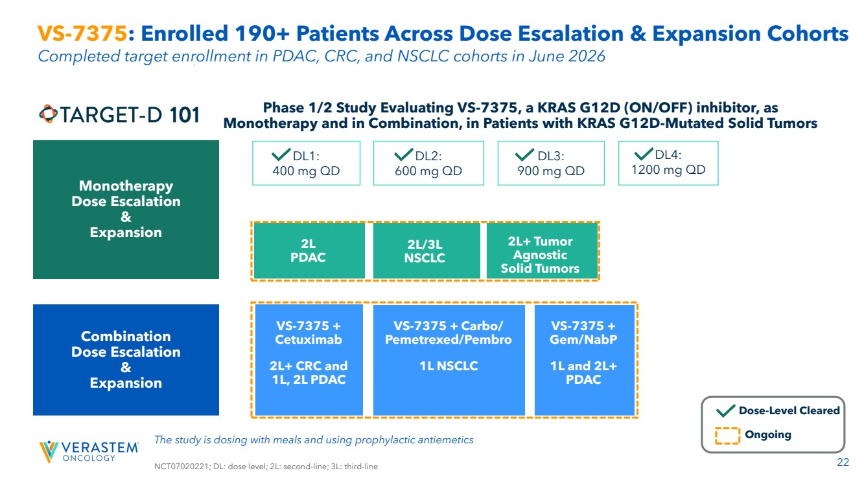 | 22 VS-7375: Enrolled 190+ Patients Across Dose Escalation & Expansion Cohorts Phase 1/2 Study Evaluating VS-7375, a KRAS G12D (ON/OFF) inhibitor, as Monotherapy and in Combination, in Patients with KRAS G12D-Mutated Solid Tumors The study is dosing with meals and using prophylactic antiemetics NCT07020221; DL: dose level; 2L: second-line; 3L: third-line Monotherapy Dose Escalation & Expansion DL2: 600 mg QD DL3: 900 mg QD DL1: 400 mg QD 2L+ Tumor Agnostic Solid Tumors 2L/3L NSCLC 2L PDAC DL4: 1200 mg QD Combination Dose Escalation & Expansion VS-7375 + Cetuximab 2L+ CRC and 1L, 2L PDAC VS-7375 + Carbo/ Pemetrexed/Pembro 1L NSCLC VS-7375 + Gem/NabP 1L and 2L+ PDAC Dose-Level Cleared Ongoing Completed target enrollment in PDAC, CRC, and NSCLC cohorts in June 2026
 | 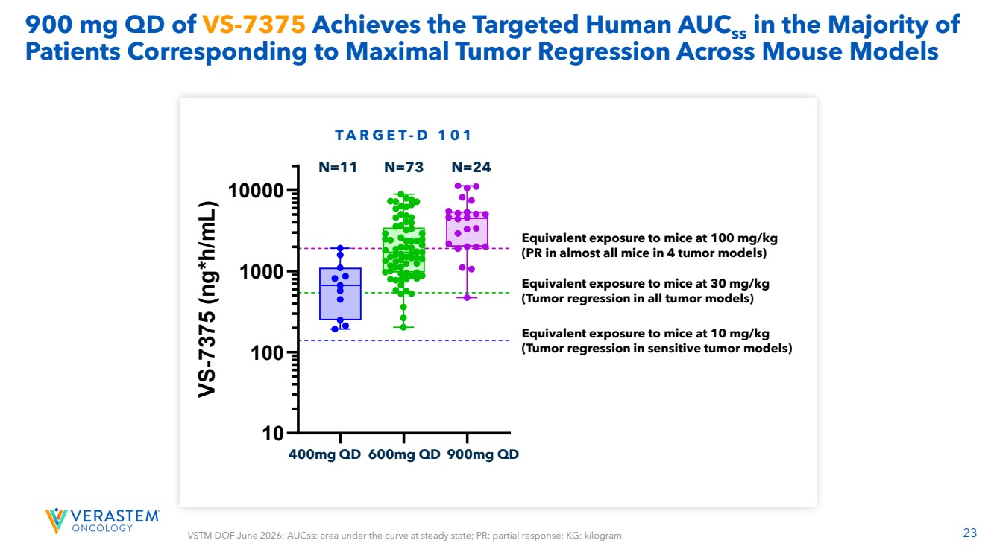 | 23 900 mg QD of VS-7375 Achieves the Targeted Human AUCss in the Majority of Patients Corresponding to Maximal Tumor Regression Across Mouse Models 400mg QD 600mg QD 900mg QD Equivalent exposure to mice at 100 mg/kg (PR in almost all mice in 4 tumor models) Equivalent exposure to mice at 10 mg/kg (Tumor regression in sensitive tumor models) Equivalent exposure to mice at 30 mg/kg (Tumor regression in all tumor models) VSTM DOF June 2026; AUCss: area under the curve at steady state; PR: partial response; KG: kilogram T A R G E T- D 1 0 1 N=11 N=73 N=24 40 mg QD 60 mg QD 90 mg QD 10 100 1000 10000 TARGET-D 101 VS-7375 (ng*h/mL) N=11 N=73 N=24
 | 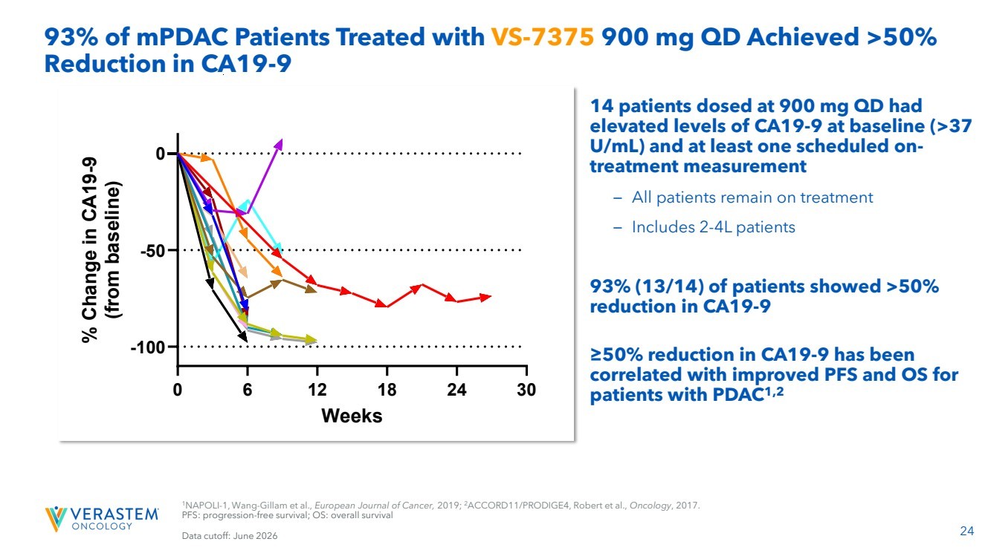 | 24 14 patients dosed at 900 mg QD had elevated levels of CA19-9 at baseline (>37 U/mL) and at least one scheduled on-treatment measurement – All patients remain on treatment – Includes 2-4L patients 93% (13/14) of patients showed >50% reduction in CA19-9 ≥50% reduction in CA19-9 has been correlated with improved PFS and OS for patients with PDAC1,2 93% of mPDAC Patients Treated with VS-7375 900 mg QD Achieved >50% Reduction in CA19-9 1NAPOLI-1, Wang-Gillam et al., European Journal of Cancer, 2019; 2ACCORD11/PRODIGE4, Robert et al., Oncology, 2017. PFS: progression-free survival; OS: overall survival Data cutoff: June 2026 0 6 12 18 24 30 -100 -50 0 Weeks % Change in CA19-9 (from baseline) 0101-020 0102-004 0103-007 0104-012 0104-016 0105-021 0105-023 0105-026 0106-016 0110-007 0112-016 0116-003 0116-005 0116-008 On Treatment
 | 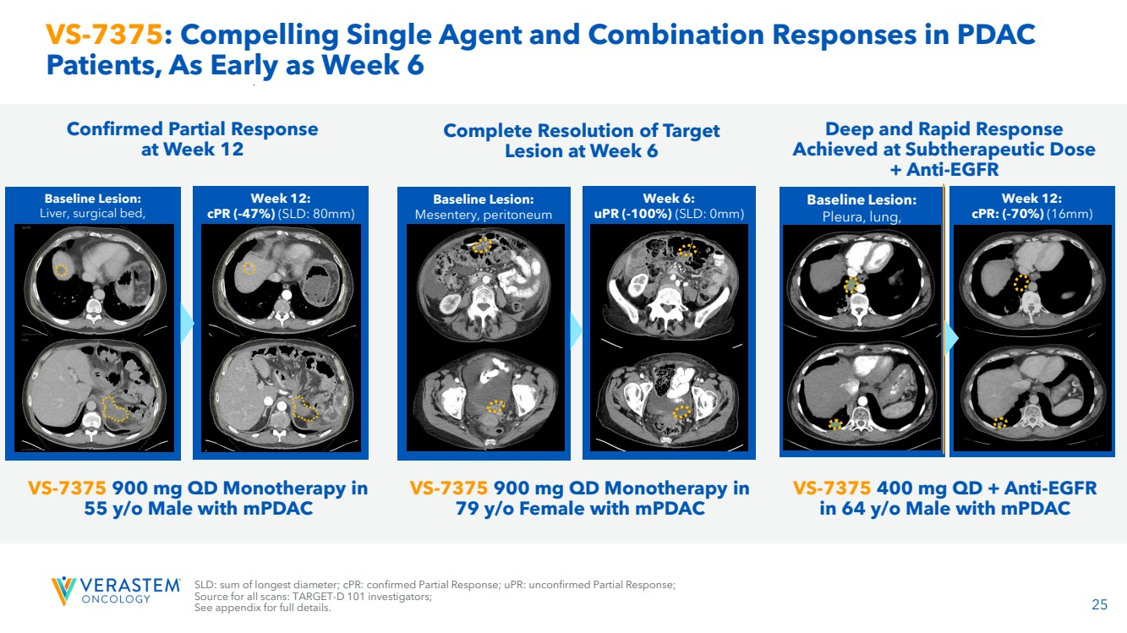 | 25 VS-7375: Compelling Single Agent and Combination Responses in PDAC Patients, As Early as Week 6 Week 12: cPR (-47%) (SLD: 80mm) Response ongoing Baseline Lesion: Liver, surgical bed, peritoneum (SLD: 151mm) Week 6: uPR (-100%) (SLD: 0mm) Response ongoing Baseline Lesion: Mesentery, peritoneum (SLD: 64mm) Baseline Lesion: Pleura, lung, mediastinum lymph node (52mm) Week 12: cPR: (-70%) (16mm) Confirmed Partial Response at Week 12 Complete Resolution of Target Lesion at Week 6 Deep and Rapid Response Achieved at Subtherapeutic Dose + Anti-EGFR VS-7375 900 mg QD Monotherapy in 55 y/o Male with mPDAC VS-7375 900 mg QD Monotherapy in 79 y/o Female with mPDAC VS-7375 400 mg QD + Anti-EGFR in 64 y/o Male with mPDAC SLD: sum of longest diameter; cPR: confirmed Partial Response; uPR: unconfirmed Partial Response; Source for all scans: TARGET-D 101 investigators; See appendix for full details.
 | 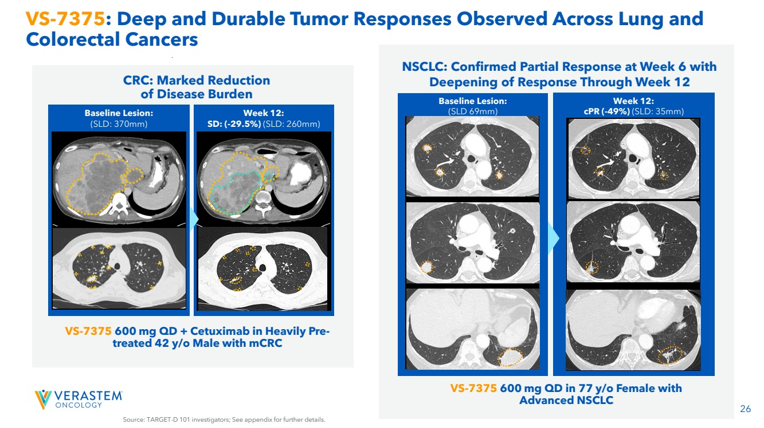 | 26 VS-7375: Deep and Durable Tumor Responses Observed Across Lung and Colorectal Cancers Week 12: SD: (-29.5%) (SLD: 260mm) Baseline Lesion: (SLD: 370mm) CRC: Marked Reduction of Disease Burden Week 12: cPR (-49%) (SLD: 35mm) Baseline Lesion: (SLD 69mm) VS-7375 600 mg QD in 77 y/o Female with Advanced NSCLC NSCLC: Confirmed Partial Response at Week 6 with Deepening of Response Through Week 12 VS-7375 600 mg QD + Cetuximab in Heavily Pre-treated 42 y/o Male with mCRC Source: TARGET-D 101 investigators; See appendix for further details.
 | 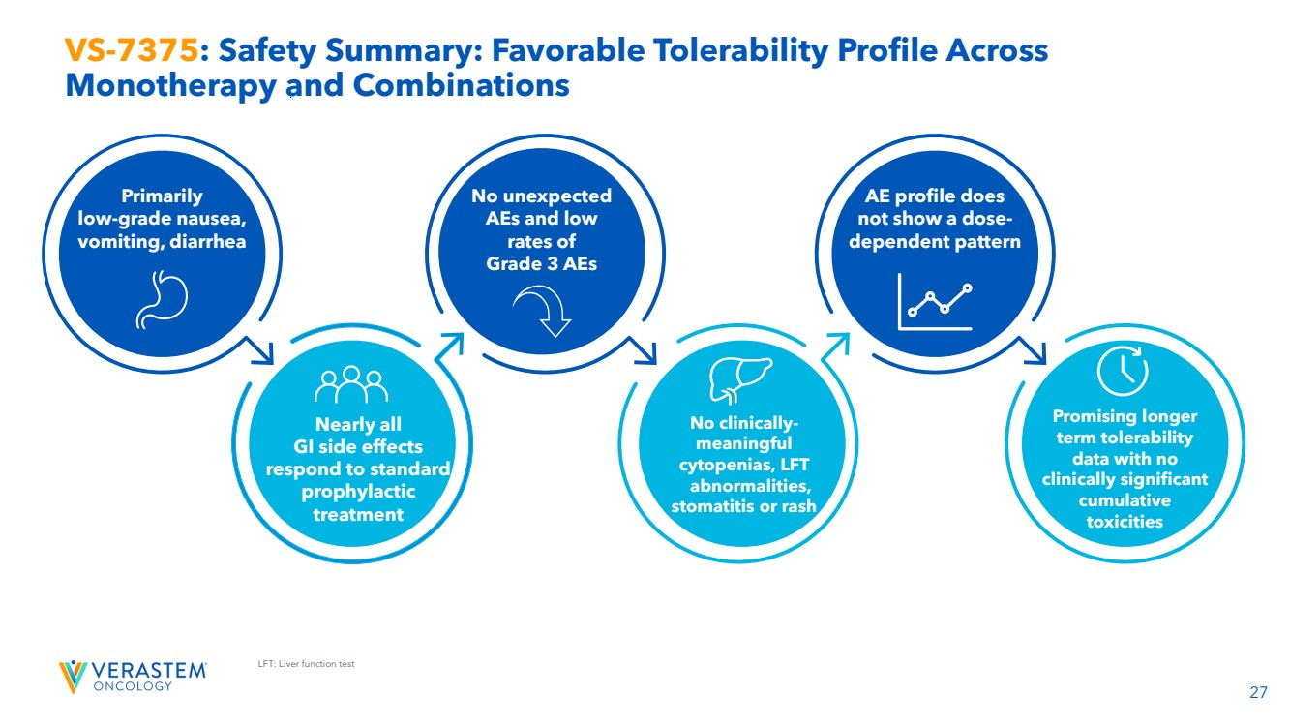 | 27 LFT: Liver function test VS-7375: Safety Summary: Favorable Tolerability Profile Across Monotherapy and Combinations Primarily low-grade nausea, vomiting, diarrhea Nearly all GI side effects respond to standard prophylactic treatment No unexpected AEs and low rates of Grade 3 AEs No clinically-meaningful cytopenias, LFT abnormalities, stomatitis or rash AE profile does not show a dose-dependent pattern Promising longer term tolerability data with no clinically significant cumulative toxicities
 | 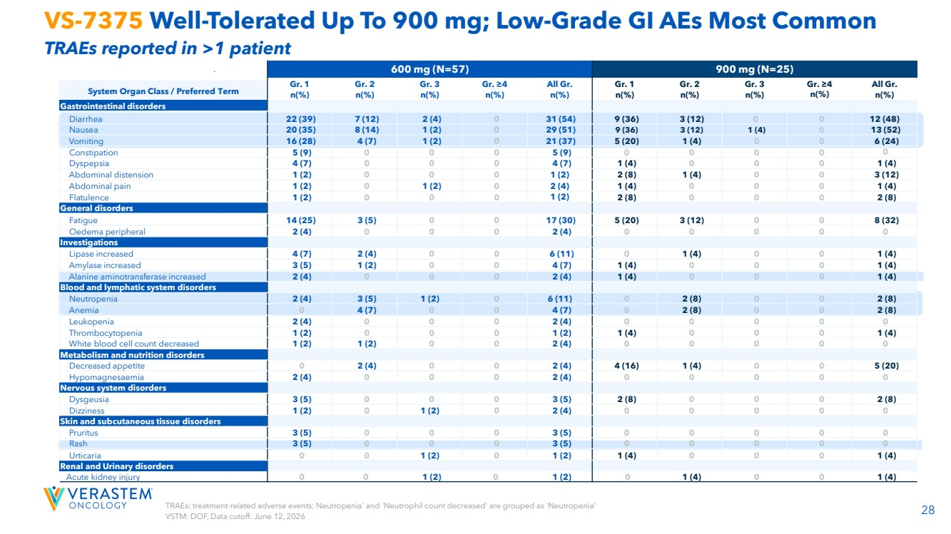 | 28 TRAEs: treatment-related adverse events; Neutropenia' and 'Neutrophil count decreased' are grouped as 'Neutropenia’ VSTM: DOF, Data cutoff: June 12, 2026 VS-7375 Well-Tolerated Up To 900 mg; Low-Grade GI AEs Most Common TRAEs reported in >1 patient 600 mg (N=57) 900 mg (N=25) Gr. 1 n(%) Gr. 2 n(%) Gr. 3 n(%) Gr. ≥4 n(%) All Gr. n(%) Gr. 1 n(%) Gr. 2 n(%) Gr. 3 n(%) Gr. ≥4 n(%) All Gr. n(%) System Organ Class / Preferred Term Gastrointestinal disorders Diarrhea 22 (39) 7 (12) 2 (4) 0 31 (54) 9 (36) 3 (12) 0 0 12 (48) Nausea 20 (35) 8 (14) 1 (2) 0 29 (51) 9 (36) 3 (12) 1 (4) 0 13 (52) Vomiting 16 (28) 4 (7) 1 (2) 0 21 (37) 5 (20) 1 (4) 0 0 6 (24) Constipation 5 (9) 0 0 0 5 (9) 0 0 0 0 0 Dyspepsia 4 (7) 0 0 0 4 (7) 1 (4) 0 0 0 1 (4) Abdominal distension 1 (2) 0 0 0 1 (2) 2 (8) 1 (4) 0 0 3 (12) Abdominal pain 1 (2) 0 1 (2) 0 2 (4) 1 (4) 0 0 0 1 (4) Flatulence 1 (2) 0 0 0 1 (2) 2 (8) 0 0 0 2 (8) General disorders Fatigue 14 (25) 3 (5) 0 0 17 (30) 5 (20) 3 (12) 0 0 8 (32) Oedema peripheral 2 (4) 0 0 0 2 (4) 0 0 0 0 0 Investigations Lipase increased 4 (7) 2 (4) 0 0 6 (11) 0 1 (4) 0 0 1 (4) Amylase increased 3 (5) 1 (2) 0 0 4 (7) 1 (4) 0 0 0 1 (4) Alanine aminotransferase increased 2 (4) 0 0 0 2 (4) 1 (4) 0 0 0 1 (4) Blood and lymphatic system disorders Neutropenia 2 (4) 3 (5) 1 (2) 0 6 (11) 0 2 (8) 0 0 2 (8) Anemia 0 4 (7) 0 0 4 (7) 0 2 (8) 0 0 2 (8) Leukopenia 2 (4) 0 0 0 2 (4) 0 0 0 0 0 Thrombocytopenia 1 (2) 0 0 0 1 (2) 1 (4) 0 0 0 1 (4) White blood cell count decreased 1 (2) 1 (2) 0 0 2 (4) 0 0 0 0 0 Metabolism and nutrition disorders Decreased appetite 0 2 (4) 0 0 2 (4) 4 (16) 1 (4) 0 0 5 (20) Hypomagnesaemia 2 (4) 0 0 0 2 (4) 0 0 0 0 0 Nervous system disorders Dysgeusia 3 (5) 0 0 0 3 (5) 2 (8) 0 0 0 2 (8) Dizziness 1 (2) 0 1 (2) 0 2 (4) 0 0 0 0 0 Skin and subcutaneous tissue disorders Pruritus 3 (5) 0 0 0 3 (5) 0 0 0 0 0 Rash 3 (5) 0 0 0 3 (5) 0 0 0 0 0 Urticaria 0 0 1 (2) 0 1 (2) 1 (4) 0 0 0 1 (4) Renal and Urinary disorders Acute kidney injury 0 0 1 (2) 0 1 (2) 0 1 (4) 0 0 1 (4)
 | 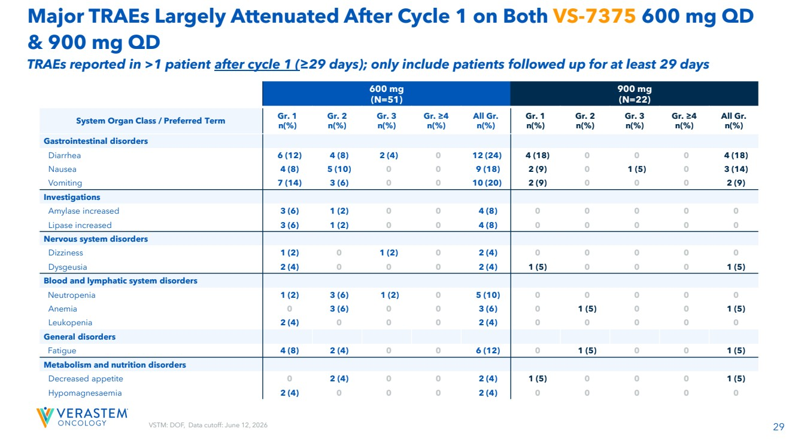 | VSTM: DOF, Data cutoff: June 12, 2026 29 Major TRAEs Largely Attenuated After Cycle 1 on Both VS-7375 600 mg QD & 900 mg QD 600 mg (N=51) 900 mg (N=22) System Organ Class / Preferred Term Gr. 1 n(%) Gr. 2 n(%) Gr. 3 n(%) Gr. ≥4 n(%) All Gr. n(%) Gr. 1 n(%) Gr. 2 n(%) Gr. 3 n(%) Gr. ≥4 n(%) All Gr. n(%) Gastrointestinal disorders Diarrhea 6 (12) 4 (8) 2 (4) 0 12 (24) 4 (18) 0 0 0 4 (18) Nausea 4 (8) 5 (10) 0 0 9 (18) 2 (9) 0 1 (5) 0 3 (14) Vomiting 7 (14) 3 (6) 0 0 10 (20) 2 (9) 0 0 0 2 (9) Investigations Amylase increased 3 (6) 1 (2) 0 0 4 (8) 0 0 0 0 0 Lipase increased 3 (6) 1 (2) 0 0 4 (8) 0 0 0 0 0 Nervous system disorders Dizziness 1 (2) 0 1 (2) 0 2 (4) 0 0 0 0 0 Dysgeusia 2 (4) 0 0 0 2 (4) 1 (5) 0 0 0 1 (5) Blood and lymphatic system disorders Neutropenia 1 (2) 3 (6) 1 (2) 0 5 (10) 0 0 0 0 0 Anemia 0 3 (6) 0 0 3 (6) 0 1 (5) 0 0 1 (5) Leukopenia 2 (4) 0 0 0 2 (4) 0 0 0 0 0 General disorders Fatigue 4 (8) 2 (4) 0 0 6 (12) 0 1 (5) 0 0 1 (5) Metabolism and nutrition disorders Decreased appetite 0 2 (4) 0 0 2 (4) 1 (5) 0 0 0 1 (5) Hypomagnesaemia 2 (4) 0 0 0 2 (4) 0 0 0 0 0 TRAEs reported in >1 patient after cycle 1 (≥29 days); only include patients followed up for at least 29 days
 | 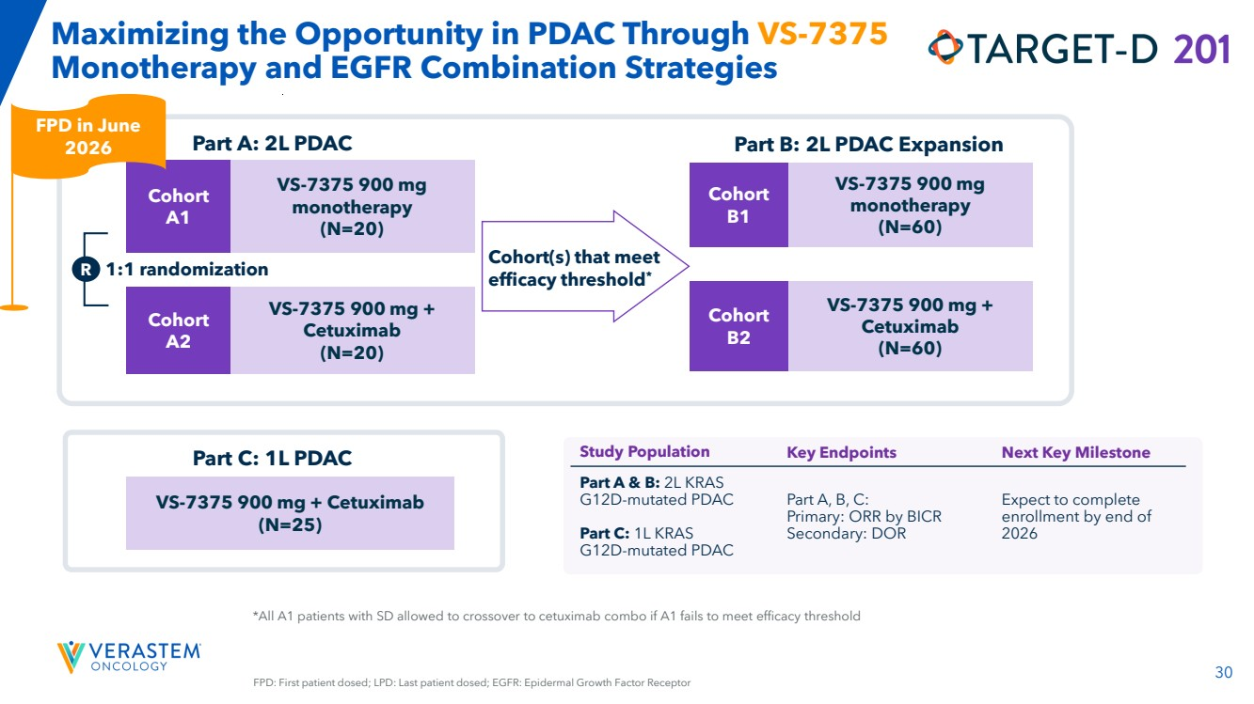 | 30 *All A1 patients with SD allowed to crossover to cetuximab combo if A1 fails to meet efficacy threshold Maximizing the Opportunity in PDAC Through VS-7375 Monotherapy and EGFR Combination Strategies R 1:1 randomization Part A: 2L PDAC Cohort A1 Cohort A2 VS-7375 900 mg monotherapy (N=20) VS-7375 900 mg + Cetuximab (N=20) Cohort B1 Cohort B2 VS-7375 900 mg monotherapy (N=60) VS-7375 900 mg + Cetuximab (N=60) Part B: 2L PDAC Expansion Cohort(s) that meet efficacy threshold* Part C: 1L PDAC VS-7375 900 mg + Cetuximab (N=25) Study Population Key Endpoints Next Key Milestone Part A & B: 2L KRAS G12D-mutated PDAC Part C: 1L KRAS G12D-mutated PDAC Part A, B, C: Primary: ORR by BICR Secondary: DOR Expect to complete enrollment by end of 2026 FPD: First patient dosed; LPD: Last patient dosed; EGFR: Epidermal Growth Factor Receptor FPD in June 2026
 | 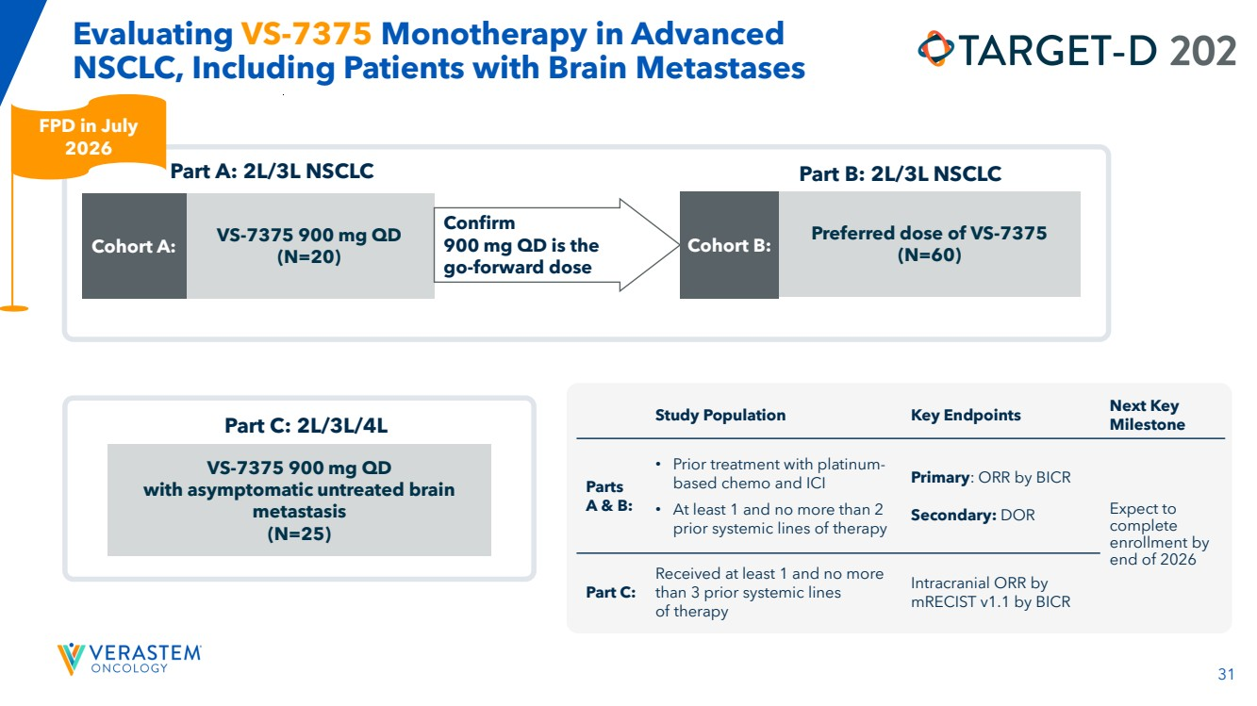 | 31 Evaluating VS-7375 Monotherapy in Advanced NSCLC, Including Patients with Brain Metastases Cohort A: Confirm 900 mg QD is the go-forward dose Part A: 2L/3L NSCLC VS-7375 900 mg QD (N=20) Cohort B: Preferred dose of VS-7375 (N=60) Part B: 2L/3L NSCLC Part C: 2L/3L/4L VS-7375 900 mg QD with asymptomatic untreated brain metastasis (N=25) Study Population Key Endpoints Next Key Milestone Parts A & B: • Prior treatment with platinum-based chemo and ICI • At least 1 and no more than 2 prior systemic lines of therapy Primary: ORR by BICR Secondary: DOR Expect to complete enrollment by end of 2026 Part C: Received at least 1 and no more than 3 prior systemic lines of therapy Intracranial ORR by mRECIST v1.1 by BICR FPD in July 2026
 | 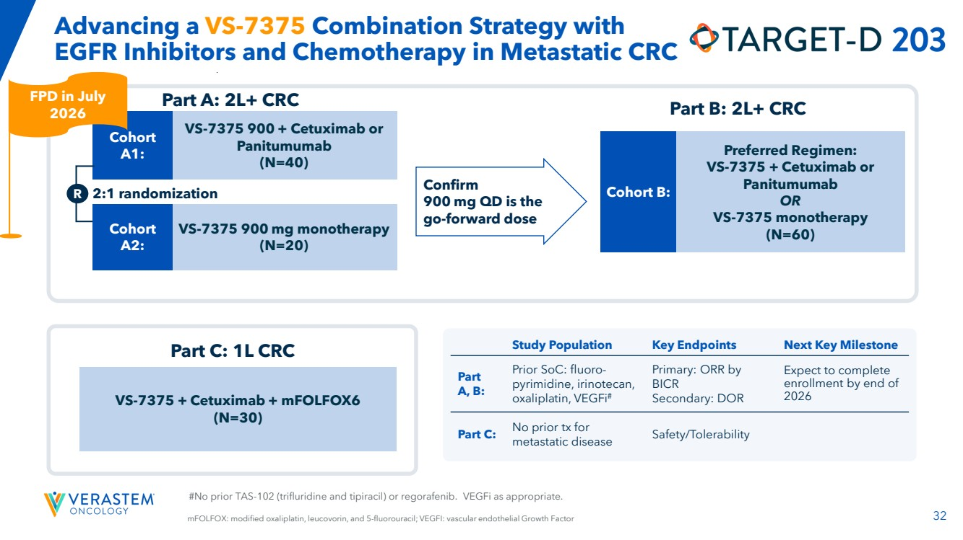 | 32 #No prior TAS-102 (trifluridine and tipiracil) or regorafenib. VEGFi as appropriate. Advancing a VS-7375 Combination Strategy with EGFR Inhibitors and Chemotherapy in Metastatic CRC Cohort A1: R Confirm 900 mg QD is the go-forward dose 2:1 randomization Cohort A2: Part A: 2L+ CRC VS-7375 900 + Cetuximab or Panitumumab (N=40) VS-7375 900 mg monotherapy (N=20) Cohort B: Preferred Regimen: VS-7375 + Cetuximab or Panitumumab OR VS-7375 monotherapy (N=60) Part C: 1L CRC VS-7375 + Cetuximab + mFOLFOX6 (N=30) Part B: 2L+ CRC mFOLFOX: modified oxaliplatin, leucovorin, and 5-fluorouracil; VEGFI: vascular endothelial Growth Factor Study Population Key Endpoints Next Key Milestone Part A, B: Prior SoC: fluoro-pyrimidine, irinotecan, oxaliplatin, VEGFi# Primary: ORR by BICR Secondary: DOR Expect to complete enrollment by end of 2026 Part C: No prior tx for metastatic disease Safety/Tolerability FPD in July 2026
 | 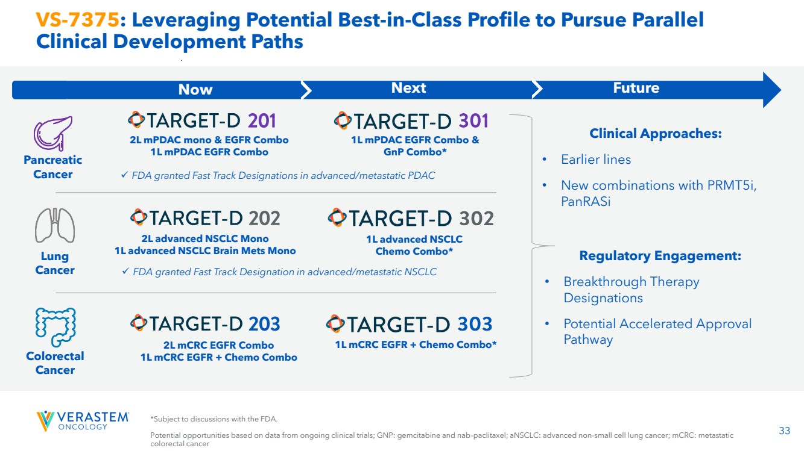 | 33 VS-7375: Leveraging Potential Best-in-Class Profile to Pursue Parallel Clinical Development Paths *Subject to discussions with the FDA. Potential opportunities based on data from ongoing clinical trials; GNP: gemcitabine and nab-paclitaxel; aNSCLC: advanced non-small cell lung cancer; mCRC: metastatic colorectal cancer 2L mPDAC mono & EGFR Combo 1L mPDAC EGFR Combo 1L mPDAC EGFR Combo & GnP Combo* 2L advanced NSCLC Mono 1L advanced NSCLC Brain Mets Mono 1L advanced NSCLC Chemo Combo* 2L mCRC EGFR Combo 1L mCRC EGFR + Chemo Combo 1L mCRC EGFR + Chemo Combo* Pancreatic Cancer Colorectal Cancer Lung Cancer Clinical Approaches: • Earlier lines • New combinations with PRMT5i, PanRASi Regulatory Engagement: • Breakthrough Therapy Designations • Potential Accelerated Approval Pathway ✓ FDA granted Fast Track Designations in advanced/metastatic PDAC ✓ FDA granted Fast Track Designation in advanced/metastatic NSCLC Now Next Future
 |  | RAMP 205: Avutometinib + Defactinib + Standard-of Care in First-Line Metastatic Pancreatic Cancer
 | 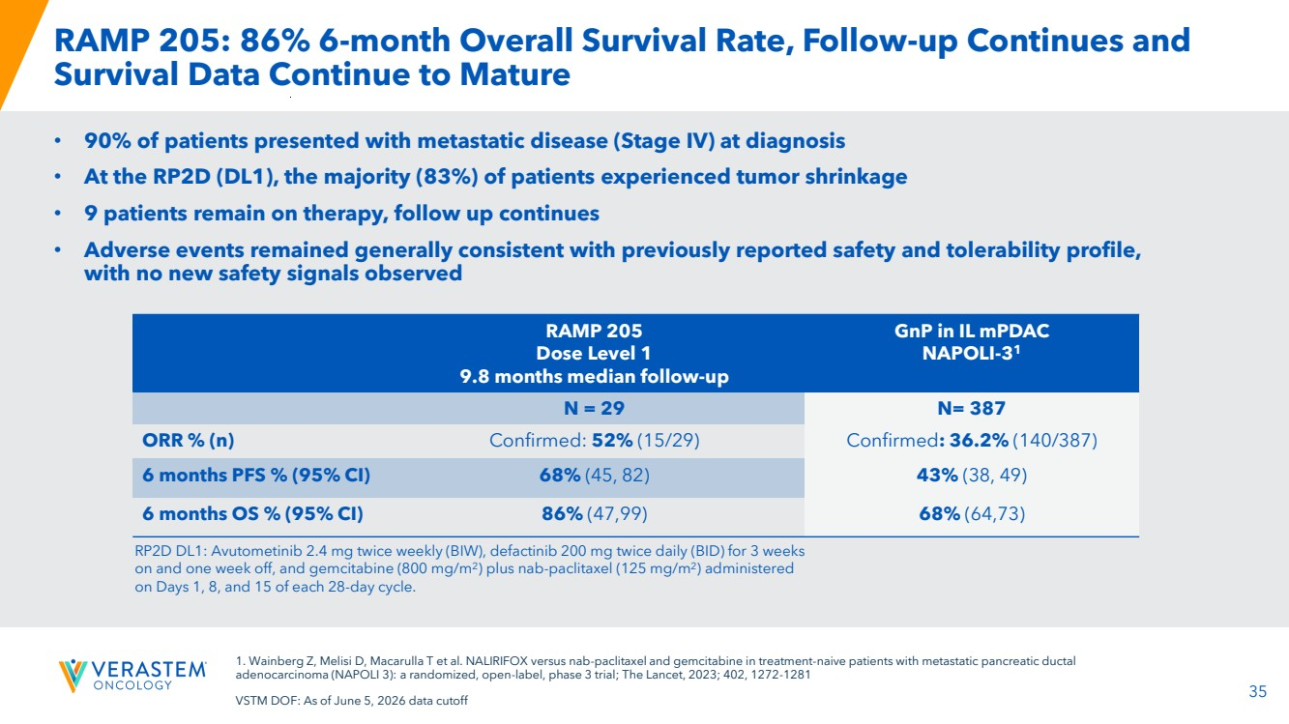 | 35 RAMP 205: 86% 6-month Overall Survival Rate, Follow-up Continues and Survival Data Continue to Mature • 90% of patients presented with metastatic disease (Stage IV) at diagnosis • At the RP2D (DL1), the majority (83%) of patients experienced tumor shrinkage • 9 patients remain on therapy, follow up continues • Adverse events remained generally consistent with previously reported safety and tolerability profile, with no new safety signals observed RAMP 205 Dose Level 1 9.8 months median follow-up GnP in IL mPDAC NAPOLI-31 N = 29 N= 387 ORR % (n) Confirmed: 52% (15/29) Confirmed: 36.2% (140/387) 6 months PFS % (95% CI) 68% (45, 82) 43% (38, 49) 6 months OS % (95% CI) 86% (47,99) 68% (64,73) RP2D DL1: Avutometinib 2.4 mg twice weekly (BIW), defactinib 200 mg twice daily (BID) for 3 weeks on and one week off, and gemcitabine (800 mg/m2 ) plus nab-paclitaxel (125 mg/m2 ) administered on Days 1, 8, and 15 of each 28-day cycle. 1. Wainberg Z, Melisi D, Macarulla T et al. NALIRIFOX versus nab-paclitaxel and gemcitabine in treatment-naive patients with metastatic pancreatic ductal adenocarcinoma (NAPOLI 3): a randomized, open-label, phase 3 trial; The Lancet, 2023; 402, 1272-1281 VSTM DOF: As of June 5, 2026 data cutoff
 |  | Financials 36
 | 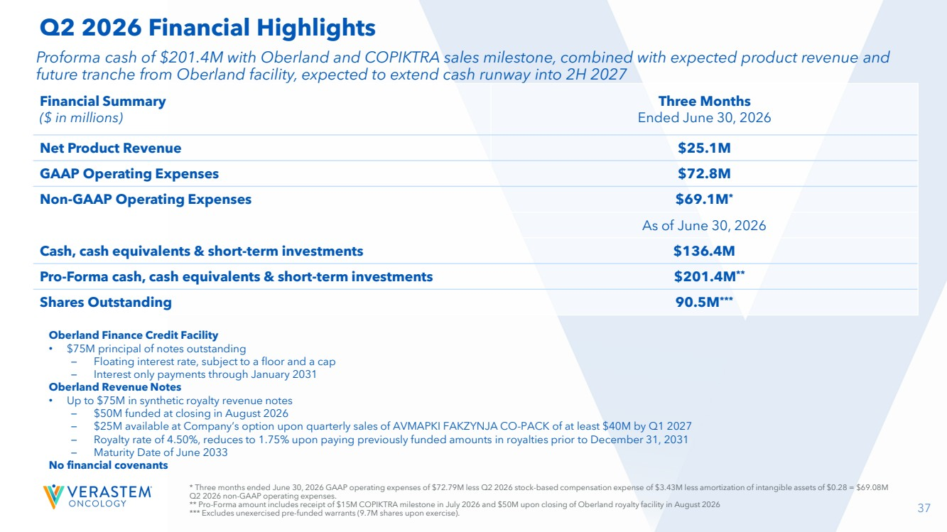 | 37 Oberland Finance Credit Facility • $75M principal of notes outstanding – Floating interest rate, subject to a floor and a cap – Interest only payments through January 2031 Oberland Revenue Notes • Up to $75M in synthetic royalty revenue notes – $50M funded at closing in August 2026 – $25M available at Company’s option upon quarterly sales of AVMAPKI FAKZYNJA CO-PACK of at least $40M by Q1 2027 – Royalty rate of 4.50%, reduces to 1.75% upon paying previously funded amounts in royalties prior to December 31, 2031 – Maturity Date of June 2033 No financial covenants Proforma cash of $201.4M with Oberland and COPIKTRA sales milestone, combined with expected product revenue and future tranche from Oberland facility, expected to extend cash runway into 2H 2027 Financial Summary ($ in millions) Three Months Ended June 30, 2026 Net Product Revenue $25.1M GAAP Operating Expenses $72.8M Non-GAAP Operating Expenses $69.1M* As of June 30, 2026 Cash, cash equivalents & short-term investments $136.4M Pro-Forma cash, cash equivalents & short-term investments $201.4M** Shares Outstanding 90.5M*** Q2 2026 Financial Highlights * Three months ended June 30, 2026 GAAP operating expenses of $72.79M less Q2 2026 stock-based compensation expense of $3.43M less amortization of intangible assets of $0.28 = $69.08M Q2 2026 non-GAAP operating expenses. ** Pro-Forma amount includes receipt of $15M COPIKTRA milestone in July 2026 and $50M upon closing of Oberland royalty facility in August 2026 *** Excludes unexercised pre-funded warrants (9.7M shares upon exercise).
 | 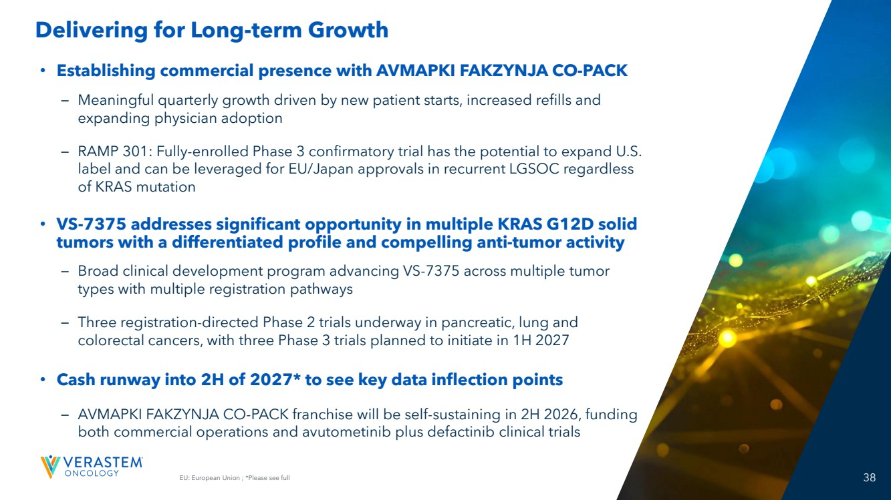 | EU: European Union ; *Please see full 38 Delivering for Long-term Growth • Establishing commercial presence with AVMAPKI FAKZYNJA CO-PACK – Meaningful quarterly growth driven by new patient starts, increased refills and expanding physician adoption – RAMP 301: Fully-enrolled Phase 3 confirmatory trial has the potential to expand U.S. label and can be leveraged for EU/Japan approvals in recurrent LGSOC regardless of KRAS mutation • VS-7375 addresses significant opportunity in multiple KRAS G12D solid tumors with a differentiated profile and compelling anti-tumor activity – Broad clinical development program advancing VS-7375 across multiple tumor types with multiple registration pathways – Three registration-directed Phase 2 trials underway in pancreatic, lung and colorectal cancers, with three Phase 3 trials planned to initiate in 1H 2027 • Cash runway into 2H of 2027* to see key data inflection points – AVMAPKI FAKZYNJA CO-PACK franchise will be self-sustaining in 2H 2026, funding both commercial operations and avutometinib plus defactinib clinical trials
 |  | THANK YOU!
 |  | Appendix
 | 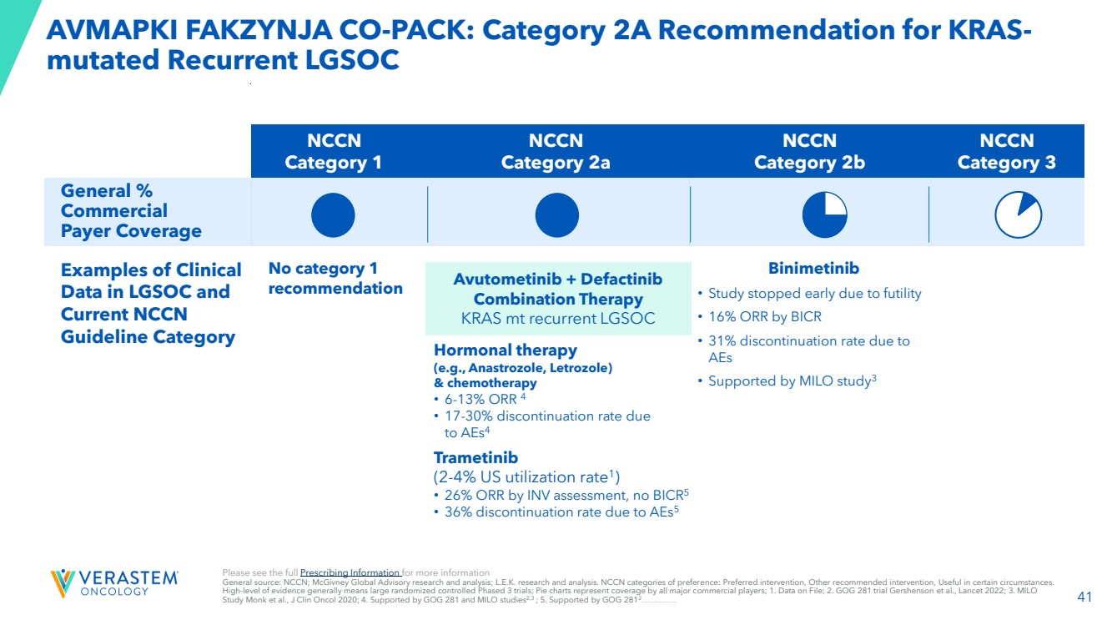 | 41 AVMAPKI FAKZYNJA CO-PACK: Category 2A Recommendation for KRAS-mutated Recurrent LGSOC NCCN Category 1 NCCN Category 2a NCCN Category 2b NCCN Category 3 General % Commercial Payer Coverage Examples of Clinical Data in LGSOC and Current NCCN Guideline Category No category 1 recommendation Hormonal therapy (e.g., Anastrozole, Letrozole) & chemotherapy • 6-13% ORR 4 • 17-30% discontinuation rate due to AEs4 Trametinib (2-4% US utilization rate1 ) • 26% ORR by INV assessment, no BICR5 • 36% discontinuation rate due to AEs5 Binimetinib • Study stopped early due to futility • 16% ORR by BICR • 31% discontinuation rate due to AEs • Supported by MILO study3 Avutometinib + Defactinib Combination Therapy KRAS mt recurrent LGSOC Please see the full Prescribing Information for more information General source: NCCN; McGivney Global Advisory research and analysis; L.E.K. research and analysis. NCCN categories of preference: Preferred intervention, Other recommended intervention, Useful in certain circumstances. High-level of evidence generally means large randomized controlled Phased 3 trials; Pie charts represent coverage by all major commercial players; 1. Data on File; 2. GOG 281 trial Gershenson et al., Lancet 2022; 3. MILO Study Monk et al., J Clin Oncol 2020; 4. Supported by GOG 281 and MILO studies2,3 ; 5. Supported by GOG 2812 ;AEs: adverse events; BICR: Blinded Independent Central Review
 | 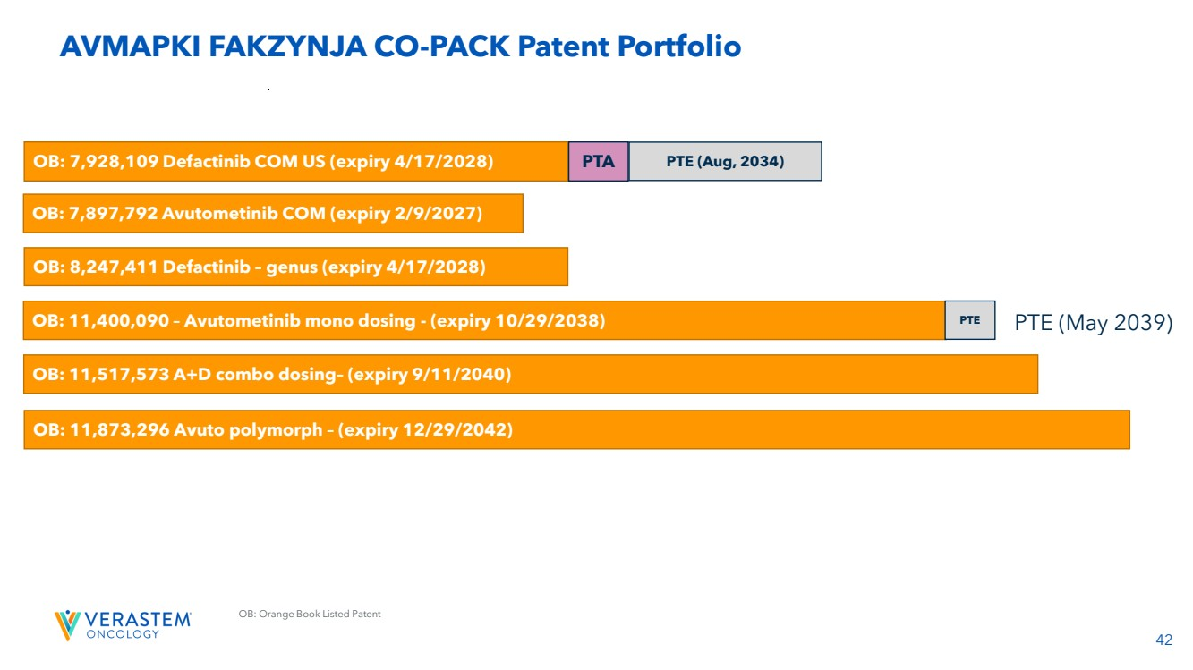 | 42 OB: Orange Book Listed Patent AVMAPKI FAKZYNJA CO-PACK Patent Portfolio OB: 7,897,792 Avutometinib COM (expiry 2/9/2027) OB: 11,400,090 – Avutometinib mono dosing - (expiry 10/29/2038) PTE OB: 7,928,109 Defactinib COM US (expiry 4/17/2028) PTA PTE (Aug, 2034) OB: 8,247,411 Defactinib – genus (expiry 4/17/2028) OB: 11,517,573 A+D combo dosing– (expiry 9/11/2040) OB: 11,873,296 Avuto polymorph – (expiry 12/29/2042) PTE (May 2039)
 | 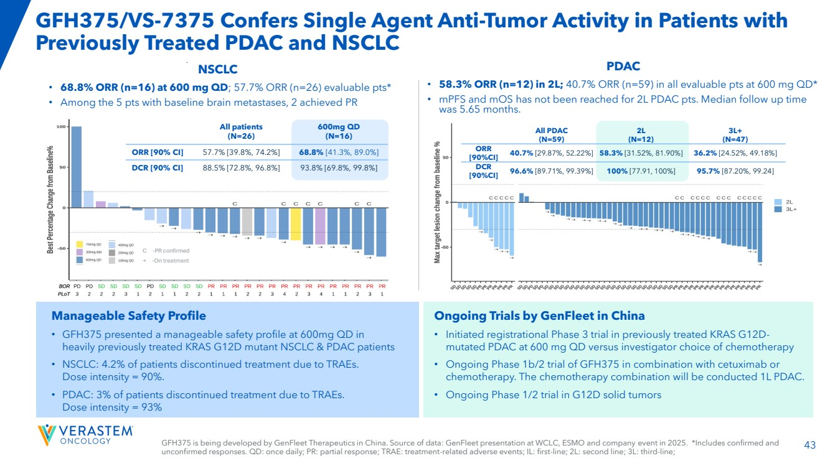 | 43 GFH375/VS-7375 Confers Single Agent Anti-Tumor Activity in Patients with Previously Treated PDAC and NSCLC PDAC • 58.3% ORR (n=12) in 2L; 40.7% ORR (n=59) in all evaluable pts at 600 mg QD* • mPFS and mOS has not been reached for 2L PDAC pts. Median follow up time was 5.65 months. C -PR confirmed → -On treatment NSCLC • 68.8% ORR (n=16) at 600 mg QD; 57.7% ORR (n=26) evaluable pts* • Among the 5 pts with baseline brain metastases, 2 achieved PR Ongoing Trials by GenFleet in China • Initiated registrational Phase 3 trial in previously treated KRAS G12D-mutated PDAC at 600 mg QD versus investigator choice of chemotherapy • Ongoing Phase 1b/2 trial of GFH375 in combination with cetuximab or chemotherapy. The chemotherapy combination will be conducted 1L PDAC. • Ongoing Phase 1/2 trial in G12D solid tumors Manageable Safety Profile • GFH375 presented a manageable safety profile at 600mg QD in heavily previously treated KRAS G12D mutant NSCLC & PDAC patients • NSCLC: 4.2% of patients discontinued treatment due to TRAEs. Dose intensity = 90%. • PDAC: 3% of patients discontinued treatment due to TRAEs. Dose intensity = 93% All patients (N=26) 600mg QD (N=16) ORR [90% CI] 57.7% [39.8%, 74.2%] 68.8% [41.3%, 89.0%] DCR [90% CI] 88.5% [72.8%, 96.8%] 93.8% [69.8%, 99.8%] All PDAC (N=59) 2L (N=12) 3L+ (N=47) ORR [90%CI] 40.7% [29.87%, 52.22%] 58.3% [31.52%, 81.90%] 36.2% [24.52%, 49.18%] DCR [90%CI] 96.6% [89.71%, 99.39%] 100% [77.91, 100%] 95.7% [87.20%, 99.24] GFH375 is being developed by GenFleet Therapeutics in China. Source of data: GenFleet presentation at WCLC, ESMO and company event in 2025. *Includes confirmed and unconfirmed responses. QD: once daily; PR: partial response; TRAE: treatment-related adverse events; IL: first-line; 2L: second line; 3L: third-line;
 | 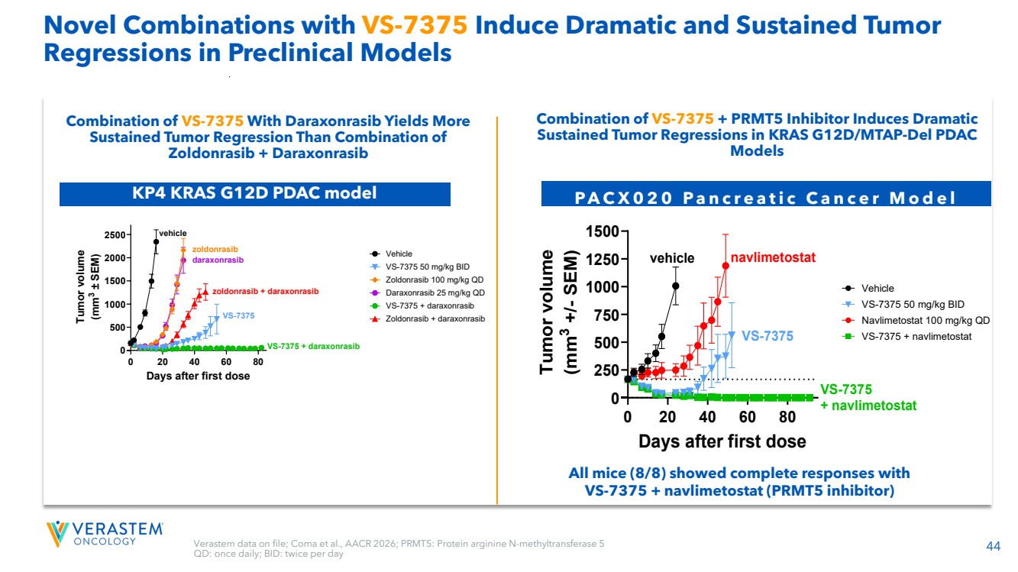 | 44 Novel Combinations with VS-7375 Induce Dramatic and Sustained Tumor Regressions in Preclinical Models Combination of VS-7375 With Daraxonrasib Yields More Sustained Tumor Regression Than Combination of Zoldonrasib + Daraxonrasib 0 20 40 60 80 0 500 1000 1500 2000 2500 Days after first dose Tumor volume (mm3 ± SEM) Vehicle VS-7375 50 mg/kg BID Zoldonrasib 100 mg/kg QD Daraxonrasib 25 mg/kg QD VS-7375 + daraxonrasib Zoldonrasib + daraxonrasib vehicle daraxonrasib zoldonrasib zoldonrasib + daraxonrasib VS-7375 VS-7375 + daraxonrasib KP4 KRAS G12D PDAC model Verastem data on file; Coma et al., AACR 2026; PRMT5: Protein arginine N-methyltransferase 5 QD: once daily; BID: twice per day Combination of VS-7375 + PRMT5 Inhibitor Induces Dramatic Sustained Tumor Regressions in KRAS G12D/MTAP-Del PDAC Models P A C X 0 2 0 P a n c r e a t i c C a n c e r M o d e l All mice (8/8) showed complete responses with VS-7375 + navlimetostat (PRMT5 inhibitor) 0 20 40 60 80 0 250 500 750 1000 1250 1500 Days after first dose Tumor volume (mm3 +/- SEM) Vehicle VS-7375 50 mg/kg BID Navlimetostat 100 mg/kg QD VS-7375 + navlimetostat vehicle navlimetostat VS-7375 VS-7375 + navlimetostat 0 20 40 60 80 0 250 500 750 1000 1250 1500 Days after first dose T u m o r v olu m e (m m 3 +/- S E M) Vehicle VS-7375 50 mg/kg BID Navlimetostat 100 mg/kg QD VS-7375 + navlimetostat vehicle navlimetostat VS-7375 VS-7375 + navlimetostat
 | 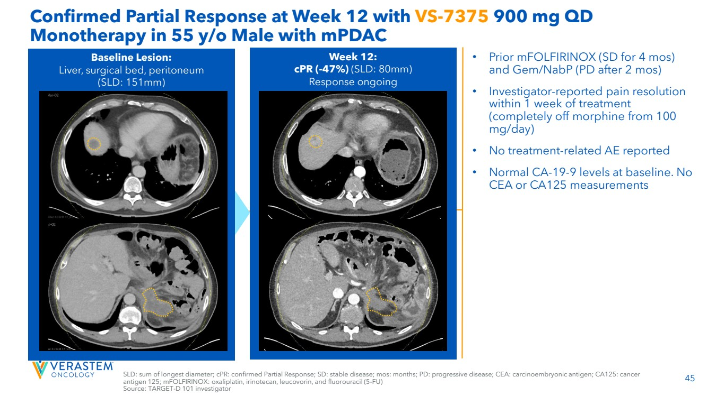 | 45 Confirmed Partial Response at Week 12 with VS-7375 900 mg QD Monotherapy in 55 y/o Male with mPDAC • Prior mFOLFIRINOX (SD for 4 mos) and Gem/NabP (PD after 2 mos) • Investigator-reported pain resolution within 1 week of treatment (completely off morphine from 100 mg/day) • No treatment-related AE reported • Normal CA-19-9 levels at baseline. No CEA or CA125 measurements Week 12: cPR (-47%) (SLD: 80mm) Response ongoing Baseline Lesion: Liver, surgical bed, peritoneum (SLD: 151mm) SLD: sum of longest diameter; cPR: confirmed Partial Response; SD: stable disease; mos: months; PD: progressive disease; CEA: carcinoembryonic antigen; CA125: cancer antigen 125; mFOLFIRINOX: oxaliplatin, irinotecan, leucovorin, and fluorouracil (5-FU) Source: TARGET-D 101 investigator
 | 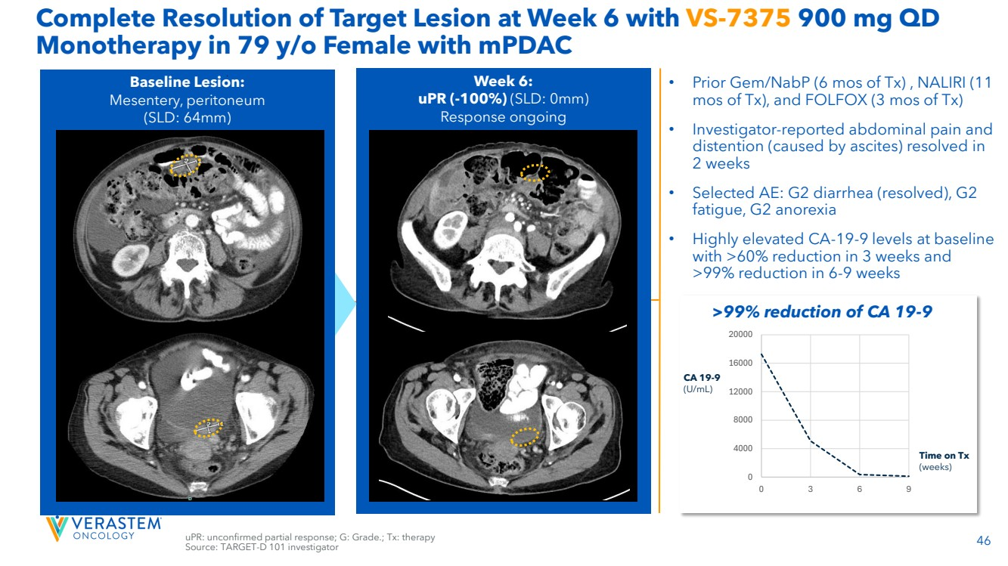 | 46 Complete Resolution of Target Lesion at Week 6 with VS-7375 900 mg QD Monotherapy in 79 y/o Female with mPDAC uPR: unconfirmed partial response; G: Grade.; Tx: therapy Source: TARGET-D 101 investigator • Prior Gem/NabP (6 mos of Tx) , NALIRI (11 mos of Tx), and FOLFOX (3 mos of Tx) • Investigator-reported abdominal pain and distention (caused by ascites) resolved in 2 weeks • Selected AE: G2 diarrhea (resolved), G2 fatigue, G2 anorexia • Highly elevated CA-19-9 levels at baseline with >60% reduction in 3 weeks and >99% reduction in 6-9 weeks Week 6: uPR (-100%) (SLD: 0mm) Response ongoing Baseline Lesion: Mesentery, peritoneum (SLD: 64mm) 0 4000 8000 12000 16000 20000 0 3 6 9 CA 19-9 (U/mL) Time on Tx (weeks) >99% reduction of CA 19-9
 | 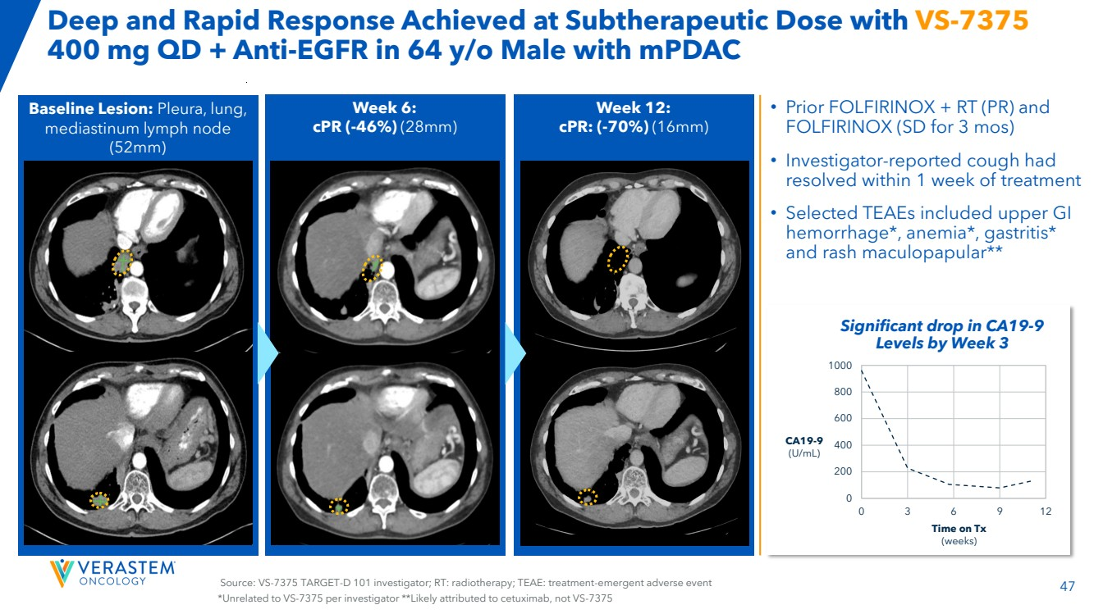 | 47 Source: VS-7375 TARGET-D 101 investigator; RT: radiotherapy; TEAE: treatment-emergent adverse event Baseline Lesion: Pleura, lung, mediastinum lymph node (52mm) 7x5mm 9x7mm Week 6: cPR (-46%) (28mm) Week 12: cPR: (-70%) (16mm) Deep and Rapid Response Achieved at Subtherapeutic Dose with VS-7375 400 mg QD + Anti-EGFR in 64 y/o Male with mPDAC • Prior FOLFIRINOX + RT (PR) and FOLFIRINOX (SD for 3 mos) • Investigator-reported cough had resolved within 1 week of treatment • Selected TEAEs included upper GI hemorrhage*, anemia*, gastritis* and rash maculopapular** 0 200 400 600 800 1000 0 3 6 9 12 CA19-9 (U/mL) Time on Tx (weeks) Significant drop in CA19-9 Levels by Week 3 *Unrelated to VS-7375 per investigator **Likely attributed to cetuximab, not VS-7375
 | 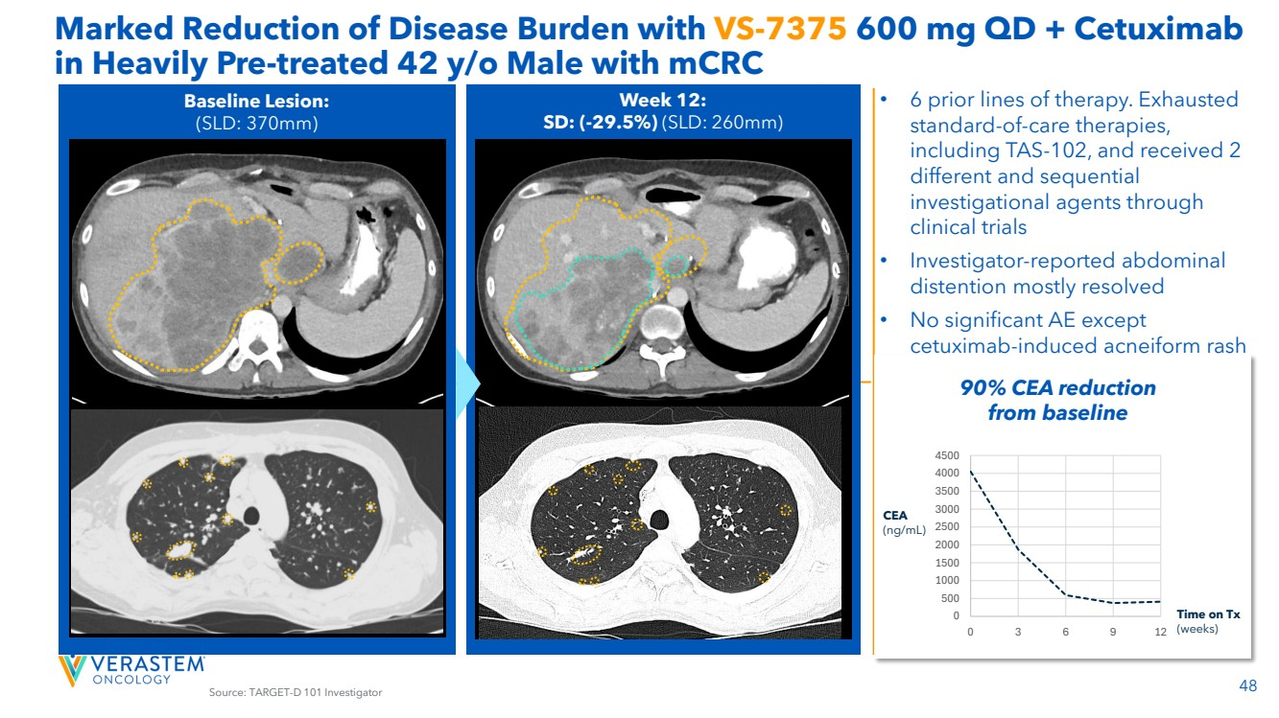 | 48 Marked Reduction of Disease Burden with VS-7375 600 mg QD + Cetuximab in Heavily Pre-treated 42 y/o Male with mCRC Source: TARGET-D 101 Investigator Week 12: SD: (-29.5%) (SLD: 260mm) Baseline Lesion: (SLD: 370mm) 0 500 1000 1500 2000 2500 3000 3500 4000 4500 0 3 6 9 12 CEA (ng/mL) Time on Tx (weeks) 90% CEA reduction from baseline • 6 prior lines of therapy. Exhausted standard-of-care therapies, including TAS-102, and received 2 different and sequential investigational agents through clinical trials • Investigator-reported abdominal distention mostly resolved • No significant AE except cetuximab-induced acneiform rash
 | 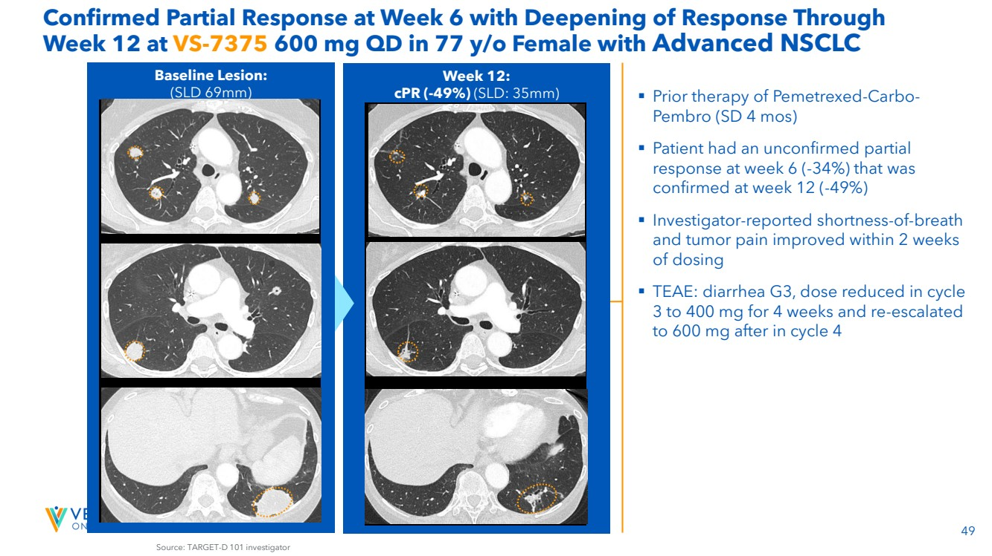 | 49 Week 12: cPR (-49%) (SLD: 35mm) Baseline Lesion: (SLD 69mm) Source: TARGET-D 101 investigator Confirmed Partial Response at Week 6 with Deepening of Response Through Week 12 at VS-7375 600 mg QD in 77 y/o Female with Advanced NSCLC ▪ Prior therapy of Pemetrexed-Carbo-Pembro (SD 4 mos) ▪ Patient had an unconfirmed partial response at week 6 (-34%) that was confirmed at week 12 (-49%) ▪ Investigator-reported shortness-of-breath and tumor pain improved within 2 weeks of dosing ▪ TEAE: diarrhea G3, dose reduced in cycle 3 to 400 mg for 4 weeks and re-escalated to 600 mg after in cycle 4

