UNITED STATES
SECURITIES AND EXCHANGE COMMISSION
WASHINGTON, D.C. 20549

FORM 8-K
CURRENT REPORT

Pursuant to Section 13 or 15(d) of the
Securities Exchange Act of 1934

Date of report (Date of earliest event reported): October 12, 2026

Verastem, Inc.
(Exact Name of Registrant as Specified in Charter)

Delaware |  | 001-35403 |  | 27-3269467
(State or Other Jurisdiction  of Incorporation) |  | (Commission  File Number) |  | (IRS Employer  Identification No.)

117 Kendrick Street, Suite 500, Needham, MA |  | 02494
(Address of Principal Executive Offices) |  | (Zip Code)

Registrant’s telephone number, including area code: (781) 292-4200

(Former Name or Former Address, if Changed Since Last Report)

Check the appropriate box below if the Form 8-K filing is intended to simultaneously satisfy the filing obligation of the registrant under any of the following provisions:

☐ | Written communications pursuant to Rule 425 under the Securities Act (17 CFR 230.425)
☐ | Soliciting material pursuant to Rule 14a-12 under the Exchange Act (17 CFR 240.14a-12)
☐ | Pre-commencement communications pursuant to Rule 14d-2(b) under the Exchange Act (17 CFR 240.14d-2(b))
☐ | Pre-commencement communications pursuant to Rule 13e-4(c) under the Exchange Act (17 CFR 240.13e-4(c))

Securities registered pursuant to Section 12(b) of the Act:

Title of each class |  | Trading  Symbol(s) |  | Name of each exchange on which registered
Common stock, $0.0001 par value per share |  | VSTM |  | The Nasdaq Capital Market

Indicate by check mark whether the registrant is an emerging growth company as defined in Rule 405 of the Securities Act of 1933 (§230.405 of this chapter) or Rule 12b-2 of the Securities Exchange Act of 1934 (§240.12b-2 of this chapter).

Emerging growth company ☐

If an emerging growth company, indicate by check mark if the registrant has elected not to use the extended transition period for complying with any new or revised financial accounting standards provided pursuant to Section 13(a) of the Exchange Act. ☐

Item 2.02. Results of Operations and Financial Condition

Set forth below are certain preliminary unaudited financial results for the three months ended September 30, 2026 of Verastem, Inc. (the “Company”). The preliminary unaudited third quarter 2026 financial results included in this Current Report on Form 8-K (the “Preliminary Financial Information”) are preliminary and were prepared by the Company’s management, based upon the Company’s estimates, a number of assumptions and currently available information, and are subject to revision based upon, among other things, quarter-end closing procedures and/or adjustments, the completion of the Company’s interim financial statements and other operational procedures. The Company’s independent registered public accounting firm has not audited, reviewed, examined, compiled, nor applied agreed-upon procedures with respect to the Preliminary Financial Information. Accordingly, the Company’s independent registered public accounting firm does not express an opinion or any other form of assurance with respect thereto. The Preliminary Financial Information is subject to completion of the Company’s financial closing and review procedures and is not a comprehensive statement of the Company’s financial results or valuations as of, or for the period ended, September 30, 2026. Actual results may differ materially from this Preliminary Financial Information as a result of the completion of the Company’s financial closing and review procedures, final adjustments, valuation process and other developments that may arise between now and the time that the Company’s financial results for such period are finalized.

Based on the Preliminary Financial Information:

 | • | Net product revenue for the three months ended September 30, 2026 is estimated to be in the range of $23.9 million to $24.1 million, compared to $11.2 million for the three months ended September 30, 2025.

 | • | Cash, cash equivalents and investments as of September 30, 2026 is estimated to be $172.8 million, compared to $137.7 million as of September 30, 2025.

The information disclosed under this Item 2.02 is being “furnished” and shall not be deemed “filed” by the Company for purposes of Section 18 of the Securities Exchange Act of 1934, as amended (the “Exchange Act”), or otherwise subject to the liabilities of that Section, and shall not be deemed incorporated by reference into any filing under the Securities Act of 1933, as amended (the “Securities Act”), or the Exchange Act, except as shall be expressly set forth by specific reference in such filing.

Item 5.02. Departure of Directors or Certain Officers; Election of Directors; Appointment of Certain Officers; Compensatory Arrangements of Certain Officers

Chief Executive Officer Transition

On October 12, 2026, Daniel W. Paterson notified the Board of Directors (the “Board”) of the Company of his decision to retire as President and Chief Executive Officer of the Company, effective January 1, 2027 (the “Effective Date”). Mr. Paterson intends to continue to serve on the Company’s Board as a Class III director. His term will expire at the Company’s 2027 annual meeting of stockholders. In connection with the retirement of Mr. Paterson, Michael Bailey, 61, will be appointed to the position of President and Chief Executive Officer as of the Effective Date. In connection with his appointment, Mr. Bailey will continue to serve as a Class II director. His term will expire at the Company’s 2029 annual meeting of stockholders.

The terms of Mr. Bailey’s compensation and employment arrangements as Chief Executive Officer will be established prior to the Effective Date and will be disclosed in an amendment to this Current Report on Form 8-K once finalized. Additionally, the Company expects that Mr. Paterson will serve as a consultant, with such service beginning on or around the Effective Date. The terms of Mr. Paterson’s consulting arrangements are expected to be established prior to the Effective Date.

There are no arrangements or understandings between Mr. Bailey and any other person pursuant to which he was selected as an officer of the Company. There are no family relationships between Mr. Bailey and any director or executive officer of the Company, and Mr. Bailey has no direct or indirect material interest in any transaction required to be disclosed pursuant to Item 404(a) of Regulation S-K.

Mr. Bailey served as president and chief executive officer of AVEO Pharmaceuticals, Inc. (“AVEO”), an LG Chem Ltd. company from January 2015 to June 2026, and has served as a member of its board of directors since January 2015. Prior to appointment as president and chief executive officer, Mr. Bailey served as chief business officer of AVEO from June 2013 to January 2015 and as chief commercial officer from September 2010 to June 2013. Prior to joining AVEO, Mr. Bailey served as senior vice president, business development and chief commercial officer at Synta Pharmaceuticals Corp., a biopharmaceutical company focused on research, development and commercialization of oncology medicines, from August 2008 to September 2010. From 1999 to 2008, Mr. Bailey worked at ImClone Systems Incorporated (“ImClone”), a biopharmaceutical company focused on the development and commercialization of treatments for cancer patients. During his nine-year tenure at ImClone, he was responsible for commercial aspects of the planning and launch of ERBITUX® (cetuximab) across multiple oncology indications, as well as new product planning for the ImClone development portfolio, which included CYRAMZA® (ramucirumab) and PORTRAZZA® (necitumumab). In addition, Mr. Bailey was a member of the strategic leadership committees for ImClone and its North American and worldwide partnerships and led its commercial organization, most recently as senior vice president of commercial operations. Prior to his role at ImClone, Mr. Bailey managed the cardiovascular new products development portfolio at Genentech, Inc., a biotechnology company, from 1997 to 1999. Mr. Bailey started his career in the pharmaceutical industry as part of Smith-Kline Beecham’s executive marketing development program, where he held a variety of commercial roles from 1992 to 1997, including sales, strategic planning and product management. Mr. Bailey received a B.S. in psychology from St. Lawrence University and an M.B.A. in international marketing from Mendoza College of Business at University of Notre Dame and continued his executive education in Finance at Harvard Business School and Board of Director Leadership at Wharton School of Business.

Item 7.01 Regulation FD Disclosure

On October 14, 2026, the Company issued a press release announcing the CEO transition, a copy of which is furnished hereto as Exhibit 99.1 to this Current Report on Form 8-K.

On October 14, 2026, the Company issued a press release announcing initial efficacy and updated safety and tolerability data in first multi-clinical cancer data update from the ongoing TARGET-D 101 Phase 1/2 clinical trial evaluating VS-7375, an oral KRAS G12D (ON/OFF) inhibitor, in patients with advanced KRAS G12D-mutated solid tumors, a copy of which is furnished hereto as Exhibit 99.2 to this Current Report on Form 8-K.

On October 14, 2026, the Company posted its updated corporate presentation on its website, a copy of which is furnished hereto as Exhibit 99.3 to this Current Report on Form 8-K.

The information disclosed under this Item 7.01, including Exhibits 99.1, 99.2, and 99.3, is being “furnished” and
shall not be deemed “filed” by the Company for purposes of Section 18 of the Exchange Act, or otherwise subject to
the liabilities of that Section, and shall not be deemed incorporated by reference into any filing under the Securities Act or the Exchange Act, except as shall be expressly set forth by specific reference in such filing.

Item 8.01 Other Events

VS-7375 in mPDAC

Efficacy was assessed in the modified intent-to-treat (mITT) population, defined as any patient that received at least one dose of VS-7375 and started therapy on or before July 22, 2026. A total of 22 patients that met the mITT criteria were included in the efficacy analysis and were treated with VS-7375 900 mg QD monotherapy with a median follow-up of 6.4 (0.8-10.9) months. Patients received a median of two prior lines of therapy (range 1–3), including standard-of-care (SoC) chemotherapy. Two patients were non-evaluable but included in the mITT: one died from coronary artery disease and stroke, while the other withdrew consent before the first assessment and died two months later; both deaths were unrelated to treatment.

As of the data cutoff date of October 7, 2026, patients receiving 900 mg VS-7375 daily had a confirmed objective response rate (ORR) of 50% (4/8) in second line (2L) PDAC, a 41% confirmed ORR (9/22) in the 2L+ setting, including two complete responses, one confirmed and one unconfirmed (treatment ongoing), and a 36% confirmed ORR (5/14) in the 3L/4L setting. The disease control rate (DCR) was 86% (n=22) in 2L+, the six month landmark progression free survival (PFS) rate was 67%, and the landmark six-month overall survival (OS) rate was 80% with the majority of patients (16/22) remaining on treatment.

Compared with 600 mg QD monotherapy (n=27 mITT), the 900 mg dose produced deeper tumor reductions and a higher response rate. At 600 mg, eight patients achieved objective responses, including four confirmed responses, and 11 of 27 patients remain on treatment.

Pharmacokinetics & Biomarker Data in mPDAC

In updated pharmacokinetic (PK) data, the 900 mg QD monotherapy dose (n=23) evaluated across KRAS G12D-driven tumors continues to achieve target plasma levels of VS-7375 and provides clear separation from the 600 mg QD monotherapy dose (n=59).

In updated CA19-9 data, 15 of 17 patients with mPDAC treated with VS-7375 900 mg QD that had elevated baseline CA19-9 achieved greater than 50% reduction in the tumor marker. All these patients remain on treatment.

Among 12 evaluable patients with KRAS G12D-mutant mPDAC treated with VS-7375 900 mg monotherapy in the second or later line setting who had detectable KRAS G12D circulating tumor DNA (ctDNA) at baseline, all patients (12/12) achieved a ≥ 50% reduction in KRAS G12D variant allele frequency (VAF) by cycle 3 day 1 treatment. Ninety-two percent of patients (11/12) achieved even deeper reductions (≥ 90%) and 58% (7/12) achieved a 100% clearance of KRAS G12D ctDNA during this same time period.

VS-7375 First-line mPDAC Phase 3 Trial

Verastem has reached alignment with the U.S. Food and Drug Administration (FDA) on the Phase 3 study design to evaluate VS-7375 in the first-line mPDAC setting. The three-arm study will evaluate a chemotherapy-free regimen of VS-7375 900 mg QD in combination with anti-EGFR, VS-7375 at 900 mg QD in combination with conventional three weeks on and one week off gemcitabine/nab-paclitaxel (GnP), and investigator choice of SoC chemotherapy (GnP or modified FOLFIRINOX). PFS and ORR will serve as dual-primary endpoints, with OS as the secondary endpoint. The Company plans to open the trial by year-end 2026.

VS-7375 in mCRC

Efficacy was assessed in the mITT population, defined as any patient that received at least one dose of VS-7375 and started therapy on or before July 22, 2026. A total of six patients met the mITT criteria, with one patient not evaluable for efficacy due to withdrawing consent prior to first disease assessment. Patients had received a median of two prior lines of SoC therapy (range 2–3).
As of the data cutoff date of October 7, 2026, with a median follow up of 6.1 (0.4-7.0) months, patients receiving 900 mg QD in combination with anti-EGFR achieved a 33% ORR (2/6 with one confirmed and one unconfirmed response) in the 3L+ setting with five patients remaining on treatment.

At 600 mg in combination with anti-EGFR (n=24 mITT), four patients achieved objective responses, including three confirmed responses and one unconfirmed response with 14 patients remaining on treatment. Compared with the combination of 600 mg VS-7375 with anti-EGFR, the 900 mg combination produced deeper tumor reductions. Patients are being enrolled at the 900 mg QD dose level in the TARGET-D 203 Phase 2 registration-directed 2L mCRC trial.

VS-7375 in Advanced NSCLC

Efficacy was assessed in the mITT population, defined as any patient that received at least one dose of VS-7375 and started therapy on or before July 22, 2026. A total of 23 patients met the mITT criteria and were included in the efficacy analysis. Patients received a median of one prior line of therapy (range 1-3) with SoC chemotherapy and immunotherapy.

As of the data cutoff date of October 7, 2026, with a median follow up of 4.4 months (2.4-12.4), in patients treated with VS-7375 600 mg QD monotherapy, the confirmed ORR was 43% (10/23) in 2L+ NSCLC. Responses were observed as early as the first post-baseline scan at six weeks. The six-months landmark PFS rate was 72%, with the majority of patients (17/23) in the 600 mg NSCLC cohort remaining on treatment. The 900 mg QD dose level is currently being evaluated in the TARGET-D 202 Phase 2 registration-directed advanced NSCLC trial.

The Company also shared preliminary data for VS-7375 600 mg with 1L triplet SOC (chemotherapy and immunotherapy). A total of eight patients met the mITT criteria, which was defined as any patient who received at least one dose of VS-7375 and started therapy on or before July 22, 2026, and were included in the efficacy analysis. One patient withdrew consent before the first post-baseline disease assessment, which was likely triggered by an infusion-related reaction to pembrolizumab.

As of the data cutoff of October 7, 2026, with a median follow-up of 4.4 (0.9-5.8) months, patients treated with VS-7375 600 mg QD in combination with carboplatin, pemetrexed plus pembrolizumab or with pembrolizumab achieved a 75% ORR (6/8) in 1L KRAS G12D adenocarcinoma of the lung. Six patients remain on therapy. Evaluation of VS-7375 900 mg plus SoC is ongoing.

Biomarker Data in NSCLC

Among five evaluable patients with KRAS G12D-mutant advanced NSCLC who received VS-7375 600 mg monotherapy in the second-line or later setting and had detectable KRAS G12D ctDNA at baseline, all patients (5/5) achieved complete clearance of detectable KRAS G12D ctDNA.

Updated Safety & Tolerability of VS-7375 Monotherapy and in Combination

Across monotherapy and combination cohorts in TARGET-D 101, VS-7375 continued to demonstrate a safety profile at both the 600 mg and 900 mg dose levels consistent with prior observations and supported by increasing patient exposure and longer follow-up. As of the September 29, 2026 data cutoff, VS-7375 monotherapy demonstrated the following safety profile at 900 mg QD across different KRAS G12D driven tumor types (n=48):

 | • | The discontinuation rate due to adverse events (AEs) was 2%.
 | • | VS-7375 at 900 mg had a relative dose intensity level of 97% (median IQR 87-100%).
 | • | Treatment-related adverse events (TRAEs) at 900 mg were primarily low-grade nausea, vomiting and diarrhea.
 | • | Twenty-five percent of patients had no gastrointestinal (GI) AEs at the start of the first cycle and by month six approximately 40% of patients had no GI AEs. The vast majority of the GI side effects were effectively managed with standard supportive care measures, with only one reported Grade 3 case of nausea at the 900 mg QD dose that resolved in four days following optimization of anti-emetic agents.
 | • | Grade 3 TRAEs occurred in 10% of patients and only 2% of patients experienced any Grade 3 GI TRAE.
 | • | The limited dose-response relationship observed for GI AEs is consistent with a localized irritant effect rather than systemic toxicity.
 | • | There were only two cases of rash, no greater than Grade 2, at the 900 mg QD dose. There were no cases of mucositis or stomatitis.
 | • | Importantly, no clinically meaningful cytopenias or liver function abnormalities were reported.
 | • | No clinically significant cumulative toxicities have been observed to date and since the June 23, 2026 update.

VS-7375 Safety with SoC Across Tumor Types

In combinations of cetuximab with VS-7375 at 600 mg (n=41) and 900 mg (n=11), no overlapping adverse events with anti-EGFR therapy were observed, and rash was consistent with the known cetuximab safety profile. In combinations of GnP with VS-7375 at 600 mg (n=13) and 900 mg (n=8), hematologic adverse events and neuropathy were considered most likely attributable to GnP. With appropriate antiemetic prophylaxis, GI AE rates in the GnP and carboplatin pemetrexed and pembrolizumab combinations at 600 mg (n=9) were comparable to VS-7375 monotherapy. To date, in a limited number of patients, the frequency and severity of liver function test elevations and diarrhea in the carboplatin pemetrexed and pembrolizumab combinations have not differed meaningfully.

Termination of ATM Prospectus

Effective October 14, 2026, the Company suspended and terminated the prospectus (the “ATM Prospectus”) relating to the sale of its common stock, $0.0001 par value per share (the “Common Stock”) in an “at-the-market” offering pursuant to the terms of the Sales Agreement, dated August 8, 2025, by and between the Company and Cantor Fitzgerald & Co. (the “Sales Agreement”). As a result, the Company will not make any sales of its Common Stock pursuant to the Sales Agreement unless and until a new prospectus, prospectus supplement or registration statement is filed. Other than the termination of the ATM Prospectus, the Sales Agreement remains in full force and effect. As of the date of this Current Report on Form 8-K, no shares of Common Stock have been sold under the ATM Prospectus.

New Drug Application

On October 7, 2026, the FDA accepted for review our Blister Pack New Drug Application (the “NDA”) for the first quarter of 2027 and notified us that the NDA has been granted priority review.

Item 9.01 Financial Statements and Exhibits

Exhibit No. |  | Description
99.1 |  | Press Release, dated October 14, 2026
99.2 |  | Press Release, dated October 14, 2026
99.3 |  | Corporate Presentation, dated October 14, 2026
104 |  | Cover Page Interactive Data File (embedded within the Inline XBRL document)

SIGNATURES

Pursuant to the requirements of the Securities Exchange Act of 1934, the registrant has duly caused this report to be signed on its behalf by the undersigned hereunto duly authorized.

 | VERASTEM, INC.
Dated: October 14, 2026 | By: | /s/ Daniel W. Paterson
 |  | Daniel W. Paterson
 |  | President and Chief Executive Officer

Exhibit 99.1

Verastem Oncology Announces Planned Chief Executive Officer Transition and Succession Plan

Accomplished biopharmaceutical executive Michael P. Bailey appointed President and CEO to advance Verastem’s commercial business and lead pipeline asset advancement for VS-7375, a potential best-in-class investigational oral KRAS G12D (ON/OFF) inhibitor

Daniel Paterson to retire as President and CEO following a 35-year career in the biopharmaceutical industry; will remain as an advisor and member of Verastem’s Board of Directors

BOSTON--(BUSINESS WIRE)--October 14, 2026-- Verastem Oncology (Nasdaq: VSTM), a biopharmaceutical company committed to advancing new medicines for patients with RAS/MAPK pathway-driven cancers, today announced that Michael P. Bailey has been appointed President and Chief Executive Officer (CEO), effective January 1, 2027. Mr. Bailey will also continue to serve on the Company’s Board of Directors. The CEO transition follows the planned retirement of Daniel Paterson, who will step down as President and CEO and continue to serve on the Company’s Board of Directors and as an advisor to the Company.

Mr. Paterson has made significant and lasting contributions to Verastem during his 15-year career with the Company. During his tenure as CEO, he led Verastem’s acquisition and commercialization of avutometinib plus defactinib as AVMAPKI® FAKZYNJA® CO-PACK, bringing the first FDA-approved treatment specifically for KRAS-mutated recurrent low-grade serous ovarian cancer to patients. He was also instrumental in the acquisition and advancement of VS-7375, an investigational oral ON/OFF KRAS G12D inhibitor that has rapidly progressed to Phase 2 clinical trials across multiple KRAS G12D-mutated tumor types.

“In alignment with our long-term succession plan, we are pleased to appoint Mr. Bailey as CEO to lead Verastem through its next phase of commercial growth, clinical advancement, and operational execution. With more than 30 years of biopharma industry experience including 25+ years of oncology drug development and commercialization experience, he brings a breadth of expertise to lead the Company forward. His time on our Board has also given him a firm understanding of the Company’s vision and priorities, and the Board is confident he will quickly transition into his new responsibilities,” said John Johnson, chairman of the Board of Directors at Verastem Oncology. “On behalf of the Board, I want to thank Dan for his important contributions throughout his time at Verastem. Under his leadership, the Company achieved accelerated FDA approval and commercial launch of AVMAPKI FAKZYNJA CO-PACK, while advancing VS-7375 into the clinic and rapidly towards a Phase 3 trial in metastatic pancreatic cancer in the first-line setting, which is expected to begin later this year. He has positioned Verastem to enter a new chapter that we believe will deliver a potential best-in-class treatment for patients with KRAS G12D-driven tumors. We are fortunate that Dan will continue to serve on our Board and as an advisor, providing valuable insight as we move forward.”

“It has been an honor being part of the Verastem team since 2011 and serving as CEO since 2023. I am proud of how far we have come. The Company’s achievements reflect the extraordinary talent, passion, and dedication of the team and our shared commitment to making a meaningful difference for people living with cancers driven by the RAS/MAPK pathway,” said Dan Paterson, president and chief executive officer of Verastem Oncology. “I welcome Michael to the team. In addition to his extensive biopharmaceutical leadership experience, he has a strong foundation and understanding of Verastem’s business and culture. Importantly, he shares the Company’s values and commitment to patients, and I look forward to working with him to support a seamless transition.”

“It is a privilege to join Verastem at this exciting inflection point and lead the Company through the next chapter of value creation. With the commercialization of AVMAPKI FAKZYNJA CO-PACK and compelling preliminary multi-tumor clinical data for VS-7375, the Company is well positioned to advance its vision of becoming a multi-asset oncology company focused on bringing effective, well tolerated treatment options to patients with cancer,” said Michael P. Bailey. “I look forward to working with Dan, the Board, and colleagues across the organization to build on this momentum and foster an inspiring, high-performing, patient-focused culture.”

Michael P. Bailey Bio

Mr. Bailey is an accomplished executive with more than 30 years of experience across all aspects of the biopharmaceutical business, with significant experience in oncology, corporate strategy, commercial operations, business development, clinical development, corporate finance, and capital markets. He has served on Verastem’s Board of Directors since May 2026. He had a distinguished 16-year career with AVEO Pharmaceuticals, Inc. (AVEO), an LG Chem, Ltd. Company, where he served as President and Chief Executive Officer since January of 2015 after previously holding the roles of Chief Business Officer and Chief Commercial Officer. Under Mr. Bailey’s leadership the company staged a notable turnaround with the approval and successful launch of FOTIVDA in 2021 and subsequent acquisition in 2023 of AVEO by LG Chem, Ltd.

Before AVEO, he was Senior Vice President of Business Development and Chief Commercial Officer at Synta Pharmaceuticals Corp. Earlier, Mr. Bailey spent nine years at ImClone Systems Inc., where he led commercial planning and the launch of ERBITUX® (cetuximab) across multiple oncology indications, as well as new product planning for the company’s development portfolio, leading up to Eli Lilly and Company’s acquisition of ImClone in 2008. Prior to ImClone, Mr. Bailey managed the cardiovascular new products development portfolio at Genentech after starting his industry career at SmithKline Beecham in 1992.

About Verastem Oncology

Verastem Oncology (Nasdaq: VSTM) is a biopharmaceutical company committed to developing and commercializing new medicines to improve the lives of patients diagnosed with RAS/MAPK pathway-driven cancers. Verastem markets AVMAPKI® FAKZYNJA® CO-PACK in the U.S. Our pipeline is focused on novel small molecule drugs that inhibit critical signaling pathways in cancer that promote cancer cell survival and tumor growth, including RAF/MEK inhibition, FAK inhibition, and KRAS G12D inhibition. For more information, please visit www.verastem.com and follow us on LinkedIn.

About VS-7375, an Oral KRAS G12D (ON/OFF) Inhibitor & TARGET-D Clinical Program

VS-7375 is a potential best-in-class, potent, and selective investigational oral KRAS G12D dual ON/OFF inhibitor. It is designed to uniquely bind to both the active (ON) and inactive (OFF) states of KRAS G12D, with the potential to inhibit KRAS G12D signaling and tumor growth more completely than compounds that block KRAS G12D only in the OFF state or only in the ON state.

Verastem is evaluating VS-7375 across the TARGET-D clinical development program in patients with advanced KRAS G12D-mutant solid tumors. The program includes the Phase 1/2 TARGET-D 101 (NCT07020221) dose-escalation, dose-expansion and combination trial, as well as three registration-directed Phase 2 trials currently enrolling patients:

 | • | TARGET-D 201 (NCT07644559) for metastatic pancreatic ductal adenocarcinoma (PDAC) including the first-line setting.
 | • | TARGET-D 202 (NCT07659782) for advanced non-small cell lung cancer (NSCLC) including in patients with asymptomatic brain metastasis.
 | • | TARGET-D 203 (NCT07659795) for metastatic colorectal cancer (CRC) including the first-line setting.

VS-7375 has received U.S. Food and Drug Administration (FDA) Fast Track Designation for the treatment of patients with KRAS G12D-mutated locally advanced or metastatic PDAC in both the first-line and previously treated settings, and for previously treated patients with KRAS G12D-mutated unresectable locally advanced or metastatic NSCLC.

VS-7375 originated from Verastem's collaboration with GenFleet Therapeutics and is being developed by GenFleet in China as GFH375. Verastem holds development and commercialization rights to VS-7375 outside GenFleet’s markets of mainland China, Hong Kong, Macau, and Taiwan.

About AVMAPKI and FAKZYNJA Combination Therapy

AVMAPKI (avutometinib) inhibits MEK kinase activity while also blocking the compensatory reactivation of MEK by upstream RAF. RAF and MEK proteins are regulators of the RAS/RAF/MEK/ERK (MAPK) pathway. Blocking RAF and/or MEK activates FAK, a key mediator of drug resistance. FAKZYNJA (defactinib) is a FAK inhibitor and together, the avutometinib and defactinib combination was designed to provide a more complete blockade of the signaling that drives the growth and drug resistance of RAS/MAPK pathway-dependent tumors.

The U.S. Food and Drug Administration (FDA) approved AVMAPKI® FAKZYNJA® CO-PACK (avutometinib capsules; defactinib tablets) for the treatment of adult patients with KRAS-mutated recurrent LGSOC who have received prior systemic therapy on May 8, 2025. Continued approval for this indication may be contingent upon verification and description of clinical benefit in a confirmatory trial. Verastem is conducting RAMP 301 (GOG-3097/ENGOT-ov81/GTG-UK) (NCT06072781), an international Phase 3 confirmatory trial evaluating the combination of avutometinib and defactinib versus standard chemotherapy or hormonal therapy for the treatment of recurrent low-grade serous ovarian cancer (LGSOC) with and without a KRAS mutation. Verastem is also evaluating avutometinib plus defactinib with standard-of-care chemotherapy as a potential treatment in the first-line for patients with advanced pancreatic cancer (RAMP 205; NCT05669482). Avutometinib and defactinib are not approved by the FDA or any other regulatory authority, either in combination or with other therapies, for any of these investigative uses. Neither avutometinib nor defactinib are approved by the FDA or any other regulatory authority on a stand-alone basis for any use.

AVMAPKI FAKZYNJA CO-PACK U.S. Indication

Indication

AVMAPKI FAKZYNJA CO-PACK is indicated for the treatment of adult patients with KRAS-mutated recurrent low-grade serous ovarian cancer (LGSOC) who have received prior systemic therapy. This indication is approved under accelerated approval based on tumor response rate and duration of response. Continued approval for this indication may be contingent upon verification and description of clinical benefit in a confirmatory trial.

Important Safety Information

Warnings and Precautions

 | • | Ocular Toxicities: Ocular toxicities, including visual impairment and vitreoretinal disorders, occurred. Perform comprehensive ophthalmic evaluation at baseline, prior to cycle 2, every three cycles thereafter, and as clinically indicated. Withhold AVMAPKI FAKZYNJA CO-PACK for ocular toxicities until improvement at the same or reduced dose. Permanently discontinue AVMAPKI FAKZYNJA CO-PACK for any grade 4 toxicity.
 | • | Serious Skin Toxicities: Skin toxicities, including photosensitivity and severe cutaneous adverse reactions (SCARs) occurred. Adhere to concomitant medications. Monitor for skin toxicities and interrupt, reduce or permanently discontinue AVMAPKI FAKZYNJA CO-PACK based on severity, tolerability and duration.
 | • | Hepatotoxicity: Monitor liver function tests prior to each cycle, on day 15 of the first 4 cycles, and as clinically indicated. Withhold, reduce or discontinue AVMAPKI FAKZYNJA CO-PACK based on severity and persistence of abnormality.
 | • | Rhabdomyolysis: Monitor creatine phosphokinase prior to the start of each cycle, on day 15 of the first four cycles, and as clinically indicated. If increased CPK occurs, evaluate patients for rhabdomyolysis or other causes. Withhold, reduce or permanently discontinue AVMAPKI FAKZYNJA CO-PACK based on severity and duration of the adverse reaction.
 | • | Embryo-Fetal Toxicity: AVMAPKI FAKZYNJA CO-PACK can cause fetal harm. Advise patients of the potential risk to a fetus and to use effective contraception.

Adverse Reactions

The most common (≥ 25%) adverse reactions, including laboratory abnormalities, were increased creatine phosphokinase, nausea, fatigue, increased aspartate aminotransferase, rash, diarrhea, musculoskeletal pain, edema, decreased hemoglobin, increased alanine aminotransferase, vomiting, increased blood bilirubin, increased triglycerides, decreased lymphocyte count, abdominal pain, dyspepsia, dermatitis acneiform, vitreoretinal disorders, increased alkaline phosphatase, stomatitis, pruritus, visual impairment, decreased platelet count, constipation, dry skin, dyspnea, cough, urinary tract infection, and decreased neutrophil count.

Drug Interactions

 | • | Strong and moderate CYP3A4 inhibitors: Avoid concomitant use with AVMAPKI FAKZYNJA CO-PACK.
 | • | Strong and moderate CYP3A4 inducers: Avoid concomitant use with AVMAPKI FAKZYNJA CO-PACK.
 | • | Warfarin: Avoid concomitant use of AVMAPKI FAKZYNJA CO-PACK with warfarin and use an alternative to warfarin.
 | • | Gastric acid reducing agents: Avoid concomitant use of AVMAPKI FAKZYNJA CO-PACK with proton pump inhibitors (PPIs) or H2 receptor antagonists. If use of an acid-reducing agent cannot be avoided, administer FAKZYNJA 2 hours before or 2 hours after the administration of a locally acting antacid.

Use in Specific Populations

 | • | Lactation: Advise not to breastfeed.
 | • | Fertility: May impair fertility in males and females.

Click here for full Prescribing Information.

Forward-Looking Statements

This press release includes forward-looking statements. These forward-looking statements generally can be identified by the use of words such as “anticipate,” “expect,” “plan,” “could,” “may,” “believe,” “estimate,” “forecast,” “goal,” “project,” and other words of similar meaning. Such forward-looking statements address various matters about, among other things, Verastem Oncology’s programs and product candidates, strategy, future plans and prospects, including statements related to the potential for and timing of commercialization of product candidates, the timing of our CEO transition, and timing of commencing and completing trials and compiling data,. Each forward-looking statement contained in this press release is subject to risks and uncertainties that could cause actual results to differ materially from those expressed or implied by such statement. Applicable risks and uncertainties include, among others: the uncertainties inherent in research and development, such as the possibility of negative or unexpected results of clinical trials; that we may not see a return on investment on the payments we have and may continue to make pursuant to the collaboration and option agreement with GenFleet, or that GenFleet may fail to fully perform under the agreement; that we may not be successful in our continued commercialization of AVMAPKI FAKZYNJA CO-PACK; that we may not satisfy the closing conditions to receive $50.0 million from our non-dilutive royalty financing arrangement with Oberland Capital; that the development and commercialization of our product candidates may take longer or cost more than planned, including as a result of conducting additional studies or our decisions regarding execution of such commercialization; that data may not be available when expected; risks associated with preliminary and interim data, which may not be representative of more mature data; risks associated with the regulatory and policy actions proposed and enacted by the current U.S. presidential administration that may adversely affect our business; risks associated with the current administration’s reductions to the FDA’s workforce and any subsequent reductions that may lead to disruptions and delays in the FDA’s review and oversight of our product candidates and impact the FDA’s ability to provide timely feedback on our development programs; that our product candidates may not receive regulatory approval, become commercially successful products, or result in new treatment options being offered to patients; and the risks identified under the heading "Risk Factors" as detailed in the Company’s Annual Report on Form 10-K for the year ended December 31, 2025, as filed with the Securities and Exchange Commission (SEC) on March 4, 2026, the Company’s Quarterly Report on Form 10-Q for the quarter ended June 30, 2026, as filed with the SEC on August 6, 2026, as well as the other information we file with the SEC, are possibly realized. We caution investors not to place considerable reliance on the forward-looking statements contained in this press release. You are encouraged to read our filings with the SEC, available at www.sec.gov, for a discussion of these and other risks and uncertainties. The forward-looking statements in this press release speak only as of the date of this press release, and we undertake no obligation to update or revise any of these statements. Our business is subject to substantial risks and uncertainties, including those referenced above. Investors, potential investors, and others should give careful consideration to these risks and uncertainties.

For Investor and Media Inquiries:
Julissa Viana
Senior Vice President, Corporate Communications,
Investor Relations & Patient Advocacy
investors@verastem.com or
media@verastem.com

Exhibit 99.2

VS-7375 Demonstrates Robust Anti-Tumor Activity Across Advanced KRAS G12D-Mutant Cancers, Highlighted by 50% Confirmed ORR in 2L Pancreatic Ductal Adenocarcinoma and Two Complete Responses in 2L+ Disease (One Confirmed)

VS-7375 900 mg QD monotherapy achieved a 41% confirmed ORR in the broader 2L+ pancreatic ductal adenocarcinoma (PDAC) patient population and a 36% confirmed ORR in 3-4L; responses are durable with a majority of patients ongoing >6 months and a 67% landmark 6-month PFS rate

FDA alignment reached on Phase 3 trial design in 1L mPDAC; plan to open trial by year-end

Early results in heavily pretreated 3L+ colorectal cancer (CRC) include 33% unconfirmed ORR with 900 mg QD in combination anti-EGFR therapy with no patients with target lesion increases

VS-7375 achieved 43% confirmed ORR with 600 mg QD monotherapy in 2L+ non-small cell lung cancer (NSCLC) including patients with prior taxane treatment; durable responses were observed and PFS is trending favorably; 900 mg QD dosing ongoing in Phase 2 Target D-202 trial

With longer follow-up and expanded enrollment VS-7375 900 mg QD maintained a consistent tolerability profile with no evidence of cumulative toxicity and a 2% discontinuation rate due to adverse events, supporting 900 mg QD as the go-forward monotherapy dose and its combination potential

Investor event and webcast to be held today at 8:00 am ET

BOSTON--(BUSINESS WIRE)—Oct. 14, 2026-- Verastem Oncology (Nasdaq: VSTM), a biopharmaceutical company committed to advancing new medicines for patients with RAS/MAPK pathway-driven cancers, today announced positive initial efficacy and updated safety and tolerability data in first multi-tumor clinical data update from the ongoing TARGET-D 101 Phase 1/2 clinical trial evaluating VS-7375, an investigational and potential best-in-class oral KRAS G12D (ON/OFF) inhibitor, in patients with advanced KRAS G12D-mutated solid tumors. The data demonstrate robust clinical activity with a favorable safety and tolerability profile across multiple dose levels and tumor types, including metastatic pancreatic ductal adenocarcinoma (mPDAC), metastatic colorectal cancer (mCRC), and advanced non-small cell lung cancer (NSCLC). The data will be presented during an investor event and webcast today at 8:00 am ET.

“Patients with KRAS G12D-driven cancers deserve an effective, highly targeted therapy suitable for long-term treatment. Today’s first multi-tumor clinical dataset for VS-7375 demonstrates compelling and robust responses across KRAS G12D-mutated cancers, marking an important development milestone and reinforcing our conviction that VS-7375 has the potential to become both a best-in-class therapy and the first therapy used for these patients,” said Michael Kauffman, M.D., Ph.D., president of development at Verastem Oncology. “The PDAC data provide the strongest evidence to date supporting 900 mg monotherapy as our go-forward dose. At this dose, among all 22 patients, no tumor target lesions grew, responses were deep, two patients achieved a complete response, and most of the patients remain on therapy. Our single-agent confirmed response rates in PDAC in 2L as well as 3-4L are among the highest reported to date with any RAS inhibitor, further strengthening our confidence as we advance VS-7375 into a first-line Phase 3 trial in metastatic PDAC that we plan to open by the end of 2026. We believe the emerging antitumor activity in non-small cell lung and colorectal cancers, together with the favorable tolerability profile that allows for multiple combinations, also supports the broader development opportunity, both as monotherapy and in combination in the frontline setting, for VS-7375.”

Clinical Data Highlights from the Ongoing TARGET-D 101 Phase 1/2 Trial

The TARGET-D 101 Phase 1/2 trial is a multi-center, open-label, dose-escalation and dose-expansion study evaluating the safety and efficacy of VS-7375, both as monotherapy and in combination, in patients with advanced KRAS G12D-mutatedsolid tumors. The study has enrolled more than 200 patients, and patient follow-up is ongoing, with data continuing to mature across both monotherapy and combination cohorts. Evaluation of the 1200 mg once daily (QD) dose is ongoing; 900 mg QD is advancing across tumors, alone or in combination.

VS-7375 in mPDAC

Initial data demonstrated compelling clinical antitumor activity in patients with previously treated mPDAC treated with 900 mg QD monotherapy of VS-7375. Efficacy was assessed in the modified intent-to-treat (mITT) population, defined as any patient that received at least one dose of VS-7375 and started therapy on or before July 22, 2026. A total of 22 patients that met the mITT criteria were included in the efficacy analysis and were treated with VS-7375 900 mg QD monotherapy with a median follow-up of 6.4 (0.8-10.9) months. Patients received a median of two prior lines of therapy (range 1–3), including standard-of-care (SoC) chemotherapy. Two patients were non-evaluable but included in the mITT: one died from coronary artery disease and stroke, while the other withdrew consent before the first assessment and died two months later; both deaths were unrelated to treatment.

As of the data cutoff date of October 7, 2026, patients receiving 900 mg VS-7375 daily demonstrated a confirmed objective response rate (ORR) of 50% (4/8) in second line (2L) PDAC, a 41% confirmed ORR (9/22) in the 2L+ setting, including two complete responses, one confirmed and one unconfirmed (treatment ongoing), and a 36% confirmed ORR (5/14) in the 3L/4L setting. The disease control rate (DCR) was 86% (n=22) in 2L+, the six-month landmark progression free survival (PFS) rate was 67%, and the landmark six-month overall survival (OS) rate was 80% with the majority of patients (16/22) remaining on treatment.

Compared with 600 mg QD monotherapy (n=27 mITT), the 900 mg dose produced deeper tumor reductions and a higher response rate. At 600 mg, eight patients achieved objective responses, including four confirmed responses, and 11 of 27 patients remain on treatment. Verastem believes these data demonstrate a clear dose response and coupled with generally similar adverse event profiles at the two doses, establish 900 mg orally QD as the superior dose.

Pharmacokinetics & Biomarker Data in mPDAC

In updated pharmacokinetic (PK) data, the 900 mg QD monotherapy dose (n=23) evaluated across KRAS G12D-driven tumors continues to achieve target plasma levels of VS-7375 with optimal drug exposure to the majority of patients and provides clear separation from the 600 mg QD monotherapy dose (n=59).

In updated CA19-9 data, 15 of 17 patients with mPDAC treated with VS-7375 900 mg QD that had elevated baseline CA19-9 achieved greater than 50% reduction in the tumor marker. All these patients remain on treatment.

A strong molecular response was observed with VS-7375 900 mg QD monotherapy correlating with antitumor activity. Among 12 evaluable patients with KRAS G12D-mutant mPDAC treated with VS-7375 900 mg monotherapy in the second or later line setting who had detectable KRAS G12D circulating tumor DNA (ctDNA) at baseline, all patients (12/12) achieved a ≥ 50% reduction in KRAS G12D variant allele frequency (VAF) by cycle 3 day 1 of treatment. Ninety-two percent of patients (11/12) achieved even deeper reductions (≥ 90%) and 58% (7/12) achieved a 100% clearance of KRAS G12D ctNDA during this same time period – meaning levels were undetectable, demonstrating deep molecular responses to VS-7375 treatment.

VS-7375 First-line mPDAC Phase 3 Trial

Verastem has reached alignment with the U.S. Food and Drug Administration (FDA) on the Phase 3 study design to evaluate VS-7375 in the first-line mPDAC setting. The three-arm study will evaluate a chemotherapy-free regimen of VS-7375 900 mg QD in combination with anti-EGFR, VS-7375 at 900 mg QD in combination with conventional three weeks on and one week off gemcitabine/nab-paclitaxel (GnP), and investigator choice of SoC chemotherapy (GnP or modified FOLFIRINOX). PFS and ORR will serve as dual-primary endpoints, with OS as the secondary endpoint. The Company plans to open the trial by year-end 2026.

“The clinical activity observed with VS-7375 is complemented by striking molecular responses in patients with pancreatic cancer, including deep reductions in KRAS G12D variant allele frequency and ctDNA clearance in more than half of the evaluable patients,” said Manuel Hidalgo, M.D., Ph.D., director of the Gastrointestinal Cancer Center at New York University (NYU) Langone Health and a professor of medicine at NYU Grossman School of Medicine. Dr. Hidalgo is an investigator in the ongoing Phase 1 and Phase 2 trials evaluating VS-7375. “These molecular data provide additional evidence of the meaningful biological activity of VS-7375. Equally important, its tolerability profile provides a promising foundation for evaluation of VS-7375 in combination regimens and earlier treatment settings.”

VS-7375 in mCRC

Initial data demonstrated encouraging antitumor activity in patients with mCRC in the 3L treatment setting. Efficacy was assessed in the mITT population, defined as any patient that received at least one dose of VS-7375 and started therapy on or before July 22, 2026. A total of six patients met the mITT criteria, with one patient not evaluable for efficacy due to withdrawing consent prior to first disease assessment. Patients had received a median of two prior lines of SoC therapy (range 2–3).
As of the data cutoff date of October 7, 2026, with a median follow up of 6.1 (0.4-7.0) months, patients receiving 900 mg QD in combination with anti-EGFR achieved a 33% ORR (2/6; with one confirmed and one unconfirmed response) in the 3L+ setting with five patients remaining on treatment.

At 600 mg in combination with anti-EGFR (n=24 mITT), four patients achieved objective responses, including three confirmed responses and one unconfirmed response with 14 patients remaining on treatment. Compared with the combination of 600 mg VS-7375 with anti-EGFR, the 900 mg combination produced deeper tumor reductions. Patients are being enrolled at the 900 mg QD dose level in the TARGET-D 203 Phase 2 registration-directed 2L mCRC trial.

VS-7375 in Advanced NSCLC

The initial data demonstrated robust confirmed responses of VS-7375 600 mg QD in patients with NSCLC being treated in the2L+ setting. Efficacy was assessed in the mITT population, defined as any patient that received at least one dose of VS-7375 and started therapy on or before July 22, 2026. A total of 23 patients met the mITT criteria and were included in the efficacy analysis. Patients received a median of one prior line of therapy (range 1-3) with SoC chemotherapy and immunotherapy.

As of the data cutoff date of October 7, 2026, with a median follow up of 4.4 months (2.4-12.4), in patients treated with VS-7375 600 mg QD monotherapy, the confirmed ORR was 43% (10/23) in 2L+ NSCLC. Responses were observed as early as the first post-baseline scan at six weeks. The six-month landmark PFS rate was 72%, with the majority of patients (17/23) remaining on treatment. The 900 mg QD dose level is currently being evaluated in the TARGET-D 202 Phase 2 registration-directed advanced NSCLC trial.

The Company shared preliminary data for VS-7375 600 mg that demonstrates early antitumor activity with 1L triplet SoC (chemotherapy and immunotherapy) supporting the combination potential in this treatment setting. A total of eight patients met the mITT criteria, which was defined as any patient who received at least one dose of VS-7375 and started therapy on or before July 22, 2026, and were included in the efficacy analysis. One patient withdrew consent before the first post-baseline disease assessment, which was likely triggered by an infusion-related reaction to pembrolizumab.

As of the data cutoff of October 7, 2026, with a median follow-up of 4.4 (0.9-5.8) months, patients treated with VS-7375 600 mg QD in combination with carboplatin, pemetrexed plus pembrolizumab or with pembrolizumab achieved a 75% ORR (6/8) in 1L KRAS G12D adenocarcinoma of the lung. Six patients remain on therapy. After clearing VS-7375 600 mg dose level with SoC and no dose-limiting toxicities in September 2026, evaluation of VS-7375 900 mg plus SoC is ongoing.

Biomarker Data in NSCLC

Among five evaluable patients with KRAS G12D-mutant advanced NSCLC who received VS-7375 600 mg monotherapy in the second or later line setting and had detectable KRAS G12D ctDNA at baseline, all patients (5/5) achieved complete clearance of detectable KRAS G12D ctNDA. This shows KRAS G12D VAF can be cleared even at the 600 mg dose.

Updated Safety & Tolerability of VS-7375 Monotherapy and in Combination

Across monotherapy and combination cohorts in TARGET-D 101, VS-7375 continued to demonstrate a favorable and manageable safety profile at both the 600 mg and 900 mg dose level, consistent with prior observations and supported by increasing patient exposure and longer follow-up.

As of the September 29, 2026, data cutoff, VS-7375 monotherapy demonstrated a favorable and manageable safety profile at 900 mg QD across different KRAS G12D driven tumor types (n=48):

 | • | The discontinuation rate due to adverse events (AEs) was 2%.
 | • | VS-7375 at 900 mg had a favorable relative dose intensity level of 97% (median IQR 87-100%).
 | • | Treatment-related adverse events (TRAEs) at 900 mg were primarily low-grade nausea, vomiting and diarrhea.
 | • | Twenty-five percent of patients had no gastrointestinal (GI) AEs at the start of the first cycle and by month six approximately 40% of patients had no GI AEs. The vast majority of the GI side effects were effectively managed with standard supportive care measures, with only one reported Grade 3 case of nausea at the 900 mg QD dose that resolved in four days following optimization of anti-emetic agents.
 | • | Grade 3 TRAEs occurred in 10% of patients and only 2% of patients experienced any Grade 3 GI TRAE.
 | • | The limited dose-response relationship observed for GI AEs is consistent with a localized irritant effect rather than systemic toxicity.
 | • | There were only two cases of rash, no greater than Grade 2, at the 900 mg QD dose. There were no cases of mucositis or stomatitis, toxicities commonly associated with panRAS inhibitors.
 | • | Importantly, no clinically meaningful cytopenias or liver function abnormalities were reported.
 | • | Emerging longer-term follow-up data are encouraging, with no clinically significant cumulative toxicities observed to date and since the June 23, 2026, update.

VS-7375 Safety with SoC Across Tumor Types

VS-7375 demonstrated consistent tolerability across combination regimens. In combination with cetuximab at 600 mg (n=41) and 900 mg (n=11), no overlapping AEs with anti-EGFR therapy were observed, and rash was consistent with the known cetuximab safety profile. In combination with GnP at 600 mg (n=13) and 900 mg (n=8), hematologic AEs and neuropathy were considered most likely attributable to GnP. With appropriate antiemetic prophylaxis, GI AE rates in the GnP and carboplatin pemetrexed and pembrolizumab combinations at 600 mg (n=9) were comparable to VS-7375 monotherapy. To date, in a limited number of patients, the frequency and severity of liver function test elevations and diarrhea in the carboplatin pemetrexed and pembrolizumab combinations have not differed meaningfully, with overall tolerability and activity remaining favorable.

“We designed our development strategy for VS-7375 around the hypothesis that deep and sustained inhibition of KRAS G12D could translate into meaningful clinical activity while maintaining the tolerability needed for long-term use and combination therapy,” said Daniel Paterson, president and chief executive officer at Verastem Oncology. “The PK and biomarker data support the target coverage and antitumor activity observed to date, which bolster our belief of the role VS-7375 will have in pancreatic cancer and other KRAS G12D-driven cancers and its potential to improve upon existing standard-of-care and RAS therapies.”

Expected Key Milestones:

 | • | Plan to report mature data from the TARGET-D 101 mCRC 900 mg combination with anti-EGFR cohort and initial data from the 600 mg VS-7375 plus cetuximab combination cohort in mPDAC by year-end 2026.
 | • | Plan to meet with the FDA before the end of the year to review Phase 3 pivotal trial designs in 1L mCRC (TARGET-D 303) and 1L advanced NSCLC (TARGET-D 302).
 | • | Plan to open the TARGET-D 301 1L mPDAC trial by year-end 2026. Plan to enroll the first patient in the CRC and NSCLC Phase 3 pivotal trials in the first half of 2027.
 | • | Expect to report initial data from the 1L mPDAC combination with GnP in Q1 2027.
 | • | Expect to complete enrollment in the TARGET-D 201 (PDAC) and 203 (CRC) Phase 2 trials by the end of 2026; TARGET-D 202 (NSCLC) expected in Q2 2027.
 | • | Plan to report initial data from Phase 2 TARGET-D 201 2L PDAC in Q2 2027; expect to report initial data from the Phase 2 TARGET-D 202 2L NSCLC and TARGET-D 203 2L CRC trials in the 2H of 2027.

Webcast Information

On Oct. 14th at 8:00 a.m. ET, a live audio webcast of the call, along with accompanying slides, will be available under "Events & Presentations" in the Investor section of the Company's website, https://investor.verastem.com/events. A replay of the webcast will be archived and available following the event.

About KRAS G12D

KRAS G12D represents 26% of all KRAS mutations, making it the most prevalent KRAS mutation in human cancers. When the KRAS gene is mutated, it can promote cancer development and growth. Patients with KRAS G12D-mutant tumors often have poorer outcomes, underscoring the need for therapies designed specifically to inhibit this mutation potently and for a long duration. The KRAS G12D mutation occurs most commonly in pancreatic (40%), colorectal (15%), endometrial (8%), biliary tract (7-15%), and non-small cell lung (5%) cancers. Currently, no therapies are approved by the U.S. Food and Drug Administration (FDA) specifically targeting KRAS G12D mutations in cancer.

About VS-7375, an Oral KRAS G12D (ON/OFF) Inhibitor & TARGET-D Clinical Program

VS-7375 is a potential best-in-class, potent, and selective investigational oral KRAS G12D dual ON/OFF inhibitor. It is designed to uniquely bind to both the active (ON) and inactive (OFF) states of KRAS G12D, with the potential to inhibit KRAS G12D signaling and tumor growth more completely than compounds that block KRAS G12D only in the OFF state or only in the ON state.

In June 2025, Verastem initiated TARGET-D 101, a Phase 1/2 dose escalation, dose expansion, and combination clinical trial evaluating the safety and efficacy of VS-7375 in patients with advanced KRAS G12D mutant solid tumors. Verastem has further expanded the VS-7375 clinical program with the initiation of three Phase 2 registration-directed, open-label clinical trials: TARGET-D 201 (NCT07644559) in second-line advanced or metastatic pancreatic ductal carcinoma, TARGET-D 202 (NCT07659782) in second/third-line advanced or metastatic non-small cell lung cancer, and TARGET-D 203 (NCT07659795) in metastatic colorectal cancer. On June 16, 2026, the first patient was dosed in the TARGET-D 201 trial.

In July 2025, the U.S. Food and Drug Administration (FDA) granted Fast Track Designation (FTD) to VS-7375 for the first-line treatment of patients with KRAS G12D-mutated locally advanced or metastatic adenocarcinoma of the pancreas and for the treatment of patients with KRAS G12D-mutated locally advanced or metastatic pancreatic ductal carcinoma who have received at least one prior line of standard systemic therapy. In June 2026, the FDA also granted FTD to VS-7375 for the treatment of adult patients with KRAS G12D-mutated unresectable locally advanced or metastatic non-small cell lung cancer (NSCLC) who have received platinum-based chemotherapy and an anti-PD-(L)1 antibody either concurrently or sequentially.

In December 2023, Verastem selected VS-7375 as its lead program from its collaboration with GenFleet Therapeutics, which aims to advance three oncology discovery programs related to RAS/MAPK pathway-driven cancers. The collaboration provides Verastem with an exclusive option to obtain a license for each of the three compounds in the collaboration after the successful completion of pre-determined milestones in a Phase 1 trial. In January 2025, Verastem exercised its license for VS-7375. The licenses would give Verastem development and commercialization rights outside the GenFleet markets of mainland China, Hong Kong, Macau, and Taiwan. GenFleet is developing VS-7375 as GFH375 in China.

About Verastem Oncology

Verastem Oncology (Nasdaq: VSTM) is a biopharmaceutical company committed to developing and commercializing new medicines to improve the lives of patients diagnosed with RAS/MAPK pathway-driven cancers. Verastem markets AVMAPKI® FAKZYNJA® CO-PACK in the U.S. Our pipeline is focused on novel small molecule drugs that inhibit critical signaling pathways in cancer that promote cancer cell survival and tumor growth, including RAF/MEK inhibition, FAK inhibition, and KRAS G12D inhibition. For more information, please visit www.verastem.com and follow us on LinkedIn.

Forward-Looking Statements

This press release includes forward-looking statements. These forward-looking statements generally can be identified by the use of words such as “anticipate,” “expect,” “plan,” “could,” “may,” “believe,” “estimate,” “forecast,” “goal,” “potential,” “project,” and other words of similar meaning. Such forward-looking statements address various matters about, among other things, Verastem Oncology’s programs and product candidates, strategy, future plans and prospects, including statements related to the potential for and timing of commercialization of product candidates, the anticipated timing for any amendments to the IND application for VS-7375/GFH375, the expected outcome and benefits of the Company’s collaboration with GenFleet Therapeutics (Shanghai), Inc., the timing of commencing and completing trials and compiling data, the expected timing of the presentation of data by the Company, the potential clinical value of various of the Company’s clinical trials, and the ability of the Company to raise sufficient capital to fund its development activities. Each forward-looking statement contained in this press release is subject to risks and uncertainties that could cause actual results to differ materially from those expressed or implied by such statement. Applicable risks and uncertainties include, among others: the uncertainties inherent in research and development, such as the possibility of negative or unexpected results of clinical trials; that we may not see a return on investment on the payments we have and may continue to make pursuant to the collaboration and option agreement with GenFleet, or that GenFleet may fail to fully perform under the agreement; that we may not be successful in our continued commercialization of AVMAPKI FAKZYNJA CO-PACK; that the development and commercialization of our product candidates may take longer or cost more than planned, including as a result of conducting additional studies or our decisions regarding execution of such commercialization; that data may not be available when expected; that preclinical studies and any positive preliminary, initial “top-line,” and interim data from our clinical trials of our product candidate may not necessarily be predictive of the results of ongoing or later clinical trials; risks associated with the regulatory and policy actions proposed and enacted by the current U.S. presidential administration that may adversely affect our business; risks associated with the current administration’s reductions to the FDA’s workforce and any subsequent reductions that may lead to disruptions and delays in the FDA’s review and oversight of our product candidates and impact the FDA’s ability to provide timely feedback on our development programs; that our product candidates may not receive regulatory approval, become commercially successful products, or result in new treatment options being offered to patients; and the risks identified under the heading "Risk Factors" as detailed in the Company’s Annual Report on Form 10-K for the year ended December 31, 2025, as filed with the Securities and Exchange Commission (SEC) on March 4, 2026, the Company’s Quarterly Report on Form 10-Q for the quarter ended June 30, 2026, as filed with the SEC on August 6, 2026, as well as the other information we file with the SEC, are possibly realized. We caution investors not to place considerable reliance on the forward-looking statements contained in this press release. You are encouraged to read our filings with the SEC, available at www.sec.gov, for a discussion of these and other risks and uncertainties. The forward-looking statements in this press release speak only as of the date of this press release, and we undertake no obligation to update or revise any of these statements. Our business is subject to substantial risks and uncertainties, including those referenced above. Investors, potential investors, and others should give careful consideration to these risks and uncertainties.

For Investor and Media Inquiries:
Julissa Viana
Senior Vice President, Corporate Communications,
Investor Relations & Patient Advocacy
investors@verastem.com or
media@verastem.com

FOR SEO & OPTIMIZATION; NO REVIEW REQUIRED

KEY TERMS/HASH TAGS/CASH TAG: KRAS, KRASG12D, G12DInhibitor, ClinicalTrials, Oncology, CancerResearch, PancreaticCancer, PDAC, LungCancer, NSCLC, ColorectalCancer, CRC, RAS, VerastemOnc, $VSTM

RELEASE SUMMARY (max 150 characters): VS-7375 demonstrates robust clinical activity with a favorable safety and tolerability profile in KRAS G12D-mutated pancreatic, lung and colorectal cancers.

Exhibit 99.3
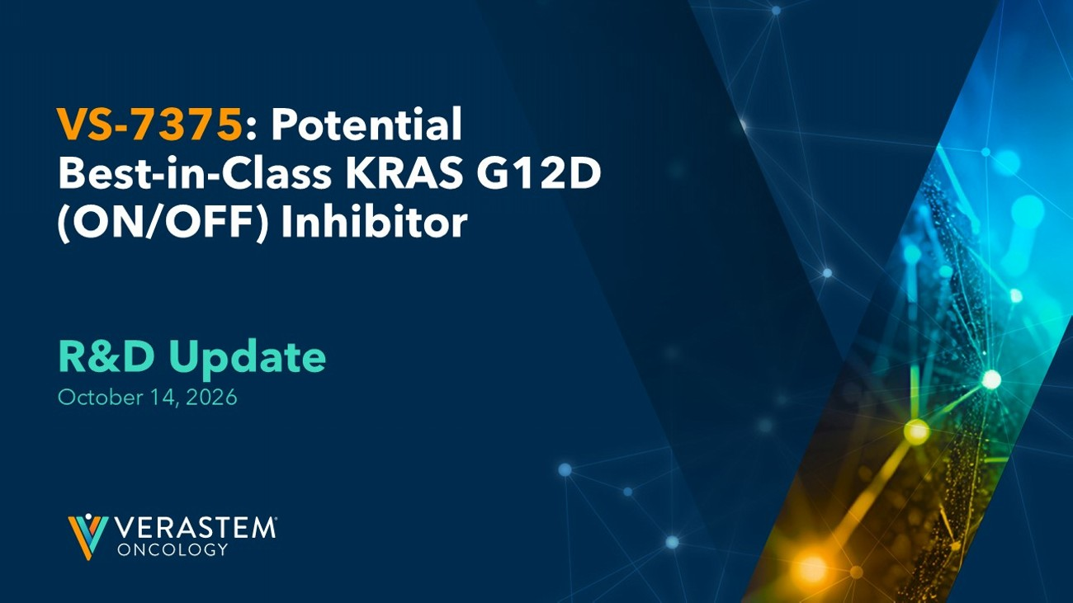
VS - 7375 : Potential Best - in - Class KRAS G12D (ON/OFF) Inhibitor R&D Update October 14, 2026

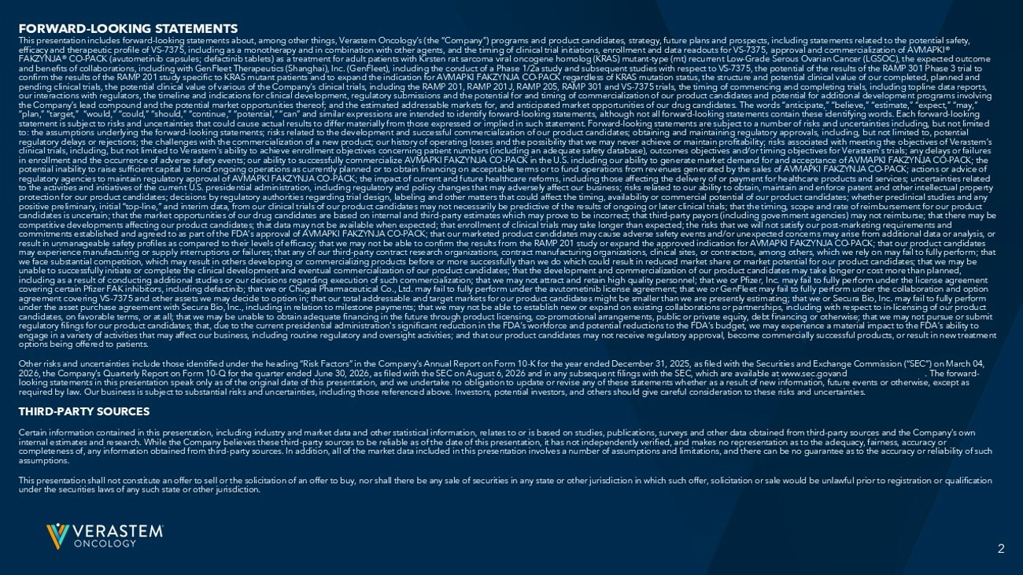
2 2 FORWARD - LOOKING STATEMENTS This presentation includes forward - looking statements about, among other things, Verastem Oncology’s (the “Company”) programs an d product candidates, strategy, future plans and prospects, including statements related to the potential safety, efficacy and therapeutic profile of VS - 7375, including as a monotherapy and in combination with other agents, and the timing of clinical trial initiations, enrollment and data readouts for VS - 7375, approval and commercialization of AVMAPKI® FAKZYNJA® CO - PACK (avutometinib capsules; defactinib tablets) as a treatment for adult patients with Kirsten rat sarcoma viral o ncogene homolog (KRAS) mutant - type (mt) recurrent Low - Grade Serous Ovarian Cancer (LGSOC), the expected outcome and benefits of collaborations, including with GenFleet Therapeutics (Shanghai), Inc. (GenFleet), including the conduct of a Pha se 1/2a study and subsequent studies with respect to VS - 7375, the potential of the results of the RAMP 301 Phase 3 trial to confirm the results of the RAMP 201 study specific to KRAS mutant patients and to expand the indication for AVMAPKI FAKZYNJA CO - PACK regardless of KRAS mutation status, the structure and potential clinical value of our completed, planned and pending clinical trials, the potential clinical value of various of the Company’s clinical trials, including the RAMP 201, RA MP 201J, RAMP 205, RAMP 301 and VS - 7375 trials, the timing of commencing and completing trials, including topline data reports, our interactions with regulators, the timeline and indications for clinical development, regulatory submissions and the poten tia l for and timing of commercialization of our product candidates and potential for additional development programs involving the Company’s lead compound and the potential market opportunities thereof; and the estimated addressable markets for, and an tic ipated market opportunities of our drug candidates. The words “anticipate,” “believe,” “estimate,” “expect,” “may,” “plan,” “target,” “would,” “could,” “should,” “continue,” “potential,” “can” and similar expressions are intended to identif y f orward - looking statements, although not all forward - looking statements contain these identifying words. Each forward - looking statement is subject to risks and uncertainties that could cause actual results to differ materially from those expressed or imp lied in such statement. Forward - looking statements are subject to a number of risks and uncertainties including, but not limited to: the assumptions underlying the forward - looking statements; risks related to the development and successful commercialization of our product candidates; obtaining and maintaining regulatory approvals, including, but not limited to, potential regulatory delays or rejections; the challenges with the commercialization of a new product; our history of operating losses and the possibility that we may never achieve or maintain profitability; risks associated with meeting the objectives of Verastem ’s clinical trials, including, but not limited to Verastem’s ability to achieve enrollment objectives concerning patient numbers (i ncluding an adequate safety database), outcomes objectives and/or timing objectives for Verastem’s trials; any delays or fail ure s in enrollment and the occurrence of adverse safety events; our ability to successfully commercialize AVMAPKI FAKZYNJA CO - PACK in the U.S. including our ability to generate market demand for and acceptance of AVMAPKI FAKZYNJA CO - PACK; the potential inability to raise sufficient capital to fund ongoing operations as currently planned or to obtain financing on acc ept able terms or to fund operations from revenues generated by the sales of AVMAPKI FAKZYNJA CO - PACK; actions or advice of regulatory agencies to maintain regulatory approval of AVMAPKI FAKZYNJA CO - PACK; the impact of current and future healthcare ref orms, including those affecting the delivery of or payment for healthcare products and services; uncertainties related to the activities and initiatives of the current U.S. presidential administration, including regulatory and policy changes th at may adversely affect our business; risks related to our ability to obtain, maintain and enforce patent and other intellectual pr operty protection for our product candidates; decisions by regulatory authorities regarding trial design, labeling and other matters th at could affect the timing, availability or commercial potential of our product candidates; whether preclinical studies and a ny positive preliminary, initial “top - line,” and interim data, from our clinical trials of our product candidates may not necessari ly be predictive of the results of ongoing or later clinical trials; that the timing, scope and rate of reimbursement for our pr oduct candidates is uncertain; that the market opportunities of our drug candidates are based on internal and third - party estimates wh ich may prove to be incorrect; that third - party payors (including government agencies) may not reimburse; that there may be competitive developments affecting our product candidates; that data may not be available when expected; that enrollment of c lin ical trials may take longer than expected; the risks that we will not satisfy our post - marketing requirements and commitments established and agreed to as part of the FDA’s approval of AVMAPKI FAKZYNJA CO - PACK; that our marketed product candi dates may cause adverse safety events and/or unexpected concerns may arise from additional data or analysis, or result in unmanageable safety profiles as compared to their levels of efficacy; that we may not be able to confirm the result s f rom the RAMP 201 study or expand the approved indication for AVMAPKI FAKZYNJA CO - PACK; that our product candidates may experience manufacturing or supply interruptions or failures; that any of our third - party contract research organizations, c ontract manufacturing organizations, clinical sites, or contractors, among others, which we rely on may fail to fully perform ; t hat we face substantial competition, which may result in others developing or commercializing products before or more successfull y t han we do which could result in reduced market share or market potential for our product candidates; that we may be unable to successfully initiate or complete the clinical development and eventual commercialization of our product candidates ; t hat the development and commercialization of our product candidates may take longer or cost more than planned, including as a result of conducting additional studies or our decisions regarding execution of such commercialization; that w e m ay not attract and retain high quality personnel; that we or Pfizer, Inc. may fail to fully perform under the license agreeme nt covering certain Pfizer FAK inhibitors, including defactinib; that we or Chugai Pharmaceutical Co., Ltd. may fail to fully pe rfo rm under the avutometinib license agreement; that we or GenFleet may fail to fully perform under the collaboration and option agreement covering VS - 7375 and other assets we may decide to option in; that our total addressable and target markets for our pr oduct candidates might be smaller than we are presently estimating; that we or Secura Bio, Inc. may fail to fully perform under the asset purchase agreement with Secura Bio, Inc., including in relation to milestone payments; that we may not be abl e t o establish new or expand on existing collaborations or partnerships, including with respect to in - licensing of our product candidates, on favorable terms, or at all; that we may be unable to obtain adequate financing in the future through product l ice nsing, co - promotional arrangements, public or private equity, debt financing or otherwise; that we may not pursue or submit regulatory filings for our product candidates; that, due to the current presidential administration’s significant reduction i n t he FDA’s workforce and potential reductions to the FDA’s budget, we may experience a material impact to the FDA’s ability to engage in a variety of activities that may affect our business, including routine regulatory and oversight activities; and th at our product candidates may not receive regulatory approval, become commercially successful products, or result in new treatme nt options being offered to patients. Other risks and uncertainties include those identified under the heading “Risk Factors” in the Company’s Annual Report on For m 1 0 - K for the year ended December 31, 2025, as filed with the Securities and Exchange Commission (“SEC”) on March 04, 2026, the Company’s Quarterly Report on Form 10 - Q for the quarter ended June 30, 2026, as filed with the SEC on August 6, 2026 a nd in any subsequent filings with the SEC, which are available at www.sec.govand www.verastem.com . The forward - looking statements in this presentation speak only as of the original date of this presentation, and we undertake no obligati on to update or revise any of these statements whether as a result of new information, future events or otherwise, except as required by law. Our business is subject to substantial risks and uncertainties, including those referenced above. Investors, po tential investors, and others should give careful consideration to these risks and uncertainties. THIRD - PARTY SOURCES Certain information contained in this presentation, including industry and market data and other statistical information, rel ate s to or is based on studies, publications, surveys and other data obtained from third - party sources and the Company’s own internal estimates and research. While the Company believes these third - party sources to be reliable as of the date of this pres entation, it has not independently verified, and makes no representation as to the adequacy, fairness, accuracy or completeness of, any information obtained from third - party sources. In addition, all of the market data included in this present ation involves a number of assumptions and limitations, and there can be no guarantee as to the accuracy or reliability of su ch assumptions. This presentation shall not constitute an offer to sell or the solicitation of an offer to buy, nor shall there be any sale o f s ecurities in any state or other jurisdiction in which such offer, solicitation or sale would be unlawful prior to registratio n o r qualification under the securities laws of any such state or other jurisdiction.

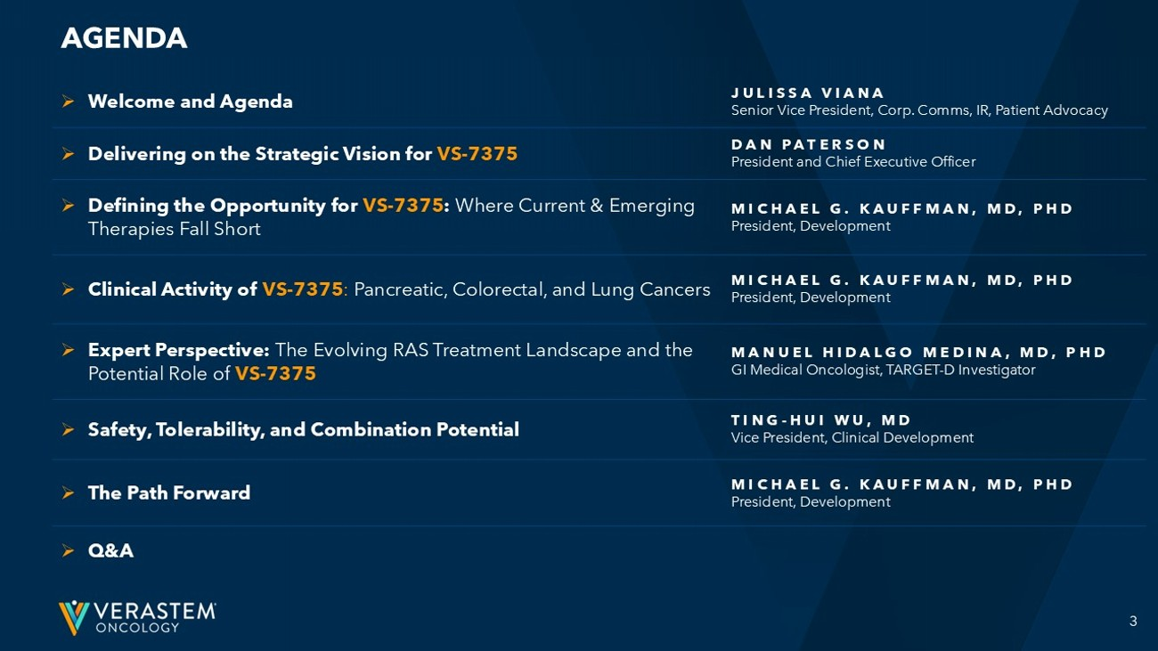
3 JULISSA VIANA Senior Vice President, Corp. Comms, IR, Patient Advocacy » Welcome and Agenda DAN PATERSON President and Chief Executive Officer » Delivering on the Strategic Vision for VS - 7375 MICHAEL G. KAUFFMAN, MD, PHD President, Development » Defining the Opportunity for VS - 7375 : Where Current & Emerging Therapies Fall Short MICHAEL G. KAUFFMAN, MD, PHD President, Development » Clinical Activity of VS - 7375 : Pancreatic, Colorectal, and Lung Cancers MANUEL HIDALGO MEDINA, MD, PHD GI Medical Oncologist, TARGET - D Investigator » Expert Perspective: The Evolving RAS Treatment Landscape and the Potential Role of VS - 7375 TING - HUI WU, MD Vice President, Clinical Development » Safety, Tolerability, and Combination Potential MICHAEL G. KAUFFMAN, MD, PHD President, Development » The Path Forward » Q&A AGENDA


Delivering on the Strategic Vision for VS - 7375 Dan Paterson President & CEO

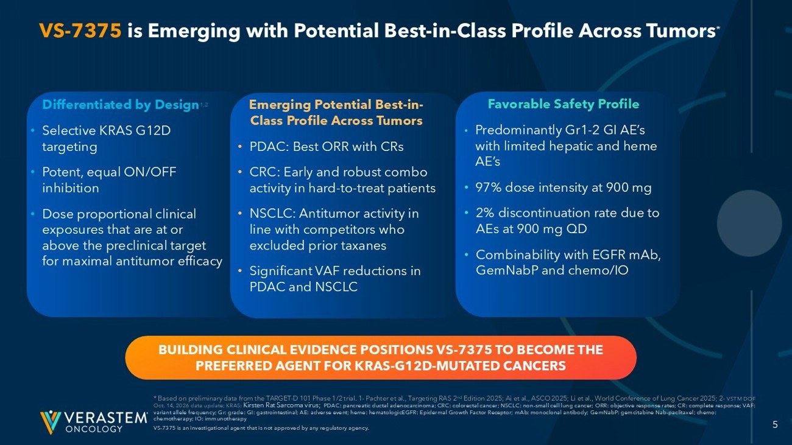
5 Differentiated by Design 1,2 • Selective KRAS G12D targeting • Potent, equal ON/OFF inhibition • ﻿﻿ Dose proportional clinical exposures that are at or above the preclinical target for maximal antitumor efficacy Emerging Potential Best - in - Class Profile Across Tumors • PDAC: Best ORR with CRs • CRC: Early and robust combo activity in hard - to - treat patients • NSCLC: Antitumor activity in line with competitors who excluded prior taxanes • Significant VAF reductions in PDAC and NSCLC Favorable Safety Profile • ﻿﻿ Predominantly Gr1 - 2 GI AE’s with limited hepatic and heme AE’s • 97% dose intensity at 900 mg • 2% discontinuation rate due to AEs at 900 mg QD • Combinability with EGFR mAb , GemNabP and chemo/IO VS - 7375 is Emerging with Potential Best - in - Class Profile Across Tumors * * Based on preliminary data from the TARGET - D 101 Phase 1/2 trial. 1 - Pachter et al., Targeting RAS 2 nd Edition 2025; Ai et al., ASCO 2025; Li et al., World Conference of Lung Cancer 2025; 2 - VSTM DOF Oct. 14, 2026 data update; KRAS: Kirsten Rat Sarcoma virus; PDAC: pancreatic ductal adenocarcinoma; CRC: colorectal cancer; NSCLC: non - small cell lung cancer; ORR: objective response rate s; CR: complete response; VAF: variant allele frequency; Gr: grade: GI: gastrointestinal; AE: adverse event; heme: hematologicEGFR: Epidermal Growth Factor Rec eptor; mAb : monoclonal antibody; GemNabP : gemcitabine Nab - paclitaxel; chemo: chemotherapy; IO: immunotherapy VS - 7375 is an investigational agent that is not approved by any regulatory agency. BUILDING CLINICAL EVIDENCE POSITIONS VS - 7375 TO BECOME THE PREFERRED AGENT FOR KRAS - G12D - MUTATED CANCERS

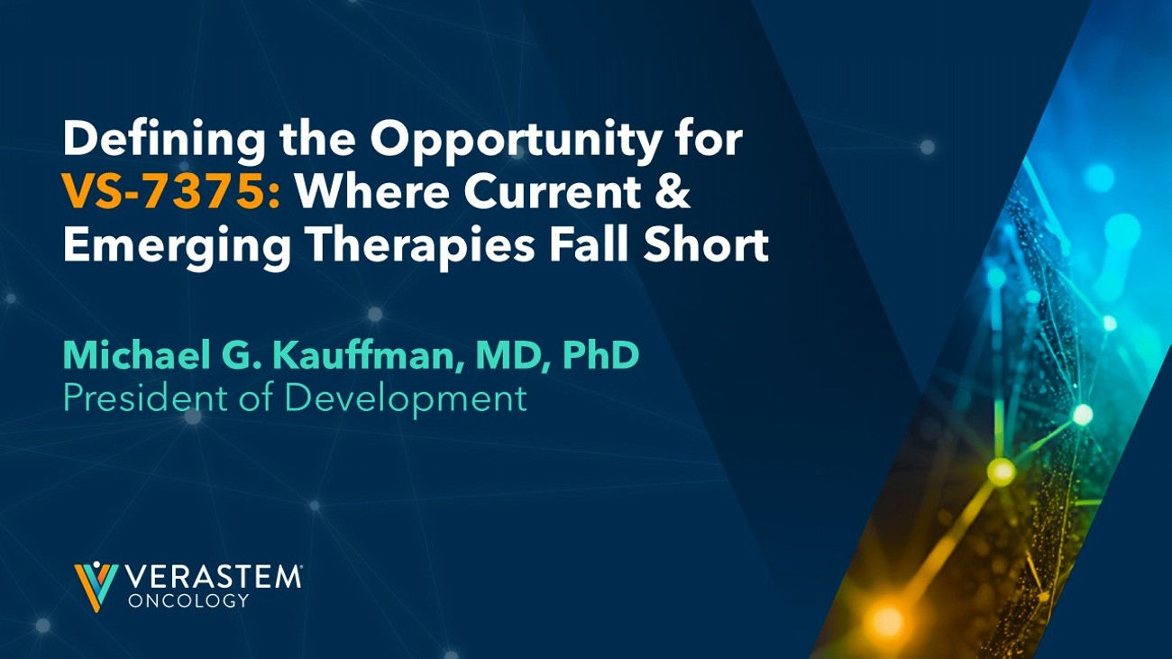
Defining the Opportunity for VS - 7375: Where Current & Emerging Therapies Fall Short Michael G. Kauffman, MD, PhD President of Development

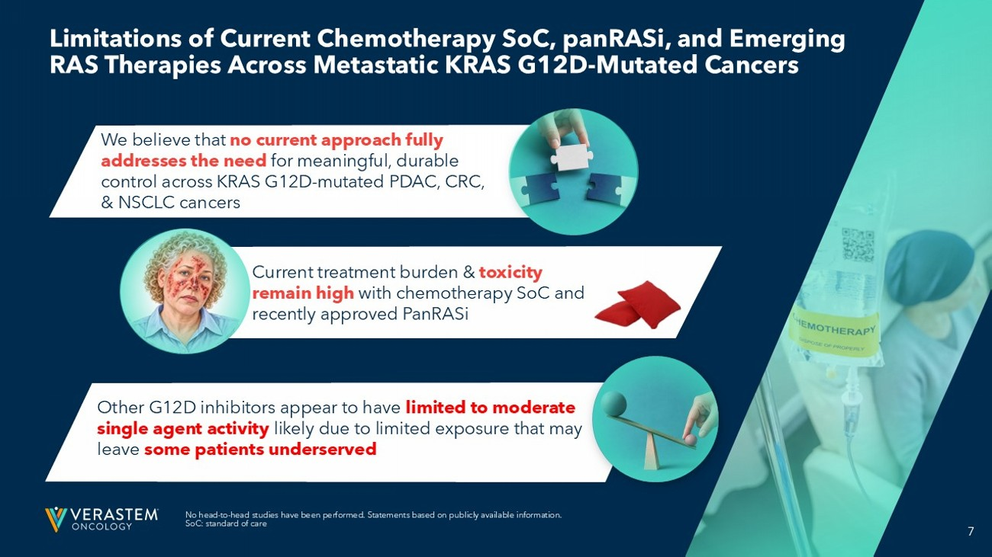
7 Limitations of Current Chemotherapy SoC, panRASi, and Emerging RAS Therapies Across Metastatic KRAS G12D - Mutated Cancers No head - to - head studies have been performed. Statements based on publicly available information. SoC: standard of care Other G12D inhibitors appear to have limited to moderate single agent activity likely due to limited exposure that may leave some patients underserved Current treatment burden & toxicity remain high with chemotherapy SoC and recently approved PanRASi We believe that no current approach fully addresses the need for meaningful, durable control across KRAS G12D - mutated PDAC, CRC, & NSCLC cancers

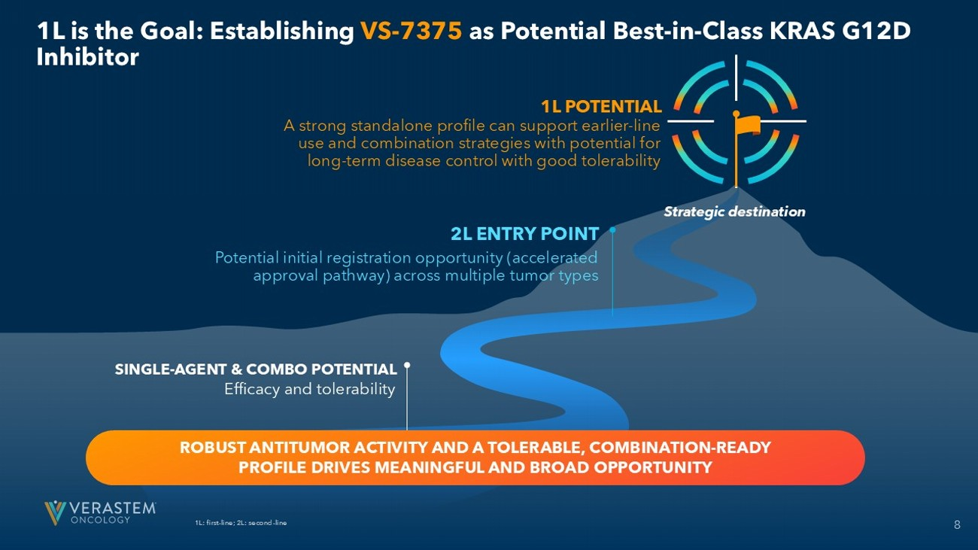
8 1L is the Goal: Establishing VS - 7375 as Potential Best - in - Class KRAS G12D Inhibitor 1L: first - line; 2L: second - line 1L POTENTIAL A strong standalone profile can support earlier - line use and combination strategies with potential for long - term disease control with good tolerability 2L ENTRY POINT Potential initial registration opportunity (accelerated approval pathway) across multiple tumor types Strategic destination SINGLE - AGENT & COMBO POTENTIAL ROBUST ANTITUMOR ACTIVITY AND A TOLERABLE, COMBINATION - READY PROFILE DRIVES MEANINGFUL AND BROAD OPPORTUNITY Efficacy and tolerability

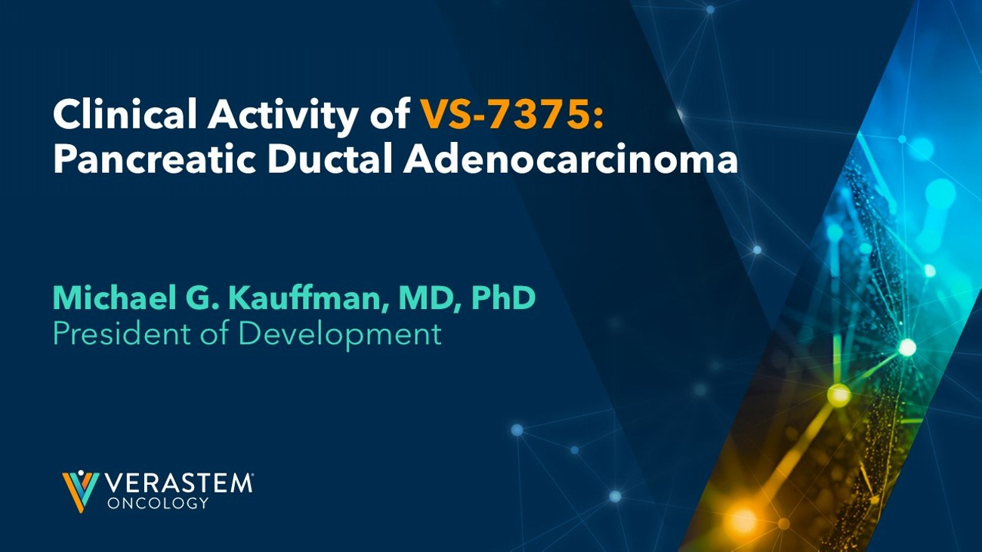
Michael G. Kauffman, MD, PhD President of Development Clinical Activity of VS - 7375: Pancreatic Ductal Adenocarcinoma

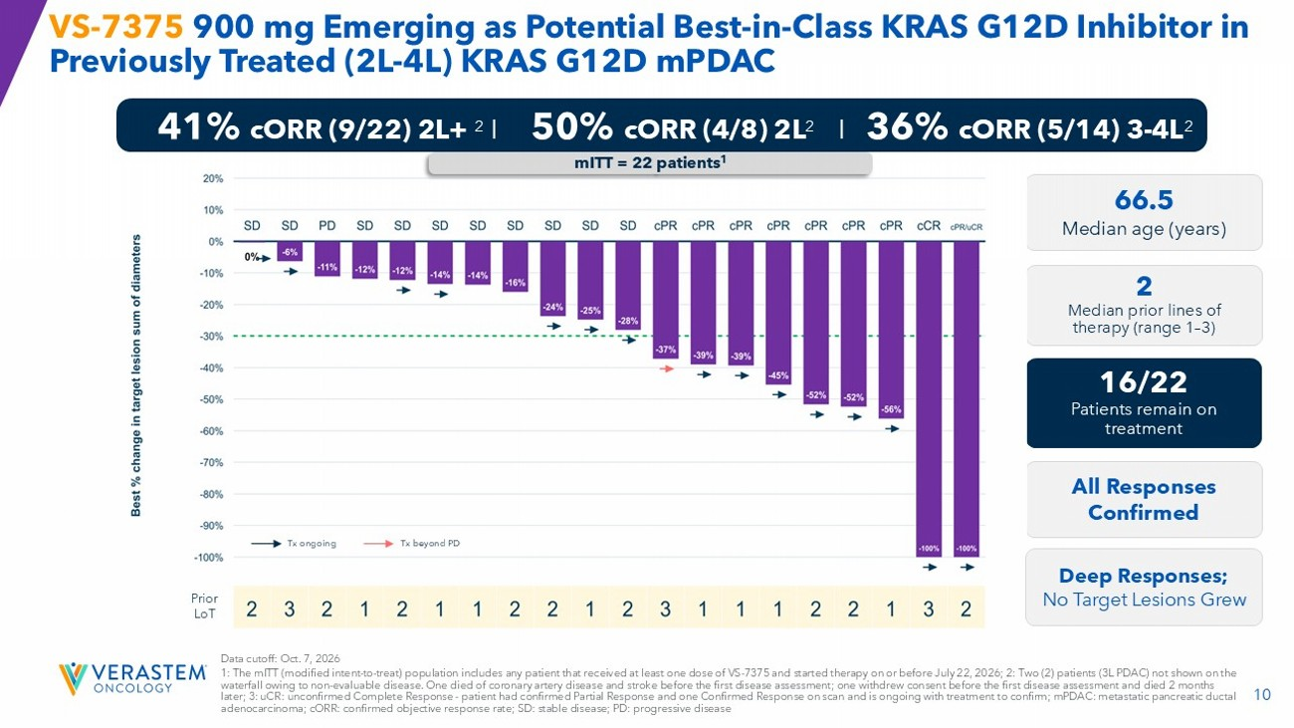
10 VS - 7375 900 mg Emerging as Potential Best - in - Class KRAS G12D Inhibitor in Previously Treated (2L - 4L) KRAS G12D mPDAC Data cutoff: Oct. 7, 2026 1: The mITT (modified intent - to - treat) population includes any patient that received at least one dose of VS - 7375 and started therapy on or before July 22, 2026; 2: Two (2) patients (3L PDAC) not shown on the waterfall owing to non - evaluable disease. One died of coronary artery disease and stroke before the first disease assessment; on e withdrew consent before the first disease assessment and died 2 months later; 3: uCR : unconfirmed Complete Response - patient had confirmed Partial Response and one Confirmed Response on scan and is ongoing with treatment to confirm; mPDAC: metastatic pancreatic ductal adenocarcinoma; cORR : confirmed objective response rate; SD: stable disease; PD: progressive disease 66.5 Median age (years) 2 Median prior lines of therapy (range 1 – 3) 16/22 Patients remain on treatment All Responses Confirmed 41% cORR (9/22) 2L+ 2 I 50% cORR (4/8) 2L 2 I 36% cORR (5/14) 3 - 4L 2 Prior LoT mITT = 22 patients 1 Deep Responses; No Target Lesions Grew Tx ongoing Tx beyond PD

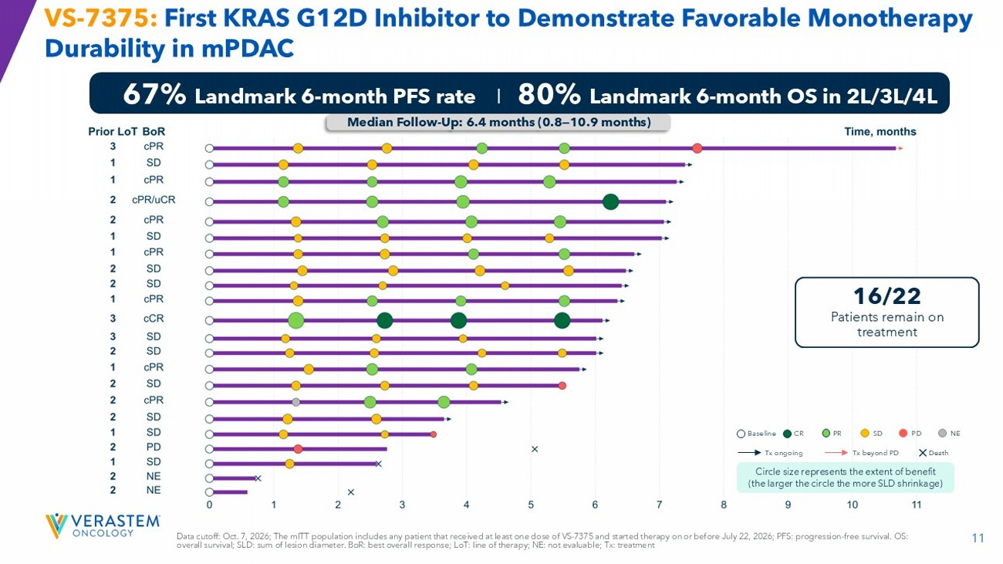
11 VS - 7375: First KRAS G12D Inhibitor to Demonstrate Favorable Monotherapy Durability in mPDAC 67% Landmark 6 - month PFS rate I 80% Landmark 6 - month OS in 2L/3L/4L Data cutoff: Oct. 7, 2026; The mITT population includes any patient that received at least one dose of VS - 7375 and started therapy on or before July 22, 2026; PFS: progression - free survival. OS: overall survival; SLD: sum of lesion diameter. BoR : best overall response; LoT : line of therapy; NE: not evaluable; Tx: treatment Median Follow - Up: 6.4 months (0.8 — 10.9 months) 16/22 Patients remain on treatment Baseline CR PR SD PD NE Tx ongoing Tx beyond PD Death Circle size represents the extent of benefit (the larger the circle the more SLD shrinkage)

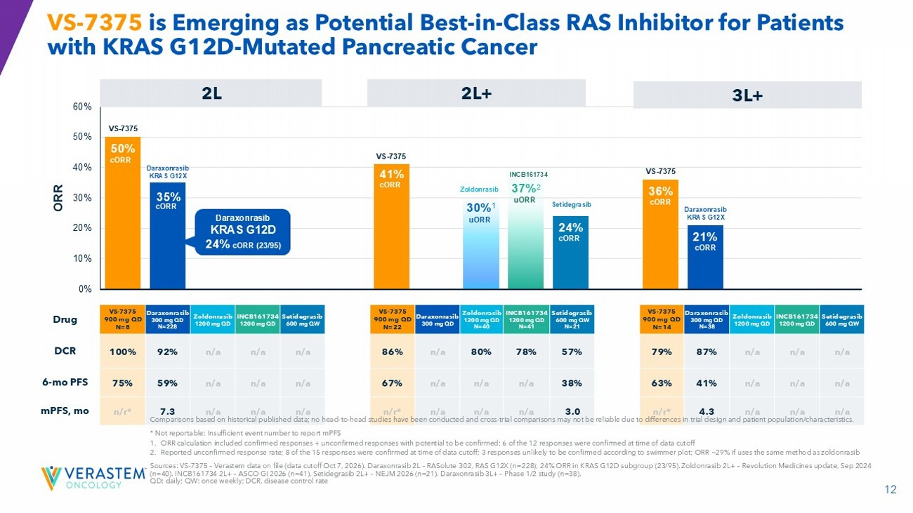
12 VS - 7375 is Emerging as Potential Best - in - Class RAS Inhibitor for Patients with KRAS G12D - Mutated Pancreatic Cancer 50% 35% 41% 30% 1 37% 2 24% 36% 21% 0% 10% 20% 30% 40% 50% 60% ORR 2L 2L+ 3L+ Setidegrasib INCB161734 Zoldonrasib Daraxonrasib VS - 7375 900 mg QD N=14 Setidegrasib INCB161734 Zoldonrasib Daraxonrasib VS - 7375 900 mg QD N=22 Setidegrasib INCB161734 Zoldonrasib Daraxonrasib VS - 7375 900 mg QD N=8 Drug n/a n/a n/a 87% 79 % 57% 78% 80% n/a 86 % n/a n/a n/a 92% 100 % DCR n/a n/a n/a 41% 63% 38% n/a n/a n/a 67% n/a n/a n/a 59% 75% 6 - mo PFS n/a n/a n/a 4.3 n/r* 3.0 n/a n/a n/a n/r* n/a n/a n/a 7.3 n/r* mPFS, mo VS - 7375 VS - 7375 VS - 7375 Daraxonrasib KRAS G12X Daraxonrasib KRAS G12X Zoldonrasib INCB161734 Setidegrasib uORR uORR cORR cORR cORR cORR cORR cORR Comparisons based on historical published data; no head - to - head studies have been conducted and cross - trial comparisons may not be reliable due to differences in trial design and patient population/characteristics. * Not reportable: Insufficient event number to report mPFS 1. ORR calculation included confirmed responses + unconfirmed responses with potential to be confirmed; 6 of the 12 responses we re confirmed at time of data cutoff 2. Reported unconfirmed response rate; 8 of the 15 responses were confirmed at time of data cutoff; 3 responses unlikely to be c onf irmed according to swimmer plot; ORR ~29% if uses the same method as zoldonrasib Sources: VS - 7375 – Verastem data on file (data cutoff Oct 2, 2026). Daraxonrasib 2L – RASolute 302, RAS G12X (n=228); 24% ORR in KRAS G12D subgroup (23/95). Zoldonrasib 2L+ – Revolution Medicines update, Sep 2024 (n=40). INCB161734 2L+ – ASCO GI 2026 (n=41). Setidegrasib 2L+ – NEJM 2026 (n=21). Daraxonrasib 3L+ – Phase 1/2 study (n=38). QD: daily; QW: once weekly; DCR, disease control rate Daraxonrasib KRAS G12D 24% cORR (23/95)

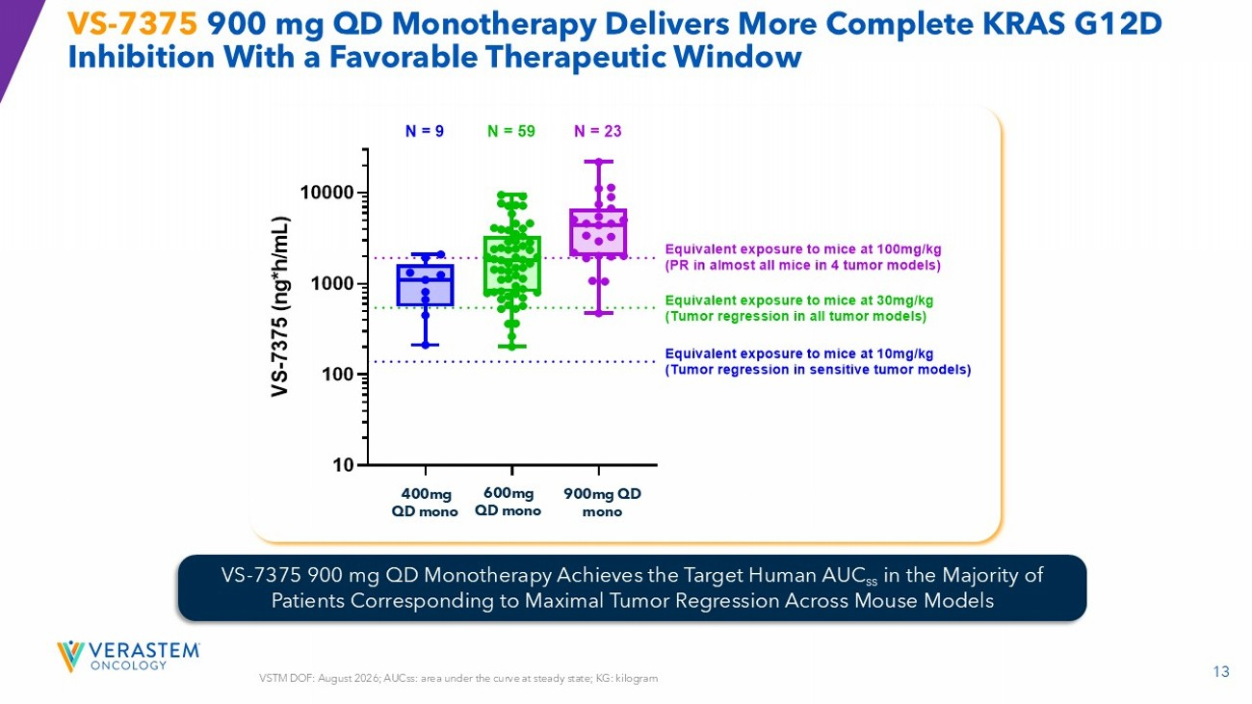
13 VSTM DOF: August 2026; AUCss : area under the curve at steady state; KG: kilogram VS - 7375 900 mg QD Monotherapy Delivers More Complete KRAS G12D Inhibition With a Favorable Therapeutic Window VS - 7375 900 mg QD Monotherapy Achieves the Target Human AUC ss in the Majority of Patients Corresponding to Maximal Tumor Regression Across Mouse Models 4 0 0 m g M o n o 6 0 0 m g M o n o 9 0 0 m g M o n o 10 100 1000 10000 V S - 7 3 7 5 ( n g * h / m L ) Equivalent exposure to mice at 100mg/kg (PR in almost all mice in 4 tumor models) Equivalent exposure to mice at 30mg/kg (Tumor regression in all tumor models) Equivalent exposure to mice at 10mg/kg (Tumor regression in sensitive tumor models) N = 9 N = 59 N = 23 400mg QD mono 600mg QD mono 900mg QD mono

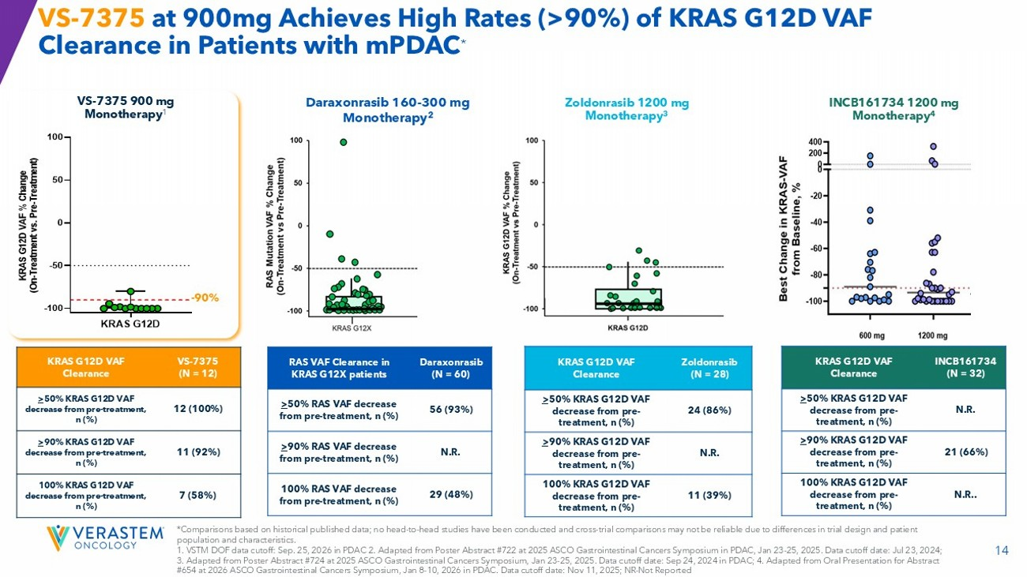
14 KRAS G12D -100 -50 0 50 100 K R A S G 1 2 D V A F % C h a n g e ( O n - T r e a t m e n t v s . P r e - T r e a t m e n t ) Zoldonrasib (N = 28) KRAS G12D VAF Clearance 24 (86%) > 50% KRAS G12D VAF decrease from pre - treatment, n (%) N.R. > 90% KRAS G12D VAF decrease from pre - treatment, n (%) 11 (39%) 100% KRAS G12D VAF decrease from pre - treatment, n (%) VS - 7375 at 900mg Achieves High Rates (>90%) of KRAS G12D VAF Clearance in Patients with mPDAC * VS - 7375 (N = 12) KRAS G12D VAF Clearance 12 (100%) > 50% KRAS G12D VAF decrease from pre - treatment, n (%) 11 (92%) > 90% KRAS G12D VAF decrease from pre - treatment, n (%) 7 (58%) 100% KRAS G12D VAF decrease from pre - treatment, n (%) VS - 7375 900 mg Monotherapy 1 Daraxonrasib 160 - 300 mg Monotherapy 2 INCB161734 1200 mg Monotherapy 4 Daraxonrasib (N = 60) RAS VAF Clearance in KRAS G12X patients 56 (93%) > 50% RAS VAF decrease from pre - treatment, n (%) N.R. > 90% RAS VAF decrease from pre - treatment, n (%) 29 (48%) 100% RAS VAF decrease from pre - treatment, n (%) INCB161734 (N = 32) KRAS G12D VAF Clearance N.R. > 50% KRAS G12D VAF decrease from pre - treatment, n (%) 21 (66%) > 90% KRAS G12D VAF decrease from pre - treatment, n (%) N.R.. 100% KRAS G12D VAF decrease from pre - treatment, n (%) Zoldonrasib 1200 mg Monotherapy 3 - 90% *Comparisons based on historical published data; no head - to - head studies have been conducted and cross - trial comparisons may not be reliable due to differences in trial design and patient population and characteristics. 1. VSTM DOF data cutoff: Sep. 25, 2026 in PDAC 2. Adapted from Poster Abstract #722 at 2025 ASCO Gastrointestinal Cancers Sym pos ium in PDAC, Jan 23 - 25, 2025. Data cutoff date: Jul 23, 2024; 3. Adapted from Poster Abstract #724 at 2025 ASCO Gastrointestinal Cancers Symposium, Jan 23 - 25, 2025. Data cutoff date: Sep 24, 2024 in PDAC; 4. Adapted from Oral Presentation for Abstract #654 at 2026 ASCO Gastrointestinal Cancers Symposium, Jan 8 - 10, 2026 in PDAC. Data cutoff date: Nov 11, 2025; NR - Not Reported

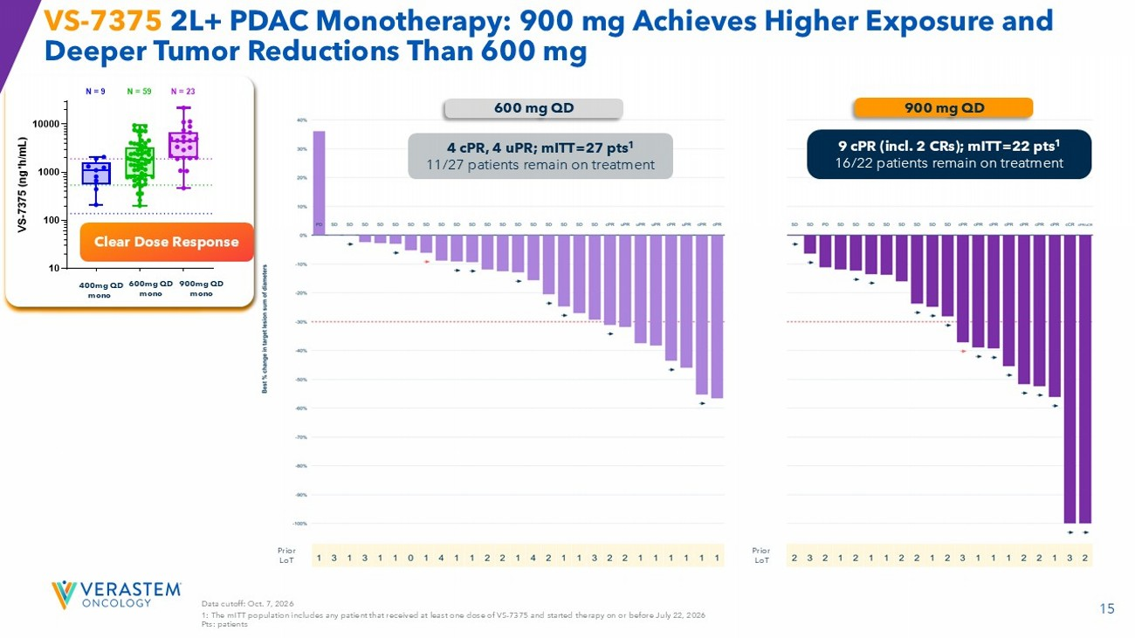
15 Prior LoT Prior LoT Data cutoff: Oct. 7, 2026 1: The mITT population includes any patient that received at least one dose of VS - 7375 and started therapy on or before July 22, 2026 Pts: patients VS - 7375 2L+ PDAC Monotherapy: 900 mg Achieves Higher Exposure and Deeper Tumor Reductions Than 600 mg Clear Dose Response 600 mg QD 900 mg QD 9 cPR (incl. 2 CRs); mITT =22 pts 1 16/22 patients remain on treatment 4 cPR , 4 uPR ; mITT =27 pts 1 11/27 patients remain on treatment 4 0 0 m g M o n o 6 0 0 m g M o n o 9 0 0 m g M o n o 10 100 1000 10000 V S - 7 3 7 5 ( n g * h / m L ) Equivalent exposure to mice at 100mg/kg (PR in almost all mice in 4 tumor models) Equivalent exposure to mice at 30mg/kg (Tumor regression in all tumor models) Equivalent exposure to mice at 10mg/kg (Tumor regression in sensitive tumor models) N = 9 N = 59 N = 23 400mg QD mono 600mg QD mono 900mg QD mono

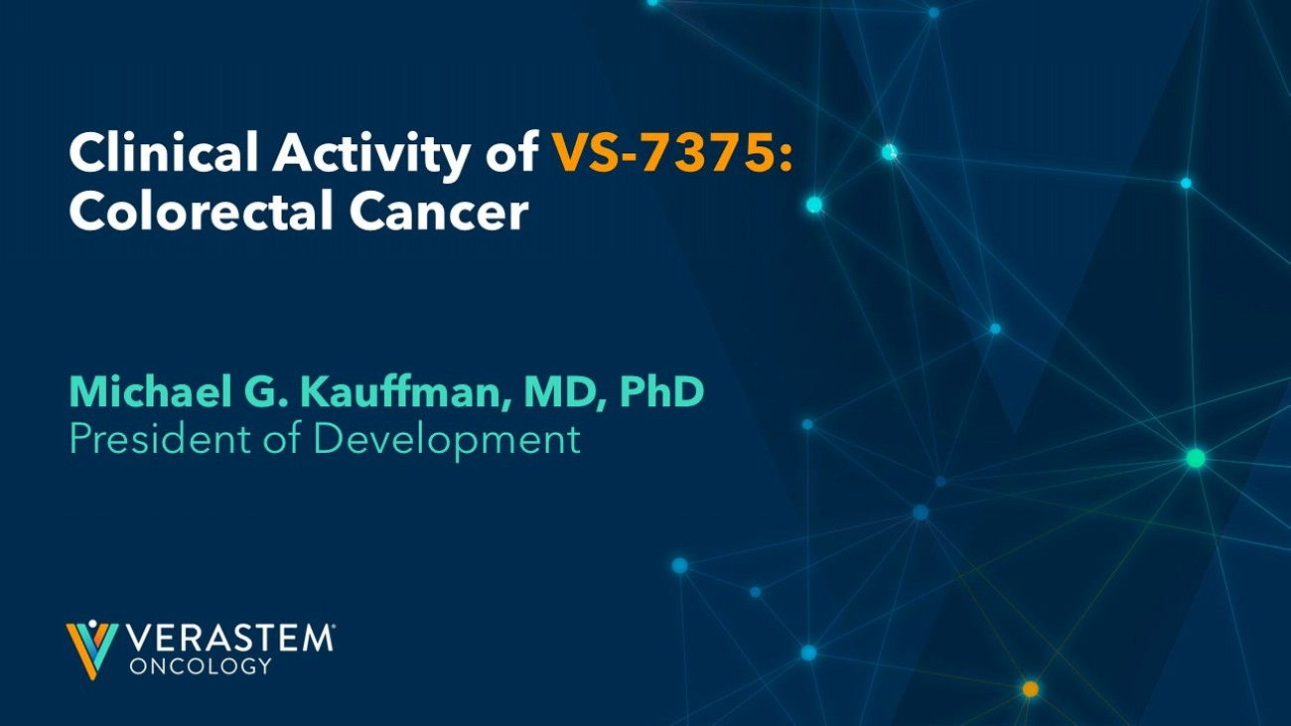
Clinical Activity of VS - 7375: Colorectal Cancer Michael G. Kauffman, MD, PhD President of Development

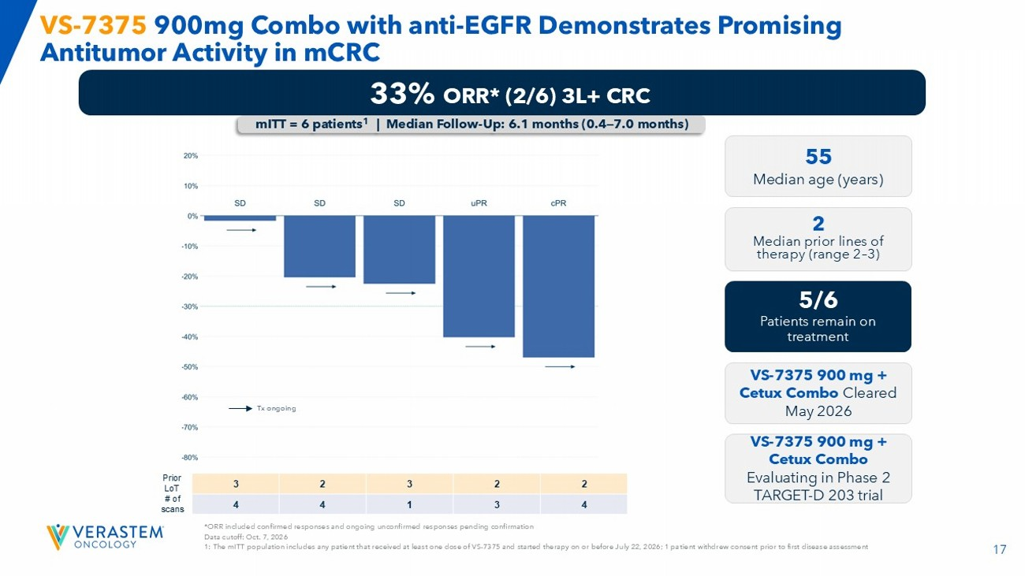
17 *ORR included confirmed responses and ongoing unconfirmed responses pending confirmation Data cutoff: Oct. 7, 2026 1: The mITT population includes any patient that received at least one dose of VS - 7375 and started therapy on or before July 22, 2026; 1 pa tient withdrew consent prior to first disease assessment VS - 7375 900mg Combo with anti - EGFR Demonstrates Promising Antitumor Activity in mCRC 2 2 3 2 3 Prior LoT 4 3 1 4 4 # of scans 33% ORR* (2/6) 3L+ CRC 55 Median age (years) 2 Median prior lines of therapy (range 2 – 3) 5/6 Patients remain on treatment VS - 7375 900 mg + Cetux Combo Cleared May 2026 VS - 7375 900 mg + Cetux Combo Evaluating in Phase 2 TARGET - D 203 trial mITT = 6 patients 1 | Median Follow - Up: 6.1 months (0.4 — 7.0 months) Tx ongoing

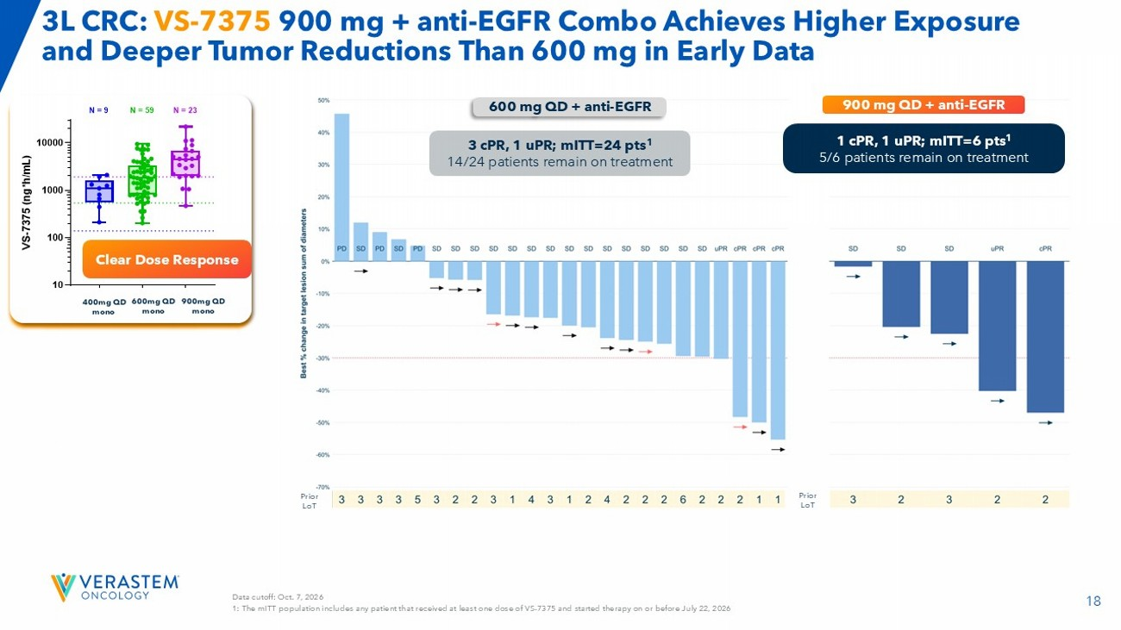
18 Data cutoff: Oct. 7, 2026 1: The mITT population includes any patient that received at least one dose of VS - 7375 and started therapy on or before July 22, 2026 3L CRC: VS - 7375 900 mg + anti - EGFR Combo Achieves Higher Exposure and Deeper Tumor Reductions Than 600 mg in Early Data 600 mg QD + anti - EGFR 900 mg QD + anti - EGFR 3 cPR , 1 uPR ; mITT =24 pts 1 14/24 patients remain on treatment Clear Dose Response 4 0 0 m g M o n o 6 0 0 m g M o n o 9 0 0 m g M o n o 10 100 1000 10000 V S - 7 3 7 5 ( n g * h / m L ) Equivalent exposure to mice at 100mg/kg (PR in almost all mice in 4 tumor models) Equivalent exposure to mice at 30mg/kg (Tumor regression in all tumor models) Equivalent exposure to mice at 10mg/kg (Tumor regression in sensitive tumor models) N = 9 N = 59 N = 23 400mg QD mono 600mg QD mono 900mg QD mono 1 cPR , 1 uPR ; mITT =6 pts 1 5/6 patients remain on treatment Prior LoT Prior LoT

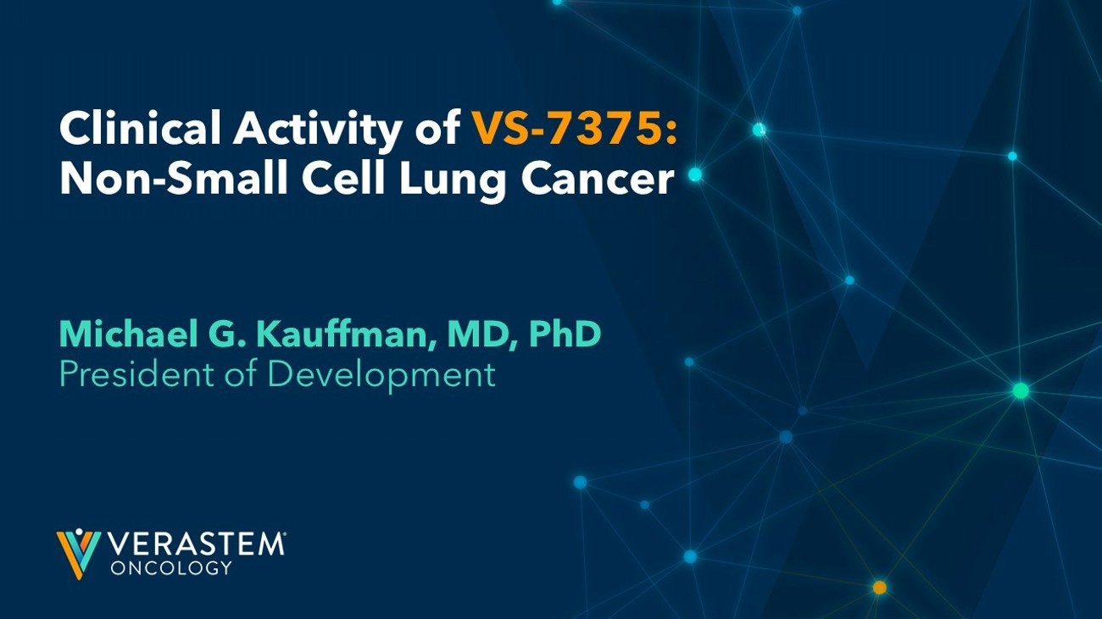
Clinical Activity of VS - 7375: Non - Small Cell Lung Cancer Michael G. Kauffman, MD, PhD President of Development

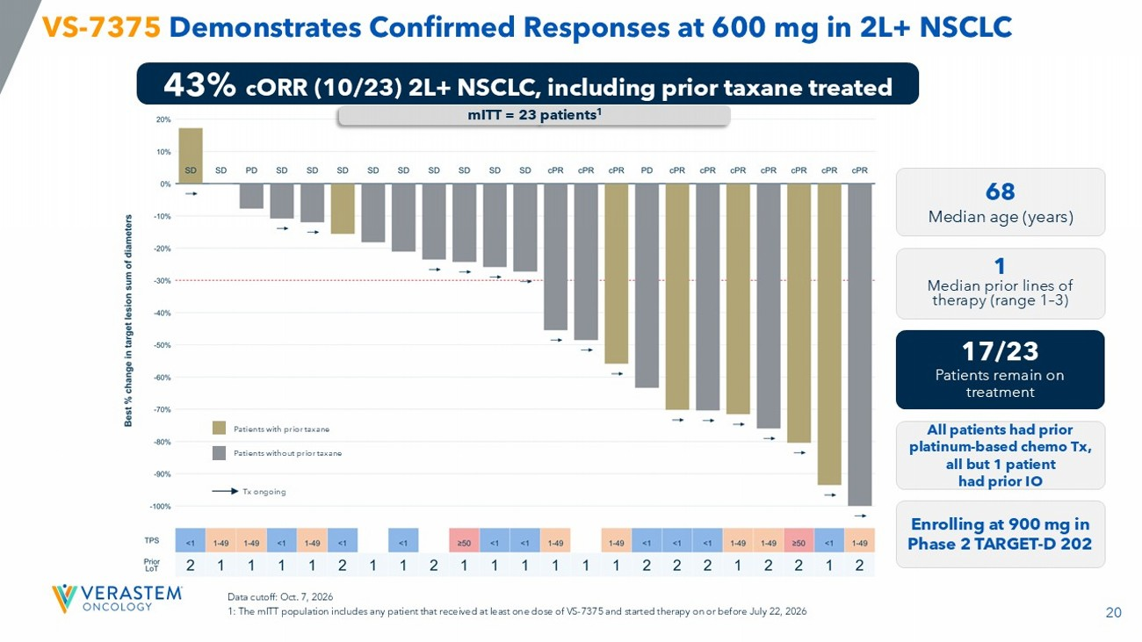
20 VS - 7375 Demonstrates Confirmed Responses at 600 mg in 2L+ NSCLC 43% c ORR (10/23) 2L+ NSCLC, including prior taxane treated 68 Median age (years) 1 Median prior lines of therapy (range 1 – 3) 17/23 Patients remain on treatment All patients had prior platinum - based chemo Tx, all but 1 patient had prior IO Enrolling at 900 mg in Phase 2 TARGET - D 202 mITT = 23 patients 1 Data cutoff: Oct. 7, 2026 1: The mITT population includes any patient that received at least one dose of VS - 7375 and started therapy on or before July 22, 2026 Tx ongoing Patients with prior taxane Patients without prior taxane

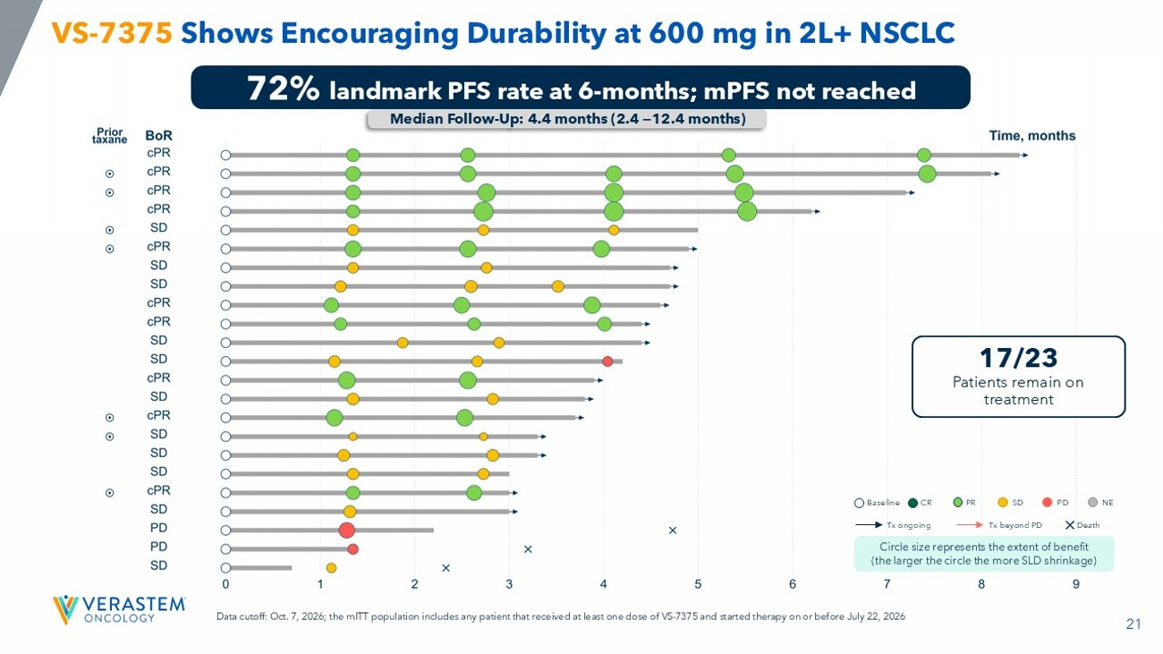
21 VS - 7375 Shows Encouraging Durability at 600 mg in 2L+ NSCLC 72% landmark PFS rate at 6 - months; mPFS not reached Median Follow - Up: 4.4 months (2.4 — 12.4 months) 17/23 Patients remain on treatment Baseline CR PR SD PD NE Tx ongoing Tx beyond PD Death Circle size represents the extent of benefit (the larger the circle the more SLD shrinkage) Data cutoff: Oct. 7, 2026; the mITT population includes any patient that received at least one dose of VS - 7375 and started therapy on or before July 22, 2026

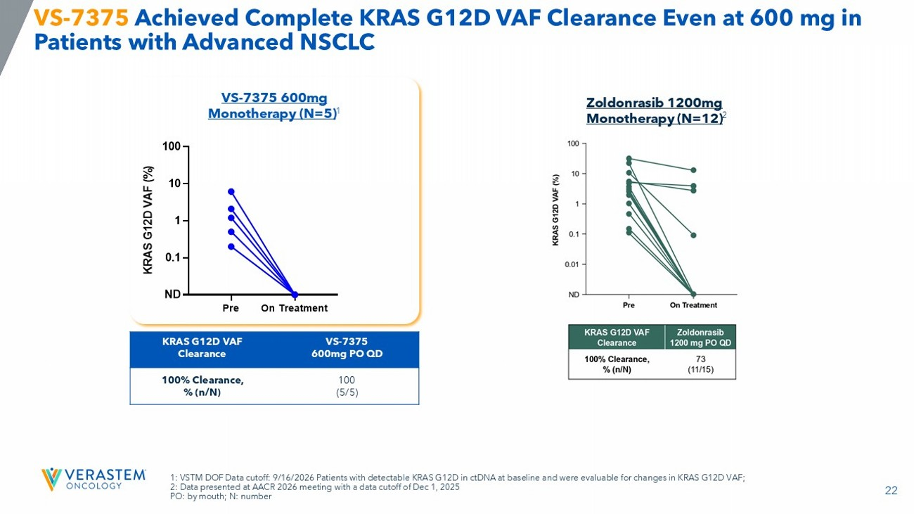
22 1: VSTM DOF Data cutoff: 9/16/2026 Patients with detectable KRAS G12D in ctDNA at baseline and were evaluable for changes in KRA S G12D VAF; 2: Data presented at AACR 2026 meeting with a data cutoff of Dec 1, 2025 PO: by mouth; N: number VS - 7375 Achieved Complete KRAS G12D VAF Clearance Even at 600 mg in Patients with Advanced NSCLC Pre On Treatment 0.1 1 10 100 K R A S G 1 2 D V A F ( % ) ND VS - 7375 600mg PO QD KRAS G12D VAF Clearance 100 (5/5) 100% Clearance, % (n/N) VS - 7375 600mg Monotherapy (N=5) 1 Zoldonrasib 1200mg Monotherapy (N=12) 2

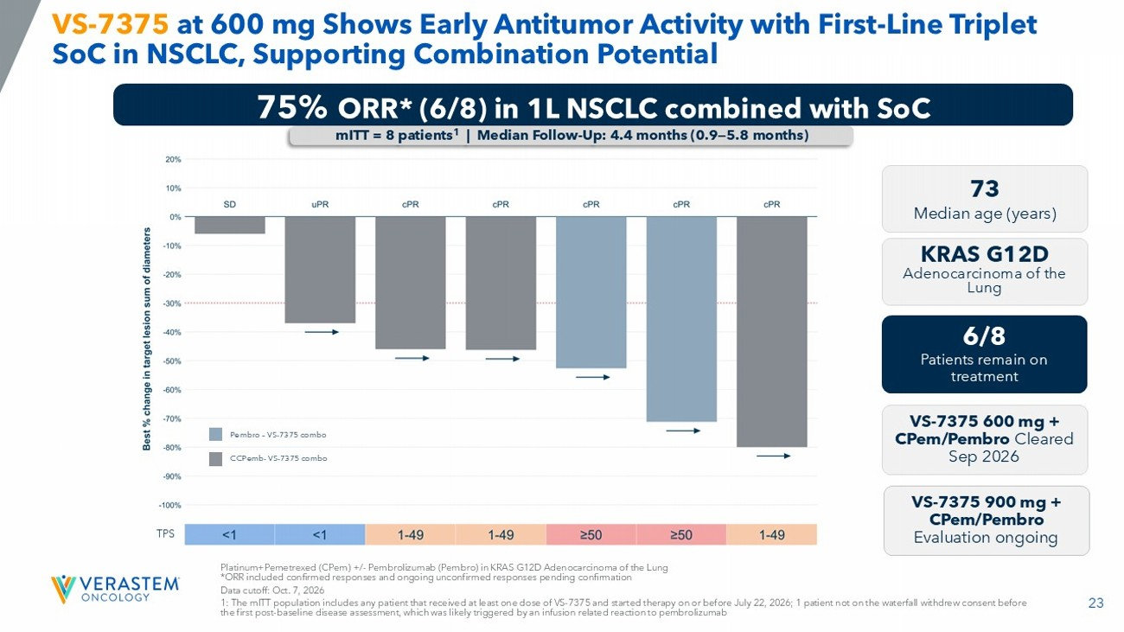
23 TPS VS - 7375 at 600 mg Shows Early Antitumor Activity with First - Line Triplet SoC in NSCLC, Supporting Combination Potential Platinum+Pemetrexed ( CPem ) +/ - Pembrolizumab ( Pembro ) in KRAS G12D Adenocarcinoma of the Lung *ORR included confirmed responses and ongoing unconfirmed responses pending confirmation Data cutoff: Oct. 7, 2026 1: The mITT population includes any patient that received at least one dose of VS - 7375 and started therapy on or before July 22, 2026; 1 pa tient not on the waterfall withdrew consent before the first post - baseline disease assessment, which was likely triggered by an infusion related reaction to pembrolizumab 75% ORR* (6/8) in 1L NSCLC combined with SoC mITT = 8 patients 1 | Median Follow - Up: 4.4 months (0.9 — 5.8 months) 73 Median age (years) 6/8 Patients remain on treatment VS - 7375 600 mg + CPem / Pembro Cleared Sep 2026 VS - 7375 900 mg + CPem/ Pembro Evaluation ongoing KRAS G12D Adenocarcinoma of the Lung Pembro – VS - 7375 combo CCPemb - VS - 7375 combo

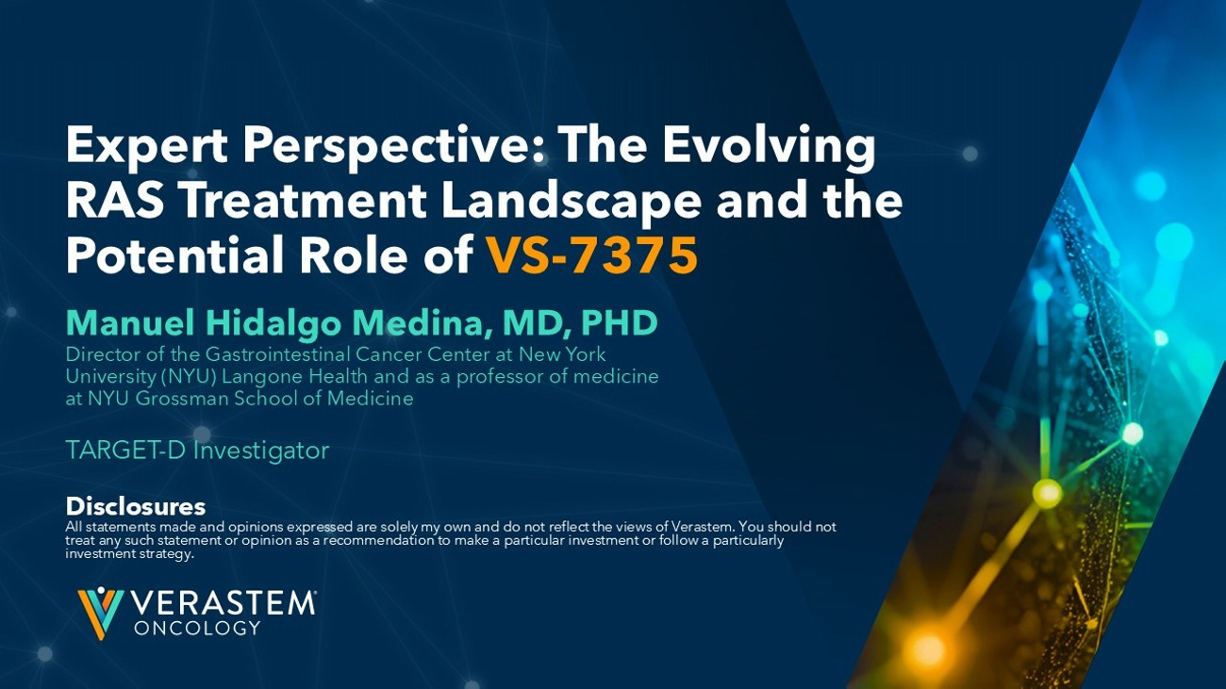
Manuel Hidalgo Medina, MD, PHD Director of the Gastrointestinal Cancer Center at New York University (NYU) Langone Health and as a professor of medicine at NYU Grossman School of Medicine TARGET - D Investigator Disclosures All statements made and opinions expressed are solely my own and do not reflect the views of Verastem. You should not treat any such statement or opinion as a recommendation to make a particular investment or follow a particularly investment strategy. Expert Perspective: The Evolving RAS Treatment Landscape and the Potential Role of VS - 7375

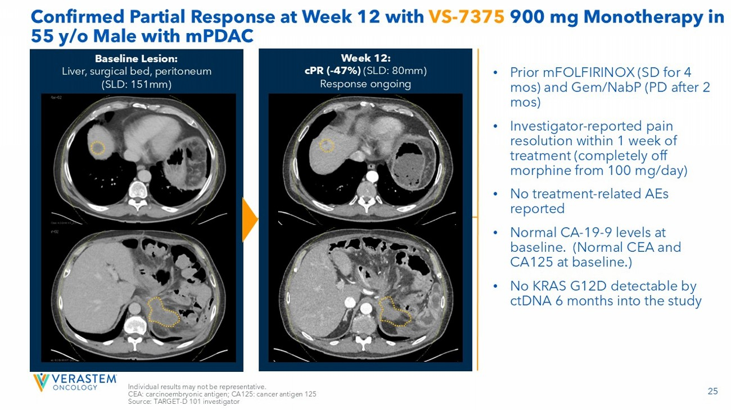
25 Confirmed Partial Response at Week 12 with VS - 7375 900 mg Monotherapy in 55 y/o Male with mPDAC • Prior mFOLFIRINOX (SD for 4 mos ) and Gem/NabP (PD after 2 mos ) • Investigator - reported pain resolution within 1 week of treatment (completely off morphine from 100 mg/day) • No treatment - related AEs reported • Normal CA - 19 - 9 levels at baseline. (Normal CEA and CA125 at baseline.) • No KRAS G12D detectable by ctDNA 6 months into the study Week 12: cPR ( - 47%) (SLD: 80mm) Response ongoing Baseline Lesion: Liver, surgical bed, peritoneum (SLD: 151mm) Individual results may not be representative. CEA: carcinoembryonic antigen; CA125: cancer antigen 125 Source: TARGET - D 101 investigator


Safety, Tolerability, and Combination Potential Ting - Hui Wu, MD Vice President of Development

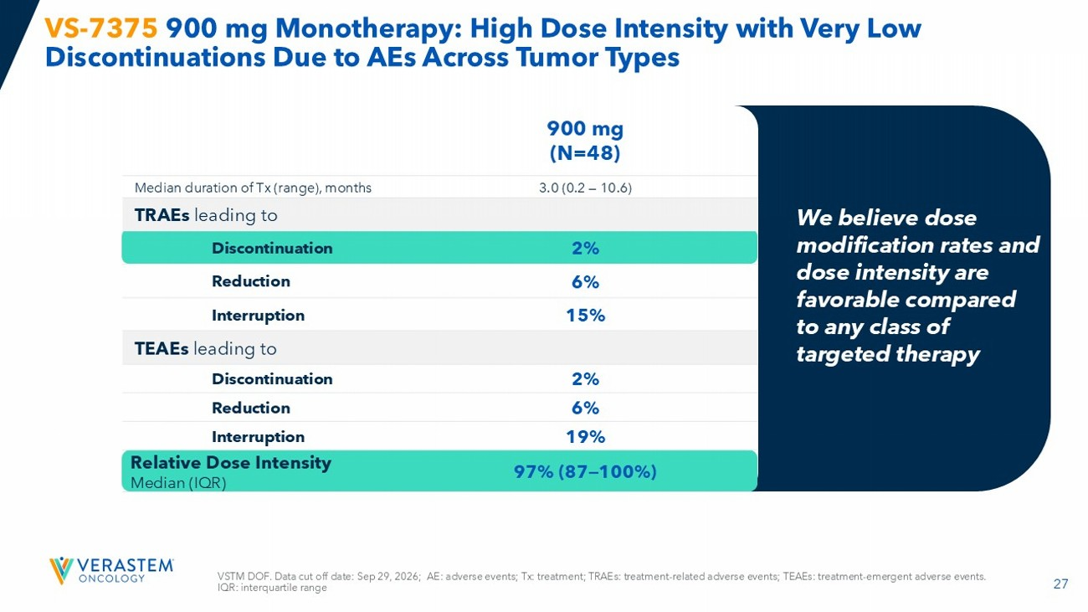
27 VSTM DOF. Data cut off date: Sep 29, 2026; AE: adverse events; Tx: treatment; TRAEs: treatment - related adverse events; TEAEs: treatment - emergent adverse events. IQR: interquartile range VS - 7375 900 mg Monotherapy: High Dose Intensity with Very Low Discontinuations Due to AEs Across Tumor Types 900 mg (N=48) 3.0 (0.2 — 10.6) Median duration of Tx (range), months TRAEs leading to 2% Discontinuation 6% Reduction 15% Interruption TEAEs leading to 2% Discontinuation 6% Reduction 19% Interruption 97% (87 — 100%) Relative Dose Intensity Median (IQR) We believe dose modification rates and dose intensity are favorable compared to any class of targeted therapy

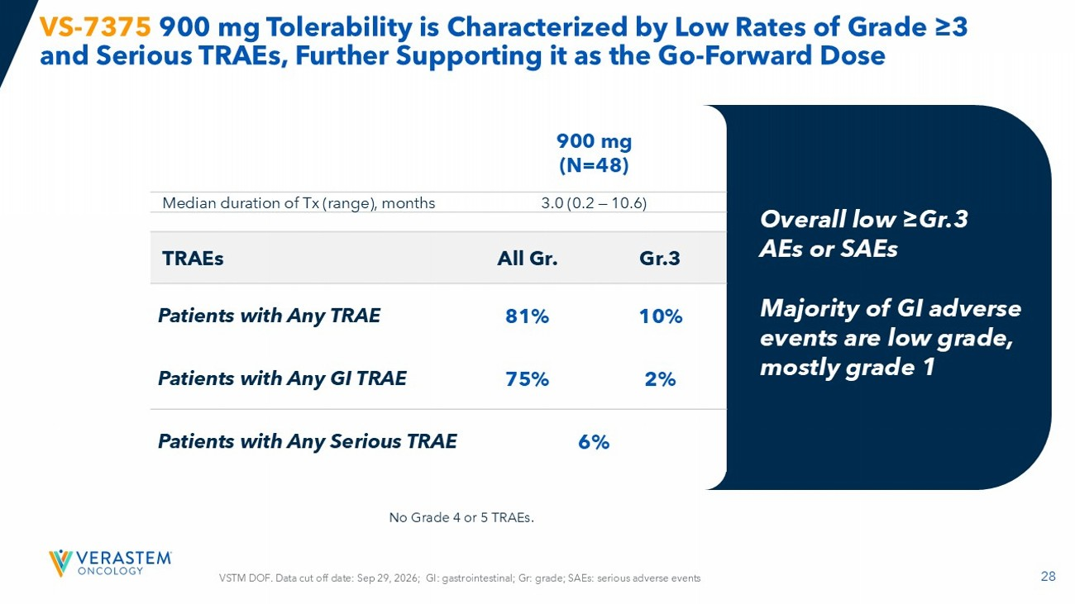
28 VS - 7375 900 mg Tolerability is Characterized by Low Rates of Grade ≥3 and Serious TRAEs, Further Supporting it as the Go - Forward Dose 900 mg (N=48) 3.0 (0.2 — 10.6) Median duration of Tx (range), months Gr.3 All Gr. TRAEs 10% 81% Patients with Any TRAE 2% 75% Patients with Any GI TRAE 6% Patients with Any Serious TRAE Overall low ≥Gr.3 AEs or SAEs Majority of GI adverse events are low grade, mostly grade 1 VSTM DOF. Data cut off date: Sep 29, 2026; GI: gastrointestinal; Gr: grade; SAEs: serious adverse events No Grade 4 or 5 TRAEs.

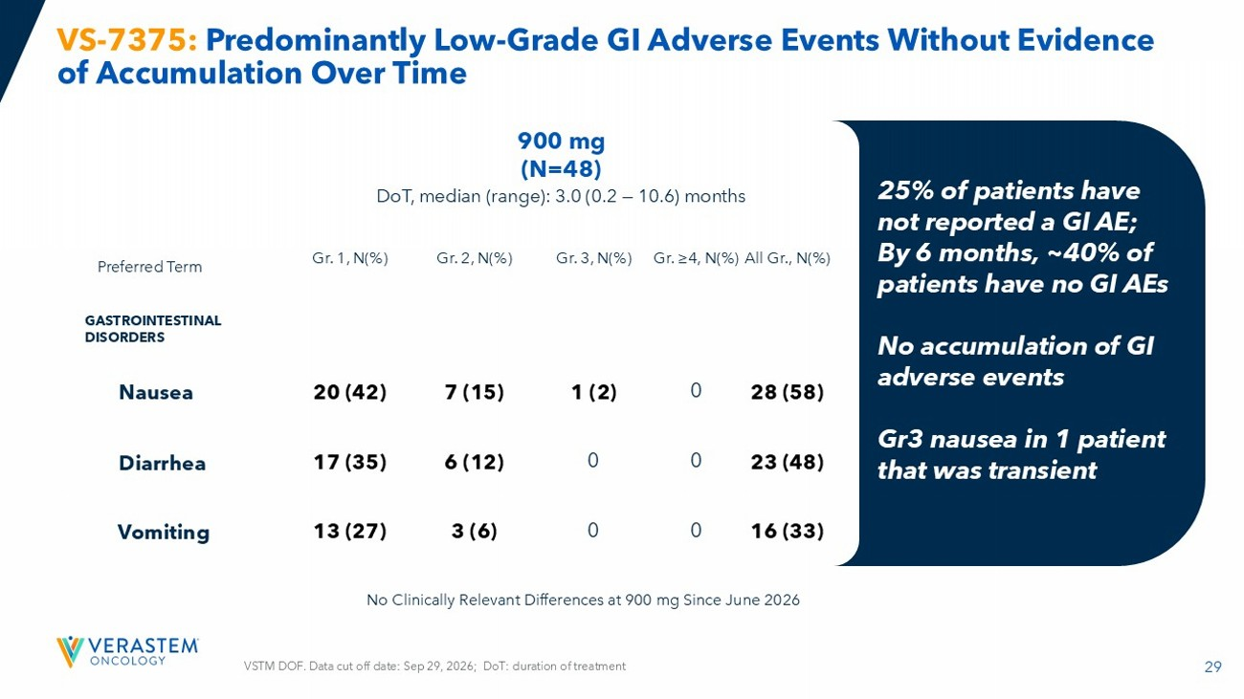
29 900 mg (N=48) DoT, median (range): 3.0 (0.2 — 10.6) months All Gr., N(%) Gr. ≥4, N(%) Gr. 3, N(%) Gr. 2, N(%) Gr. 1, N(%) Preferred Term GASTROINTESTINAL DISORDERS 28 (58) 0 1 (2) 7 (15) 20 (42) Nausea 23 (48) 0 0 6 (12) 17 (35) Diarrhea 16 (33) 0 0 3 (6) 13 (27) Vomiting VS - 7375: Predominantly Low - Grade GI Adverse Events Without Evidence of Accumulation Over Time 25% of patients have not reported a GI AE; By 6 months, ~40% of patients have no GI AEs No accumulation of GI adverse events Gr3 nausea in 1 patient that was transient No Clinically Relevant Differences at 900 mg Since June 2026 VSTM DOF. Data cut off date: Sep 29, 2026; DoT: duration of treatment

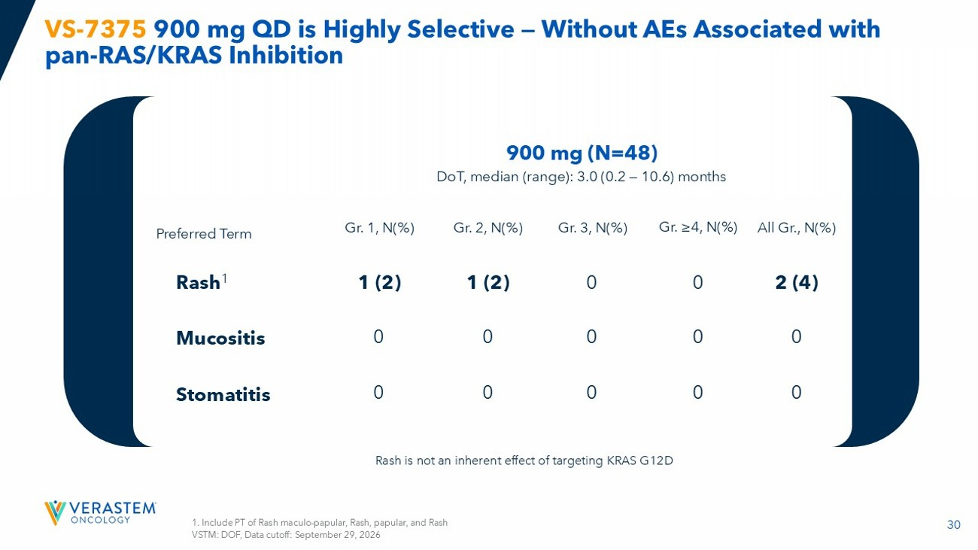
30 VS - 7375 900 mg QD is Highly Selective — Without AEs Associated with pan - RAS/KRAS Inhibition 1. Include PT of Rash maculo - papular, Rash, papular, and Rash VSTM: DOF, Data cutoff: September 29, 2026 900 mg (N=48) DoT, median (range): 3.0 (0.2 — 10.6) months All Gr., N(%) Gr. ≥4, N(%) Gr. 3, N(%) Gr. 2, N(%) Gr. 1, N(%) Preferred Term 2 (4) 0 0 1 (2) 1 (2) Rash 1 0 0 0 0 0 Mucositis 0 0 0 0 0 Stomatitis Rash is not an inherent effect of targeting KRAS G12D

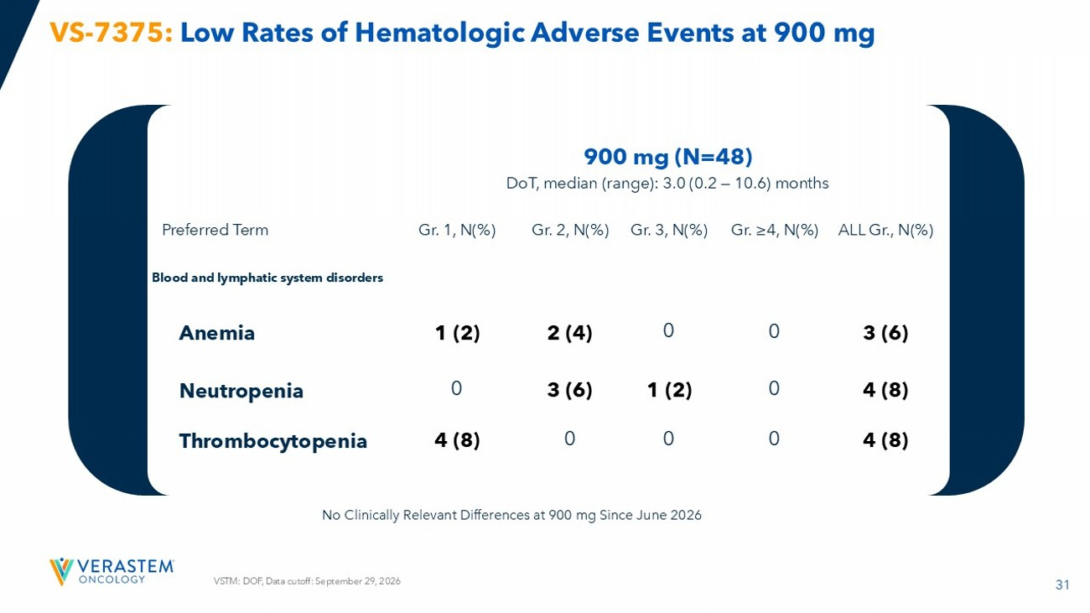
31 VS - 7375: Low Rates of Hematologic Adverse Events at 900 mg VSTM: DOF, Data cutoff: September 29, 2026 900 mg (N=48) DoT, median (range): 3.0 (0.2 — 10.6) months ALL Gr., N(%) Gr. ≥4, N(%) Gr. 3, N(%) Gr. 2, N(%) Gr. 1, N(%) Preferred Term Blood and lymphatic system disorders 3 (6) 0 0 2 (4) 1 (2) Anemia 4 (8) 0 1 (2) 3 (6) 0 Neutropenia 4 (8) 0 0 0 4 (8) Thrombocytopenia No Clinically Relevant Differences at 900 mg Since June 2026

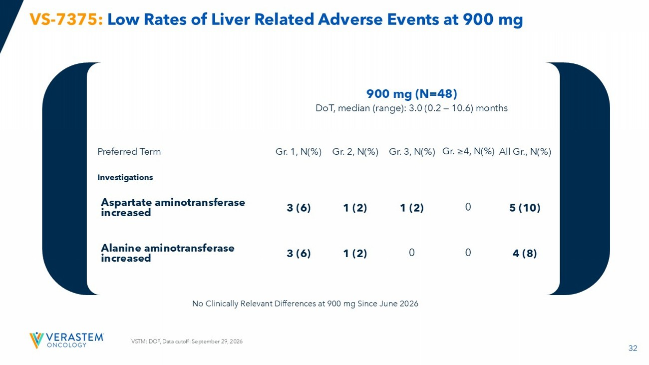
32 VS - 7375: Low Rates of Liver Related Adverse Events at 900 mg VSTM: DOF, Data cutoff: September 29, 2026 900 mg (N=48) DoT, median (range): 3.0 (0.2 — 10.6) months All Gr., N(%) Gr. ≥4, N(%) Gr. 3, N(%) Gr. 2, N(%) Gr. 1, N(%) Preferred Term Investigations 5 (10) 0 1 (2) 1 (2) 3 (6) Aspartate aminotransferase increased 4 (8) 0 0 1 (2) 3 (6) Alanine aminotransferase increased No Clinically Relevant Differences at 900 mg Since June 2026

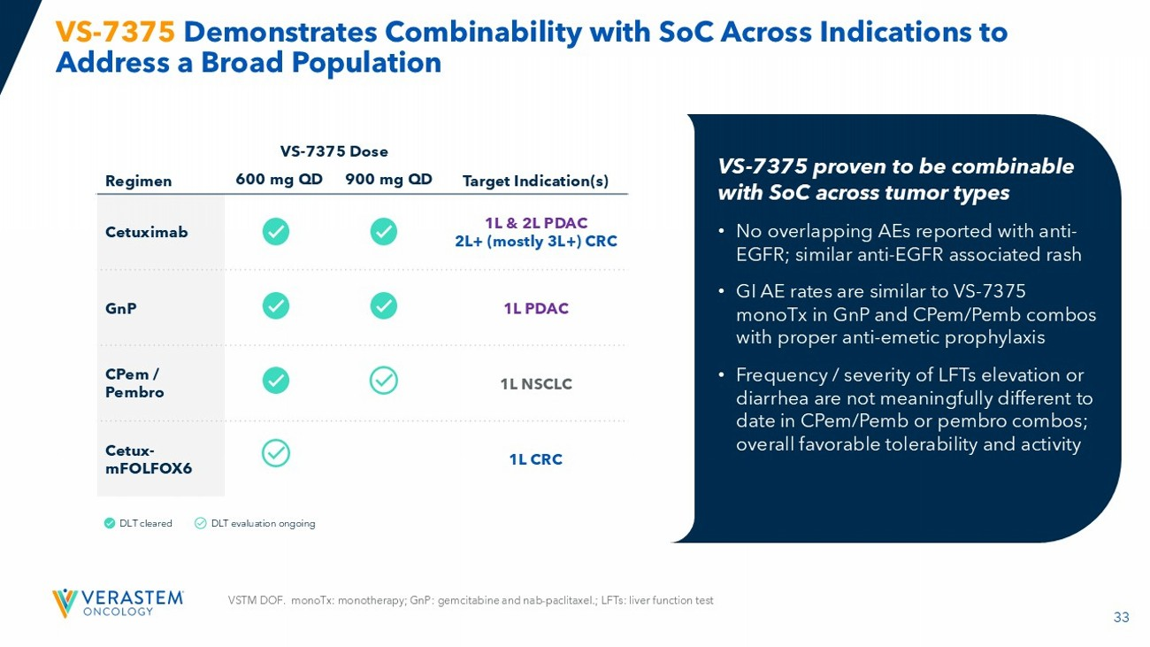
33 VS - 7375 Demonstrates Combinability with SoC Across Indications to Address a Broad Population Target Indication(s) VS - 7375 Dose Regimen 900 mg QD 600 mg QD 1L & 2L PDAC 2L+ (mostly 3L+) CRC Cetuximab 1L PDAC GnP 1L NSCLC CPem / Pembro 1L CRC Cetux - mFOLFOX6 DLT cleared DLT evaluation ongoing VS - 7375 proven to be combinable with SoC across tumor types • No overlapping AEs reported with anti - EGFR; similar anti - EGFR associated rash • GI AE rates are similar to VS - 7375 monoTx in GnP and CPem / Pemb combos with proper anti - emetic prophylaxis • Frequency / severity of LFTs elevation or diarrhea are not meaningfully different to date in CPem / Pemb or pembro combos; overall favorable tolerability and activity VSTM DOF. monoTx : monotherapy; GnP : gemcitabine and nab - paclitaxel.; LFTs: liver function test

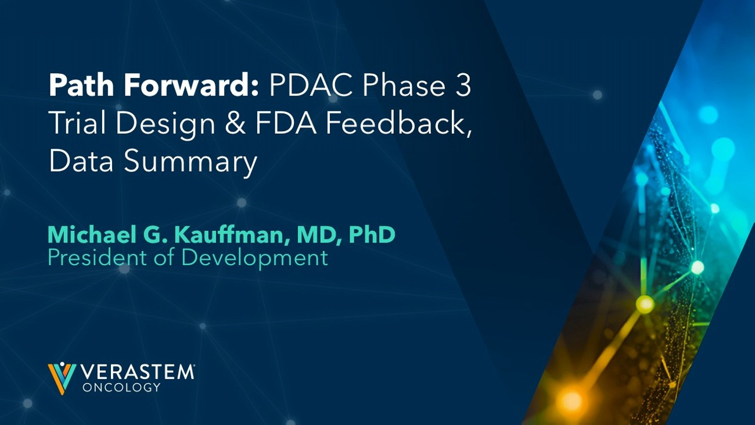
Path Forward: PDAC Phase 3 Trial Design & FDA Feedback, Data Summary Michael G. Kauffman, MD, PhD President of Development

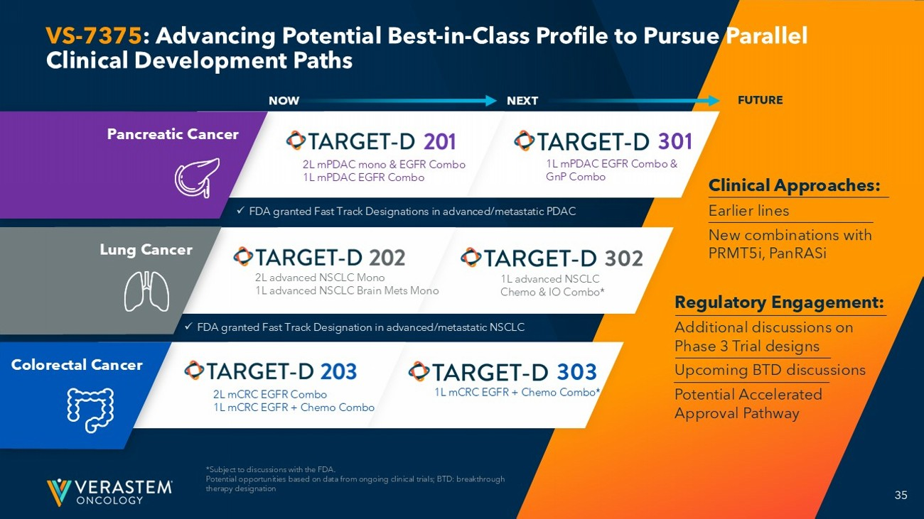
35 1L advanced NSCLC Chemo & IO Combo* 1L mCRC EGFR + Chemo Combo* 1L mPDAC EGFR Combo & GnP Combo NEXT VS - 7375 : Advancing Potential Best - in - Class Profile to Pursue Parallel Clinical Development Paths *Subject to discussions with the FDA. Potential opportunities based on data from ongoing clinical trials; BTD: breakthrough therapy designation x FDA granted Fast Track Designations in advanced/metastatic PDAC 2L advanced NSCLC Mono 1L advanced NSCLC Brain Mets Mono 2L mCRC EGFR Combo 1L mCRC EGFR + Chemo Combo 2L mPDAC mono & EGFR Combo 1L mPDAC EGFR Combo Pancreatic Cancer Lung Cancer Colorectal Cancer x FDA granted Fast Track Designation in advanced/metastatic NSCLC Clinical Approaches: Earlier lines New combinations with PRMT5i, PanRASi Regulatory Engagement: Additional d iscussions on Phase 3 Trial d esigns Upcoming BTD discussions Potential Accelerated Approval Pathway FUTURE NOW

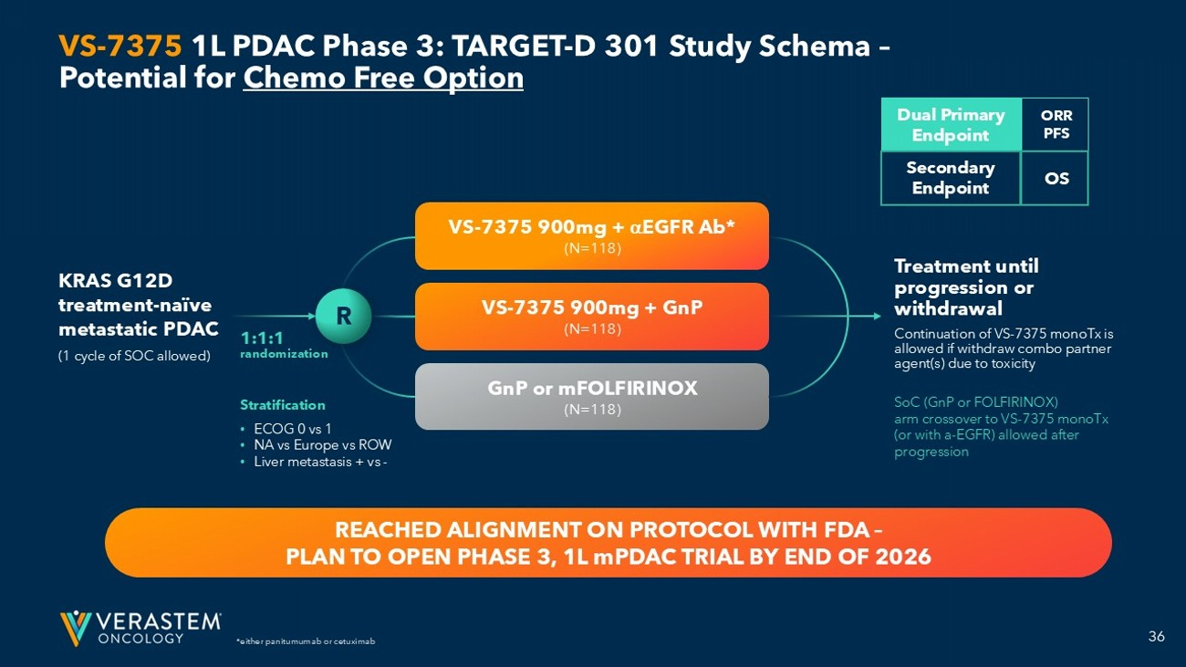
36 ORR PFS *either panitumumab or cetuximab VS - 7375 1L PDAC Phase 3: TARGET - D 301 Study Schema – Potential for Chemo Free Option 1:1:1 randomization Stratification • ECOG 0 vs 1 • NA vs Europe vs ROW • Liver metastasis + vs - SoC (GnP or FOLFIRINOX) arm crossover to VS - 7375 monoTx (or with a - EGFR) allowed after progression Dual Primary Endpoint Secondary Endpoint OS VS - 7375 900mg + EGFR Ab* (N=118) VS - 7375 900mg + GnP (N=118) GnP or mFOLFIRINOX (N=118) R Treatment until progression or withdrawal Continuation of VS - 7375 monoTx is allowed if withdraw combo partner agent(s) due to toxicity KRAS G12D treatment - naïve metastatic PDAC (1 cycle of SOC allowed) REACHED ALIGNMENT ON PROTOCOL WITH FDA – PLAN TO OPEN PHASE 3, 1L mPDAC TRIAL BY END OF 2026

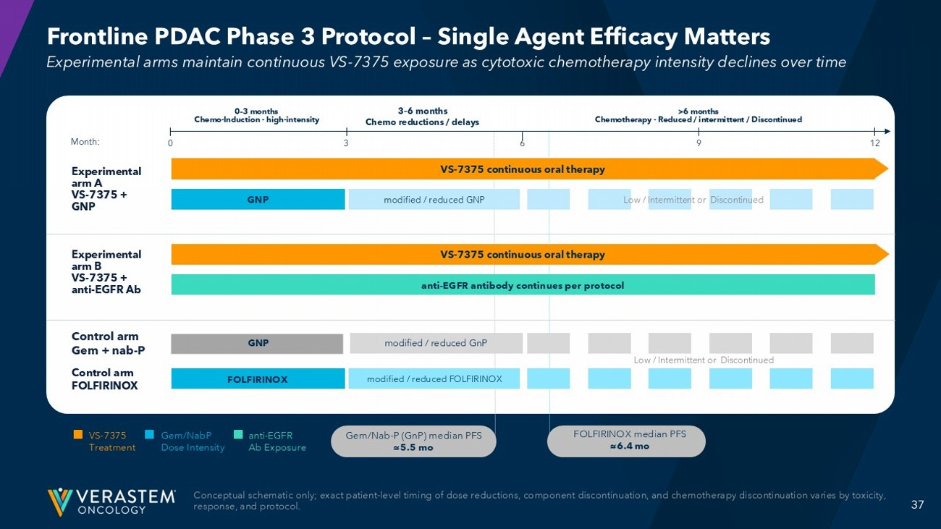
37 Frontline PDAC Phase 3 Protocol – Single Agent Efficacy Matters Conceptual schematic only; exact patient - level timing of dose reductions, component discontinuation, and chemotherapy discontinu ation varies by toxicity, response, and protocol. Experimental arms maintain continuous VS - 7375 exposure as cytotoxic chemotherapy intensity declines over time Month: 0 3 6 9 12 0 – 3 months Chemo - Induction - high - intensity 3 – 6 months Chemo reductions / delays >6 months Chemotherapy - Reduced / intermittent / Discontinued Experimental arm A VS - 7375 + GNP Experimental arm B VS - 7375 + anti - EGFR Ab Control arm FOLFIRINOX VS - 7375 continuous oral therapy GNP modified / reduced GNP Low / Intermittent or Discontinued VS - 7375 continuous oral therapy anti - EGFR antibody continues per protocol FOLFIRINOX modified / reduced FOLFIRINOX VS - 7375 Treatment Gem/NabP Dose Intensity anti - EGFR Ab Exposure Gem/Nab - P ( GnP ) median PFS ≈5.5 mo Control arm Gem + nab - P GNP modified / reduced GnP Low / Intermittent or Discontinued FOLFIRINOX median PFS ≈6.4 mo

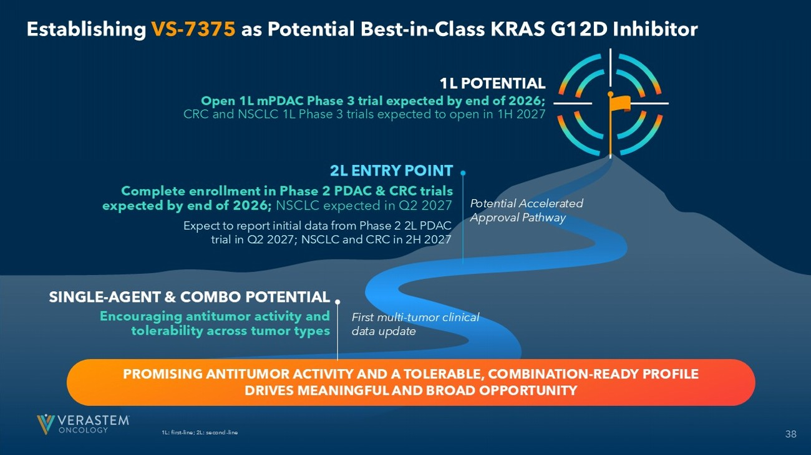
38 Establishing VS - 7375 as Potential Best - in - Class KRAS G12D Inhibitor 1L: first - line; 2L: second - line PROMISING ANTITUMOR ACTIVITY AND A TOLERABLE, COMBINATION - READY PROFILE DRIVES MEANINGFUL AND BROAD OPPORTUNITY 1L POTENTIAL Open 1L mPDAC Phase 3 trial expected by end of 2026; CRC and NSCLC 1L Phase 3 trials expected to open in 1H 2027 2L ENTRY POINT Complete enrollment in Phase 2 PDAC & CRC trials expected by end of 2026; NSCLC expected in Q2 2027 SINGLE - AGENT & COMBO POTENTIAL Encouraging antitumor activity and tolerability across tumor types Potential Accelerated Approval Pathway Expect to report initial data from Phase 2 2L PDAC trial in Q2 2027; NSCLC and CRC in 2H 2027 First multi - tumor clinical data update


Addendum

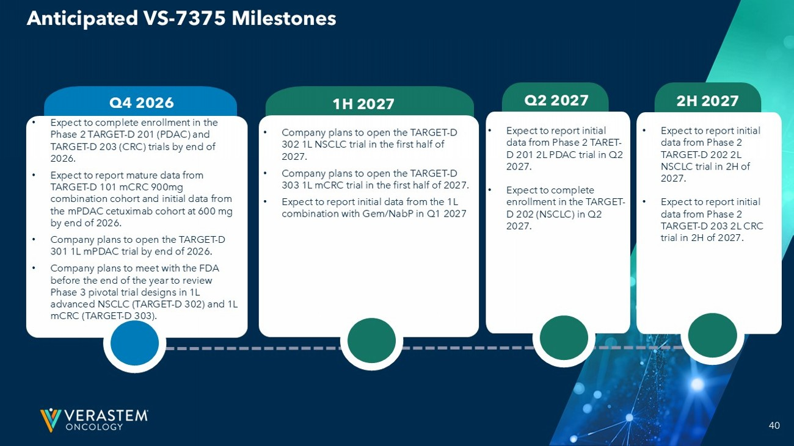
40 • Expect to complete enrollment in the Phase 2 TARGET - D 201 (PDAC) and TARGET - D 203 (CRC) trials by end of 2026. • Expect to report mature data from TARGET - D 101 mCRC 900mg combination cohort and initial data from the mPDAC cetuximab cohort at 600 mg by end of 2026. • Company plans to open the TARGET - D 301 1L mPDAC trial by end of 2026. • Company plans to meet with the FDA before the end of the year to review Phase 3 pivotal trial designs in 1L advanced NSCLC (TARGET - D 302) and 1L mCRC (TARGET - D 303). Q4 2026 • Expect to report initial data from Phase 2 TARET - D 201 2L PDAC trial in Q2 2027. • Expect to complete enrollment in the TARGET - D 202 (NSCLC) in Q2 2027. 1H 2027 Q2 2027 2H 2027 • Expect to report initial data from Phase 2 TARGET - D 202 2L NSCLC trial in 2H of 2027. • Expect to report initial data from Phase 2 TARGET - D 203 2L CRC trial in 2H of 2027. • Company plans to open the TARGET - D 302 1L NSCLC trial in the first half of 2027. • Company plans to open the TARGET - D 303 1L mCRC trial in the first half of 2027. • Expect to report initial data from the 1L combination with Gem/NabP in Q1 2027 Anticipated VS - 7375 Milestones

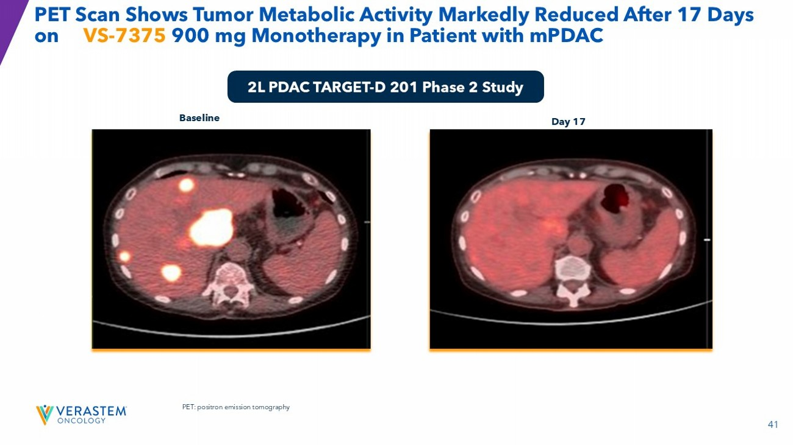
41 Baseline Day 17 PET Scan Shows Tumor Metabolic Activity Markedly Reduced After 17 Days on VS - 7375 900 mg Monotherapy in Patient with mPDAC 2L PDAC TARGET - D 201 Phase 2 Study PET: positron emission tomography

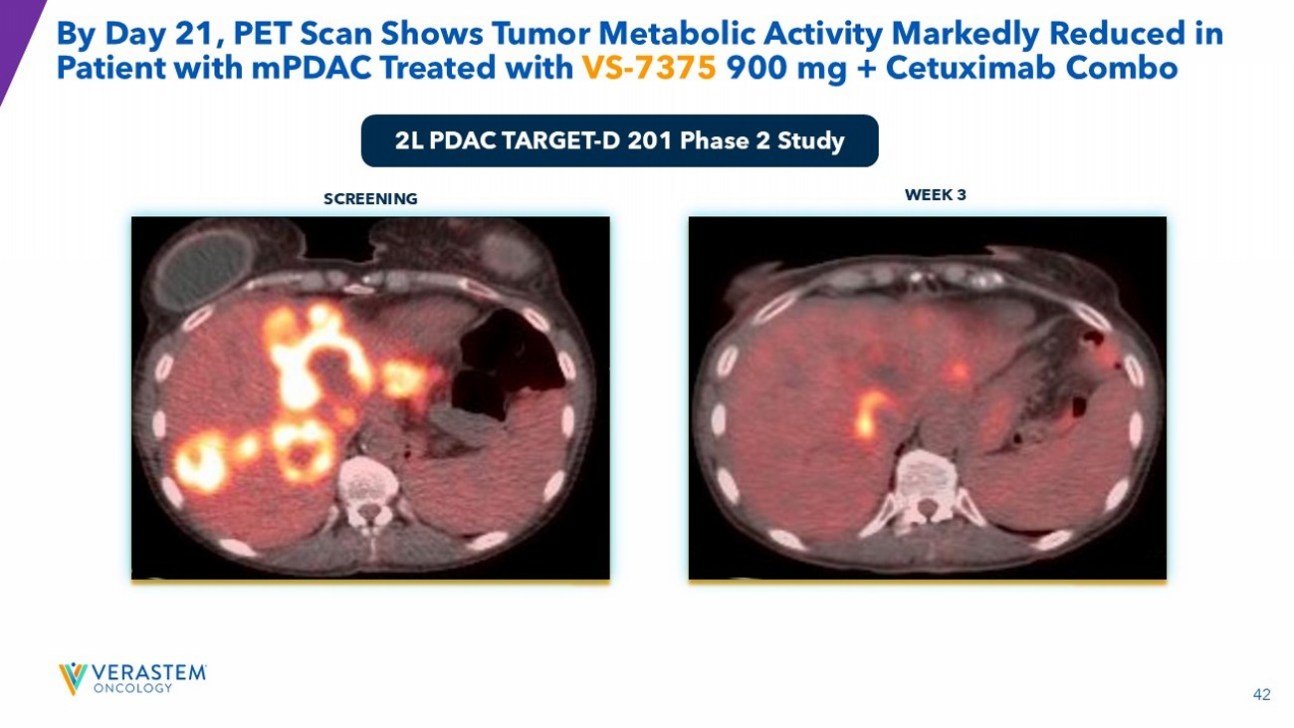
42 SCREENING WEEK 3 By Day 21, PET Scan Shows Tumor Metabolic Activity Markedly Reduced in Patient with mPDAC Treated with VS - 7375 900 mg + Cetuximab Combo 2L PDAC TARGET - D 201 Phase 2 Study

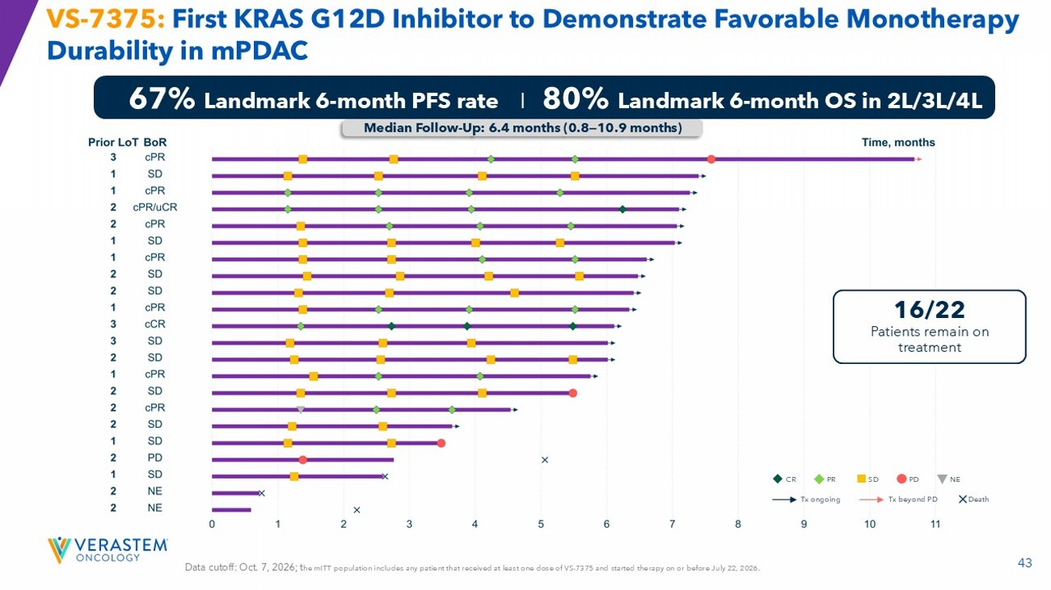
43 VS - 7375: First KRAS G12D Inhibitor to Demonstrate Favorable Monotherapy Durability in mPDAC 67% Landmark 6 - month PFS rate I 80% Landmark 6 - month OS in 2L/3L/4L Data cutoff: Oct. 7, 2026; t he mITT population includes any patient that received at least one dose of VS - 7375 and started therapy on or before July 22, 2026. Median Follow - Up: 6.4 months (0.8 — 10.9 months) 16/22 Patients remain on treatment CR PR SD PD NE Tx ongoing Tx beyond PD Death

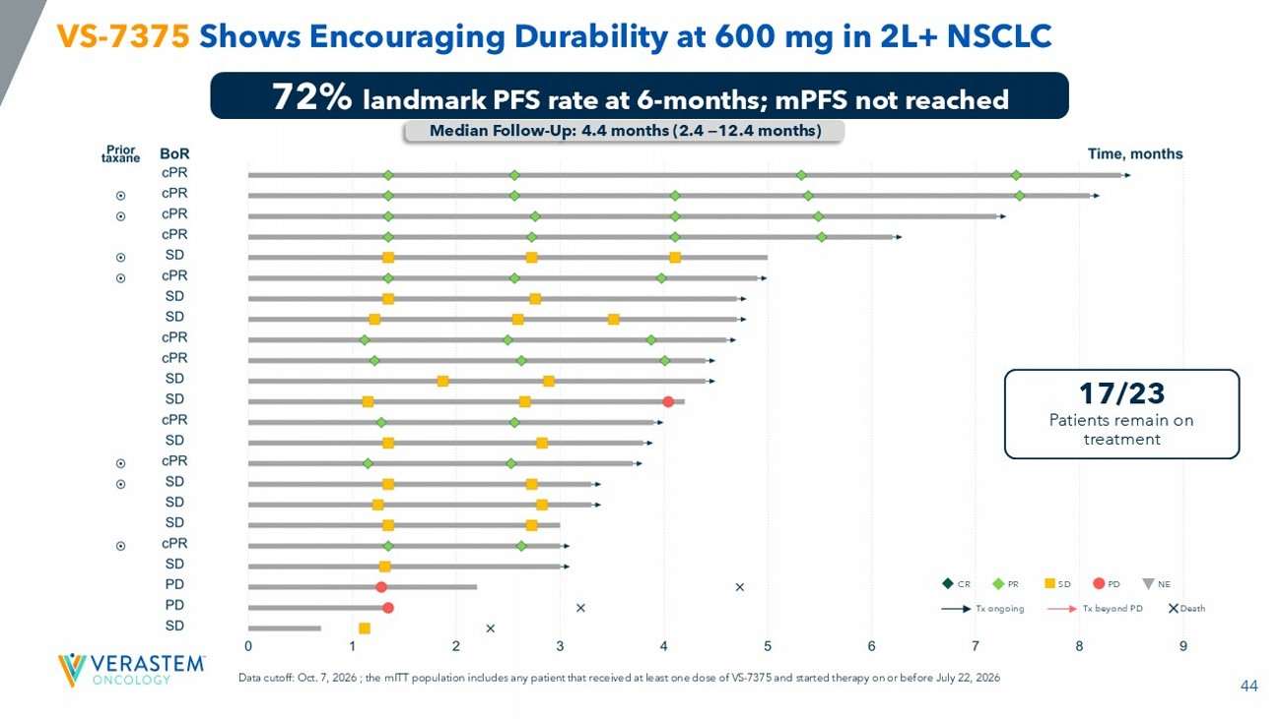
44 VS - 7375 Shows Encouraging Durability at 600 mg in 2L+ NSCLC 72% landmark PFS rate at 6 - months; mPFS not reached Median Follow - Up: 4.4 months (2.4 — 12.4 months) Data cutoff: Oct. 7, 2026; the mITT population includes any patient that received at least one dose of VS - 7375 and started therapy on or before July 22, 2026 17/23 Patients remain on treatment CR PR SD PD NE Tx ongoing Tx beyond PD Death

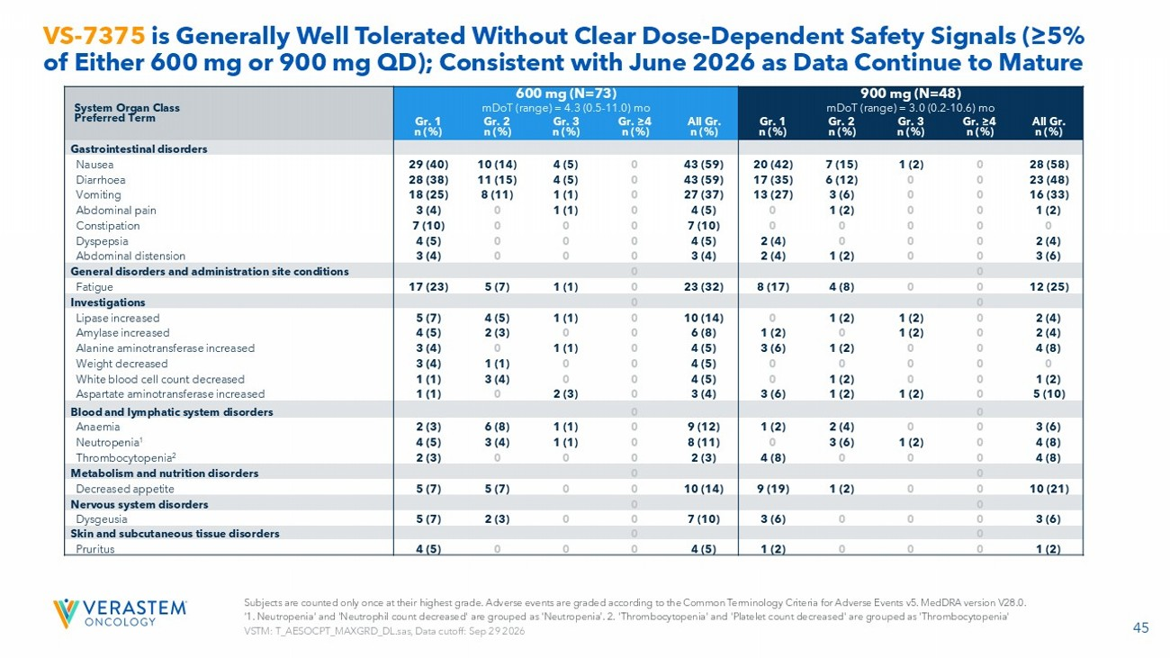
45 VS - 7375 is Generally Well Tolerated Without Clear Dose - Dependent Safety Signals (≥5% of Either 600 mg or 900 mg QD); Consistent with June 2026 as Data Continue to Mature 900 mg (N=48) 600 mg (N=73) System Organ Class Preferred Term mDoT (range) = 3.0 (0.2 - 10.6) mo mDoT (range) = 4.3 (0.5 - 11.0) mo All Gr. n (%) Gr. ≥4 n (%) Gr. 3 n (%) Gr. 2 n (%) Gr. 1 n (%) All Gr. n (%) Gr. ≥4 n (%) Gr. 3 n (%) Gr. 2 n (%) Gr. 1 n (%) Gastrointestinal disorders 28 (58) 0 1 (2) 7 (15) 20 (42) 43 (59) 0 4 (5) 10 (14) 29 (40) Nausea 23 (48) 0 0 6 (12) 17 (35) 43 (59) 0 4 (5) 11 (15) 28 (38) Diarrhoea 16 (33) 0 0 3 (6) 13 (27) 27 (37) 0 1 (1) 8 (11) 18 (25) Vomiting 1 (2) 0 0 1 (2) 0 4 (5) 0 1 (1) 0 3 (4) Abdominal pain 0 0 0 0 0 7 (10) 0 0 0 7 (10) Constipation 2 (4) 0 0 0 2 (4) 4 (5) 0 0 0 4 (5) Dyspepsia 3 (6) 0 0 1 (2) 2 (4) 3 (4) 0 0 0 3 (4) Abdominal distension 0 0 General disorders and administration site conditions 12 (25) 0 0 4 (8) 8 (17) 23 (32) 0 1 (1) 5 (7) 17 (23) Fatigue 0 0 Investigations 2 (4) 0 1 (2) 1 (2) 0 10 (14) 0 1 (1) 4 (5) 5 (7) Lipase increased 2 (4) 0 1 (2) 0 1 (2) 6 (8) 0 0 2 (3) 4 (5) Amylase increased 4 (8) 0 0 1 (2) 3 (6) 4 (5) 0 1 (1) 0 3 (4) Alanine aminotransferase increased 0 0 0 0 0 4 (5) 0 0 1 (1) 3 (4) Weight decreased 1 (2) 0 0 1 (2) 0 4 (5) 0 0 3 (4) 1 (1) White blood cell count decreased 5 (10) 0 1 (2) 1 (2) 3 (6) 3 (4) 0 2 (3) 0 1 (1) Aspartate aminotransferase increased 0 0 Blood and lymphatic system disorders 3 (6) 0 0 2 (4) 1 (2) 9 (12) 0 1 (1) 6 (8) 2 (3) Anaemia 4 (8) 0 1 (2) 3 (6) 0 8 (11) 0 1 (1) 3 (4) 4 (5) Neutropenia 1 4 (8) 0 0 0 4 (8) 2 (3) 0 0 0 2 (3) Thrombocytopenia 2 0 0 Metabolism and nutrition disorders 10 (21) 0 0 1 (2) 9 (19) 10 (14) 0 0 5 (7) 5 (7) Decreased appetite 0 0 Nervous system disorders 3 (6) 0 0 0 3 (6) 7 (10) 0 0 2 (3) 5 (7) Dysgeusia 0 0 Skin and subcutaneous tissue disorders 1 (2) 0 0 0 1 (2) 4 (5) 0 0 0 4 (5) Pruritus Subjects are counted only once at their highest grade. Adverse events are graded according to the Common Terminology Criteria fo r Adverse Events v5. MedDRA version V28.0. ‘1. Neutropenia' and 'Neutrophil count decreased' are grouped as 'Neutropenia’. 2. 'Thrombocytopenia' and 'Platelet count dec rea sed' are grouped as 'Thrombocytopenia' VSTM: T_AESOCPT_MAXGRD_DL.sas , Data cutoff: Sep 29 2026

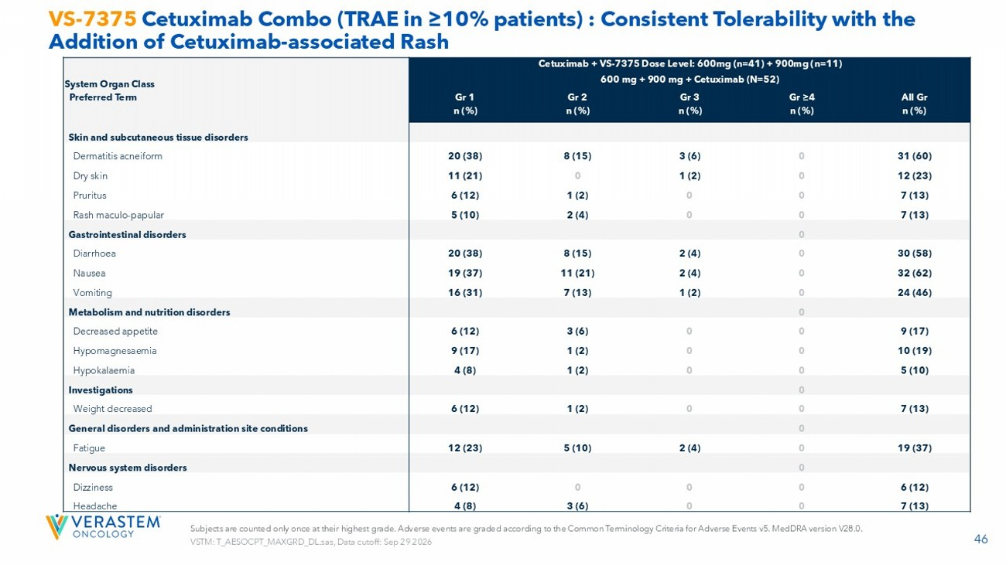
46 VS - 7375 Cetuximab Combo (TRAE in ≥10% patients) : Consistent Tolerability with the Addition of Cetuximab - associated Rash Subjects are counted only once at their highest grade. Adverse events are graded according to the Common Terminology Criteria fo r Adverse Events v5. MedDRA version V28.0. VSTM: T_AESOCPT_MAXGRD_DL.sas , Data cutoff: Sep 29 2026 Cetuximab + VS - 7375 Dose Level: 600mg (n=41) + 900mg (n=11) 600 mg + 900 mg + Cetuximab (N=52) System Organ Class Preferred Term All Gr n (%) Gr ≥4 n (%) Gr 3 n (%) Gr 2 n (%) Gr 1 n (%) Skin and subcutaneous tissue disorders 31 (60) 0 3 (6) 8 (15) 20 (38) Dermatitis acneiform 12 (23) 0 1 (2) 0 11 (21) Dry skin 7 (13) 0 0 1 (2) 6 (12) Pruritus 7 (13) 0 0 2 (4) 5 (10) Rash maculo - papular 0 Gastrointestinal disorders 30 (58) 0 2 (4) 8 (15) 20 (38) Diarrhoea 32 (62) 0 2 (4) 11 (21) 19 (37) Nausea 24 (46) 0 1 (2) 7 (13) 16 (31) Vomiting 0 Metabolism and nutrition disorders 9 (17) 0 0 3 (6) 6 (12) Decreased appetite 10 (19) 0 0 1 (2) 9 (17) Hypomagnesaemia 5 (10) 0 0 1 (2) 4 (8) Hypokalaemia 0 Investigations 7 (13) 0 0 1 (2) 6 (12) Weight decreased 0 General disorders and administration site conditions 19 (37) 0 2 (4) 5 (10) 12 (23) Fatigue 0 Nervous system disorders 6 (12) 0 0 0 6 (12) Dizziness 7 (13) 0 0 3 (6) 4 (8) Headache

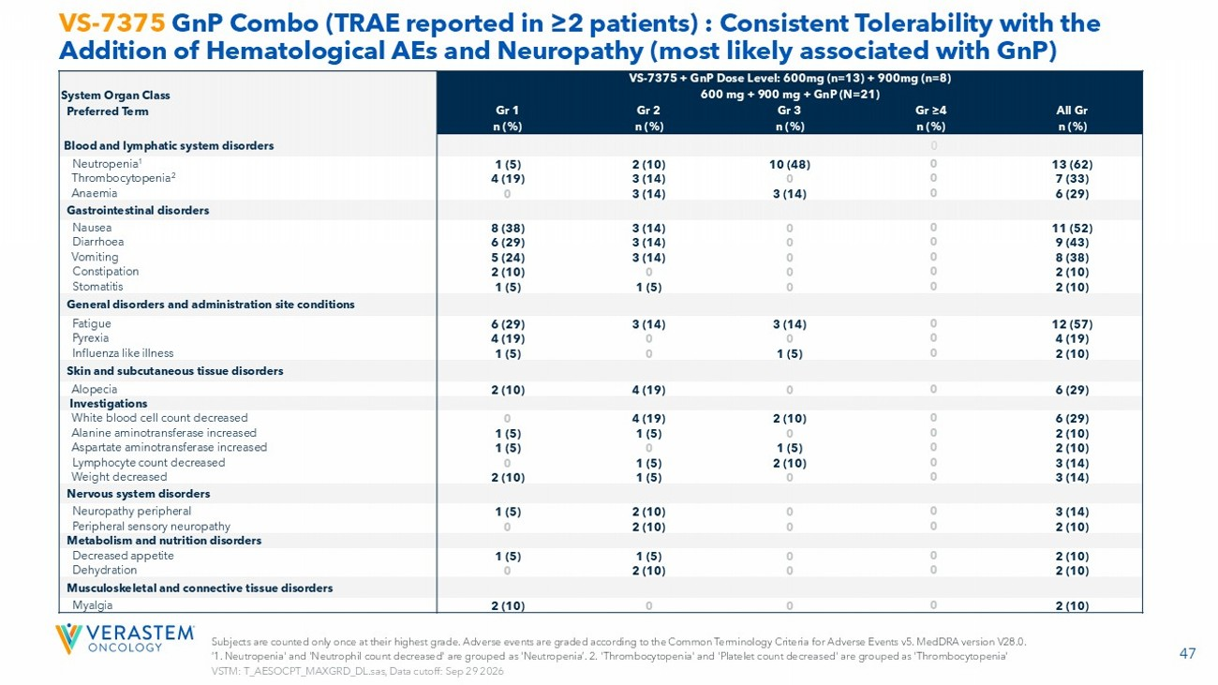
47 VS - 7375 GnP Combo (TRAE reported in ≥2 patients) : Consistent Tolerability with the Addition of Hematological AEs and Neuropathy (most likely associated with GnP ) Subjects are counted only once at their highest grade. Adverse events are graded according to the Common Terminology Criteria fo r Adverse Events v5. MedDRA version V28.0. ‘1. Neutropenia' and 'Neutrophil count decreased' are grouped as 'Neutropenia’. 2. 'Thrombocytopenia' and 'Platelet count dec rea sed' are grouped as 'Thrombocytopenia' VSTM: T_AESOCPT_MAXGRD_DL.sas , Data cutoff: Sep 29 2026 VS - 7375 + GnP Dose Level: 600mg (n=13) + 900mg (n=8) 600 mg + 900 mg + GnP (N=21) System Organ Class Preferred Term All Gr n (%) Gr ≥4 n (%) Gr 3 n (%) Gr 2 n (%) Gr 1 n (%) 0 Blood and lymphatic system disorders 13 (62) 0 10 (48) 2 (10) 1 (5) Neutropenia 1 7 (33) 0 0 3 (14) 4 (19) Thrombocytopenia 2 6 (29) 0 3 (14) 3 (14) 0 Anaemia Gastrointestinal disorders 11 (52) 0 0 3 (14) 8 (38) Nausea 9 (43) 0 0 3 (14) 6 (29) Diarrhoea 8 (38) 0 0 3 (14) 5 (24) Vomiting 2 (10) 0 0 0 2 (10) Constipation 2 (10) 0 0 1 (5) 1 (5) Stomatitis General disorders and administration site conditions 12 (57) 0 3 (14) 3 (14) 6 (29) Fatigue 4 (19) 0 0 0 4 (19) Pyrexia 2 (10) 0 1 (5) 0 1 (5) Influenza like illness Skin and subcutaneous tissue disorders 6 (29) 0 0 4 (19) 2 (10) Alopecia Investigations 6 (29) 0 2 (10) 4 (19) 0 White blood cell count decreased 2 (10) 0 0 1 (5) 1 (5) Alanine aminotransferase increased 2 (10) 0 1 (5) 0 1 (5) Aspartate aminotransferase increased 3 (14) 0 2 (10) 1 (5) 0 Lymphocyte count decreased 3 (14) 0 0 1 (5) 2 (10) Weight decreased Nervous system disorders 3 (14) 0 0 2 (10) 1 (5) Neuropathy peripheral 2 (10) 0 0 2 (10) 0 Peripheral sensory neuropathy Metabolism and nutrition disorders 2 (10) 0 0 1 (5) 1 (5) Decreased appetite 2 (10) 0 0 2 (10) 0 Dehydration Musculoskeletal and connective tissue disorders 2 (10) 0 0 0 2 (10) Myalgia

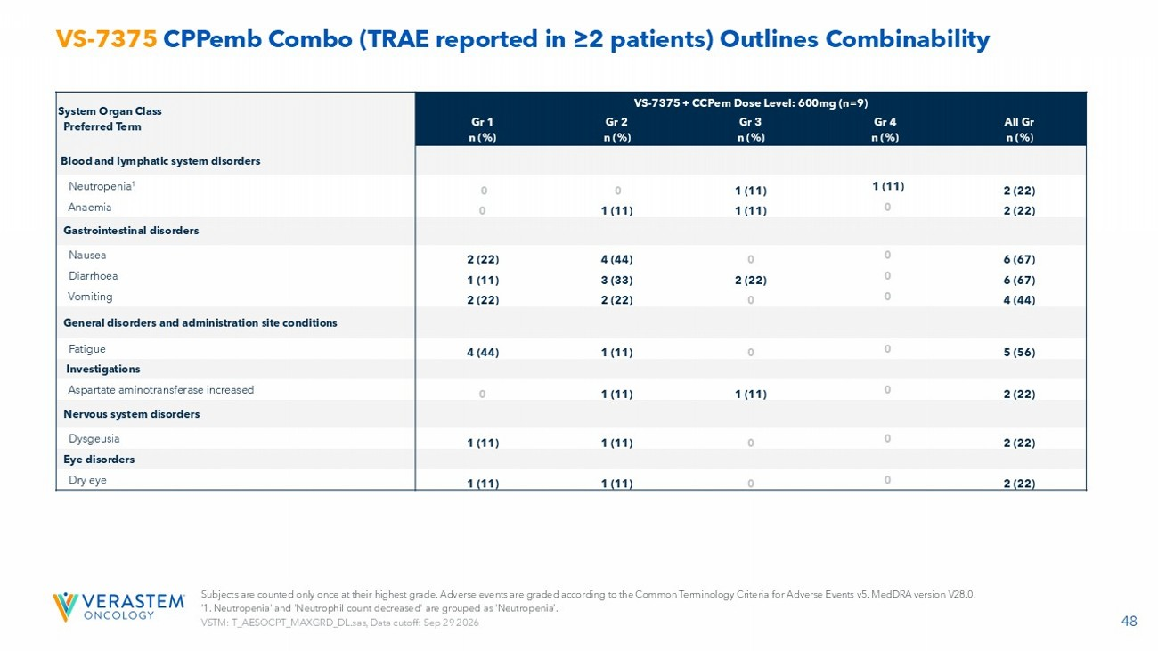
48 VS - 7375 CPPemb Combo (TRAE reported in ≥2 patients) Outlines Combinability VS - 7375 + CCPem Dose Level: 600mg (n=9) System Organ Class Preferred Term All Gr n (%) Gr 4 n (%) Gr 3 n (%) Gr 2 n (%) Gr 1 n (%) Blood and lymphatic system disorders 2 (22) 1 (11) 1 (11) 0 0 Neutropenia 1 2 (22) 0 1 (11) 1 (11) 0 Anaemia Gastrointestinal disorders 6 (67) 0 0 4 (44) 2 (22) Nausea 6 (67) 0 2 (22) 3 (33) 1 (11) Diarrhoea 4 (44) 0 0 2 (22) 2 (22) Vomiting General disorders and administration site conditions 5 (56) 0 0 1 (11) 4 (44) Fatigue Investigations 2 (22) 0 1 (11) 1 (11) 0 Aspartate aminotransferase increased Nervous system disorders 2 (22) 0 0 1 (11) 1 (11) Dysgeusia Eye disorders 2 (22) 0 0 1 (11) 1 (11) Dry eye Subjects are counted only once at their highest grade. Adverse events are graded according to the Common Terminology Criteria fo r Adverse Events v5. MedDRA version V28.0. ‘1. Neutropenia' and 'Neutrophil count decreased' are grouped as 'Neutropenia’. VSTM: T_AESOCPT_MAXGRD_DL.sas , Data cutoff: Sep 29 2026

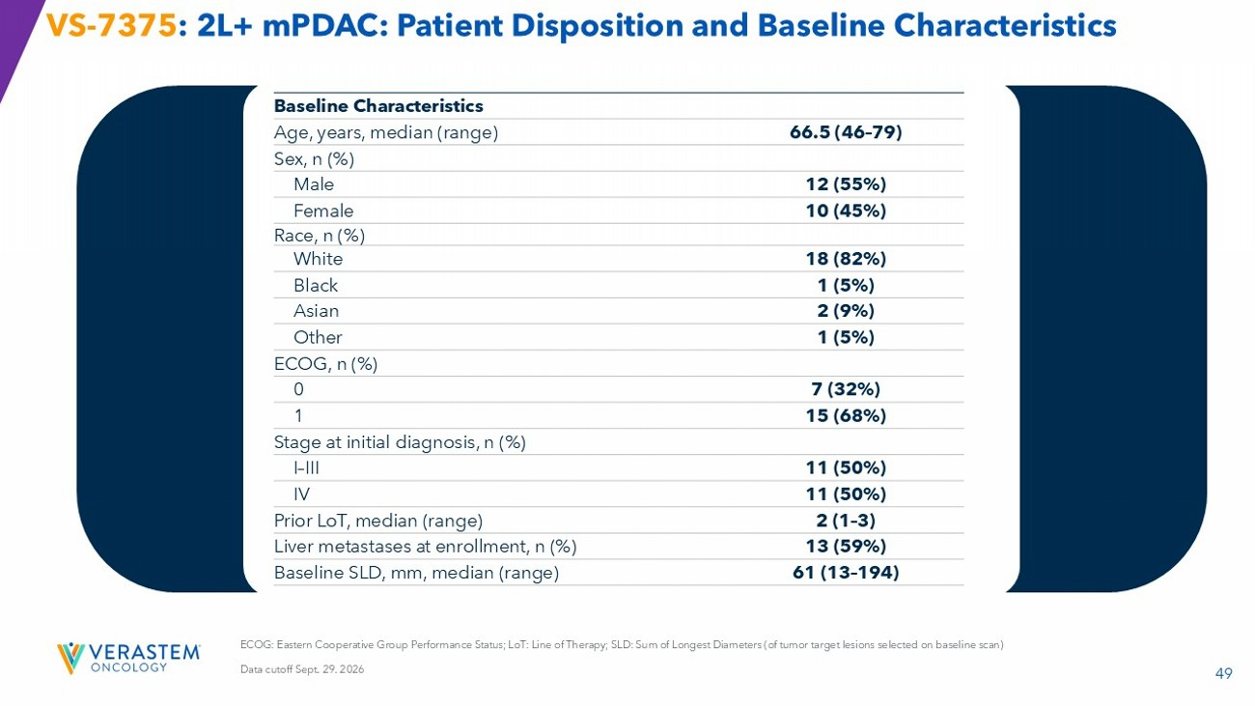
49 ECOG: Eastern Cooperative Group Performance Status; LoT : Line of Therapy; SLD: Sum of Longest Diameters (of tumor target lesions selected on baseline scan) Data cutoff Sept. 29. 2026 VS - 7375 : 2L+ mPDAC: Patient Disposition and Baseline Characteristics Baseline Characteristics 66.5 (46 – 79) Age, years, median (range) Sex, n (%) 12 (55%) Male 10 (45%) Female Race, n (%) 18 (82%) White 1 (5%) Black 2 (9%) Asian 1 (5%) Other ECOG, n (%) 7 (32%) 0 15 (68%) 1 Stage at initial diagnosis, n (%) 11 (50%) I – III 11 (50%) IV 2 (1 – 3) Prior LoT, median (range) 13 (59%) Liver metastases at enrollment, n (%) 61 (13 – 194) Baseline SLD, mm, median (range)

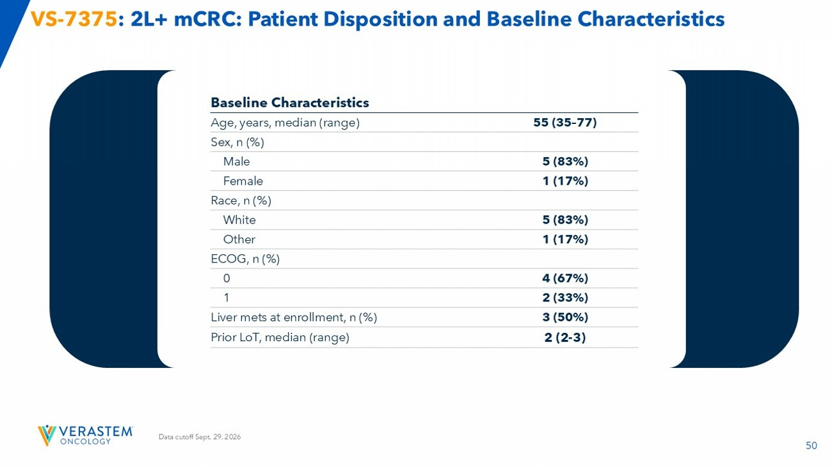
50 Data cutoff Sept. 29. 2026 VS - 7375 : 2L+ mCRC: Patient Disposition and Baseline Characteristics Baseline Characteristics 55 (35 – 77) Age, years, median (range) Sex, n (%) 5 (83%) Male 1 (17%) Female Race, n (%) 5 (83%) White 1 (17%) Other ECOG, n (%) 4 (67%) 0 2 (33%) 1 3 (50%) Liver mets at enrollment, n (%) 2 (2 - 3) Prior LoT, median (range)

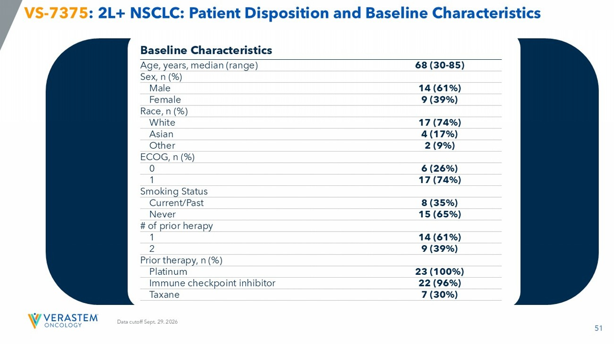
51 Data cutoff Sept. 29. 2026 VS - 7375 : 2L+ NSCLC: Patient Disposition and Baseline Characteristics Baseline Characteristics 68 (30 - 85) Age, years, median (range) Sex, n (%) 14 (61%) Male 9 (39%) Female Race, n (%) 17 (74%) White 4 (17%) Asian 2 (9%) Other ECOG, n (%) 6 (26%) 0 17 (74%) 1 Smoking Status 8 (35%) Current/Past 15 (65%) Never # of prior herapy 14 (61%) 1 9 (39%) 2 Prior therapy, n (%) 23 (100%) Platinum 22 (96%) Immune checkpoint inhibitor 7 (30%) Taxane

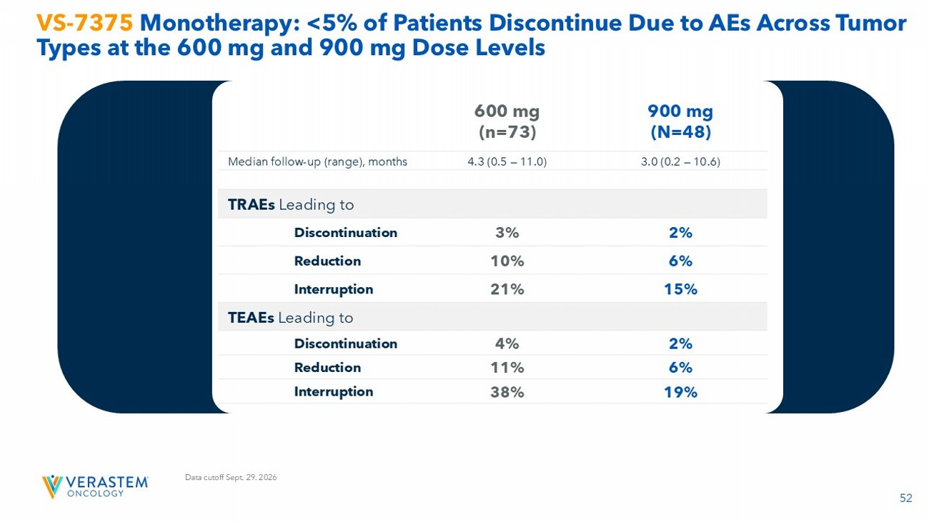
52 VS - 7375 Monotherapy: <5% of Patients Discontinue Due to AEs Across Tumor Types at the 600 mg and 900 mg Dose Levels 900 mg (N=48) 600 mg (n=73) 3.0 (0.2 — 10.6) 4.3 (0.5 — 11.0) Median follow - up (range), months TRAEs Leading to 2% 3% Discontinuation 6% 10% Reduction 15% 21% Interruption TEAEs Leading to 2% 4% Discontinuation 6% 11% Reduction 19% 38% Interruption Data cutoff Sept. 29. 2026

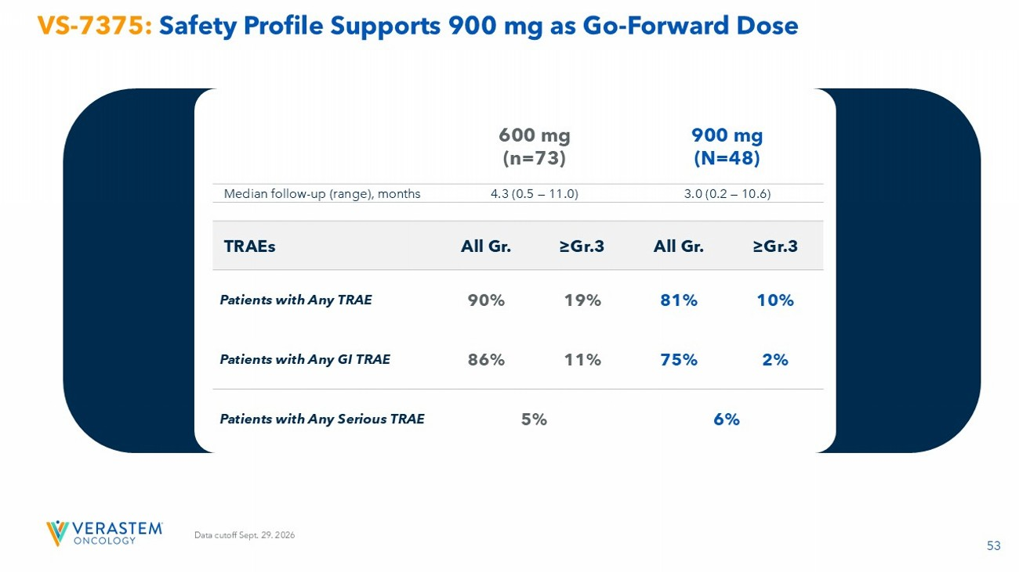
53 VS - 7375: Safety Profile Supports 900 mg as Go - Forward Dose 900 mg (N=48) 600 mg (n=73) 3.0 (0.2 — 10.6) 4.3 (0.5 — 11.0) Median follow - up (range), months ≥Gr.3 All Gr. ≥Gr.3 All Gr. TRAEs 10% 81% 19% 90% Patients with Any TRAE 2% 75% 11% 86% Patients with Any GI TRAE 6% 5% Patients with Any Serious TRAE Data cutoff Sept. 29. 2026

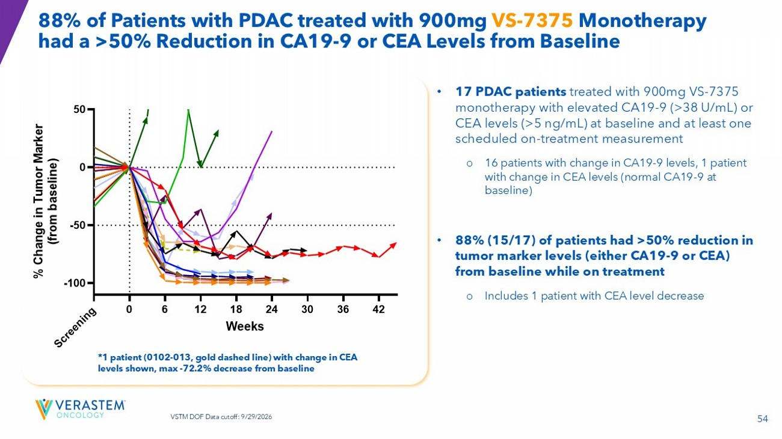
54 88% of Patients with PDAC treated with 900mg VS - 7375 Monotherapy had a >50% Reduction in CA19 - 9 or CEA Levels from Baseline • 17 PDAC patients treated with 900mg VS - 7375 monotherapy with elevated CA19 - 9 (>38 U/mL) or CEA levels (>5 ng/mL) at baseline and at least one scheduled on - treatment measurement o 14/17 remain on treatment o 16 patients with change in CA19 - 9 levels, 1 patient with change in CEA levels (normal CA19 - 9 at baseline) • 88% (15/17) of patients had >50% reduction in tumor marker levels (either CA19 - 9 or CEA) from baseline while on treatment o Includes 1 patient with CEA level decrease *1 patient (0102 - 013, gold dashed line) with change in CEA levels shown, max - 72.2% decrease from baseline 0 6 12 18 24 30 36 42 -100 -50 0 50 Weeks % C h a n g e i n T u m o r M a r k e r ( f r o m b a s e l i n e ) 0101-020 0102-004 0103-007 0104-012 0104-016 0105-021 0105-023 0105-026 0106-016 0110-007 0110-011 0112-016 0116-003 0116-005 0116-008 1202-001 S c r e e n i n g 0102-013 VSTM DOF Data cutoff: 9/29/2026

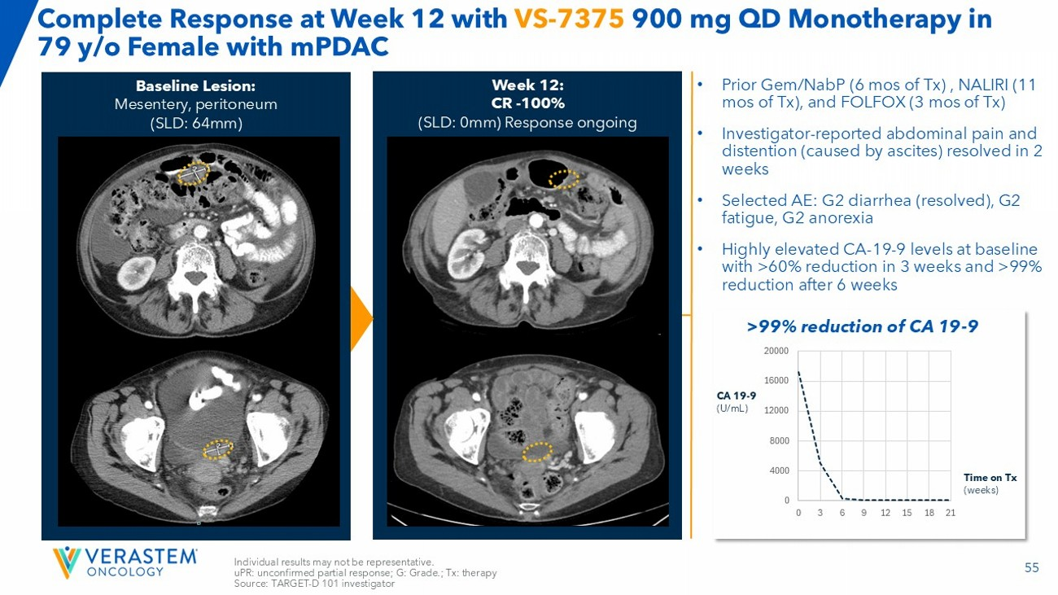
55 Complete Response at Week 12 with VS - 7375 900 mg QD Monotherapy in 79 y/o Female with mPDAC Individual results may not be representative. uPR : unconfirmed partial response; G: Grade.; Tx: therapy Source: TARGET - D 101 investigator • Prior Gem/ NabP (6 mos of Tx) , NALIRI (11 mos of Tx), and FOLFOX (3 mos of Tx) • Investigator - reported abdominal pain and distention (caused by ascites) resolved in 2 weeks • Selected AE: G2 diarrhea (resolved), G2 fatigue, G2 anorexia • Highly elevated CA - 19 - 9 levels at baseline with >60% reduction in 3 weeks and >99% reduction after 6 weeks Week 12: CR - 100% (SLD: 0mm) Response ongoing Baseline Lesion: Mesentery, peritoneum (SLD: 64mm) 0 4000 8000 12000 16000 20000 0 3 6 9 12 15 18 21 CA 19 - 9 (U/mL) Time on Tx (weeks) >99% reduction of CA 19 - 9

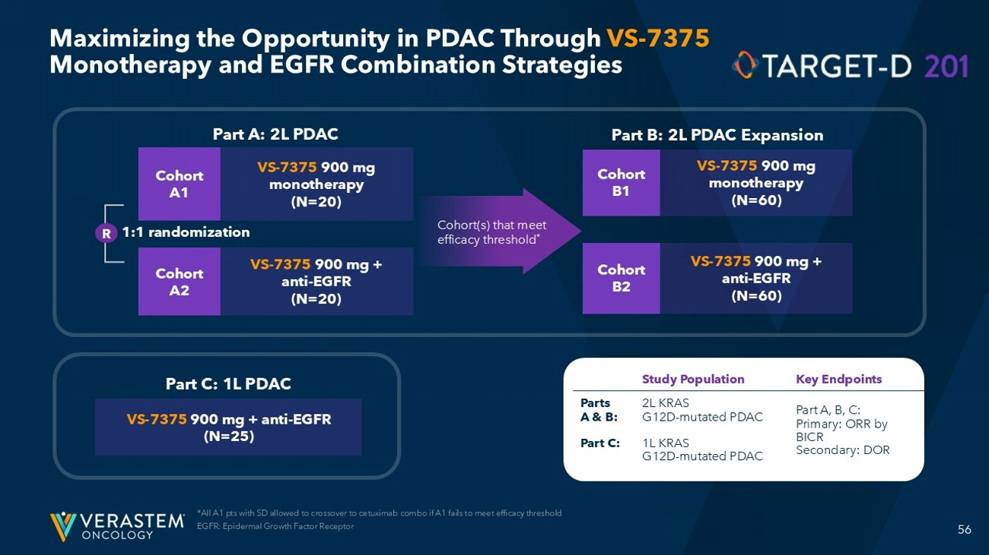
56 Maximizing the Opportunity in PDAC Through VS - 7375 Monotherapy and EGFR Combination Strategies *All A1 pts with SD allowed to crossover to cetuximab combo if A1 fails to meet efficacy threshold EGFR: Epidermal Growth Factor Receptor R 1:1 randomization Part A: 2L PDAC Cohort A 1 Cohort A2 VS - 7375 900 mg monotherapy (N=20) VS - 7375 900 mg + anti - EGFR (N=20) Cohort B1 Cohort B2 VS - 7375 900 mg monotherapy (N=60) VS - 7375 900 mg + anti - EGFR (N=60) Part B: 2L PDAC Expansion Cohort(s) that meet efficacy threshold * Part C: 1L PDAC VS - 7375 900 mg + anti - EGFR (N=25) Key Endpoints Study Population Part A, B, C: Primary: ORR by BICR Secondary: DOR 2L KRAS G12D - mutated PDAC 1L KRAS G12D - mutated PDAC Parts A & B: Part C:

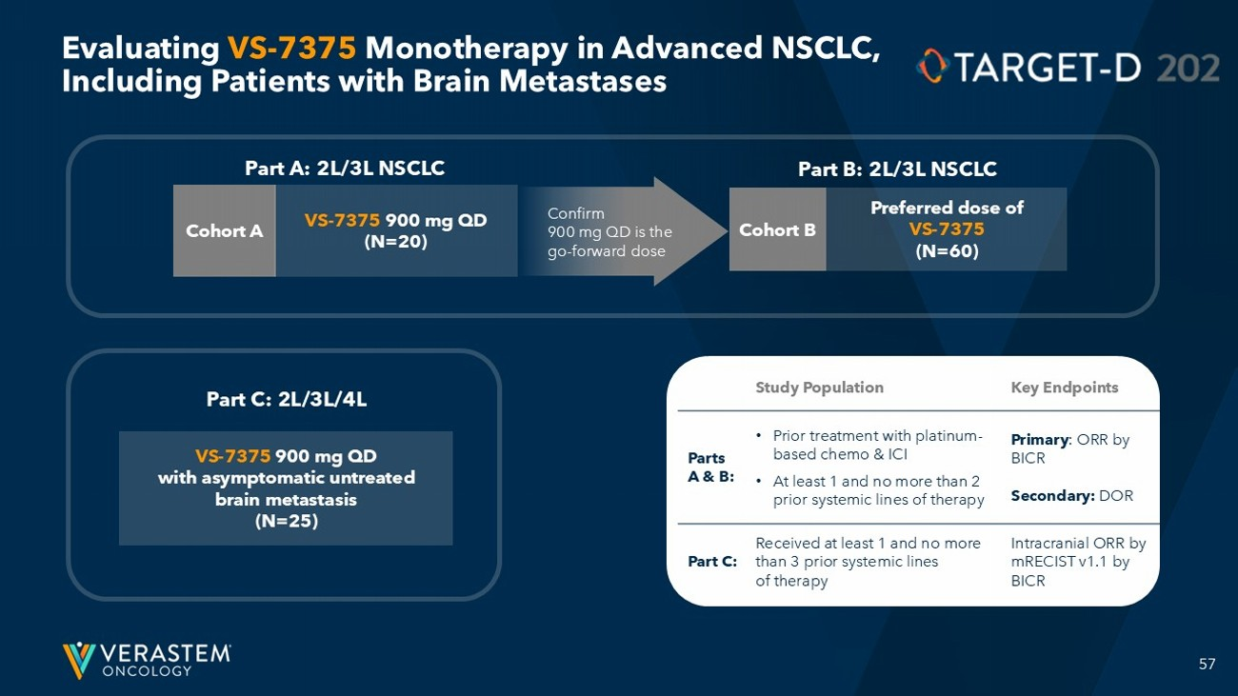
57 Evaluating VS - 7375 Monotherapy in Advanced NSCLC, Including Patients with Brain Metastases Part A: 2L/3L NSCLC Cohort A VS - 7375 900 mg QD (N=20) Cohort B Preferred dose of VS - 7375 (N=60) Part B: 2L/3L NSCLC Confirm 900 mg QD is the go - forward dose Part C: 2L/3L/4L VS - 7375 900 mg QD with asymptomatic untreated brain metastasis (N=25) Key Endpoints Study Population Primary : ORR by BICR Secondary: DOR • Prior treatment with platinum - based chemo & ICI • At least 1 and no more than 2 prior systemic lines of therapy Parts A & B: Intracranial ORR by mRECIST v1.1 by BICR Received at least 1 and no more than 3 prior systemic lines of therapy Part C:

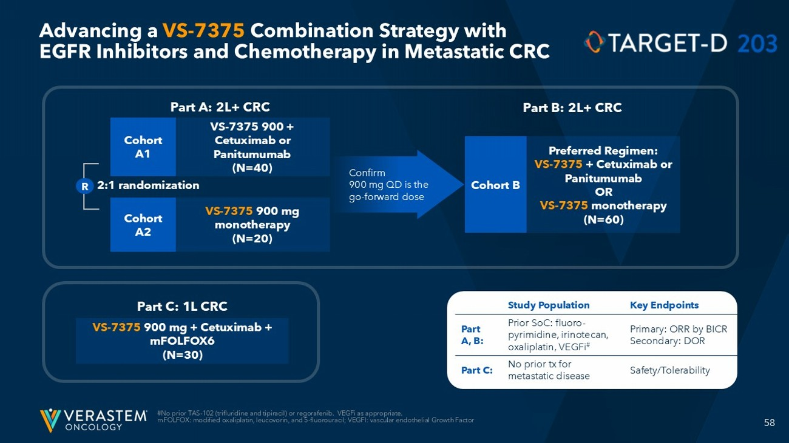
58 Advancing a VS - 7375 Combination Strategy with EGFR Inhibitors and Chemotherapy in Metastatic CRC #No prior TAS - 102 ( trifluridine and tipiracil ) or regorafenib. VEGFi as appropriate. mFOLFOX : modified oxaliplatin, leucovorin, and 5 - fluorouracil; VEGFI: vascular endothelial Growth Factor R 2:1 randomization Part A: 2L+ CRC Cohort A 1 Cohort A2 VS - 7375 900 + Cetuximab or Panitumumab (N=40) VS - 7375 900 mg monotherapy (N=20) Cohort B Preferred Regimen: VS - 7375 + Cetuximab or Panitumumab OR VS - 7375 monotherapy (N=60) Part B: 2L+ CRC Confirm 900 mg QD is the go - forward dose Part C: 1L CRC VS - 7375 900 mg + Cetuximab + mFOLFOX6 (N=30) Key Endpoints Study Population Primary: ORR by BICR Secondary: DOR Prior SoC: fluoro - pyrimidine, irinotecan, oxaliplatin, VEGFi # Part A, B: Safety/Tolerability No prior tx for metastatic disease Part C:

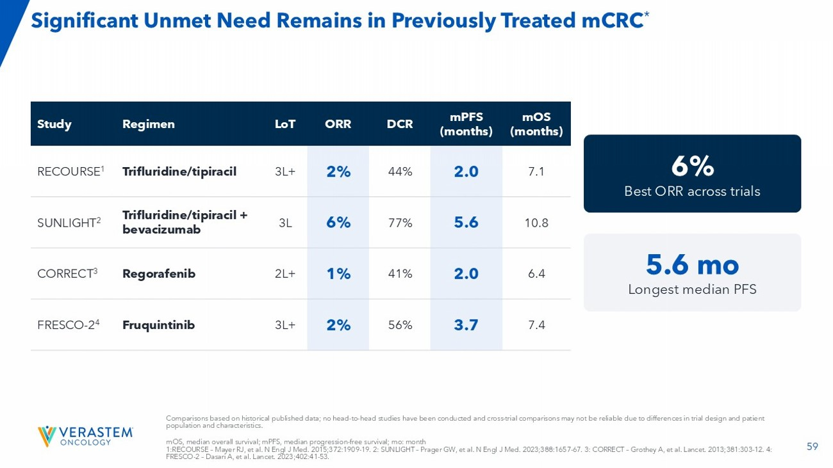
59 Comparisons based on historical published data; no head - to - head studies have been conducted and cross - trial comparisons may not be reliable due to differences in trial design and patient population and characteristics. mOS , median overall survival; mPFS , median progression - free survival; mo : month 1:RECOURSE – Mayer RJ, et al. N Engl J Med. 2015;372:1909 - 19. 2: SUNLIGHT – Prager GW, et al. N Engl J Med. 2023;388:1657 - 67. 3: CORRECT – Grothey A, et al. Lancet. 2013;381:303 - 12. 4: FRESCO - 2 – Dasari A, et al. Lancet. 2023;402:41 - 53. mOS (months) mPFS (months) DCR ORR LoT Regimen Study 7.1 2.0 44% 2% 3L+ Trifluridine/ tipiracil RECOURSE 1 10.8 5.6 77% 6% 3L Trifluridine/ tipiracil + bevacizumab SUNLIGHT 2 6.4 2.0 41% 1% 2L+ Regorafenib CORRECT 3 7.4 3.7 56% 2% 3L+ Fruquintinib FRESCO - 2 4 6% Best ORR across trials 5.6 mo Longest median PFS Significant Unmet Need Remains in Previously Treated mCRC *



